**Work Method 17- Hardwood Flooring**

(WM17-MCDC Template)

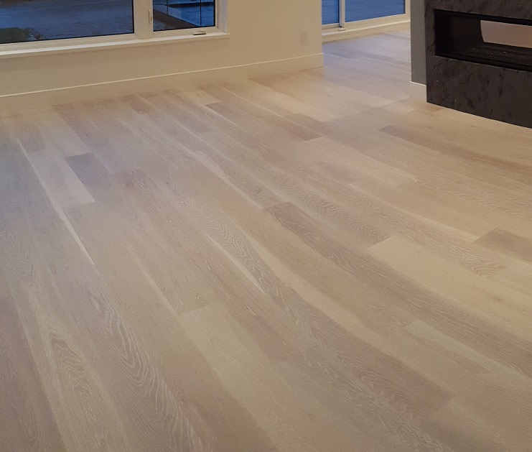

**Industry Based Project (CMGT 8800)**

**September 20, 2018**

**BCIT**

Faculty Advisor: Jim Turnham, P. Eng, MASc., ISO 9001 Lead Auditor

Prepared by: Behrouz Chehrehpardaz

Table of Contents

2. SIGNATURE PAGE 3

3. Proponent and Project Description 4

4. PURPOSE and SCOPE 5

5. DEFINITIONS 5

6. RESPONSIBILITIES 6

7. SAFETY AND ENVIRONMENT 8

8. SUBMITTALS 8

9. PROCEDURE 10

9.1. General Requirements 10

9.2. Planning the floor layout (TS1) 11

9.3. Position the First Row (TS2) 12

9.4. Gluing the Boards Together (TS3) 15

9.5. Installing Remainder of Floor Boards (TS4) 17

9.6. Installing the Last Row and Temporary Protection (TS5) 19

10. Quality Assurance Approval 22

11. References 22

12. Construction Organization Chart 23

13. Flow Chart 24

14. Inspection and Test Plan 25

# SIGNATURE PAGE

As an Approver, with my signature, I confirm that this Work Method is the plan for construction of the work. If the plan changes, I will inform the Originator so that the Work Method can be revised. Alternately, I will make revisions myself and reissue to those that require copies.

As a Reviewer, my signature confirms that I have reviewed the document and any comments to the WM have been provided to the Originator and/or to the Approver.

MCDC Construction Manager

Name: Date: ____ __ Title: _____________________ Signature: _________________

MCDC Project Manager

Name: Date: ____ __ Title: _____________________ Signature:_________________

Contractor

Name: Date: ____ __ Title: _____________________ Signature: _________________

Initial Reviewer

Name: Date: Title: Signature:

# Proponent and Project Description

**Company Name:** MC DEVELOPMENT CORP. (MCDC)

**Company type of service**

MCDC is a small construction company building Single Family Houses (SFHs) in North Vancouver, and the company’s vision is to be recognized as a model of quality excellence in construction.

**Project Description**

Under a Project Management/Design Build method, MCDC itself or on behalf of the owners manages construction projects to build new single-family houses mostly in North Vancouver.

MCDC contract out all work activities in construction stage including Hardwood Flooring.

**Work Method Activity Description**

This Work Method (WM) provides the required details of how the installation of hardwood is carried out, and it is also subject to a series of inspections, before the commencement, during the work, and after completion.

This Work Method will be used in order to ensure full compliance with MCDC’s quality policy and Quality Plan, drawings, specifications, and BC Building Codes.

**Work Method Scope**

This work method shall apply to any work in relation to hardwood flooring that has been shown in the drawings of the project.

**Limitation of liability:**

Any organization engaged as a Contractor or Subcontractor (the Contractor) agrees to use this Work Method only under the condition that those that wrote and developed this Work Method are to be held harmless for any errors or omissions, any inaccuracies in content resulting in any damages to property or any injury to any personnel that may be involved. It remains the sole responsibility of the Contractor to review any and all items contained in the above Work Method and to make any changes that may be required in order to satisfy any project specification or any regulatory or statutory obligation. As well, the Contractor shall review any and all suggested methods as contained herein and shall make any changes required and shall reissue prior to commencement of construction in order to achieve the specified product or to provide a safe work site for all workers involved. Ownership and final responsibility for the use of all Work Methods remains with the Contractor.

# PURPOSE and SCOPE

**Purpose**: To define the responsibilities, describe methods and documentation to be used for installation of hardwood in MCDC’s SFH projects.

**Scope**: This work method applies to all activities required for hardwood flooring at (the address of the project). Reference Standards include:

* British Columbia (or applicable province) Building Code 2012.

Note: Construction documents (design drawings and specifications) should be referenced as applicable and will govern over any procedure included in this document.

# DEFINITIONS

MCDC - MC Development Corp.

CM - MCDC’s Construction Manager

PM - MCDC’s Project Manager

QC - Quality Control

WM - Work Method (this document)

WP **-** Work Procedure

TS - Task Step

CL - Checklist

RM - Review Meeting

NCP - Nonconformity Procedure

ITP - Inspection and Test Plan

BI - Before the TS Inspection

DI - During the TS Inspection

AI – After the TS Inspection

DNV - District of North Vancouver

SWP – Safe Work Practice

SWRB – Solid Waste Removal Bylaw (DNV)

# RESPONSIBILITIES

* 1. **Construction Manager (CM)** is responsible for project scheduling, and final approving the inspections, tests, and changes. The CM is also responsible for preparation of drawings and sketches to support construction as required and all making any changes if required.
  2. **Project Manager (PM)** is responsible for; identifying necessary resources and assigning individual responsibilities to run and monitor the quality control procedure that defined by MCDC’s QP and this WM. He is responsible for overseeing the Quality Management Plan, enforcing project construction standards, assisting the CM in the creation of work method documents by providing appropriate sequence and task definitions, executing the project, scheduling and delegation of the roles of quality assurance inspections, safety, environmental items and Contractor coordination.
  3. The PM is accountable for the Site Superintendent’s all responsibilities as well. The PM, for each WM contemplated for use at the site, provides a review and makes changes if necessary to any clause so that it is consistent with best practice, consistent with the building code of the Province, and consistent with local conditions. Issues should be reviewed by email with the CM.
  4. **Site Superintendent** must work well with people and is responsible for:
  + Requesting copies of subcontractor’s liability insurance and workmen’s compensation certificate.
  + Overall site activities; applying project methodology and enforcing project construction standards; organizing field staff and ensuring they perform as required; and supervising Contractors and ensuring they perform as required
  + Assisting the PM and the Contractors in the creation and execution of work plans including revisions to these plans as necessary.
  + Assisting the PM in supervision of Contractors’ work quality.
  + Working closely with and support the Contractor to identify potential risks/opportunities, discuss necessary changes, and conduct the inspections.
  + Scheduling and monitoring each workday with appropriately resources.
  + Serving as the representative of and primary contact with the PM.
  + Attending review meetings.
  + Maintaining site logs and other documents in jobsite.
  + Ensuring the jobsite safety and ensuring that safety practices are followed.
  1. **Trade Contractor** (Contractor) refers to the company that is bound by contract to MCDC for a certain scope of work. For their scope, the Contractor is responsible for environmental control, safety controls, and quality control for self-performed work. The Contractor is responsible to write his/her Work Methods. However, if the Contractor cannot provide the required WMs, MCDC may assist, but the final WM will be reviewed, changes made to reflect project requirements, codes, laws, and resubmitted to MCDC and owned by the Contractor. The Contractor performs the work required by the contract documents and approved Work Methods to start and complete the Project and fulfill everything indicated by the contract documents. The Contractor shall perform activities described in this WM. If any revision is needed, the Contractor shall be instructed to revise and update this WM so that the WM reflects the intent and methods of the Contractor as well. The Contractor shall be fully responsible for his means and methods, and for the content of the revised WM. The Contractor shall assign a representative who will permanently attend at the job site when the job is being done. The Site Manager or the Contractor’s site representative shall ensure following the guidelines and/or Standard Specifications outline on this work method.

# SAFETY AND ENVIRONMENT

All construction activities and job procedures shall conform to

* WCB Regulations and other applicable codes, regulations and acts
* DNV Noise Regulation Bylaw (Bylaw 7188)

Before any work takes place, the PM and Site Superintendent will ensure that all operators, laborers, and Contractors have been site orientated.

All works in relation to Hardwood installation must comply with safe practices and with the requirements of the bylaw, codes and ordinances.

All work process shall be fully consistent to DNV Bylaws.

# SUBMITTALS

The contractor submittals to MCDC:

* Contractor Quotation for doing the job described in MCDC’s RFQ package, including
  + Contract price and time (including the start time of work on site)
  + Declaration of accepting all contract terms and documents
  + Written promise to provide the required submittals (including Contractor’s Work Method and Checklists), 14 days prior to the work start
  + Documented processes and submittals to enable the PM review
  + Contractor’s initial Work Method, Checklists, and ITP for MCDC review
* The final revision of MCDC QP reviewed and confirmed by the Contractor
* Finalized WM, ITPs, Checklists, and any other documents required by the contract documents, not later than 7 days prior to the work start time, (MCDC CM written confirmation required)
* Any drawing, specs, and designing layout which is required for carrying out the work, and in order to satisfy any project specification or any regulatory or statutory obligation.
* Reports that identifies the Self inspection result and scope of work, before each MCDC scheduled inspection
* Insurance and WCB coverage

All contractor submittals are stated in the Contract and include (but not limited to)

* Product description and actual samples
* Material Data Sheet including the following products:
  + Self-leveling compound primer
  + Self-leveling compound
  + Wood flooring adhesive, and vapor barrier
  + Concrete flooring adhesive, and vapor barrier
  + Noise reduction underlay
  + Moisture retarder and vapor barrier coating
  + Shop drawings
* Shop drawings
  + Indicate hardwood flooring layout, and patterns
  + Junctions with other flooring surfaces
  + Connections with fireplace, kitchen island, stairs, etc.
* Installer’s qualification proof
* Installer’s Safety Orientation sheet
* Maintenance sheet

# PROCEDURE

## General Requirements

Consult the specifications and construction drawings to determine the requirements for any aspect of the work. This Work Method is a guideline used by MCDC to describe the work process and the process of quality control by conducting the specific Inspections and relevant Checklists. The Drawings, and Specifications as well as any code and by-law are the ultimate requirements. The PM and the Contractor shall review the Work Method and make any revision (prior to each use if necessary) so that any requirements will be identified and met.

The following Task Steps (procedures) TSs are included in this Work Method:

* 9.2 Planning the floor layout (TS1)
* 9.3 Position the First Row (TS2)
* 9.4 Gluing the Boards Together (TS3)
* 9.5 Installing Remainder of Floor Boards (TS4)
* 9.6 Installing the Last Row and Temporary Protection (TS5)

Each TS comes with a Checklist and each Checklist is subject to three Inspections, before, during, and after completion of the TS. Each Checklist includes several checkpoints which must be controlled and verified by the MCDC’s PM or Site Superintendent. To continue the work and proceed to next step, the Contractor must obtain the approval of PM for all Inspections. The PM will give the approval only if all Checklist’s items are checked and passed.

The Inspections and Testing shall follow the instructions described in the Inspection and Testing Plan number 17(ITP17). The PM shall review the results of the ITP and Checklists and check if the results are acceptable. The PM will communicate the acceptable results to the CM and if the results are not acceptable, the PM will communicate this issue to the CM and the Contractor to evaluate the default and issue instructions for the corrective actions.

## Planning the floor layout (TS1)

Before you begin:

* Ensure sub floor is dry, flat, rigid (doesn’t move or squeak), structurally sound, clean, and smooth.
* Check sub floor thickness is strong enough for wood flooring. (5/8”-3/4”).
* It is recommended that the opened packages of flooring sit in the area in which they are to be installed for several days to acclimatize.
  + 1. Before beginning the actual installation, provide proper layout of flooring by distributing short and long lengths equally over the areas where the flooring is to be installed only in case of random length.
    2. Flooring is to be installed at right angles to the floor joists so that they can be nailed securely.
    3. Work out of several cartons at a time to insure proper color and shade mixture.
    4. Align the first row of planks to be sure you have a good straight line from one side of the room to the other. Snap a chalk line at the desired distance from the wall to help align the first row of planks.
    5. The end joints of plank or strip flooring should be staggered to achieve the best appearance in the finished floor (Minimum 6”.)
    6. Leave at least 13.0MM-19.0 MM (1/2” to ¾”) for expansion at all vertical surfaces, or leave at least what will be covered by the baseboard or quarter round trim.

## Position the First Row (TS2)

Before you begin:

* Make sure all cartons of flooring are checked for consistent shade and grain of flooring.
* Ensure any under floor layer has been installed.
* Before starting, first measure the width of the room, and then divide the room’s width by the width of the plank. If this means that the last row of planks will be narrower than 2”, then you will need to cut the first row of planks to make it narrower.
  + 1. Cut in such a way that both the first and last rows of planks to be installed in the room will have the same approximate width for an overall continuous look.

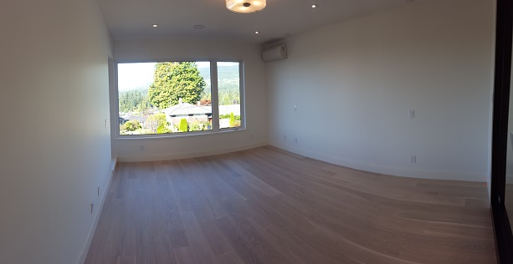

* + 1. To cut the boards, always saw with the teeth cutting down into the face or top of the board**.** Cutting from the top down helps protect the surface. Use a carbide tip blade to ensure smooth cuts.

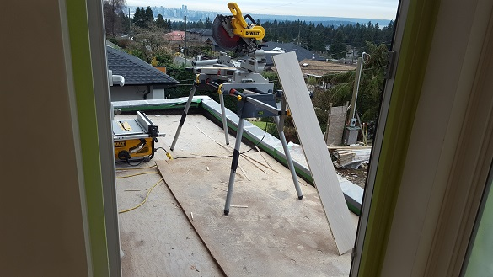

* + 1. Begin the installation of the planks in the left-hand corner of the room with the flooring perpendicular to the floor joists. Always start so that you will be working left to right when facing starting wall. When possible, run the length of the planks in the same direction as incoming sunlight.
    2. Install the first row of engineered planks with the groove side facing the wall (Versa- lock planks – tongue faces starting wall).
    3. Always place expansion spacers against the wall every 2-3’. Also place spacers at each plank end joint connection, as this will make maintaining a good square easier. Larger rooms require additional expansion space. Add 1/16” to the width of the expansion space for every 3’ the room extends beyond 25’. Dimensions exceeding 40’in length or width, requires the use of a T-Molding for expansion.

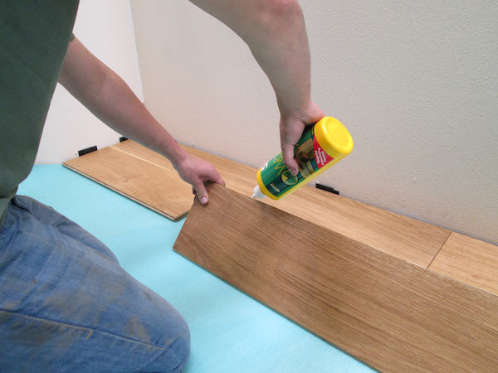

* + 1. If the starting wall is out of square, it will be necessary to scribe the first row to match the wall, allowing the opposite side of the row to present a true square base for the rest of the floor. When the first row is complete, you must have a straight, even base established.

|  |  |  |  |  |  |  |  |  |
| --- | --- | --- | --- | --- | --- | --- | --- | --- |
|  | Checklist 17-2: **Position the First Row (TS2)** | | | | | | | |
| MC Development Corp. | | Project: | Contractor: | | | | | |
| **Number** | **Checkpoints** | | | BI | DI | | | AI |
| **1** | DNV permit/inspection approval as required | | |  |  | | |  |
| **Comment** |  | | | | | | | |
| **2** | Substrate approved and surface even and free of irregularities | | |  | |  |  | |
| **Comment** |  | | | | | | | |
| **3** | Defective boards are out, and board colors randomly distributed | | |  | |  |  | |
| **Comment** |  | | | | | | | |
| **4** | Wood style and pattern approved by PM | | |  |  | | |  |
| **Comment** |  | | | | | | | |
| **5** | First and last rows in the room have same approximate width? | | |  |  | | |  |
| **Comment** |  | | | | | | | |
| **6** | Carbide tip blade used to make smooth cuts? | | |  |  | | |  |
| **Comment** |  | | | | | | | |
| **7** | Expansion spacers used every 2-3’? | | |  |  | | |  |
| **Comment** |  | | | | | | | |
| **8** | First row scribed to match the wall if starting wall is not square? | | |  |  | | |  |
| **Comment** |  | | | | | | | |
| **9** | Glue cleaned up from floor, and no Scratches or Gouges | | |  |  | | |  |
| **Comment** |  | | | | | | | |
| **Quality Scores and Completion Sign-off** | | | | | | | | |
| **Inspection#**  Quality 5 4 3 2 1 Notes:  On-Time 5 4 3 2 1 Notes:  Sign and date*: Cell # / ID #: Signed: Date:  Task has been verified complete and in compliance with contract drawings and specifications except for non-conformances and incomplete items reported above. | | | | | | | | |
| **BI=** Inspection **B**efore task begin **-----------DI=** Inspection **D**uring task in-process --------**AI=** Inspection **A**fter task completed  *Quality Score**5 = 100% NO problems 4 = 1 minor problems 3 = Hotspot or 2-3 minor 2 = 6+ or major problems 1 = Excessive problems*  ***On-Time Score*** *5 = On Time 4 = Late 3 = Late by 1 day 2 = Late by 2 days 1 = Late more than 2 days*  ***Safety Score*** *5 = 100% NO problems 4 = 1 minor problem 3 = Hotspot or 2-3 minor 2= 4+ or major problem 1= Injury* | | | | | | | | |

## Gluing the Boards Together (TS3)

Before you begin:

* Have a complete row selected for installation before starting to glue.
  + 1. When installing the hardwood flooring products which have been approved for the floating installation method, the boards must be side and end glued using specific hardwood adhesives, except for Versa Lock Hardwoods.
    2. Apply the adhesive into the bottom of the groove on each board. Do not fill the groove. Apply a continuous bead, filling the bottom of the groove no more than halfway full.



* + 1. Start & stop adhesive 2” from the ends on the long side of the board and 1” from the ends on the butt end. If any excess adhesive squeezes up to the finished surface, wipe it off immediately using a water-dampened cloth or special adhesive remover.
    2. Immediately dry the surface and buff with a damp cloth followed by a dry cloth. If the adhesive has dried, use a soft white cloth moistened with adhesive remover. Do not abrade the wood surface.

|  |  |  |  |  |  |  |  |  |
| --- | --- | --- | --- | --- | --- | --- | --- | --- |
|  | Checklist 17-3: **Gluing the Boards Together (TS3)** | | | | | | | |
| MC Development Corp. | | Project: | Contractor: | | | | | |
| **Number** | **Checkpoints** | | | BI | DI | | | AI |
| **1** | Contact surfaces clean and undamaged | | |  |  | | |  |
| **Comment** |  | | | | | | | |
| **2** | If gluing boards is required, are both sides and ends of boards glued using a hardwood adhesive? | | |  | |  |  | |
| **Comment** |  | | | | | | | |
| **3** | Boards glued with continuous bead no more than halfway full in the bottom of the groove? | | |  | |  |  | |
| **Comment** |  | | | | | | | |
| **4** | Adhesive stopped 2” from the ends on the long side of the board and 1” from the ends on the butt end? | | |  |  | | |  |
| **Comment** |  | | | | | | | |
| **5** | Any adhesive of finished surface wiped off immediately using a water-dampened cloth or special adhesive remover? | | |  |  | | |  |
| **Comment** |  | | | | | | | |
| **6** | Surface dried and buffed and any adhesive remaining on the finished surface removed? | | |  |  | | |  |
| **Comment** |  | | | | | | | |
| **7** |  | | |  |  | | |  |
| **Comment** |  | | | | | | | |
| **Quality Scores and Completion Sign-off** | | | | | | | | |
| **Inspection#**  Quality 5 4 3 2 1 Notes:  On-Time 5 4 3 2 1 Notes:  Sign and date*: Cell # / ID #: Signed: Date:  Task has been verified complete and in compliance with contract drawings and specifications except for non-conformances and incomplete items reported above. | | | | | | | | |
| **BI=** Inspection **B**efore task begin **-----------DI=** Inspection **D**uring task in-process --------**AI=** Inspection **A**fter task completed  *Quality Score**5 = 100% NO problems 4 = 1 minor problems 3 = Hotspot or 2-3 minor 2 = 6+ or major problems 1 = Excessive problems*  ***On-Time Score*** *5 = On Time 4 = Late 3 = Late by 1 day 2 = Late by 2 days 1 = Late more than 2 days*  ***Safety Score*** *5 = 100% NO problems 4 = 1 minor problem 3 = Hotspot or 2-3 minor 2= 4+ or major problem 1= Injury* | | | | | | | | |

## Installing Remainder of Floor Boards (TS4)

Before you begin:

* Always stagger approximately 12” to 24” between end joints of adjacent board rows. The end joints should not repeat visually across the installed floor.
  + 1. After installing the first row of boards, apply the adhesive to the first board on the second row using the above gluing instructions. Connect that board to the first row remembering the 12”to 24” stagger between the end joint of the board on the first row.
    2. Tap the boards together with a hammer and an identical tongue and groove (same as your flooring material) tapping block. Be sure that the tapping block is against the tongue only and use only a gentle tapping motion to tap the boards together. Excessive force will damage the board making it difficult to install additional boards.

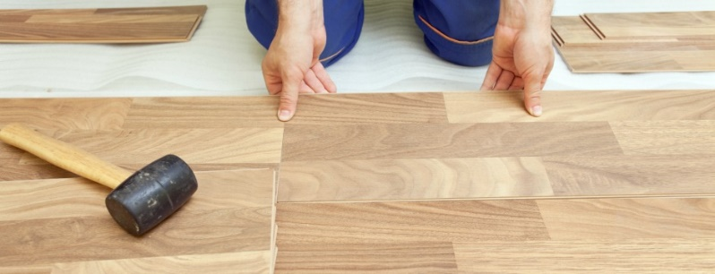

* + 1. Once the board has been tapped into place check for a tight fit on sides and ends. To install the rest of the flooring, continue placing the boards from left to right, building a rack 3 to 4 rows wide, as the installation continues to complete the floor.

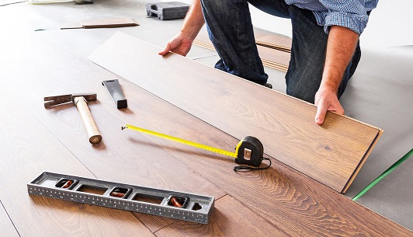

|  |  |  |  |  |  |  |  |  |
| --- | --- | --- | --- | --- | --- | --- | --- | --- |
|  | Checklist 17-4: **Installing Remainder of Floor Boards (TS4)** | | | | | | | |
| MC Development Corp. | | Project: | Contractor: | | | | | |
| **Number** | **Checkpoints** | | | BI | DI | | | AI |
| **1** | Joints staggered 12”-24” between rows? | | |  |  | | |  |
| **Comment** |  | | | | | | | |
| **2** | Tongue and groove tapping block used against the tongue only using gentle taps? | | |  |  | | |  |
| **Comment** |  | | | | | | | |
| **3** | Boards checked for tight fit on sides and ends? | | |  | |  |  | |
| **Comment** |  | | | | | | | |
| **4** | Defective boards culled out - not installed | | |  | |  |  | |
| **Comment** |  | | | | | | | |
| **5** | Board colors randomly distributed | | |  |  | | |  |
| **Comment** |  | | | | | | | |
| **6** | Wood extends to wall | | |  |  | | |  |
| **Comment** |  | | | | | | | |
| **7** | Check for Scratches or Gouges | | |  |  | | |  |
| **Comment** |  | | | | | | | |
| **Quality Scores and Completion Sign-off** | | | | | | | | |
| **Inspection#**  Quality 5 4 3 2 1 Notes:  On-Time 5 4 3 2 1 Notes:  Sign and date*: Cell # / ID #: Signed: Date:  Task has been verified complete and in compliance with contract drawings and specifications except for non-conformances and incomplete items reported above. | | | | | | | | |
| **BI=** Inspection **B**efore task begin **-----------DI=** Inspection **D**uring task in-process --------**AI=** Inspection **A**fter task completed  *Quality Score**5 = 100% NO problems 4 = 1 minor problems 3 = Hotspot or 2-3 minor 2 = 6+ or major problems 1 = Excessive problems*  ***On-Time Score*** *5 = On Time 4 = Late 3 = Late by 1 day 2 = Late by 2 days 1 = Late more than 2 days*  ***Safety Score*** *5 = 100% NO problems 4 = 1 minor problem 3 = Hotspot or 2-3 minor 2= 4+ or major problem 1= Injury* | | | | | | | | |

## Installing the Last Row and Temporary Protection (TS5)

Before you begin:

* Have spacers set against the wall.
  + 1. Most often the entire length of the last row will need to be cut so that it is narrow enough to fit the remaining space. When this occurs, use the following steps.
    2. Lay a row of boards, unglued, with the tongue toward the wall, directly on top of the last row installed. Take a full width scrap piece of the hardwood product that is being installed with the face down and the tongue side against the wall. Use appropriate spacers against the wall to ensure the proper expansion space.

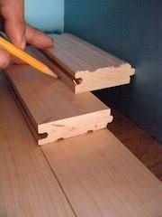

* + 1. Draw a line along the row moving down the wall. The resulting line gives the proper width for the last row which, when cut, can then be wedged into place using the pull bar. Spacers should remain while the adhesive sets.

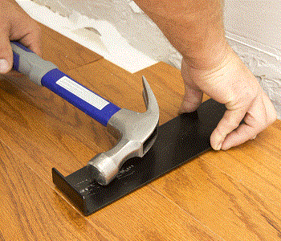

* + 1. Floor should remain free of foot traffic for a minimum of 12 hours while adhesive sets.

A drying time of 24 hours is recommended before any damp-dry mopping, cleaning or heavy objects or furniture can be put back into place.

* + 1. Make sure when the installation is complete that the spacers are removed and the expansion space is covered with an appropriate molding.
    2. Cover floor with builder paper protection. To avoid scratches and stains, we need temporary floor protection. Take note of these four quick tips for using construction floor paper rolls on the floor:
       - Make sure to clean the surface well before laying out your heavy-duty paper cover. A clean floor will prevent against scratches from trapped debris.
       - After you roll out the paper and cut it to size, be sure to use a durable construction tape to keep your paper connected and in place.

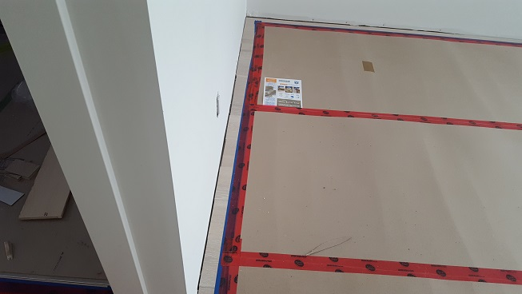

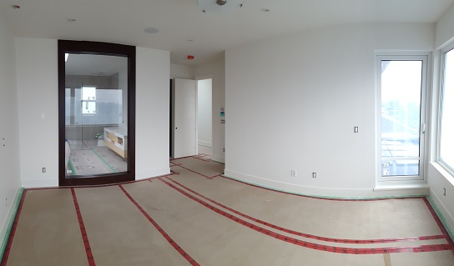

|  |  |  |  |  |  |  |  |  |
| --- | --- | --- | --- | --- | --- | --- | --- | --- |
|  | Checklist 17-5: **Installing the Last Row and Protection (TS5)** | | | | | | | |
| MC Development Corp. | | Project: | Contractor: | | | | | |
| **Number** | **Checkpoints** | | | BI | DI | | | AI |
| **1** | Spacers used to ensure proper expansion space? | | |  |  | | |  |
| **Comment** |  | | | | | | | |
| **2** | Expansion slots allowed at walls and partitions | | |  | |  |  | |
| **Comment** |  | | | | | | | |
| **3** | Cleaned and Check for Scratches or Gouges | | |  | |  |  | |
| **Comment** |  | | | | | | | |
| **4** | Glued floor free of foot traffic for 12 hours while adhesive sets? | | |  |  | | |  |
| **Comment** |  | | | | | | | |
| **5** | Waited 24 hours to put heavy objects on the floor? | | |  |  | | |  |
| **Comment** |  | | | | | | | |
| **6** | Spacers removed once installation is complete? | | |  |  | | |  |
| **Comment** |  | | | | | | | |
| **7** | Expansion space covered with appropriate moulding? | | |  |  | | |  |
| **Comment** |  | | | | | | | |
| **8** | Flooring is free of irregularities caused by placement over  dampness// loose particles// and other foreign materials | | |  |  | | |  |
| **Comment** |  | | | | | | | |
| **9** | Covered properly with builder paper protection | | |  |  | | |  |
| **Comment** |  | | | | | | | |
| **Quality Scores and Completion Sign-off** | | | | | | | | |
| **Inspection#**  Quality 5 4 3 2 1 Notes:  On-Time 5 4 3 2 1 Notes:  Sign and date*: Cell # / ID #: Signed: Date:  Task has been verified complete and in compliance with contract drawings and specifications except for non-conformances and incomplete items reported above. | | | | | | | | |

# Quality Assurance Approval

Only if all 12 required Inspections, associated with 5 TS Checklists mentioned in this WM, are approved by the PM and the CM as OK, the PM will carry out the final Inspection and issues the written approval if the results are OK.

If the results do not match the allowable tolerances, the PM will communicate this issue to the CM who evaluates the NCs and issues instructions for the corrective actions to be taken.

Any non-conformance shall be reported through the NCR procedure described in MCDC’s QP and is applicable to any and all phases of Hardwood Flooring.

# References

1. The Handouts and QMS sample documents provided by Mr. Jim Turnham (CMGT-7246)
2. Based on Behrouz Chehrehpardaz work experience
3. BC Building Code
4. WorkSafeBC Regulations
5. DNV Bylaws

# Construction Organization Chart

MCDC Board of Directors

Construct Manager/CEO

Project Manager

Site Super Intendent

Trade Contractor

# Flow Chart

Contract

Specs

Dwgs

WM/ITP

QP

END

Pre-Work WM Review Meeting

Certificate of Completion

NCP

Corrective Action

Initial Inspection

NO YES

Final Inspection

Passed?

NO/NCP

Inspection

Passed?

YES YES

(BI & DI & AI) Inspections

Passed?

Planning the floor layout

NO/NCP

NO/NCP

Installing the Last Row and Protection

(BI & DI & AI) Inspections

Passed?

YES YES

(BI & DI & AI) Inspections

Passed?

Position the First Row

NO/NCP

NO/NCP

Installing Remainder of Floor Boards

(BI & DI & AI) Inspections

Passed?

YES YES

(BI & DI & AI) Inspections

Passed?

Gluing the Boards Together

NO/NCP

# Inspection and Test Plan

|  |  |  |  |  |  |  |  |  |  |  |
| --- | --- | --- | --- | --- | --- | --- | --- | --- | --- | --- |
| MC Development Corp | | Inspection and Test Plan # 17  **Hardwood Flooring** | | | CM: MCDC Construction Manager  PM: MCDC Project Manager  C: Contractor | | | | | |
| Contractor: | | | Project: | | | | | |
| **#** | **Inspections** | **To Inspect Items listed in** | **Time of Inspection** | **QC**  **by** | **Acceptance Criteria** | **H/W/D** | | **Score &**  **(lowest)** | **Initials** | **Date** |
| 1 | Initial Inspection | QMP004b | Prior to any work | C | CM approval | H |  |  |  |  |
| 2 | First Row BI | Checklist 17-2 | Prior TS2 | C | PM Approval |  |  |  |  |  |
| 3 | First Row DI | Checklist 17-2 | During TS2 | C | PM Approval |  |  |  |  |  |
| 4 | First Row AI | Checklist 17-2 | After TS2 | C | PM Approval |  |  |  |  |  |
| 5 | Gluing Boards BI | Checklist 17-3 | Before TS3 | C | PM Approval |  |  |  |  |  |
| 6 | Gluing Boards DI | Checklist 17-3 | During TS3 | C | PM Approval |  |  |  |  |  |
| 7 | Gluing Boards AI | Checklist 17-3 | After TS3 | C | PM Approval |  |  |  |  |  |
| 8 | Installation BI | Checklist 17-4 | Before TS4 | C | PM Approval |  |  |  |  |  |
| 9 | Installation DI | Checklist 17-4 | During TS4 | C | PM Approval |  |  |  |  |  |
| 10 | Installation AI | Checklist 17-4 | After TS4 | C | PM Approval |  |  |  |  |  |
| 11 | Last Protection BI | Checklist 21-5 | Before TS5 | C | PM Approval |  |  |  |  |  |
| 12 | Last Protection DI | Checklist 21-5 | During TS5 | C | PM Approval |  |  |  |  |  |
| 13 | Last Protection AI | Checklist 21-5 | After TS5 | C | PM Approval |  |  |  |  |  |
| 14 | Final Inspection | List of NCs | After Completion | PM | CM Approval |  |  |  |  |  |
| ITP Accepted by ……………………… Signature ……………………………… Date ……………. | | | | | | | | | | |
| **(BI**: Inspection Before Task Begin----**DI**: Inspection During Task Work----**AI**: Inspection After Task Finished)  **(W**: Witnessed by CM---- **H**: Hold further work----**D**: Document) | | | | | | | | | | |