**Work Method 13- Siding Installation (Longboards)**

(WM13-MCDC Template)

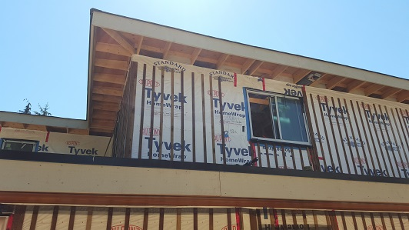

**Industry Based Project (CMGT 8800)**

**September 20, 2018**

**BCIT**

Faculty Advisor: Jim Turnham, P. Eng, MASc., ISO 9001 Lead Auditor

Prepared by: Behrouz Chehrehpardaz

Table of Contents

2. SIGNATURE PAGE 3

3. Proponent and Project Description 4

4. PURPOSE and SCOPE 5

5. DEFINITIONS 5

6. RESPONSIBILITIES 6

7. SAFETY AND ENVIRONMENT 8

8. SUBMITTALS 8

9. PROCEDURE 10

9.1. General Requirements 10

9.2. Application of Building Paper (TS1) 11

9.3. Sill Membrane Installation (TS2) 13

9.4. Rainscreen Installation (TS3) 16

9.5. Longboard Installation (TS4) 19

10. Quality Assurance Approval 31

11. References 31

12. Construction Organization Chart 32

13. Flow Chart 33

14. Inspection and Test Plan 34

# SIGNATURE PAGE

As an Approver, with my signature, I confirm that this Work Method is the plan for construction of the work. If the plan changes, I will inform the Originator so that the Work Method can be revised. Alternately, I will make revisions myself and reissue to those that require copies.

As a Reviewer, my signature confirms that I have reviewed the document and any comments to the WM have been provided to the Originator and/or to the Approver.

MCDC Construction Manager

Name: Date: ____ __ Title: _____________________ Signature: _________________

MCDC Project Manager

Name: Date: ____ __ Title: _____________________ Signature:_________________

Contractor

Name: Date: ____ __ Title: _____________________ Signature: _________________

Initial Reviewer

Name: Date: Title: Signature:

# Proponent and Project Description

**Company Name:** MC DEVELOPMENT CORP. (MCDC)

**Company type of service**

MCDC is a small construction company building Single Family Houses (SFHs) in North Vancouver, and the company’s vision is to be recognized as a model of quality excellence in construction.

**Project Description**

Under a Project Management/Design Build method, MCDC itself or on behalf of the owners manages construction projects to build new single-family houses mostly in North Vancouver.

MCDC contract out all work activities in construction stage including Siding Installation.

**Work Method Activity Description**

This Work Method (WM) provides the required details of how the installation of Longboard Aluminum Siding is carried out, and it is also subject to a series of inspections, before the commencement, during the work, and after completion.

This Work Method will be used in order to ensure full compliance with MCDC’s quality policy and Quality Plan, drawings, specifications, and BC Building Codes.

**Work Method Scope**

This work method shall apply to the installation of Longboard Aluminum Siding that has been shown in drawings of the project.

**Limitation of liability:**

Any organization engaged as a Contractor or Subcontractor (the Contractor) agrees to use this Work Method only under the condition that those that wrote and developed this Work Method are to be held harmless for any errors or omissions, any inaccuracies in content resulting in any damages to property or any injury to any personnel that may be involved. It remains the sole responsibility of the Contractor to review any and all items contained in the above Work Method and to make any changes that may be required in order to satisfy any project specification or any regulatory or statutory obligation. As well, the Contractor shall review any and all suggested methods as contained herein and shall make any changes required and shall reissue prior to commencement of construction in order to achieve the specified product or to provide a safe work site for all workers involved. Ownership and final responsibility for the use of all Work Methods remains with the Contractor.

# PURPOSE and SCOPE

**Purpose**: To define the responsibilities, describe methods and documentation to be used for installation of Longboard Aluminum Siding in MCDC’s SFH projects.

**Scope**: This work method applies to all activities required for Longboard Aluminum Siding installation at (the address of the project). Reference Standards include:

* British Columbia (or applicable province) Building Code 2012.

Note: Construction documents (design drawings and specifications) should be referenced as applicable and will govern over any procedure included in this document.

# DEFINITIONS

MCDC - MC Development Corp.

CM - MCDC’s Construction Manager

PM - MCDC’s Project Manager

QC - Quality Control

WM - Work Method (this document)

WP **-** Work Procedure

TS - Task Step

CL - Checklist

RM - Review Meeting

NCP - Nonconformity Procedure

ITP - Inspection and Test Plan

BI - Before the TS Inspection

DI - During the TS Inspection

AI – After the TS Inspection

DNV - District of North Vancouver

SWP – Safe Work Practice

SWRB – Solid Waste Removal Bylaw (DNV)

# RESPONSIBILITIES

* 1. **Construction Manager (CM)** is responsible for project scheduling, and final approving the inspections, tests, and changes. The CM is also responsible for preparation of drawings and sketches to support construction as required and all making any changes if required.
  2. **Project Manager (PM)** is responsible for; identifying necessary resources and assigning individual responsibilities to run and monitor the quality control procedure that defined by MCDC’s QP and this WM. He is responsible for overseeing the Quality Management Plan, enforcing project construction standards, assisting the CM in the creation of work method documents by providing appropriate sequence and task definitions, executing the project, scheduling and delegation of the roles of quality assurance inspections, safety, environmental items and Contractor coordination.
  3. The PM is accountable for the Site Superintendent’s all responsibilities as well. The PM, for each WM contemplated for use at the site, provides a review and makes changes if necessary to any clause so that it is consistent with best practice, consistent with the building code of the Province, and consistent with local conditions. Issues should be reviewed by email with the CM.
  4. **Site Superintendent** must work well with people and is responsible for:
  + Requesting copies of subcontractor’s liability insurance and workmen’s compensation certificate.
  + Overall site activities; applying project methodology and enforcing project construction standards; organizing field staff and ensuring they perform as required; and supervising Contractors and ensuring they perform as required
  + Assisting the PM and the Contractors in the creation and execution of work plans including revisions to these plans as necessary.
  + Assisting the PM in supervision of Contractors’ work quality.
  + Working closely with and support the Contractor to identify potential risks/opportunities, discuss necessary changes, and conduct the inspections.
  + Scheduling and monitoring each workday with appropriately resources.
  + Serving as the representative of and primary contact with the PM.
  + Attending review meetings.
  + Maintaining site logs and other documents in jobsite.
  + Ensuring the jobsite safety and ensuring that safety practices are followed.
  1. **Trade Contractor** (Contractor) refers to the company that is bound by contract to MCDC for a certain scope of work. For their scope, the Contractor is responsible for environmental control, safety controls, and quality control for self-performed work. The Contractor is responsible to write his/her Work Methods. However, if the Contractor cannot provide the required WMs, MCDC may assist, but the final WM will be reviewed, changes made to reflect project requirements, codes, laws, and resubmitted to MCDC and owned by the Contractor. The Contractor performs the work required by the contract documents and approved Work Methods to start and complete the Project and fulfill everything indicated by the contract documents. The Contractor shall perform activities described in this WM. If any revision is needed, the Contractor shall be instructed to revise and update this WM so that the WM reflects the intent and methods of the Contractor as well. The Contractor shall be fully responsible for his means and methods, and for the content of the revised WM. The Contractor shall assign a representative who will permanently attend at the job site when the job is being done. The Site Manager or the Contractor’s site representative shall ensure following the guidelines and/or Standard Specifications outline on this work method.

# SAFETY AND ENVIRONMENT

All construction activities and job procedures shall conform to

* WCB Regulations and other applicable codes, regulations and acts
* DNV Noise Regulation Bylaw (Bylaw 7188)
* DNV Environmental Protection and Preservation Bylaw (Bylaw 6515)

Before any work takes place, the PM and Site Superintendent will ensure that all operators, laborers, and Contractors have been site orientated.

Longboard Siding installation work must comply with safe practices and with the requirements of the bylaw, codes and ordinances.

1. **SUBMITTALS**

The contractor submittals to MCDC:

* Contractor Quotation for doing the job described in MCDC’s RFQ package, including
  + Contract price and time (including the start time of work on site)
  + Declaration of accepting all contract terms and documents
  + Written promise to provide the required submittals (including Contractor’s Work Method and Checklists), 14 days prior to the work start
  + Documented processes and submittals to enable the PM review
  + Contractor’s initial Work Method, Checklists, and ITP for MCDC review
* The final revision of MCDC QP reviewed and confirmed by the Contractor
* Finalized WM, ITPs, Checklists, and any other documents required by the contract documents, not later than 7 days prior to the work start time, (MCDC CM written confirmation required)
* Any drawing, specs, and designing layout which is required for carrying out the work, and in order to satisfy any project specification or any regulatory or statutory obligation.
* Reports that identifies the Self inspection result and scope of work, before each MCDC scheduled inspection
* Insurance and WCB coverage
* 15 Year Long Board (LB) manufacturer’s Warranty (Mayne Coatings Corp.)
* Required Tools;
  + LB proper cutter
  + LB metal folder or a pair of folding tongs
  + Screwdriver
  + A pair of sheet cutters,
  + A level
  + Tape measure
  + Safety goggles



* All aluminum Long Boards calculated for this project (in contract)
* Required accessories;
  + LB wood screws or metal screws, depending on the type of project
  + LB waterproof membrane
  + LB Adhesive elastomeric membrane
  + LB Steel roll
  + LB Mouldings
  + LB sealant
* Installer’s qualification proof
* Installer’s Safety Orientation sheet
* Maintenance sheet

# PROCEDURE

## General Requirements

Consult the specifications and construction drawings to determine the requirements for any aspect of the work. This Work Method is a guideline used by MCDC to describe the work process and the process of quality control by conducting the specific Inspections and relevant Checklists. The Drawings, and Specifications as well as any code and by-law are the ultimate requirements. The PM and the Contractor shall review the Work Method and make any revision (prior to each use if necessary) so that any requirements will be identified and met.

The following Task Steps (procedures) TSs are included in this Work Method:

* 9.2 Application of Building Paper (TS1)
* 9.3 Sill Membrane Installation (TS2)
* 9.4 Rainscreen Installation (TS3)
* 9.5 Longboard Installation (TS4)

Each TS comes with a Checklist and each Checklist is subject to three Inspections, before, during, and after completion of the TS. Each Checklist includes several checkpoints which must be controlled and verified by the MCDC’s PM or Site Superintendent. To continue the work and proceed to next step, the Contractor must obtain the approval of PM for all Inspections. The PM will give the approval only if all Checklist’s items are checked and passed.

The Inspections and Testing shall follow the instructions described in the Inspection and Testing Plan number 13(ITP13). The PM shall review the results of the ITP and Checklists and check if the results are acceptable. The PM will communicate the acceptable results to the CM and if the results are not acceptable, the PM will communicate this issue to the CM and the Contractor to evaluate the default and issue instructions for the corrective actions.

## Application of Building Paper (TS1)

* + 1. Make sure that the building paper/house wrap is overlapped correctly. For example, it should be overlapped towards the outside, from top to bottom.
    2. If tears or damage occur during installation, repair with an appropriate exterior air barrier tape (e.g. tuck-tape)
    3. Large tears should be repaired by larger piece of building paper/house wrap, and tuck-tape at the top and the sides but not at the bottom.
    4. The staples should not be used carelessly, because the least amount of penetrations through the building paper/house wrap, the better chances there is for it not leaking.

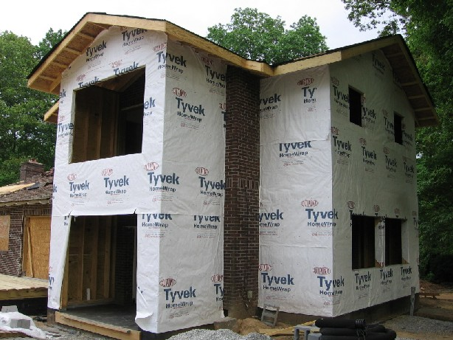

Building Paper

Paper Overlap

|  |  |  |  |  |  |  |  |  |
| --- | --- | --- | --- | --- | --- | --- | --- | --- |
|  | Checklist 12-3: **Application of Building Paper (TS3)** and  Checklist 13-1: **Application of Building Paper (TS1)** | | | | | | | |
| MC Development Corp. | | Project: | Contractor: | | | | | |
| **Number** | **Checkpoints** | | | BI | DI | | | AI |
| **1** | Status of previous TS inspections are approved by the PM/DNV | | |  |  | | |  |
| **Comment** |  | | | | | | | |
| **2** | Is the building paper/house wrap overlapped from top to bottom and towards the outside? | | |  | |  |  | |
| **Comment** |  | | | | | | | |
| **3** | Are tears repaired properly? | | |  | |  |  | |
| **Comment** |  | | | | | | | |
| **4** | Are large tears left without tape at the bottom side? | | |  |  | | |  |
| **Comment** |  | | | | | | | |
| **5** | Is the building paper/house wrap secure with enough, but not too many staples? | | |  |  | | |  |
| **Comment** |  | | | | | | | |
| **6** |  | | |  |  | | |  |
| **Comment** |  | | | | | | | |
|  |  | | | | | | | |
| **Quality Scores and Completion Sign-off** | | | | | | | | |
| **Inspection#**  Quality 5 4 3 2 1 Notes:  On-Time 5 4 3 2 1 Notes:  Sign and date*: Cell # / ID #: Signed: Date:  Task has been verified complete and in compliance with contract drawings and specifications except for non-conformances and incomplete items reported above. | | | | | | | | |
| **BI=** Inspection **B**efore task begin **-----------DI=** Inspection **D**uring task in-process --------**AI=** Inspection **A**fter task completed  *Quality Score**5 = 100% NO problems 4 = 1 minor problems 3 = Hotspot or 2-3 minor 2 = 6+ or major problems 1 = Excessive problems*  ***On-Time Score*** *5 = On Time 4 = Late 3 = Late by 1 day 2 = Late by 2 days 1 = Late more than 2 days*  ***Safety Score*** *5 = 100% NO problems 4 = 1 minor problem 3 = Hotspot or 2-3 minor 2= 4+ or major problem 1= Injury* | | | | | | | | |

## Sill Membrane Installation (TS2)

Before you begin:

* The glue application should be done perfectly in order to proceed. Within a minute or two the BLUE SKIN (or equivalent) should be peeled off and then applied to the glue surface.

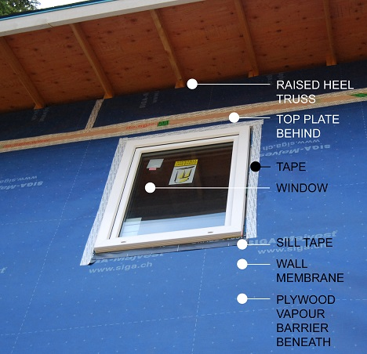

* + 1. Make sure there are no air bubbles under the membrane surface. If there are any air bubbles, then they should be popped and filled with calking.
    2. Make sure there are no scratches or tears on the membrane, if there is then make sure to use a larger piece of BLUE SKIN to repair deficiency.
    3. The membrane on the window sill should come up 6 inches off the right and left jambs of the window, to ensure water proofing.
    4. The corner should have a double layer of the blue skin, depending on the size of the window, to prevent any holes that might result from a weak spot or a damaged area.



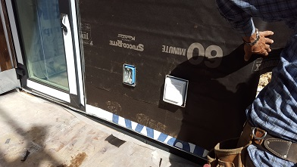

|  |  |  |  |  |  |  |  |  |
| --- | --- | --- | --- | --- | --- | --- | --- | --- |
|  | Checklist 12-4: **Sill Membrane Installation (TS4)** and  Checklist 13-2: **Sill Membrane Installation (TS2)** | | | | | | | |
| MC Development Corp. | | Project: | Contractor: | | | | | |
| **Number** | **Checkpoints** | | | BI | DI | | | AI |
| **1** | Status of previous TS inspections are approved by the PM/DNV | | |  |  | | |  |
| **Comment** |  | | | | | | | |
| **2** | Have any air bubbles been filled with caulking? | | |  |  | | |  |
| **Comment** |  | | | | | | | |
| **3** | Are any major scratches or tears in the BLUE SKIN covered? | | |  | |  |  | |
| **Comment** |  | | | | | | | |
| **4** | Does the window sill membrane reach far enough up each side to ensure waterproofing? | | |  | |  |  | |
| **Comment** |  | | | | | | | |
| **5** | Is there a double layer of BLUE SKIN (or Plastic flashing corners) on the corners of the window sill? | | |  |  | | |  |
| **Comment** |  | | | | | | | |
|  |  | | | | | | | |
| **Quality Scores and Completion Sign-off** | | | | | | | | |
| **Inspection#**  Quality 5 4 3 2 1 Notes:  On-Time 5 4 3 2 1 Notes:  Sign and date*: Cell # / ID #: Signed: Date:  Task has been verified complete and in compliance with contract drawings and specifications except for non-conformances and incomplete items reported above. | | | | | | | | |
| **BI=** Inspection **B**efore task begin **-----------DI=** Inspection **D**uring task in-process --------**AI=** Inspection **A**fter task completed  *Quality Score**5 = 100% NO problems 4 = 1 minor problems 3 = Hotspot or 2-3 minor 2 = 6+ or major problems 1 = Excessive problems*  ***On-Time Score*** *5 = On Time 4 = Late 3 = Late by 1 day 2 = Late by 2 days 1 = Late more than 2 days*  ***Safety Score*** *5 = 100% NO problems 4 = 1 minor problem 3 = Hotspot or 2-3 minor 2= 4+ or major problem 1= Injury* | | | | | | | | |

## Rainscreen Installation (TS3)

The current BC Building Code now requires two layers of wall protection with an air cavity in between (the rainscreen). So, Strapping will be used as vertical wood furring to create a capillary break and ventilation space (rainscreen cavity).

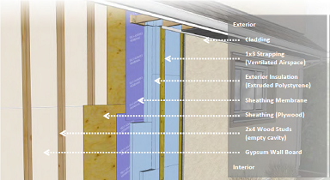

* + 1. Vertical strapping will be fastened with long screws through the exterior insulation and into the framed wall. The strapping creates a drainage space, capillary break, and ventilation cavity (rainscreen cavity) which is consistent with effective moisture-management techniques.
    2. Plywood furring strips typically come in thicknesses of 1/2 or 3/4 inch. The depth of the plywood strips depends on the weight of the material used for cladding. Spacing of furring strips depend on stud spacing (typically 16” or 24”).
    3. The BCBC codes require that rainscreen cavities have a minimum free area of 80% (9.27.2), meaning that material used to create the space must not exceed 20% of the cross-sectional area of the drained and vented cavity. This requirement can generally be met with most strapping arrangements, including the strapping widths given in the following table.



* + 1. The most appropriate strapping for this application will be plywood strapping nominal 1/2”x3”.

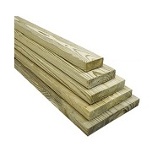

* + 1. Screws used to attach the strapping should be either stainless steel or galvanized steel with a coating rated to 2000-hour salt spray per ASTM B117.

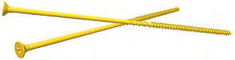

* + 1. Make sure the insect screen has been taped to the bottom of the strips.

|  |  |  |  |  |  |  |  |  |
| --- | --- | --- | --- | --- | --- | --- | --- | --- |
|  | Checklist 13-3: **Rainscreen Installation (TS3)** | | | | | | | |
| MC Development Corp. | | Project: | Contractor: | | | | | |
| **Number** | **Checkpoints** | | | BI | DI | | | AI |
| **1** | Status of previous TS inspections are approved by the PM/DNV | | |  |  | | |  |
| **Comment** |  | | | | | | | |
| **2** | Building papers are completely and correctly installed | | |  |  | | |  |
| **Comment** |  | | | | | | | |
| **3** | All Windows are flashed and sealed properly | | |  |  | | |  |
| **Comment** |  | | | | | | | |
| **4** | Bottom of the wall flashed, overlapped under the building paper | | |  | |  |  | |
| **Comment** |  | | | | | | | |
| **5** | Bug screen installed on the bottom wide enough to wrap up over the furring strips | | |  | |  |  | |
| **Comment** |  | | | | | | | |
| **6** | Plywood strapping have a right size (1/2”x3”) | | |  |  | | |  |
| **Comment** |  | | | | | | | |
| **7** | strapping have been fastened with long screws through the exterior insulation and into the framed wall. | | |  |  | | |  |
| **Comment** |  | | | | | | | |
| **8** | Screws used are either stainless steel or galvanized steel | | | | | | | |
| **Comment** |  | | | | | | | |
| **Quality Scores and Completion Sign-off** | | | | | | | | |
| **Inspection#**  Quality 5 4 3 2 1 Notes:  On-Time 5 4 3 2 1 Notes:  Sign and date*: Cell # / ID #: Signed: Date:  Task has been verified complete and in compliance with contract drawings and specifications except for non-conformances and incomplete items reported above. | | | | | | | | |
| **BI=** Inspection **B**efore task begin **-----------DI=** Inspection **D**uring task in-process --------**AI=** Inspection **A**fter task completed  *Quality Score**5 = 100% NO problems 4 = 1 minor problems 3 = Hotspot or 2-3 minor 2 = 6+ or major problems 1 = Excessive problems*  ***On-Time Score*** *5 = On Time 4 = Late 3 = Late by 1 day 2 = Late by 2 days 1 = Late more than 2 days*  ***Safety Score*** *5 = 100% NO problems 4 = 1 minor problem 3 = Hotspot or 2-3 minor 2= 4+ or major problem 1= Injury* | | | | | | | | |

## Longboard Installation (TS4)

**Panels Features**

* 0.16”-wide screw rail along the entire length of the structure
* 3/4’’ holes for screws, with 2.36’’ between each hole (centre to centre)

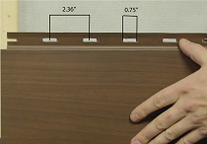

* + 1. Before beginning to install the siding, ensure that your walls are sub straight and level. Aluminum Longboard siding can be installed horizontally, vertically or diagonally.
    2. **Starter Strips**. Using a laser-guided level, a chalk tracer or a standard level, trace a reference line as a guide to insure the starter strip in place.

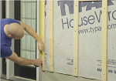

* + 1. Now, fix the #102044 wide starter strips 2 ¾” above where you want your wall to begin. Use Longboard ½” flathead wood screws. Secure the strip using one screw, and when you are satisfied with the alignment, screw the rest of strip in place. Ensure that the starter strip is level, as it will serve as a guide for the rest of the installation.

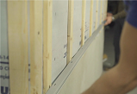 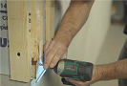

* + 1. **Sealant**. It is important to apply 1” W x ¼” H strips of sealant at 24” intervals along the plank joints and starter strips. Strips of sealant must be applied in the seams of the groove so as not to be visible. Apply the strip of sealant under the holes designed for the screws, in order to avoid the sealant from overflowing and staining the plank when the next plank is inserted beside it. Make sure to clean the sealant immediately before it dry.

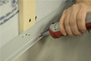 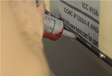

* + 1. Wherever possible, only remove the plastic coating once the siding has been installed.

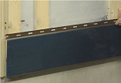

* + 1. **Screws**. Tighten screws by applying moderate pressure to the metal to allows expansion. Screws should not be placed under upward or downward pressure, to avoid deforming the siding and/or opening the joints. Screws should be installed every 16” in the middle of the pre-cut holes, to allow expansion.



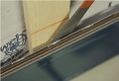 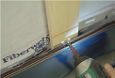

* + 1. If a section of furring appears not to be aligned, leave some space between the wall and the furring of the metal siding once the screw has been inserted. This will avoid placing too much pressure on the product, which can cause an undesired effect.

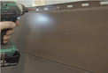 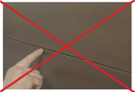

* + 1. **Cutting**. For cutting the panels, use the specialized cutter for Longboard siding, recommended by Longboard Aluminum Architectural. If another cutting tool has to be used, be assured that it will not damage the product, opt for an electric saw with a steel blade designed for cold cutting, in order to minimize any damage to the siding. If cutting with an electric saw, ensure that your material is well covered in order to avoid any flying debris from coming into contact with the panel, which will automatically cause damage.



* + 1. **Joints.** Only factory cuts should be used for wall joints and cutting onsite should only be done for wall mouldings.

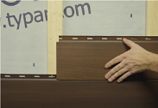

* + 1. **Expansion**. When joining the panels along their length, a space must be left for the dilation and expansion of the material, depending on the temperature during installation. A 1/16” space should be left between planks and 1/8” for mouldings. Also, an expansion joint should be used on the main floor. Moulding should also be used for edging between the two materials.

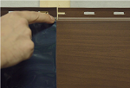

* + 1. **Inside Corners.** Place an L-shaped steel corner or adhesive elastomeric membrane directly on the weather-stripping or strapping.

 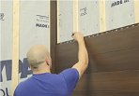

* + 1. Continue cladding the siding on one of the walls, and attach the QJ corner mouldings for inside corners. Continue installing siding on the other wall, while ensuring to slide the planks right to the end of the QJ inside-corner mouldings.

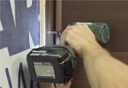 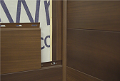

* + 1. **Outside Corners**. Outside moulding corners should be installed in two steps:

**Step 1:** Corner moulding

After completing the installation of the siding on two adjacent walls, fix the mouldings in place using screws.

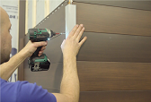

**Step2:** Finished Trim

Randomly apply drops of sealant inside the trim mouldings before stapling them in place. Apply a 1” W x ¼” H strips of sealant at 24” intervals along the trim.

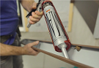 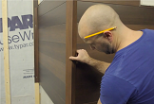

If you do not have an anchor point, then trim and fold back the bottom of the trim moulding to create a surface area to hold it in place. You must secure the corner with a screw as well.

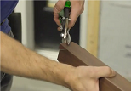 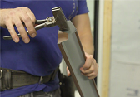

* + 1. **Window Framing.**

Measure and adjust the plank appropriately before attaching it. If the board does not come flush with the height of the lower side of the window, cut it with an extra ½” of space in order to fold it at a 45-degree angle. Then set the extra piece backwards to add support and staple the folded sheet onto the extra piece.

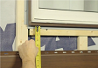 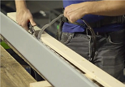

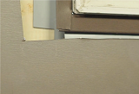 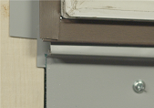

If the wall that you are cladding has a window, start by installing J moulding (Soffit J Trim) around the three sides of the window. Then install a drip cap over the top of the window frame.

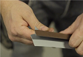 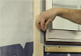

Continue installing the siding around the sides of the window, while ensuring to place planks with different numbers in random order.

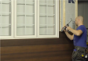

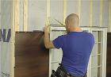

You must install a drip cap before placing the first plank above the window. If the plank does not come flush with the height of the wall, cut it with an extra ½” of material in order to fold it at a 45-degree angle. Then set the extra piece backwards to add support and staple the folded sheet onto the extra piece.

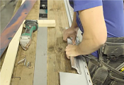 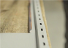

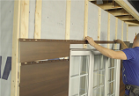 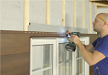

* + 1. **Wall Termination**

Measure and adjust the final plank accordingly using an electric shear, before attaching it to the J moulding.

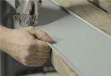

If the plank doesn’t come flush with the height of the wall, place the extra piece backwards onto the J moulding to add support to the plank that was cut.

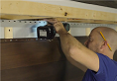 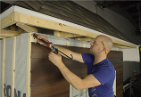

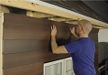

Then install a soffit J-Trim moulding at the top of the wall.

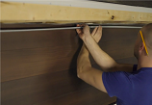

Double check the work and do any trimming if needed.

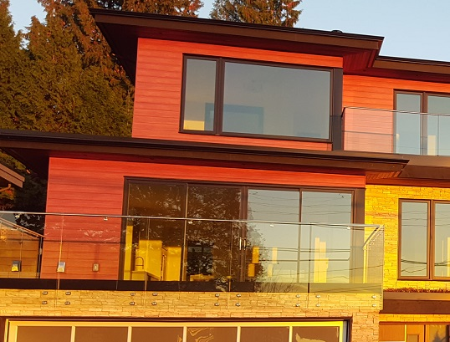

|  |  |  |  |  |  |  |  |  |
| --- | --- | --- | --- | --- | --- | --- | --- | --- |
|  | Checklist 13-4: **Longboard Installation (TS4)** | | | | | | | |
| MC Development Corp. | | Project: | Contractor: | | | | | |
| **Number** | **Checkpoints** | | | BI | DI | | | AI |
| **1** | Status of previous TS inspections are approved by the PM/DNV | | |  |  | | |  |
| **Comment** |  | | | | | | | |
| **2** | walls and furring are sub straight and level | | |  | |  |  | |
| **Comment** |  | | | | | | | |
| **3** | starter strip in place, aligned, leveled, and sealed properly | | |  | |  |  | |
| **Comment** |  | | | | | | | |
| **4** | Screws are not placed under upward or downward pressure | | |  |  | | |  |
| **Comment** |  | | | | | | | |
| **5** | Cuttings are done properly | | |  |  | | |  |
| **Comment** |  | | | | | | | |
| **6** | A 1/16” space left between planks and 1/8” for mouldings | | |  |  | | |  |
| **Comment** |  | | | | | | | |
| **7** | Inside corners membranes installed correctly as instructed (8.5.11) | | |  |  | | |  |
| **Comment** |  | | | | | | | |
| **8** | Outside corners moulding and trimming done properly (8.5.13) | | | | | | | |
| **Comment** |  | | | | | | | |
| **9** | Window framing and wall termination done properly (8.5.14) and (8.5.15) | | | | | | | |
| **Quality Scores and Completion Sign-off** | | | | | | | | |
| **Inspection#**  Quality 5 4 3 2 1 Notes:  On-Time 5 4 3 2 1 Notes:  Sign and date*: Cell # / ID #: Signed: Date:  Task has been verified complete and in compliance with contract drawings and specifications except for non-conformances and incomplete items reported above. | | | | | | | | |
| **BI=** Inspection **B**efore task begin **-----------DI=** Inspection **D**uring task in-process --------**AI=** Inspection **A**fter task completed  *Quality Score**5 = 100% NO problems 4 = 1 minor problems 3 = Hotspot or 2-3 minor 2 = 6+ or major problems 1 = Excessive problems*  ***On-Time Score*** *5 = On Time 4 = Late 3 = Late by 1 day 2 = Late by 2 days 1 = Late more than 2 days*  ***Safety Score*** *5 = 100% NO problems 4 = 1 minor problem 3 = Hotspot or 2-3 minor 2= 4+ or major problem 1= Injury* | | | | | | | | |

# Quality Assurance Approval

Only if all 12 required Inspections, associated with 4 TS Checklists mentioned in this WM, are approved by the PM and the CM as OK, the PM will carry out the final Inspection and issues the written approval if the results are OK.

If the results do not match the allowable tolerances, the PM will communicate this issue to the CM who evaluates the NCs and issues instructions for the corrective actions to be taken.

Any non-conformance shall be reported through the NCR procedure described in MCDC’s QP and is applicable to any and all phases of the installation of Longboard Siding.

# References

1. The Handouts and QMS sample documents provided by Mr. Jim Turnham (CMGT-7246)
2. Based on Behrouz Chehrehpardaz work experience
3. Manufacturer Installation Guide
4. BC Building Code
5. WorkSafeBC Regulations
6. DNV Bylaws

# Construction Organization Chart

MCDC Board of Directors

Construct Manager/CEO

Project Manager

Site Super Intendent

Trade Contractor

# Flow Chart

Contract

Specs

Dwgs

WM/ITP

QP

END

Pre-Work WM Review Meeting

Certificate of Completion

NCP

Corrective Action

Initial Inspection

NO YES

Final Inspection

Passed?

NO/NCP

Inspection

Passed?

YES

Application of Building Paper

NO/NCP

(BI & DI & AI) Inspections

Passed?

YES YES

(BI & DI & AI) Inspections

Passed?

Sill Membrane Installation

NO/NCP

NO/NCP

Longboard Installation

(BI & DI & AI) Inspections

Passed?

YES YES

(BI & DI & AI) Inspections

Passed?

Rainscreen Installation

NO/NCP

# Inspection and Test Plan

|  |  |  |  |  |  |  |  |  |  |  |
| --- | --- | --- | --- | --- | --- | --- | --- | --- | --- | --- |
| MC Development Corp | | Inspection and Test Plan # 13  **Aluminum Longboard Installation** | | | CM: MCDC Construction Manager  PM: MCDC Project Manager  C: Contractor | | | | | |
| Contractor: | | | Project: | | | | | |
| **#** | **Inspections** | **To Inspect Items listed in** | **Time of Inspection** | **QC**  **by** | **Acceptance Criteria** | **H/W/D** | | **Score &**  **(lowest)** | **Initials** | **Date** |
| 1 | Initial Inspection | QMP004b | Prior to any work | C | CM approval | H |  |  |  |  |
| 2 | Building Paper BI | Checklist 13-1 | Prior to TS1 | C | PM Approval |  |  |  |  |  |
| 3 | Building Paper DI | Checklist 13-1 | During TS1 | C | PM Approval |  |  |  |  |  |
| 4 | Building Paper AI | Checklist 13-1 | After TS1 | C | PM Approval |  |  |  |  |  |
| 5 | Sill Membrane BI | Checklist 13-2 | Prior TS2 | C | PM Approval |  |  |  |  |  |
| 6 | Sill Membrane DI | Checklist 13-2 | During TS2 | C | PM Approval |  |  |  |  |  |
| 7 | Sill Membrane AI | Checklist 13-2 | After TS2 | C | PM Approval |  |  |  |  |  |
| 8 | Rainscreen BI | Checklist 13-3 | Before TS3 | C | PM Approval |  |  |  |  |  |
| 9 | Rainscreen DI | Checklist 13-3 | During TS3 | C | PM Approval |  |  |  |  |  |
| 10 | Rainscreen AI | Checklist 13-3 | After TS3 | C | PM Approval |  |  |  |  |  |
| 11 | Longboard Installation BI | Checklist 13-4 | Before TS4 | C | PM Approval |  |  |  |  |  |
| 12 | Longboard Installation DI | Checklist 13-4 | During TS4 | C | PM Approval |  |  |  |  |  |
| 13 | Longboard Installation AI | Checklist 13-4 | After TS4 | C | PM Approval |  |  |  |  |  |
| 23 | Final Inspection | List of NCs | After Completion | PM | CM Approval |  |  |  |  |  |
| ITP Accepted by ……………………… Signature ……………………………… Date ……………. | | | | | | | | | | |
| **(BI**: Inspection Before Task Begin----**DI**: Inspection During Task Work----**AI**: Inspection After Task Finished)  **(W**: Witnessed by CM---- **H**: Hold further work----**D**: Document) | | | | | | | | | | |