**Work Method 10- Electrical Rough-in**

(WM10-MCDC Template)

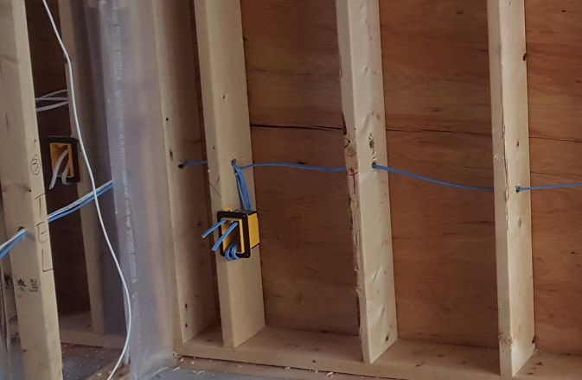

**Industry Based Project (CMGT 8800)**

**September 20, 2018**

**BCIT**

Faculty Advisor: Jim Turnham, P. Eng, MASc., ISO 9001 Lead Auditor

Prepared by: Behrouz Chehrehpardaz

Table of Contents

2. SIGNATURE PAGE 3

3. Proponent and Project Description 4

4. PURPOSE and SCOPE 5

5. DEFINITIONS 5

6. RESPONSIBILITIES 6

7. SAFETY AND ENVIRONMENT 8

8. SUBMITTALS 9

9. PROCEDURE 10

9.1. General Requirements 10

9.2. Layout the Plan (TS1) 11

9.3. Nail up Boxes (TS2) 16

9.4. Drill the Framing (TS3) 23

9.5. Pull Wire (TS4) 29

9.6. Residential Electricity Wire Pulling guidelines 33

9.7. Make up Connections (TS5) 38

10. Quality Assurance Approval 43

11. References 43

12. Construction Organization Chart 44

13. Flow Chart 45

14. Inspection and Test Plan 46

# SIGNATURE PAGE

As an Approver, with my signature, I confirm that this Work Method is the plan for construction of the work. If the plan changes, I will inform the Originator so that the Work Method can be revised. Alternately, I will make revisions myself and reissue to those that require copies.

As a Reviewer, my signature confirms that I have reviewed the document and any comments to the WM have been provided to the Originator and/or to the Approver.

MCDC Construction Manager

Name: Date: ____ __ Title: _____________________ Signature: _________________

MCDC Project Manager

Name: Date: ____ __ Title: _____________________ Signature:_________________

Contractor

Name: Date: ____ __ Title: _____________________ Signature: _________________

Initial Reviewer

Name: Date: Title: Signature:

# Proponent and Project Description

**Company Name:** MC DEVELOPMENT CORP. (MCDC)

**Company type of service**

MCDC is a small construction company building Single Family Houses (SFHs) in North Vancouver, and the company’s vision is to be recognized as a model of quality excellence in construction.

**Project Description**

Under a Project Management/Design Build method, MCDC itself or on behalf of the owners manages construction projects to build new single-family houses mostly in North Vancouver.

MCDC contract out all work activities in construction stage including Electrical Rough-in.

**Work Method Activity Description**

This Work Method (WM) provides the required details of how Electrical Rough-in is carried out, and it is also subject to a series of inspections, before the commencement, during the work, and after completion.

This Work Method will be used in order to ensure full compliance with MCDC’s quality policy and Quality Plan, drawings, specifications, and BC Building Codes.

**Work Method Scope**

This work method shall apply to the Electrical Rough-in that has been shown in electrical drawings of the project.

**`Limitation of liability:**

Any organization engaged as a Contractor or Subcontractor (the Contractor) agrees to use this Work Method only under the condition that those that wrote and developed this Work Method are to be held harmless for any errors or omissions, any inaccuracies in content resulting in any damages to property or any injury to any personnel that may be involved. It remains the sole responsibility of the Contractor to review any and all items contained in the above Work Method and to make any changes that may be required in order to satisfy any project specification or any regulatory or statutory obligation. As well, the Contractor shall review any and all suggested methods as contained herein and shall make any changes required and shall reissue prior to commencement of construction in order to achieve the specified product or to provide a safe work site for all workers involved. Ownership and final responsibility for the use of all Work Methods remains with the Contractor.

# PURPOSE and SCOPE

**Purpose**

To define the responsibilities, describe methods and documentation to be used for Electrical Rough-in work, in MCDC’s SFH projects.

**Scope**

This work method applies to all activities required for Electrical Rough-in at (the address of the project). Reference Standards include:

* British Columbia (or applicable province) Building Code 2012.

Note: Construction documents (design drawings and specifications) should be referenced as applicable and will govern over any procedure included in this document.

# DEFINITIONS

MCDC - MC Development Corp.

CM - MCDC’s Construction Manager

PM - MCDC’s Project Manager

QC - Quality Control

WM - Work Method (this document)

WP **-** Work Procedure

TS - Task Step

CL - Checklist

RM - Review Meeting

NCP - Nonconformity Procedure

ITP - Inspection and Test Plan

BI - Before the TS Inspection

DI - During the TS Inspection

AI – After the TS Inspection

DNV - District of North Vancouver

SWP – Safe Work Practice

SWRB – Solid Waste Removal Bylaw (DNV)

# RESPONSIBILITIES

* 1. **Construction Manager (CM)** is responsible for project scheduling, and final approving the inspections, tests, and changes. The CM is also responsible for preparation of drawings and sketches to support construction as required and all making any changes if required.
  2. **Project Manager (PM)** is responsible for; identifying necessary resources and assigning individual responsibilities to run and monitor the quality control procedure that defined by MCDC’s QP and this WM. He is responsible for overseeing the Quality Management Plan, enforcing project construction standards, assisting the CM in the creation of work method documents by providing appropriate sequence and task definitions, executing the project, scheduling and delegation of the roles of quality assurance inspections, safety, environmental items and Contractor coordination.
  3. The PM is accountable for the Site Superintendent’s all responsibilities as well. The PM, for each WM contemplated for use at the site, provides a review and makes changes if necessary to any clause so that it is consistent with best practice, consistent with the building code of the Province, and consistent with local conditions. Issues should be reviewed by email with the CM.
  4. **Site Superintendent** must work well with people and is responsible for:
  + Requesting copies of subcontractor’s liability insurance and workmen’s compensation certificate.
  + Overall site activities; applying project methodology and enforcing project construction standards; organizing field staff and ensuring they perform as required; and supervising Contractors and ensuring they perform as required
  + Assisting the PM and the Contractors in the creation and execution of work plans including revisions to these plans as necessary.
  + Assisting the PM in supervision of Contractors’ work quality.
  + Working closely with and support the Contractor to identify potential risks/opportunities, discuss necessary changes, and conduct the inspections.
  + Scheduling and monitoring each workday with appropriately resources.
  + Serving as the representative of and primary contact with the PM.
  + Attending review meetings.
  + Maintaining site logs and other documents in jobsite.
  + Ensuring the jobsite safety and ensuring that safety practices are followed.
  1. **Trade Contractor** (Contractor) refers to the company that is bound by contract to MCDC for a certain scope of work. For their scope, the Contractor is responsible for environmental control, safety controls, and quality control for self-performed work. The Contractor is responsible to write his/her Work Methods. However, if the Contractor cannot provide the required WMs, MCDC may assist, but the final WM will be reviewed, changes made to reflect project requirements, codes, laws, and resubmitted to MCDC and owned by the Contractor. The Contractor performs the work required by the contract documents and approved Work Methods to start and complete the Project and fulfill everything indicated by the contract documents. The Contractor shall perform activities described in this WM. If any revision is needed, the Contractor shall be instructed to revise and update this WM so that the WM reflects the intent and methods of the Contractor as well. The Contractor shall be fully responsible for his means and methods, and for the content of the revised WM. The Contractor shall assign a representative who will permanently attend at the job site when the job is being done. The Site Manager or the Contractor’s site representative shall ensure following the guidelines and/or Standard Specifications outline on this work method.

# SAFETY AND ENVIRONMENT

All construction activities and job procedures shall conform to

* WCB Regulations and other applicable codes, regulations and acts
* DNV Street and Traffic Bylaw (Bylaw 7125)
* DNV Noise Regulation Bylaw (Bylaw 7188)
* DNV Environmental Protection and Preservation Bylaw (Bylaw 6515)
* DNV Tree Protection Bylaw (Bylaw 7671)

Before any work takes place, the PM and Site Superintendent will ensure that all operators, laborers, and Contractors have been site orientated.

Electrical Rough-in procedures must comply with safe practices and with the requirements of the bylaw, codes and ordinances.

1. All work process shall be fully consistent to DNV Bylaws.

# SUBMITTALS

The contractor submittals to MCDC:

* Contractor Quotation for doing the job described in MCDC’s RFQ package, including
  + Contract price and time (including the start time of work on site)
  + Declaration of accepting all contract terms and documents
  + Written promise to provide the required submittals (including Contractor’s Work Method and Checklists), 14 days prior to the work start
  + Documented processes and submittals to enable the PM review
  + Contractor’s initial Work Method, Checklists, and ITP for MCDC review
* The final revision of MCDC QP reviewed and confirmed by the Contractor
* Finalized WM, ITPs, Checklists, and any other documents required by the contract documents, not later than 7 days prior to the work start time, (MCDC CM written confirmation required)
* Any drawing, specs, and designing layout which is required for carrying out the work, and in order to satisfy any project specification or any regulatory or statutory obligation.
* Reports that identifies the Self inspection result and scope of work, before each MCDC scheduled inspection
* Electrical Rough-in layout diagram
* Insurance and WCB coverage

All contractor submittals are stated in the Contract and include (but not limited to)

* A complete list of wires, boxes, and other required Electrical materials
* All required Electrical materials (according to the list)
* All required Electrical equipment

# PROCEDURE

## General Requirements

Consult the specifications and construction drawings to determine the requirements for any aspect of the work. This Work Method is a guideline used by MCDC to describe the work process and the process of quality control by conducting the specific Inspections and relevant Checklists. The Drawings, and Specifications as well as any code and by-law are the ultimate requirements. The PM and the Contractor shall review the Work Method and make any revision (prior to each use if necessary) so that any requirements will be identified and met.

The following Task Steps (procedures) TSs are included in this Work Method:

* 9.2 Layout the Plan (TS1)
* 9.3 Nail up Boxes (TS2)
* 9.4 Drill the Framing (TS3)
* 9.5 Pull Wire (TS4)
* 9.6 Make up Connections (TS5)

Each TS comes with a Checklist and each Checklist is subject to three Inspections, before, during, and after completion of the TS. Each Checklist includes several checkpoints which must be controlled and verified by the MCDC’s PM or Site Superintendent. To continue the work and proceed to next step, the Contractor must obtain the approval of PM for all Inspections. The PM will give the approval only if all Checklist’s items are checked and passed.

The Inspections and Testing shall follow the instructions described in the Inspection and Testing Plan number 10(ITP10). The PM shall review the results of the ITP and Checklists and check if the results are acceptable. The PM will communicate the acceptable results to the CM and if the results are not acceptable, the PM will communicate this issue to the CM and the Contractor to evaluate the default and issue instructions for the corrective actions.

## Layout the Plan (TS1)

Before start the electrical rough-in work consider several sources when determining electrical box locations;

* The C22.1-15 Canadian Electrical Code, and Safety Standard for Electrical Installations (23rd edition) has been adopted for use in BC as the BC Electrical Code Regulation 2015. These Electrical Codes and DNV regulations will require specific locations on items in order to pass an electrical inspection. These codes might require an item like a smoke detector, to be placed in a specific location even if it’s not shown on the blue prints.
* The PM provides blueprints; a drawing, on paper, showing the locations of walls, doors, lights, switches and so on. The prints are more of a general guideline.

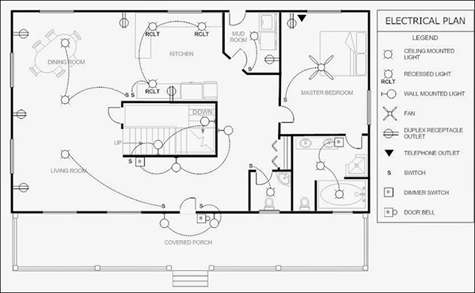

* The instructions of PM overrule the blueprint. Sometimes the PM may add something to the script. Written change order is needed before adding any major wiring.
  + 1. The first step of wiring a house is to layout the locations of all the electrical items. The Contractor will mark the layout days before any other electricians arrive. An electrical script is used to identify the placement of items. Items like switches and lights, ovens and dishwashers.

For example, the letter “R” is written on a stud to identify where a receptacle will be located and the letter “S” is marked where a switch will go. write “S3 Kit” for a kitchen 3-way switch.

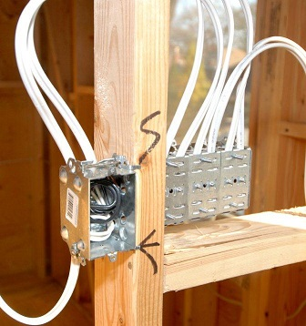

* + 1. Electrical script is written right on the wall studs or floors with a permanent marker. Transfer the electrical plan from the blueprint plan to the structure. When the layout is complete it looks like technical marks written all around the house.
    2. Electrical script will contain words, numbers, abbreviations and symbols. Here is some script that might be used;
       - HR = written stud, means a “home run” wire be run from the panel to here.
       - S = This “S” written on a stud means a single pole switch will be located here.
       - S Van = This switch will be a single pole for the bathroom vanity light.
       - S3 = A 3-way switch will be here.
       - PH = A phone plate will be here.
       - R = A single duplex receptacle will be here.
       - RR = A fourplex (2 x duplex receptacles) will be here.
       - © = This symbol written on the floor tells you a can light will go on the ceiling above here.

**Tip**; mark the script while walking through the house with the PM. Begin by finding a starting point in a room to mark the first item. Then determine where the switches will be located based on the priorities like which way the bedroom door will swing and the number of switches by looking at the blue prints or by instructions of the PM.  Then, at the stud next to the bedroom door, take your tape measure and mark the height where the switch box will be nailed in place. A good height for switches is 44 inches to the bottom of the box. Next, they will write the letter S near the height mark. This S represents a switch for the bedroom lights. Now, any electrician who enters this room will know that there will be one switch next to the door for the bedroom lighting. After identifying the switch location, move along the wall and write the letter R on a 2×4 wall stud close to where the first receptacle will be. No height is marked for general receptacles. The height can be set by holding the box on top of a standing hammer.

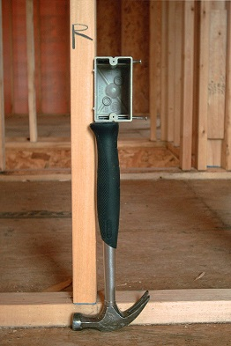

* + 1. Continue to identify every spot where a wall receptacle, phone jack or cable TV box will be located.

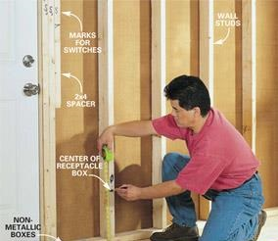

* + 1. Next draw a © (6-inch circle with a C in the center) on the floor below where a recessed can light will be mounted. For example, the bedroom may have 4 recessed can lights, 1 near each corner of the room. Draw all 4 can symbols on the floor, 1 at each corner. The electrical layout of this bedroom is now complete. An electrician who enters this bedroom can read the wall and floor script and determine where everything goes. Mark boxes for the phone, TV receptacles, and light switch and that there is 1 switch for 4 can lights. This process of measuring, marking and drawing continues in other rooms and areas until the Layout for the whole house is complete.

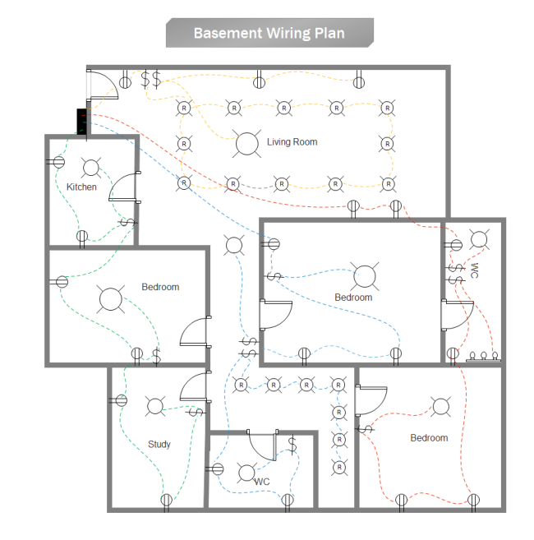

* + 1. Recessed can lights, fixture boxes and other ceiling items are also placed on the floor below the spot where they are to be mounted. Mark the locations of each and every electrical item.
    2. Marking switches on the wrong side of the door or forgetting to mark something like a garage freezer can be an expensive mistake to fix after sheet rock is installed. Any changes to the location of items should be brought to the attention of the Project Manager or Ste Superintendent.

|  |  |  |  |  |  |  |  |  |
| --- | --- | --- | --- | --- | --- | --- | --- | --- |
|  | Checklist 10-1: **Layout the Electrical Plan (TS1)** | | | | | | | |
| MC Development Corp. | | Project: | Contractor: | | | | | |
| **Number** | **Checkpoints** | | | BI | DI | | | AI |
| **1** | DNV permit/inspection approval as required | | |  |  | | |  |
| **Comment** |  | | | | | | | |
| **2** | The PM and contractors have reviewed the electrical plans and scripts | | |  | |  |  | |
| **Comment** |  | | | | | | | |
| **3** | The electrical blueprints and scripts are in site and accessible by electricians | | |  | |  |  | |
| **Comment** |  | | | | | | | |
| **4** | mark the script while walking through the house with the PM, specially the ceiling recessed lights (pot lights) | | |  |  | | |  |
| **Comment** |  | | | | | | | |
| **5** | Outlets, switches, fixture, phone and TV locations per plan | | |  |  | | |  |
| **Comment** |  | | | | | | | |
| **6** | Lighting pattern// direction// and intensity within design  parameters | | |  |  | | |  |
| **Comment** |  | | | | | | | |
| **7** | Switches are all marked correctly (on the wrong side of the doors) | | |  |  | | |  |
| **Comment** |  | | | | | | | |
| **8** | None of boxes are forgotten to be marked | | |  |  | | |  |
| **Comment** |  | | | | | | | |
| **9** | Double measure, all Receptacles and Switches heights | | |  |  | | |  |
| **Comment** |  | | | | | | | |
| **Quality Scores and Completion Sign-off** | | | | | | | | |
| **Inspection#**  Quality 5 4 3 2 1 Notes:  On-Time 5 4 3 2 1 Notes:  Sign and date*: Cell # / ID #: Signed: Date:  Task has been verified complete and in compliance with contract drawings and specifications except for non-conformances and incomplete items reported above. | | | | | | | | |
| **BI=** Inspection **B**efore task begin **-----------DI=** Inspection **D**uring task in-process --------**AI=** Inspection **A**fter task completed  *Quality Score**5 = 100% NO problems 4 = 1 minor problems 3 = Hotspot or 2-3 minor 2 = 6+ or major problems 1 = Excessive problems*  ***On-Time Score*** *5 = On Time 4 = Late 3 = Late by 1 day 2 = Late by 2 days 1 = Late more than 2 days*  ***Safety Score*** *5 = 100% NO problems 4 = 1 minor problem 3 = Hotspot or 2-3 minor 2= 4+ or major problem 1= Injury* | | | | | | | | |

## Nail up Boxes (TS2)

Before you begin:

* The floors are clean and debris is moved out
  + 1. Ordering, buying or unloading supplies. (in communication with PM)

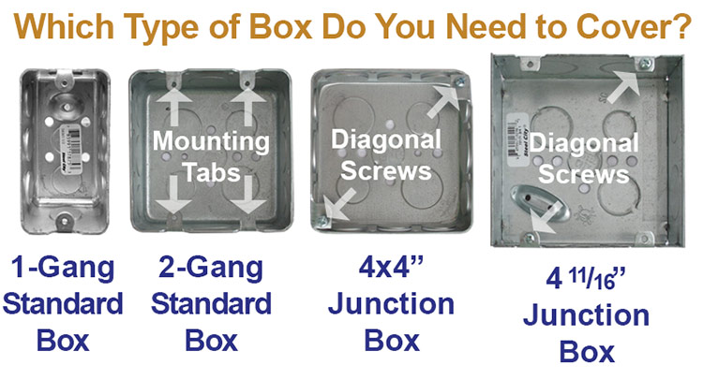

* + 1. After marking locations in the layout and acquiring the supplies, the next step is to mount the electrical boxes and housings to the wall studs and ceiling joists. Mounting is done with nails, screws and staples. Nails come attached to most boxes and a few models of recessed can lights. Screws are enclosed with some items like ceiling fan boxes. Staples, that are used for wires, come in handy for mounting other items. Supplies shall be distributed around the house according to the script and then nailed in place.
    2. First, Distribute the supplies. Begin the Nailing up step by distributing supplies around the house. Someone will grab an armful of single gang nail on boxes and start laying them down on the floor, one at a time, under the marks that indicate where these single gangs will be nailed up. Someone else will distribute the 2 and 3 gang boxes. By reading the layout script, the electricians know which boxes go where. If the stud is marked “S” for switch, it will need a single gang nail on box for a single switch. If the mark reads SS it will need a 2-gang box for 2 switches. SSS needs a 3 gang. So, does S1S3S4, where there will also be 3 switches; one single pole (S1), one three way (S3) and one four-way switch (S4).

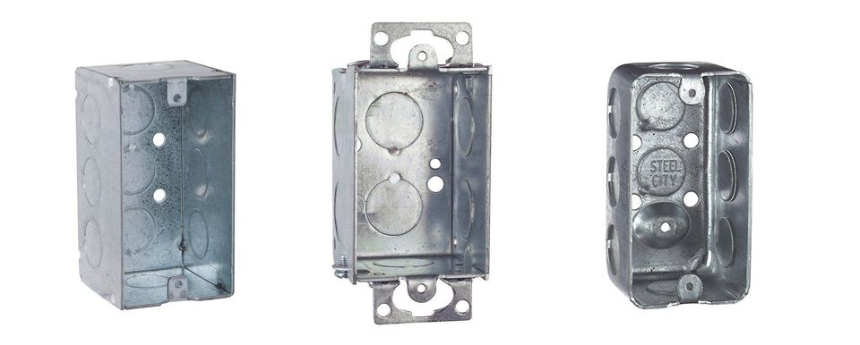

* + 1. Outside the building, special boxes are used for insulated walls and ceilings. These boxes have an additional weather gasket attached to them. So, an “R” on a wall between bedrooms would get a standard one gang nail on box but an “R” on the bedroom wall that is shared with the outside will get a special one gang nail on box with the insulating gasket. A standard 4/0 light box is used when the space above the light is a second-floor room but a special 4/0 box with a gasket when the space above is an insulated attic.
    2. Clean the floor surface and then set the items for the ceiling on the floor below their mounting location. If the area is cluttered and busy, set ceiling items by the wall switch that will control them. Single gang nail on boxes come in different depths. You might use 20 cubic inch boxes for all single gang needs, or you can use a deep 22 cubic inch single gang for GFI receptacle locations.
    3. Recessed can lights are usually sold 6 to a case. These cases are distributed around the house to rooms where they will be needed. If a room needs 6 recessed can lights, then a case can be set by the switch box in that room. Can lights that are not in a case need to be set close to walls where workers won’t trip over them or have them tangle up in their extension cords. Some houses have only one style of can light housing. For variety sizes and styles, you will have to know how the script identifies different styles of recessed can lights.
    4. Distributing light boxes should be done by the PM contribution. Light boxes require knowing where center will be before you can decide which style of box to use:
* If the center is exactly on a ceiling joist then a pancake box is used.

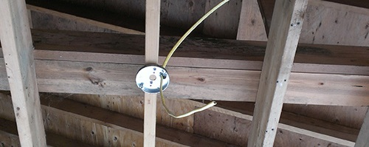

* If the center is 2 inches off the joist a 4/0 nail on box is used.

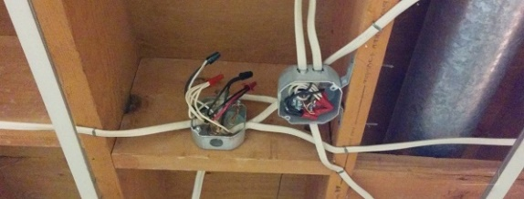

* If the center is beyond 2 inches from the joist a bar hanger box is used.

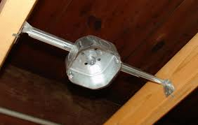

* Heavy lights in dining rooms and entryways require a heavy-duty metal light box.
* Ceiling fans require a special fan rated box.

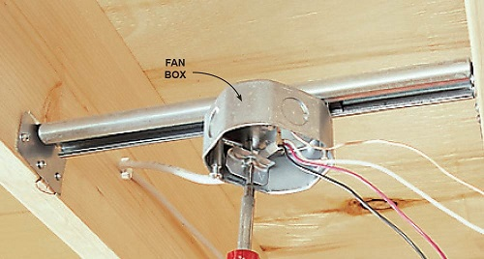

* + 1. The Nailing up begins after a good number of boxes and can lights are distributed around the house.

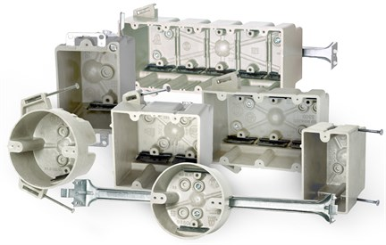

* + 1. The basics of nailing up the nail-on boxes;
       - Know the height method and measurement. There are three different height methods for mounting device (switch and receptacle) boxes. Be sure to use the same method as those you are working with. Some measure, mark and nail the box with the mark even with the bottom of the box, others set the mark even with the top of the box and yet others nail the box with the mark in the center. It is best to mount rectangular device boxes with the mark on the bottom of the box and round boxes with the mark at the center of the box.

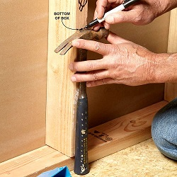

* + - * Use 44″ to the bottom of switches, kitchen counter outlets and garages.
      * Know the depth of the finished wall or ceiling. You want the box to be flush, not sticking out past the drywall surface and you also don’t want the box sunk deep into a wall. Most houses use 1/2-inch sheet rock which means your box can stick out according to the depth marks indicated on the side of your box. Fire walls might have a double layer of 1/2 or 5/8-inch sheet rock. Sometimes, 1″ thick brick is used on the inside walls. Check the prints or ask you’re the PM for the correct depth.

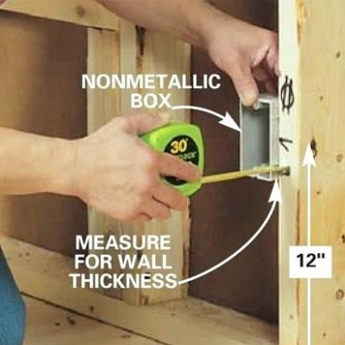

* + - * Nail the box level, flush and plumb. Loosen or sink one of the 2 nails until the box is level. A properly nailed box can still stick out of the wall on one side if the stud is twisted. Try hitting the stud at the bottom until your box looks flush (it will not stick out when drywall is installed) A plastic switch box can twist and distort. The top and bottom can be level but, because of a twist in the middle, the top screw hole will be out of plumb with the bottom screw hole making it hard to mount the device. Loosen or sink one of the 2 nails until the box screw holes are plumb.
      * Close boxes have to be more exact. Take a little more time to get the exact height when 2 separate boxes are on either side of the same stud at the same heights. Especially on a kitchen counter.
    1. The basics of nailing up any recessed can light;
  + Find the center mark. Measure off the wall, that the ceiling joists are heading to, and mark your center on the ceiling joist with a marker. On complex ceiling framing, attach a string to the ceiling, parallel with the wall, to help you find your centers.
  + Orient the junction box. Recessed can lights come with an attached wiring compartment or junction box. Think about the best placement of the junction box before mounting a can light. If you know your wires are coming from the right then spin the can light around until the junction box is facing the right.
  + Mount to one joist at a time. Place the can on the center mark and grab the can and the joist with one hand while nailing the 2 brackets with your other hand. Then slide the brackets over to the other joist and nail in place.
  + Lock into exact position. The can should be able to slide on the brackets from one joist to the other. Measure off the other wall and mark your center on your brackets. Slide the can until it is centered on your mark and lock the can into position. Can lights are locked into position by tightening a bracket screw or by using your lineman pliers to fold a piece of metal that the bracket passes thru.

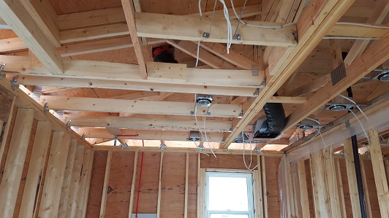

|  |  |  |  |  |  |  |  |  |
| --- | --- | --- | --- | --- | --- | --- | --- | --- |
|  | Checklist 10-2: **Nail up Boxes (TS2)** | | | | | | | |
| MC Development Corp. | | Project: | Contractor: | | | | | |
| **Number** | **Checkpoints** | | | BI | DI | | | AI |
| **1** | Electrical Boxes are supplied correctly | | |  |  | | |  |
| **Comment** |  | | | | | | | |
| **2** | Double check the plans and marks on the walls and ceiling | | |  | |  |  | |
| **Comment** |  | | | | | | | |
| **3** | Supplies are distributed around the house properly and according to the plan scripts | | |  | |  |  | |
| **Comment** |  | | | | | | | |
| **4** | Duplex outlets roughed at 14 1/2" with a tolerance of +/-1/4" | | |  |  | | |  |
| **Comment** |  | | | | | | | |
| **5** | Counter top and garage outlets roughed at 44" with a tolerance of +/-1/4" | | |  |  | | |  |
| **Comment** |  | | | | | | | |
| **6** | All similar boxes are leveled and plumbed | | |  |  | | |  |
| **Comment** |  | | | | | | | |
| **7** | The thickness of drywall has been considered for all boxes, double check them | | |  |  | | |  |
| **Comment** |  | | | | | | | |
| **8** | Ceiling boxes are per plan (approved by PM) within 1/2 inch | | |  |  | | |  |
| **Comment** |  | | | | | | | |
| **9** | Outlets, switches, fixture, phone and TV locations per plan | | |  |  | | |  |
| **Comment** |  | | | | | | | |
| **Quality Scores and Completion Sign-off** | | | | | | | | |
| **Inspection#**  Quality 5 4 3 2 1 Notes:  On-Time 5 4 3 2 1 Notes:  Sign and date*: Cell # / ID #: Signed: Date:  Task has been verified complete and in compliance with contract drawings and specifications except for non-conformances and incomplete items reported above. | | | | | | | | |
| **BI=** Inspection **B**efore task begin **-----------DI=** Inspection **D**uring task in-process --------**AI=** Inspection **A**fter task completed  *Quality Score**5 = 100% NO problems 4 = 1 minor problems 3 = Hotspot or 2-3 minor 2 = 6+ or major problems 1 = Excessive problems*  ***On-Time Score*** *5 = On Time 4 = Late 3 = Late by 1 day 2 = Late by 2 days 1 = Late more than 2 days*  ***Safety Score*** *5 = 100% NO problems 4 = 1 minor problem 3 = Hotspot or 2-3 minor 2= 4+ or major problem 1= Injury* | | | | | | | | |

## Drill the Framing (TS3)

**Drilling Tips:**

* (Safety) The drill’s side handle can spin around and hit you in the head, try to hold the drill at a distance or rest the handle against a stud. Drilling without the secondary, detachable side handle can injure your wrists. Long hair, coat hood strings or necklaces can get caught in the spinning drill bit and cause injury. Wear safety glasses, drilling up and into an unseen nail can cause hot metal shavings to fall into your eyes.
* When drilling up through the top plate the drill handle can spin around and hit you in the head, try to hold the drill at a distance or rest the handle against a stud.
* Protect the drill bit tip. Avoid hitting concrete or bricks with the tip of the drill bit. Sometimes brick or concrete lies just beyond a stud that you are drilling, especially in basements. Try to ease off on the drill so you don’t bounce into these hard surfaces.
* Look around to the back side of the wood before you drill through, to avoid damaging any plumbing pipe or wires hiding on the other side of the stud or joist.
* If you damage a plumbing pipe, be sure to address it to PM. Most repairs are easy and cheap to do before the drywall is installed. If you don’t tell someone, it might go unnoticed until the house is finished. Then when the water is turned on it will leak out and cause expensive damage.

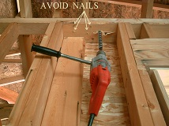

* + 1. You are ready to begin drilling when the electrical Layout is complete and all the boxes and housings have been Nailed up according to your script markings on the walls and floor, providing a pathway for all the wiring that you will be running throughout the house. Electrical wires, low voltage doorbell wires and, when required, phone and TV wires.

For example, you will drill a line of holes along the length of a wall from receptacle box to receptacles box, and a hole above a switch box to run a cable up to a light. The goal is to drill as many holes as possible without drilling any unnecessary holes. The more holes (necessary holes) that are drilled before pulling wire, the less risk there is of accidentally drilling through a wire.



* + 1. Some drilling requires jobsite’s circuit and wire pulling plan, to know which way to drill; up, down, left or right. Other drilling pathways are more predictable.
    2. Here is a list of good places to begin drilling because they are so common.
       - The path connecting receptacles and switches in a bedroom.
       - Above a switch box
       - Above a vanity receptacle.
       - Above a phone or cable TV box
       - Above garage receptacles and garage door eyes.
    3. The rough in drill bit. It is recommended using a **⅞** inch wide by 17-inch-long bit with a double cutting edge. The bit needs to be long enough to drill through 6 to 8 framing studs that are nailed together. Auger bits drill faster and require less effort. It’s easier to drill straight holes through the studs with a right-angle drill. Choose a bit like this ship auger bit that will chew through nails.

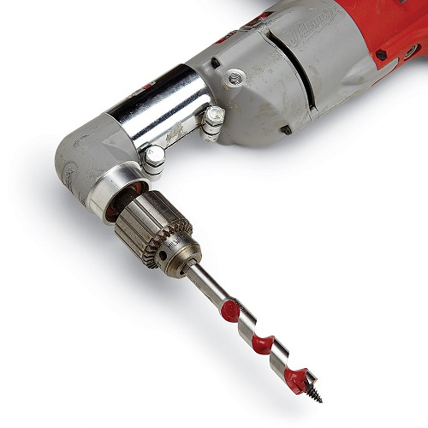

* + 1. Drilling across a wall. Keep your holes in the center of the stud so that a sheet rock screw can’t damage the wire running through it. The code requires a nail plate to be nail on the stud by your wire if the hole is too close to the nailing surface. Try to drill your holes level with each other, the same height off the floor. It doesn’t have to be exact, just somewhat level. Don’t drill so low that your holes will be at the height where the base board will be nailed. Avoid the mounting screws of upper and lower kitchen cabinets by keeping your holes within the back-splash area of the kitchen counter.

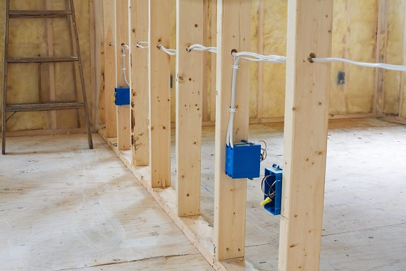 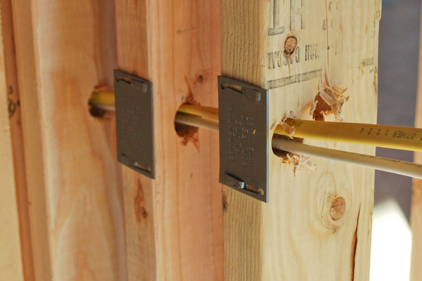

* + 1. When you pull your wire around a bedroom, from receptacle to receptacle, the wire will go up the stud from the box to your hole, thru your holes and back down to the next box. If your holes are a foot higher than necessary, you will be wasting a foot of wire to get up to your hole and another foot wasted going back down. Keep your holes within 8 inches above or below a line of boxes to save wire and make you a more productive.

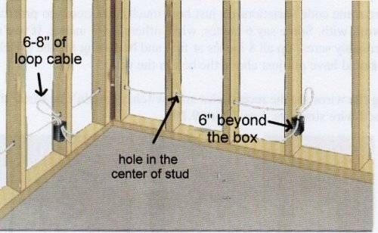

* + 1. Drill through the soft spots. Avoid drilling through knots and nails. If you start a hole and you realize you are going real slow because of a knot, stop and start a new hole 2 or 3 inches away from the knot. Avoid nails that you see and areas where you know nails are, like where a stud is nailed to a bottom plate. When you hear or feel your bit hitting a nail, stop drilling and start a new hole or you can try to remove the nail and then continue drilling.



* + 1. Drilling up. Many wires are run up the wall, through the top plate and across the ceiling. For example, a wall switch for a ceiling fan will have a wire run from the switch box up the wall and across the ceiling to the fan box. Holes need to be drilled through the top plate above switch box. Electrical panels will have many wires, called home runs, that will have to pass through several holes in the top plate. If you are pulling the phone wire and TV coax cable, a hole will be drilled above and/or below each phone and TV box.
    2. Start the bit very slowly into the wood to see how the handle will move as it spins clockwise. Then, allow the handle to slowly spin until it rests against a stud. Next, adjust your body and drill position to prepare for this spinning force and begin drilling.

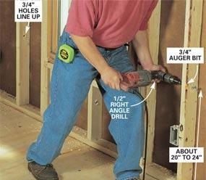

* + 1. Walls exceeding 10 feet will require the use of a small ladder. Using a 20-inch extension bit will allow a greater reach and make drilling faster by avoiding the need to haul a ladder around.
    2. Drilling down. When drilling down, prepare to stop the moment you punch through so you don’t hit something like a pipe or vent. When drilling down it is also common to end up stuck in a floor joist. When this happens, stop, pull the bit out and drill a new hole down at a double 45º angle. Meaning 45º off a plumb line and 45º off a north-south wall line (north-east is 45º from a north south line) If the wall is running north-south and the floor joists are running east-west, aim your drill bit at a 45º angle pointing northwest (or northeast, southwest etc.)

|  |  |  |  |  |  |  |  |  |
| --- | --- | --- | --- | --- | --- | --- | --- | --- |
|  | Checklist 10-3: **Drill the Framing (TS3)** | | | | | | | |
| MC Development Corp. | | Project: | Contractor: | | | | | |
| **Number** | **Checkpoints** | | | BI | DI | | | AI |
| **1** | Double check; Layout is complete and all required boxes are Nailed up according to the script markings on the walls and floor | | |  |  | | |  |
| **Comment** |  | | | | | | | |
| **2** | Safety first when drilling; safety glasses | | |  | |  |  | |
| **Comment** |  | | | | | | | |
| **3** | Plumbing pipes are marked, and No damaging to plumbing pipes | | |  | |  |  | |
| **Comment** |  | | | | | | | |
| **4** | Proper drill has been chosen | | |  |  | | |  |
| **Comment** |  | | | | | | | |
| **5** | holes within 8 inches above or below a line of boxes | | |  |  | | |  |
| **Comment** |  | | | | | | | |
| **6** | holes within the back-splash area of the kitchen counter | | |  |  | | |  |
| **Comment** |  | | | | | | | |
| **7** | Sizes, height, and locations of the holes are correct | | |  |  | | |  |
| **Comment** |  | | | | | | | |
| **8** | the holes straight aligned and at the same height. | | |  |  | | |  |
| **Comment** |  | | | | | | | |
| **9** | a nail plate is nailed on the stud if the hole is too close to the nailing surface | | |  |  | | |  |
| **Comment** |  | | | | | | | |
| **Quality Scores and Completion Sign-off** | | | | | | | | |
| **Inspection#**  Quality 5 4 3 2 1 Notes:  On-Time 5 4 3 2 1 Notes:  Sign and date*: Cell # / ID #: Signed: Date:  Task has been verified complete and in compliance with contract drawings and specifications except for non-conformances and incomplete items reported above. | | | | | | | | |
| **BI=** Inspection **B**efore task begin **-----------DI=** Inspection **D**uring task in-process --------**AI=** Inspection **A**fter task completed  *Quality Score**5 = 100% NO problems 4 = 1 minor problems 3 = Hotspot or 2-3 minor 2 = 6+ or major problems 1 = Excessive problems*  ***On-Time Score*** *5 = On Time 4 = Late 3 = Late by 1 day 2 = Late by 2 days 1 = Late more than 2 days*  ***Safety Score*** *5 = 100% NO problems 4 = 1 minor problem 3 = Hotspot or 2-3 minor 2= 4+ or major problem 1= Injury* | | | | | | | | |

## Pull Wire (TS4)

**Review the basic concept of wiring**:

In summary, it means wiring together electrical items in separate groups or circuits and connecting them to the panel, pulling phone, TV and low voltage wiring like garage door openers, doorbells and thermostats.

Wires spreading out in all different directions are a well-organized collection of individual circuits. Each circuit in circle way from the transformer (panel) through meter, through the circuit breaker in the panel, through a switch, through a light bulb (through boxes) and back again to the transformer. Any boxes not connected to the panel or to another box that is connected to the panel, will not have any power and will not work. This group of boxes connected together including one wire heading to the panel is called a circuit. The wire heading to the panel is called a “Home Run”.

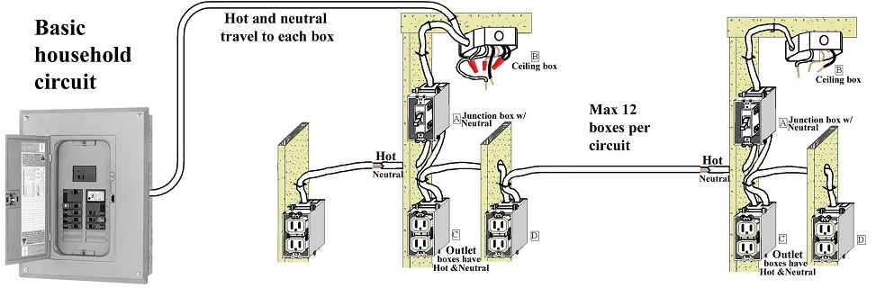

It is easier working on one circuit at a time pulling the Home Run first and then interconnecting all the boxes on that circuit. A wire is pulled from the first box, with the Home Run, to the 2nd box and stapled to the stud by the 2nd box. The wire is cut and then stapled at the first box. Next, the wire is pulled from the 2nd box to the 3rd box and so on. The code requires the wire (NMB 14/2, 12/2 …) to be stapled less than 12 inches away from boxes and every 4 feet 6 inches with no more than 2 wires under each staple and stay an inch and a quarter away from the nailing edge of the stud. The wire is left outside the box, unstripped. Stripping off the sheathing and stuffing the wires into the box is done in the “Make Up Connections Step” after all the wire pulling is complete.

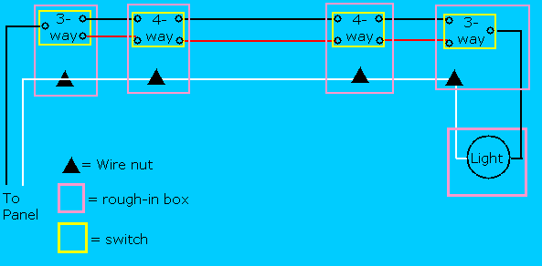

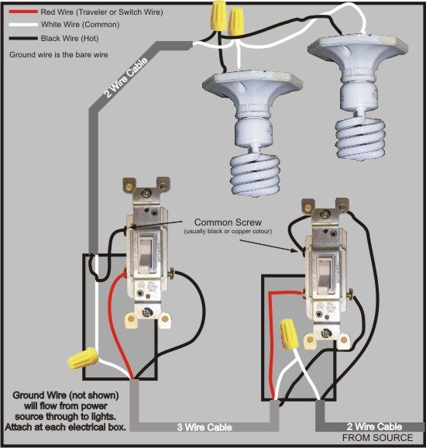

**The wire pulling step consists of 5 different tasks;**

1. **Creating the Circuit Plan.**Only an architect or a licensed electrician will create the circuiting plan by following all the rules established in the BC Electrical Code, local codes, builder requirements, and your own company’s policies.

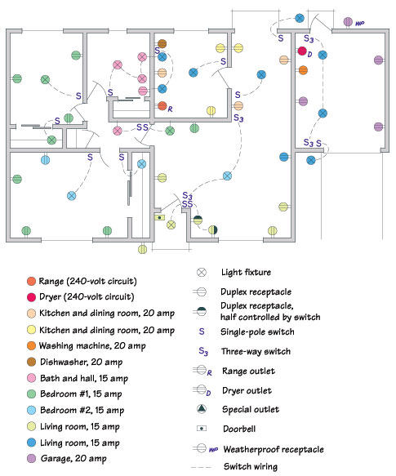

1. **Pulling circuits.**  It involves connecting together all the boxes and electrical items that will be on one circuit breaker. It consists of many short lengths of wire run from box to box and might also have different types of wire (14/2, 14/3). A roll of wire is set up on a wire reel. Take a visual preview of all the boxes that will be on the circuit and then begin pulling the wire thru the holes in the wall studs from the first receptacle box to the second receptacle box and cut the wire. Staple the wire by the boxes and repeat this process by pulling another wire from the second box to the third receptacle. The hard part is knowing which light boxes will connect together and to which switches they will be controlled by.

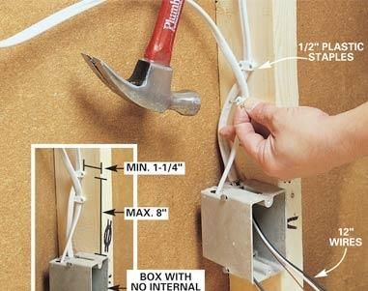

1. **Pulling low voltage wiring.**It includes small wiring for thermostats, door chimes and such. A thermostat can be a simple as pulling an 18/5 wire from a hallway stat location to the furnace unit. A door chime uses 18/2 from the front door to the hallway chime with the chime’s transformer located in a 2-gang box behind the chime.
2. **Pulling Home Runs.** A home run is a wire pulled from a circuit to the circuit breaker in the panel. It is the longest length of wire on a circuit.  A roll of wire is set up on a wire reel near the circuit like a bedroom. The name of the circuit is written on the end of the wire “Master Bed” The wire is then carried up into the attic (or by some other route) and then walked across the ceiling to the area above the panel where it is brought down. Then the home run wire is stapled to the studs and joists all the way back to the closest box on the master bedroom circuit. After a little practice pulling one Home Run at a time, try pulling 2 Home Runs at the same time. This will make you twice as productive. Eventually you should be able to pull 4 Home Runs at the same time. Pull all 4 Home Runs across the attic to the panel and then staple your way back.
3. **Pulling TV coax cable and phone wire.**A box of phone wire or coax cable is set up near the electrical meter or at a media distribution panel. The wire is then pulled up into the attic (or by some other route) and then walked across the ceiling and brought down to a box where a phone or TV will be located.  Then the wire is stapled to the studs and joists all the way back to the starting point.

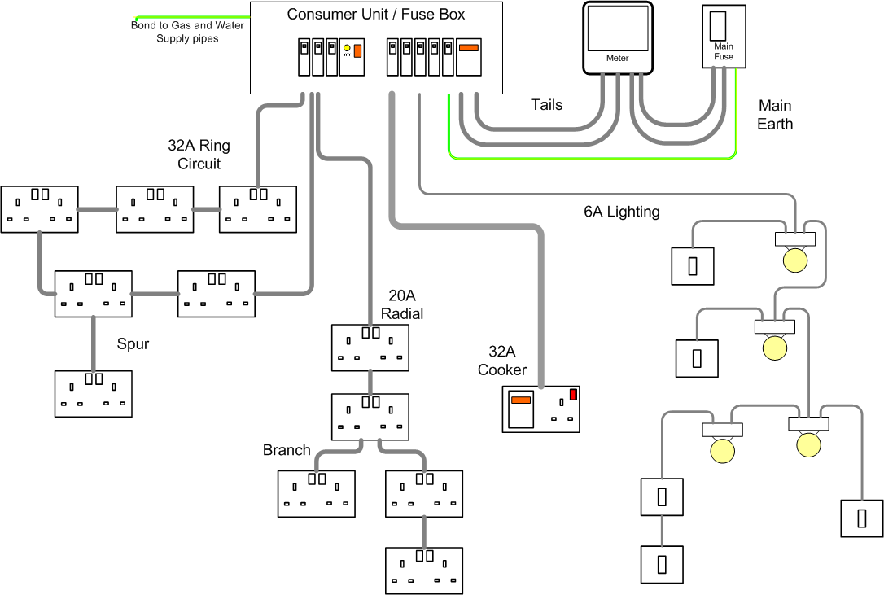

## Residential Electricity Wire Pulling guidelines

* + 1. **Eye hazard.** Hold the end of the wire to prevent it from whipping back into your eye.
    2. **Wire Sizes**. Wires come in different sizes. The most used is size 14 and size 12. Make sure you are using the correct size wire for your circuit. Find the size by reading the label on the sheathing or use the wire gauge on your wire stripper.
    3. **Wire Types**. Wires come in different types 14/2 and 14/3 are both size 14 wire but one has 2 conductors and the other has 3. Make sure you are using the correct type of wire. Find the type by reading the label on the sheathing or stripping off the sheathing and counting the number of conductors inside.
    4. **Wire Labeling**. Before an electrician can make up the wiring connections at a switch box they have to know which wire goes up to the light because that is the only wire they want the switch to shut off. This wire (NMB cable with a black wire a white wire and a bare ground) is called a switch leg and one way to find it is to get up on your ladder and use your hands to follow the wire from the light down to the switch box being sure not to confuse it with the other wires stapled alongside of it. An easier way to find a switch leg is to label it when it is pulled from the light to the switch box. Switch legs are not the only wires that need to be identified. The 4 most common are;

1. The Switch Leg
2. The Home Run
3. Travelers
4. GFI’s Line and/or Load

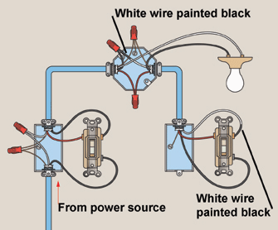

There are different methods to labeling wires, and the two most common ways to label wires during residential wire pulling are; Marking or Folding:

1. Marking**;** The best method for beginners and complex wiring. A permanent ink marker is used to write information directly on the sheathing near the end of the wire.  Write:
   1. “HR” to label a wire as a “Home Runs” (the wire that runs to the panel),
   2. “Cans” for a switch leg to the can lights,
   3. “Fan” for a switch leg to a fan,
   4. “Line” “Load” for GFI’s,
   5. “Trav” for travelers.
2. Folding**;** The best method for simple wiring. The end of the wire is folded in different ways for different meanings.
   1. One-fold like a J means switch leg or at a GFI the switched off load side,
   2. A curl like curly fries means Home Run,
   3. Two wire travelers are twisted like licorice,
   4. Three wire travelers are wrapped around the switch leg.

**Importan**t: only these two wiring methods are accepted by MCDC, and it should be mentioned in the contract.

* + 1. **Wires have to be secured and supported according to specific rules.**

The wire has to be stapled at specific intervals with limits on how many wires can be under one staple and within a close distance from the box or light.

* + 1. **There are limits to how many wires can be inside one box**

The cubic inch volume is marked on the inside of a nail on box. The NEC explains how to calculate how many wires you can stuff into your box based on its volume and the size of your wires.

* + 1. **There are things wires should stay away from;**
       1. The sharp edges of metal found on; air ducts, plumbing straps and metal truss framing couplers and framing brackets.
       2. Heat; Do not lay your cable on or near hot stuff like metal chimneys, hot water pipes or the top of a recessed can lights.
       3. The area where crawl space vents are cut in which is above the concrete foundation in the outer floor joist.
       4. Below bottom plates and on top of top plates where drill bits will venture**.**
    2. **There are spaces in the framing of a house where wires are not allowed.**

An empty wall space during the Rough in Stage can be completely filled from stud to stud with a built-in wall iron allowing no room for you wire to pass thru. Be careful not to pull wire thru areas designated for built in iron boards, skylights, attic fans, attic access holes, garage attic pull down stairs, pocket doors, return air vents or recessed medicine cabinets.

* + 1. **Avoid Rope burn**

Rope burn, a fast-moving wire rubbing against a stationary wire, will take the insulation off of a wire. Avoid pulling wires in such a way that one fast moving wire rubs against another especially through holes in the framing.

|  |  |  |  |  |  |  |  |  |
| --- | --- | --- | --- | --- | --- | --- | --- | --- |
|  | Checklist 10-4: **Pull Wire (TS4)** | | | | | | | |
| MC Development Corp. | | Project: | Contractor: | | | | | |
| **Number** | **Checkpoints** | | | BI | DI | | | AI |
| **1** | A Circuit plan is provided by contractor and approved by PM | | |  |  | | |  |
| **Comment** |  | | | | | | | |
| **2** | Double check; all required boxes are Nailed up according to the plan, and all drilling done correctly | | |  |  | | |  |
| **Comment** |  | | | | | | | |
| **3** | Panels, breakers, switches, and boxes are all wired properly | | |  | |  |  | |
| **Comment** |  | | | | | | | |
| **4** | Residential Electricity Wire Pulling guidelines (8.6) has been follow properly; wire sizes, wire types, wire labeling, | | |  | |  |  | |
| **Comment** |  | | | | | | | |
| **5** | Wires are secured and supported according to the governing codes | | |  |  | | |  |
| **Comment** |  | | | | | | | |
| **6** | Wire are away from Sharp edges, Heat, roof openings, top and bottom plates | | |  |  | | |  |
| **Comment** |  | | | | | | | |
| **7** | Low voltage, TV coax, and phone are wired properly (if contracted) | | |  |  | | |  |
| **Comment** |  | | | | | | | |
| **8** | Tuck wires inside wall cavity | | |  |  | | |  |
| **Comment** |  | | | | | | | |
| **9** | NO wire thru areas designated for built in iron boards, skylights, attic fans, attic access holes, garage attic pull down stairs, pocket doors, return air vents or recessed medicine cabinets | | |  |  | | |  |
| **Comment** |  | | | | | | | |
| **Quality Scores and Completion Sign-off** | | | | | | | | |
| **Inspection#**  Quality 5 4 3 2 1 Notes:  On-Time 5 4 3 2 1 Notes:  Sign and date*: Cell # / ID #: Signed: Date:  Task has been verified complete and in compliance with contract drawings and specifications except for non-conformances and incomplete items reported above. | | | | | | | | |
| **BI=** Inspection **B**efore task begin **-----------DI=** Inspection **D**uring task in-process --------**AI=** Inspection **A**fter task completed  *Quality Score**5 = 100% NO problems 4 = 1 minor problems 3 = Hotspot or 2-3 minor 2 = 6+ or major problems 1 = Excessive problems*  ***On-Time Score*** *5 = On Time 4 = Late 3 = Late by 1 day 2 = Late by 2 days 1 = Late more than 2 days*  ***Safety Score*** *5 = 100% NO problems 4 = 1 minor problem 3 = Hotspot or 2-3 minor 2= 4+ or major problem 1= Injury* | | | | | | | | |

## Make up Connections (TS5)

When all the wire pulling is complete, it is time to begin making up the wiring connections.

The ends of the wires that are stapled outside of the box, are stripped from their sheathing and placed inside the box and then about a 1/2 inch of insulation is stripped off of each conductor. Specific wires are twisted together with a lineman pliers, capped by twisting on wire nuts and folded deep into the box where the sheet rocker’s tools will not damage the conductors’ insulation.

Take notice of the key points and recommended methods mentioned here;

1) All the wires are pulled and left outside the box until all wire pulling is complete.

2) The sheathing (not wires) is stripped outside the box and then inserted into the box.

3) The stripped ends of the wires are twisted together with a lineman and then capped.

* + 1. Stripping off the sheathing. First, we have to remove the correct amount of sheathing. The sheathing has to extend into the box 1 inch. Hold the cable next to the box and find the point on the cable that would extend 1 inch into the box. Score the sheathing at this point. The sheathing can be scored with a knife or with the teeth of your stripper. Pull the sheathing off the wires and insert the wires into the box.

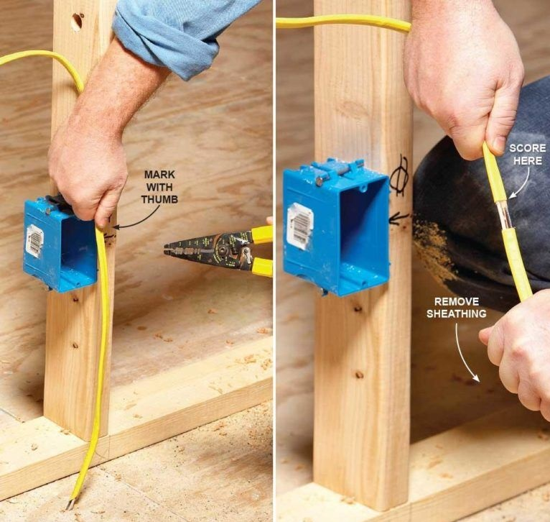

* + 1. Stripping UF sheathing. UF or “underground feeder” can be buried in the ground. It is different from standard wire. Instead of wrapping the conductors in a sheathing they are totally encased in solid plastic making they difficult to separate and strip. To separate the wires, grab the center, bare ground and peel it back out of the plastic. This will expose the black and white wires which can also be peeled out. Cut off the excess plastic.
    2. Stripping off the insulation. Some use a lineman pliers to strip the insulation off a conductor. They pinch the wire with the cutting blade to score the insulation, then pivot the pliers back and forth to score all around the wire and then slide the insulation off the end if the conductor. This method is OK if you can do it without nicking the metal conductor.

The best way to strip off the insulation is to use a wire stripper. The stripper has different sized grooves for different sized conductors. Some wire strippers are for solid wires, others are for stranded wires. If you are using size 14 wire, set the wire in the groove labeled 14 and close the stripper. This will cut the insulation without nicking the metal. With the stripper held closed, slide the insulation off the end of the wire.

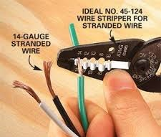

* + 1. Connecting the wires. When connecting wires, it is best to twist the conductors together with a “lineman’s pliers” before screwing on the wire nut. Hold the conductors so that the ends of their insulation are even (rather than the ends of the copper) Grab the ends of the wire with your lineman and twist several times (about 360 degrees twice) Cut off the end of the finished twist of copper that exceeds 1/2 inch. Screw on your wire nut. If you can see the copper part of the wires sticking out of the wire nut then remove the nut and cut off more of the copper.

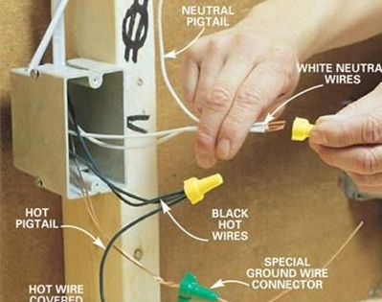

* + 1. Combining solid wires with stranded. When combining solid wire with stranded wire, always hold the stranded slightly longer than the solid, about 1/8 inch past the end of the solid, to ensure that the wire nut grabs the stranded as you screw it on. If you have multiple wires, twist the solid wires together first then twist the stranded wires together, then hold the stranded wires 1/8th inch past the solids and screw on the wire nut.

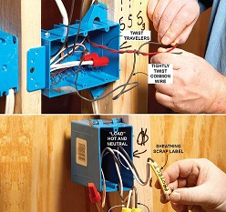

* + 1. Different size wire nuts. Wire nuts come in different sizes and colors. Each size has a limited number of wires that it is designed to connect. The number of wires permitted is printed on the packaging the nuts are shipped in.

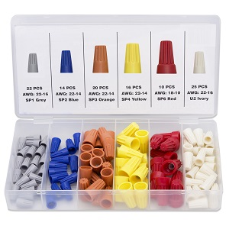

* + 1. Packing the wires into the box. Try to fold the wires into the box neatly, keeping the wire ends towards the front of the box where they can be easily pulled and attached to the devices.

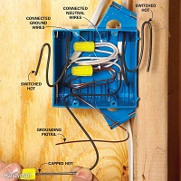

|  |  |  |  |  |  |  |  |  |
| --- | --- | --- | --- | --- | --- | --- | --- | --- |
|  | Checklist 10-5: **Make up Connections (TS5)** | | | | | | | |
| MC Development Corp. | | Project: | Contractor: | | | | | |
| **Number** | **Checkpoints** | | | BI | DI | | | AI |
| **1** | Stripping off the sheathing is done as explained in (WM10- 8.7.1) | | |  |  | | |  |
| **Comment** |  | | | | | | | |
| **2** | Stripping off the insulation is done as explained in (WM10- 8.7.3) | | |  |  | | |  |
| **Comment** |  | | | | | | | |
| **3** | Connecting the wires is done as explained in (WM10-8.7.4 &.5) | | |  |  | | |  |
| **Comment** |  | | | | | | | |
| **4** | All Connections have a properly covered by right-sized wire nuts | | |  | |  |  | |
| **Comment** |  | | | | | | | |
| **5** | The wires are folded in to the boxes neatly | | |  | |  |  | |
| **Comment** |  | | | | | | | |
| **6** | Smoke detector box installed in rooms per code | | |  |  | | |  |
| **Comment** |  | | | | | | | |
| **7** | Damaged outlet and switch boxes replaced | | |  |  | | |  |
| **Comment** |  | | | | | | | |
| **8** | Nail plates installed 100% | | |  |  | | |  |
| **Comment** |  | | | | | | | |
| **9** | Final review, everything as per plan? Sweep out house | | |  |  | | |  |
| **Comment** |  | | | | | | | |
| **Quality Scores and Completion Sign-off** | | | | | | | | |
| **Inspection#**  Quality 5 4 3 2 1 Notes:  On-Time 5 4 3 2 1 Notes:  Sign and date*: Cell # / ID #: Signed: Date:  Task has been verified complete and in compliance with contract drawings and specifications except for non-conformances and incomplete items reported above. | | | | | | | | |
| **BI=** Inspection **B**efore task begin **-----------DI=** Inspection **D**uring task in-process --------**AI=** Inspection **A**fter task completed  *Quality Score**5 = 100% NO problems 4 = 1 minor problems 3 = Hotspot or 2-3 minor 2 = 6+ or major problems 1 = Excessive problems*  ***On-Time Score*** *5 = On Time 4 = Late 3 = Late by 1 day 2 = Late by 2 days 1 = Late more than 2 days*  ***Safety Score*** *5 = 100% NO problems 4 = 1 minor problem 3 = Hotspot or 2-3 minor 2= 4+ or major problem 1= Injury* | | | | | | | | |

# Quality Assurance Approval

Only if all 15 required Inspections, associated with 5 TS Checklists mentioned in this WM, are approved by the PM and the CM as OK, the PM will carry out the final Inspection and issues the written approval if the results are OK.

If the results do not match the allowable tolerances, the PM will communicate this issue to the CM who evaluates the NCs and issues instructions for the corrective actions to be taken.

Any non-conformance shall be reported through the NCR procedure described in MCDC’s QP and is applicable to any and all phases of Electrical rough-in.

# References

1. The Handouts and QMS sample documents provided by Mr. Jim Turnham (CMGT-7246)
2. Based on Behrouz Chehrehpardaz work experience
3. The various public online resources
4. BC Building Code
5. WorkSafeBC Regulations
6. DNV Bylaws

# Construction Organization Chart

MCDC Board of Directors

Construct Manager/CEO

Project Manager

Site Super Intendent

Trade Contractor

# Flow Chart

Contract

Specs

Dwgs

WM/ITP

QP

END

Pre-Work WM Review Meeting

Certificate of Completion

NCP

Corrective Action

Initial Inspection

NO YES

Final Inspection

Passed?

NO/NCP

Inspection

Passed?

YES YES

(BI & DI & AI) Inspections

Passed?

Layout the Plan

NO/NCP

NO/NCP

Make up Connections

(BI & DI & AI) Inspections

Passed?

YES YES

(BI & DI & AI) Inspections

Passed?

Nail up Boxes

NO/NCP

NO/NCP

Pull Wire

(BI & DI & AI) Inspections

Passed?

YES YES

(BI & DI & AI) Inspections

Passed?

Drill the Framing

NO/NCP

# Inspection and Test Plan

|  |  |  |  |  |  |  |  |  |  |  |
| --- | --- | --- | --- | --- | --- | --- | --- | --- | --- | --- |
| MC Development Corp | | Inspection and Test Plan # 10  **Electrical Rough-in** | | | PM: MCDC Project Manager  C: Contractor | | | | | |
| Contractor: | | | Project: | | | | | |
| **#** | **Inspections** | **To Inspect Items listed in** | **Time of Inspection** | **QC**  **by** | **Acceptance Criteria** | **H/W/D** | | **Score &**  **(lowest)** | **Initials** | **Date** |
| 1 | Initial Inspection | QMP004b | Prior to any work | C | CM approval | H |  |  |  |  |
| 2 | Layout the Plan BI | Checklist 10-1 | Prior to TS1 | C | PM Approval |  |  |  |  |  |
| 3 | Layout the Plan DI | Checklist 10-1 | During TS1 | C | PM Approval |  |  |  |  |  |
| 4 | Layout the Plan AI | Checklist 10-1 | After TS1 | C | PM Approval |  |  |  |  |  |
| 5 | Nail up Boxes BI | Checklist 10-2 | Prior TS2 | C | PM Approval |  |  |  |  |  |
| 6 | Nail up Boxes DI | Checklist 10-2 | During TS2 | C | PM Approval |  |  |  |  |  |
| 7 | Nail up Boxes AI | Checklist 10-2 | After TS2 | C | PM Approval |  |  |  |  |  |
| 8 | Drilling BI | Checklist 10-3 | Before TS3 | C | PM Approval |  |  |  |  |  |
| 9 | Drilling DI | Checklist 10-3 | During TS3 | C | PM Approval |  |  |  |  |  |
| 10 | Drilling AI | Checklist 10-3 | After TS3 | C | PM Approval |  |  |  |  |  |
| 11 | Pull Wire BI | Checklist 10-4 | Before TS4 | C | PM Approval |  |  |  |  |  |
| 12 | Pull Wire DI | Checklist 10-4 | During TS4 | C | PM Approval |  |  |  |  |  |
| 13 | Pull Wire AI | Checklist 10-4 | After TS4 | C | PM Approval |  |  |  |  |  |
| 14 | Wire Connect BI | Checklist 10-5 | Before TS5 | C | PM Approval |  |  |  |  |  |
| 15 | Wire Connect DI | Checklist 10-5 | During TS5 | C | PM Approval |  |  |  |  |  |
| 16 | Wire Connect AI | Checklist 10-5 | After TS5 | C | PM Approval |  |  |  |  |  |
| 23 | Final Inspection | List of NCs | After Completion | PM | CM Approval |  |  |  |  |  |
| ITP Accepted by ……………………… Signature ……………………………… Date ……………. | | | | | | | | | | |
| **(BI**: Inspection Before Task Begin----**DI**: Inspection During Task Work----**AI**: Inspection After Task Finished)  **(W**: Witnessed by CM---- **H**: Hold further work----**D**: Document) | | | | | | | | | | |