**Work Method 09- Plumbing Rough-in**

(WM09-MCDC Template)

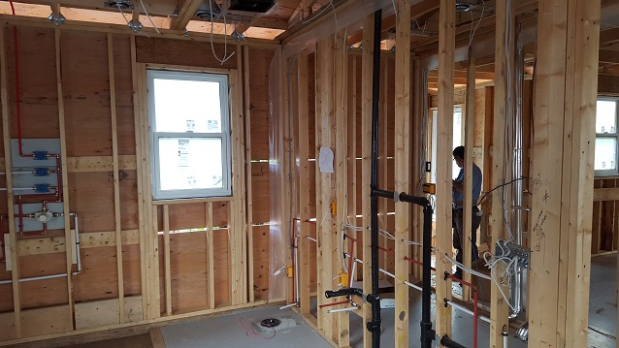

**Industry Based Project (CMGT 8800)**

**September 20, 2018**

**BCIT**

Faculty Advisor: Jim Turnham, P. Eng, MASc., ISO 9001 Lead Auditor

Prepared by: Behrouz Chehrehpardaz

Table of Contents

2. SIGNATURE PAGE 3

3. Proponent and Project Description 4

4. PURPOSE and SCOPE 5

5. DEFINITIONS 5

6. RESPONSIBILITIES 6

7. SAFETY AND ENVIRONMENT 8

8. SUBMITTALS 8

9. PROCEDURE 9

9.1. General Requirements 9

9.2. Plumbing Planning and Layout (TS1) 10

9.3. Installing Drains (TS2) 15

9.4. Venting Installation (TS3) 19

9.5. Installing Water Lines (TS4) 23

9.6. Testing the Pipe Lines (TS5) 31

10. Quality Assurance Approval 33

11. References 33

12. Construction Organization Chart 34

13. Flow Chart 35

14. Inspection and Test Plan 36

# SIGNATURE PAGE

As an Approver, with my signature, I confirm that this Work Method is the plan for construction of the work. If the plan changes, I will inform the Originator so that the Work Method can be revised. Alternately, I will make revisions myself and reissue to those that require copies.

As a Reviewer, my signature confirms that I have reviewed the document and any comments to the WM have been provided to the Originator and/or to the Approver.

MCDC Construction Manager

Name: Date: ____ __ Title: _____________________ Signature: _________________

MCDC Project Manager

Name: Date: ____ __ Title: _____________________ Signature:_________________

Contractor

Name: Date: ____ __ Title: _____________________ Signature: _________________

Initial Reviewer

Name: Date: Title: Signature:

# Proponent and Project Description

**Company Name:** MC DEVELOPMENT CORP. (MCDC)

**Company type of service**

MCDC is a small construction company building Single Family Houses (SFHs) in North Vancouver, and the company’s vision is to be recognized as a model of quality excellence in construction.

**Project Description**

Under a Project Management/Design Build method, MCDC itself or on behalf of the owners manages construction projects to build new single-family houses mostly in North Vancouver.

MCDC contract out all work activities in construction stage including Rough-in Plumbing.

**Work Method Activity Description**

This Work Method (WM) provides the required details of how the Rough-in Plumbing is carried out, and it is also subject to a series of inspections, before the commencement, during the work, and after completion.

This Work Method will be used in order to ensure full compliance with MCDC’s quality policy and Quality Plan, drawings, specifications, and BC Building Codes.

**Work Method Scope**

This work method shall apply to the Rough-in Plumbing that has been shown in drawings of the project.

**Limitation of liability:** Any organization engaged as a Contractor or Subcontractor (the Contractor) agrees to use this Work Method only under the condition that those that wrote and developed this Work Method are to be held harmless for any errors or omissions, any inaccuracies in content resulting in any damages to property or any injury to any personnel that may be involved. It remains the sole responsibility of the Contractor to review any and all items contained in the above Work Method and to make any changes that may be required in order to satisfy any project specification or any regulatory or statutory obligation. As well, the Contractor shall review any and all suggested methods as contained herein and shall make any changes required and shall reissue prior to commencement of construction in order to achieve the specified product or to provide a safe work site for all workers involved. Ownership and final responsibility for the use of all Work Methods remains with the Contractor.

# PURPOSE and SCOPE

**Purpose**: To define the responsibilities, describe methods and documentation to be used for Rough-in Plumbing in MCDC’s SFH projects.

**Scope**: This work method applies to all activities required for Rough-in Plumbing at (the address of the project). Reference Standards include:

* British Columbia (or applicable province) Building Code 2012.

Note: Construction documents (design drawings and specifications) should be referenced as applicable and will govern over any procedure included in this document.

# DEFINITIONS

MCDC - MC Development Corp.

CM - MCDC’s Construction Manager

PM - MCDC’s Project Manager

QC - Quality Control

WM - Work Method (this document)

WP **-** Work Procedure

TS - Task Step

CL - Checklist

RM - Review Meeting

NCP - Nonconformity Procedure

ITP - Inspection and Test Plan

BI - Before the TS Inspection

DI - During the TS Inspection

AI – After the TS Inspection

DNV - District of North Vancouver

SWP – Safe Work Practice

SWRB – Solid Waste Removal Bylaw (DNV)

DWV - Drains, Waste, and Vents

# RESPONSIBILITIES

* 1. **Construction Manager (CM)** is responsible for project scheduling, and final approving the inspections, tests, and changes. The CM is also responsible for preparation of drawings and sketches to support construction as required and all making any changes if required.
  2. **Project Manager (PM)** is responsible for; identifying necessary resources and assigning individual responsibilities to run and monitor the quality control procedure that defined by MCDC’s QP and this WM. He is responsible for overseeing the Quality Management Plan, enforcing project construction standards, assisting the CM in the creation of work method documents by providing appropriate sequence and task definitions, executing the project, scheduling and delegation of the roles of quality assurance inspections, safety, environmental items and Contractor coordination.
  3. The PM is accountable for the Site Superintendent’s all responsibilities as well. The PM, for each WM contemplated for use at the site, provides a review and makes changes if necessary to any clause so that it is consistent with best practice, consistent with the building code of the Province, and consistent with local conditions. Issues should be reviewed by email with the CM.
  4. **Site Superintendent** must work well with people and is responsible for:
  + Requesting copies of subcontractor’s liability insurance and workmen’s compensation certificate.
  + Overall site activities; applying project methodology and enforcing project construction standards; organizing field staff and ensuring they perform as required; and supervising Contractors and ensuring they perform as required
  + Assisting the PM and the Contractors in the creation and execution of work plans including revisions to these plans as necessary.
  + Assisting the PM in supervision of Contractors’ work quality.
  + Working closely with and support the Contractor to identify potential risks/opportunities, discuss necessary changes, and conduct the inspections.
  + Scheduling and monitoring each workday with appropriately resources.
  + Serving as the representative of and primary contact with the PM.
  + Attending review meetings.
  + Maintaining site logs and other documents in jobsite.
  + Ensuring the jobsite safety and ensuring that safety practices are followed.
  1. **Trade Contractor** (Contractor) refers to the company that is bound by contract to MCDC for a certain scope of work. For their scope, the Contractor is responsible for environmental control, safety controls, and quality control for self-performed work. The Contractor is responsible to write his/her Work Methods. However, if the Contractor cannot provide the required WMs, MCDC may assist, but the final WM will be reviewed, changes made to reflect project requirements, codes, laws, and resubmitted to MCDC and owned by the Contractor. The Contractor performs the work required by the contract documents and approved Work Methods to start and complete the Project and fulfill everything indicated by the contract documents. The Contractor shall perform activities described in this WM. If any revision is needed, the Contractor shall be instructed to revise and update this WM so that the WM reflects the intent and methods of the Contractor as well. The Contractor shall be fully responsible for his means and methods, and for the content of the revised WM. The Contractor shall assign a representative who will permanently attend at the job site when the job is being done. The Site Manager or the Contractor’s site representative shall ensure following the guidelines and/or Standard Specifications outline on this work method.

# SAFETY AND ENVIRONMENT

All construction activities and job procedures shall conform to

* WCB Regulations and other applicable codes, regulations and acts
* DNV Street and Traffic Bylaw (Bylaw 7125)
* DNV Noise Regulation Bylaw (Bylaw 7188)
* DNV Environmental Protection and Preservation Bylaw (Bylaw 6515)
* DNV Tree Protection Bylaw (Bylaw 7671)

Before any work takes place, the PM and Site Superintendent will ensure that all plumbers, laborers, and Contractors have been site orientated.

Rough-in Plumbing procedures must comply with safe practices and with the requirements of the bylaw, codes and ordinances.

All work process shall be fully consistent to DNV Bylaws.

# SUBMITTALS

The contractor submittals to MCDC:

* Contractor Quotation for doing the job described in MCDC’s RFQ package, including
  + Contract price and time (including the start time of work on site)
  + Declaration of accepting all contract terms and documents
  + Written promise to provide the required submittals (including Contractor’s Work Method and Checklists), 14 days prior to the work start
  + Documented processes and submittals to enable the PM review
  + Contractor’s initial Work Method, Checklists, and ITP for MCDC review
* The final revision of MCDC QP reviewed and confirmed by the Contractor
* Finalized WM, ITPs, Checklists, and any other documents required by the contract documents, not later than 7 days prior to the work start time, (MCDC CM written confirmation required)
* Any drawing, specs, and designing layout which is required for carrying out the work, and in order to satisfy any project specification or any regulatory or statutory obligation.
* Reports that identifies the Self inspection result and scope of work, before each MCDC scheduled inspection
* Plumbing Rough-in layout diagram
* Insurance and WCB coverage

All contractor submittals are stated in the Contract and include (but not limited to)

* A complete list of pipes, fittings, and other required plumbing materials
* All required plumbing materials (according to the list)
* All required plumbing equipment

# PROCEDURE

## General Requirements

Consult the specifications and construction drawings to determine the requirements for any aspect of the work. This Work Method is a guideline used by MCDC to describe the work process and the process of quality control by conducting the specific Inspections and relevant Checklists. The Drawings, and Specifications as well as any code and by-law are the ultimate requirements. The PM and the Contractor shall review the Work Method and make any revision (prior to each use if necessary) so that any requirements will be identified and met.

The following Task Steps (procedures) TSs are included in this Work Method:

* 9.2 Plumbing Planning and Layout (TS1)
* 9.3 Installing Drains (TS2
* 9.4 Venting Installation (TS3)
* 9.5 Installing Water Lines (TS4)
* 9.6 Testing the Pipe Lines (TS5)

Each TS comes with a Checklist and each Checklist is subject to three Inspections, before, during, and after completion of the TS. Each Checklist includes several checkpoints which must be controlled and verified by the MCDC’s PM or Site Superintendent. To continue the work and proceed to next step, the Contractor must obtain the approval of PM for all Inspections. The PM will give the approval only if all Checklist’s items are checked and passed.

The Inspections and Testing shall follow the instructions described in the Inspection and Testing Plan number 09(ITP09). The PM shall review the results of the ITP and Checklists and check if the results are acceptable. The PM will communicate the acceptable results to the CM and if the results are not acceptable, the PM will communicate this issue to the CM and the Contractor to evaluate the default and issue instructions for the corrective actions.

## Plumbing Planning and Layout (TS1)

Before you begin:

* Make sure all plumbers are completely familiar with the DNV and BC plumbing codes.
* Make sure permit and approved plans are on site and accessible to DNV inspectors.
* Three types of plastic DWV pipe are used in residential construction:  polymerized vinyl chloride (PVC), a thermoplastic polymer; chlorinated PVC (CPVC); and acrylonitrile butadiene styrene (ABS). ABS piping is simpler to install and doesn’t require a primer before applying solvent cement.
  + 1. First, prepare a rough-in plumbing diagram, and obtain the PM and CM’s approval. The drawing should show what size pipes are planned to be used and how the plumbing will be laid out and connected. The diagram is intended to show that the proposed system will meet the all company’s expectations and the local code requirements.

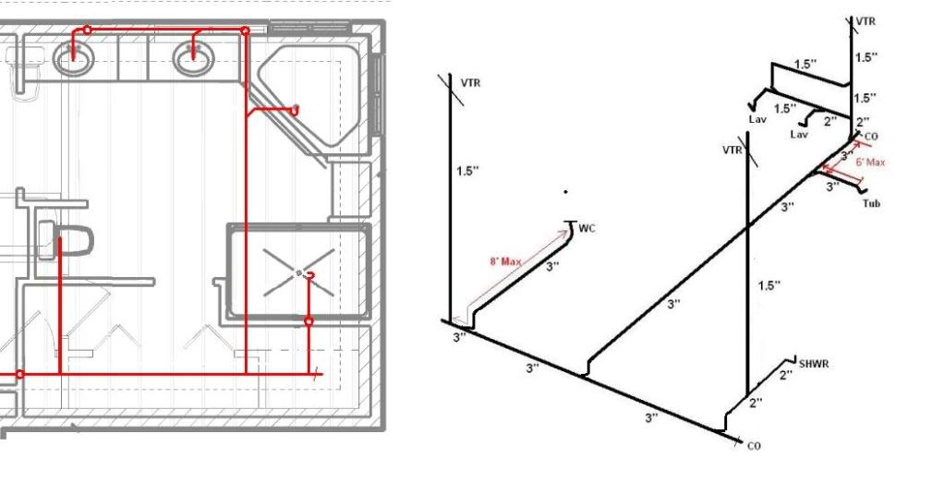

* + 1. Consult with the PM about various options, including the type of pipework to be used (i.e. copper or plastic), the hot water system, the heating system, the style of spouting/gutters and downpipes and so forth.

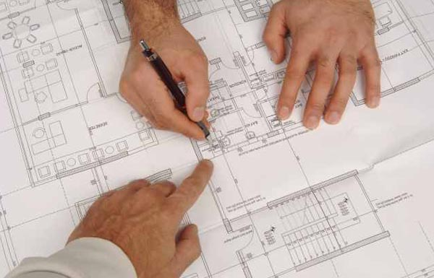

* + 1. First, plan the drain layout. When you are plotting the course for your drains, you must ensure you have adequate room in the ﬂoor system to provide the required slope and fall of the drain pipe. Not enough slope may cause the pipes to drain too slowly, and this slow draining can cause waste to be left behind. Too much fall may cause the waste flow noise and damage the fittings. The standard is a ¼-inch fall for each running foot of drain pipe. This varies, depending on the size of the pipe. Larger pipes require less fall. Once you plan the drain layout, plan the vents. Determine whether a single- or multi-drain and vent system is appropriate.

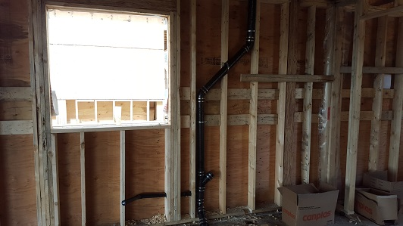

* + 1. For venting a sink in a vanity, consider where the light ﬁxture over that sink will be. You will likely have to elbow your drain pipe to one side, so it doesn’t interfere with the electrician’s work.
    2. The vent pipes should be stud out on the rear of the roof, so they are not visible from the street side. Conﬁrm this with the PM.
    3. The key to optimizing home designs for PEX plumbing is to minimize pipe lengths from the water main and water heater.



* + 1. Begin laying out the fixtures and mark key locations. Carefully mark the location of tubs, showers, sinks and appliances. Check to be sure everything will fit and necessary backing and support are in place.
    2. Determine where all the toilets will be and mark its center on the wall and measure out 13 1/2 inches from that point. Make a mark on the floor at that point for the toilet flange. Center the actual flange on top of the mark and trace a line around the outside of the ring.

|  |  |  |  |  |  |  |  |  |
| --- | --- | --- | --- | --- | --- | --- | --- | --- |
|  | Checklist 09-1: **Plumbing Planning and Layout (TS1)** | | | | | | | |
| MC Development Corp. | | Project: | Contractor: | | | | | |
| **Number** | **Checkpoints** | | | BI | DI | | | AI |
| **1** | DNV permit/inspection approval as required | | |  |  | | |  |
| **Comment** |  | | | | | | | |
| **2** | Review the work with ENGINEER and PM when needed | | |  | |  |  | |
| **Comment** |  | | | | | | | |
| **3** | The rough in diagram reviewed and approved by PM | | |  | |  |  | |
| **Comment** |  | | | | | | | |
| **4** | Double check utility layouts for construction conflicts | | |  |  | | |  |
| **Comment** |  | | | | | | | |
| **5** | Proper slopes applicable for all lines | | |  |  | | |  |
| **Comment** |  | | | | | | | |
| **6** | Make sure all drain and fixture locations are marked; arrows on test caps indicating the tub basin location, X's indicating showers, and so on | | |  |  | | |  |
| **Comment** |  | | | | | | | |
| **7** | 2” test cap nailed to the form board to denote the sewer cleanout location after backfilling has been completed | | |  |  | | |  |
| **Comment** |  | | | | | | | |
| **8** | The vent pipes are not visible from the street side | | |  |  | | |  |
| **Comment** |  | | | | | | | |
| **9** | The overall pipes lengths minimized | | |  |  | | |  |
| **Comment** |  | | | | | | | |
| **Quality Scores and Completion Sign-off** | | | | | | | | |
| **Inspection#**  Quality 5 4 3 2 1 Notes:  On-Time 5 4 3 2 1 Notes:  Sign and date*: Cell # / ID #: Signed: Date:  Task has been verified complete and in compliance with contract drawings and specifications except for non-conformances and incomplete items reported above. | | | | | | | | |
| **BI=** Inspection **B**efore task begin **-----------DI=** Inspection **D**uring task in-process --------**AI=** Inspection **A**fter task completed  *Quality Score**5 = 100% NO problems 4 = 1 minor problems 3 = Hotspot or 2-3 minor 2 = 6+ or major problems 1 = Excessive problems*  ***On-Time Score*** *5 = On Time 4 = Late 3 = Late by 1 day 2 = Late by 2 days 1 = Late more than 2 days*  ***Safety Score*** *5 = 100% NO problems 4 = 1 minor problem 3 = Hotspot or 2-3 minor 2= 4+ or major problem 1= Injury* | | | | | | | | |

## Installing Drains (TS2)

Before you begin:

* The waste-water system is usually installed first. All waste-water pipes must be angled downward, towards the septic outlet and away from plumbing drains, at a standard drop of at least 1/4 inches per each horizontal foot of pipe. Also, local plumbing codes will specify where cleanouts must be installed.
* Very important requirement for installing toilet drains is to make sure their exact location matches with fixtures specs. For example, typically the center of a toilet should be mounted 15 inches from a wall or vanity on all sides, but it differs based on the toilet sizes.

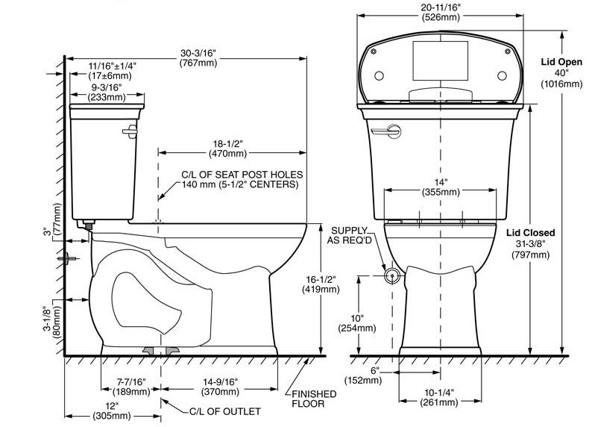

* + 1. Cut holes for the drains. Using a [hole saw](https://www.proconstructionguide.com/how-to-use-a-hole-saw/) sized 1⁄⁄8-inch larger than the pipe or fitting needed for the drain, cut out the decking, and see what is below. With proper planning, you should have a clear path for the drainpipe. Find alternative solutions for obstructions, such as trusses, joists or beams.

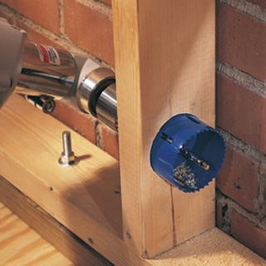

* + 1. Looking up from below, once the holes for the drains are cut, you can see where you want your pipe to be and determine the best path through trusses, walls, and joists. Insure adequate room exists for ﬁttings. If framing obstructs the route, don’t cut it until you are certain it’s non-structural. Always ask and check it with the Project Manager or Site Superintendent before you cut.

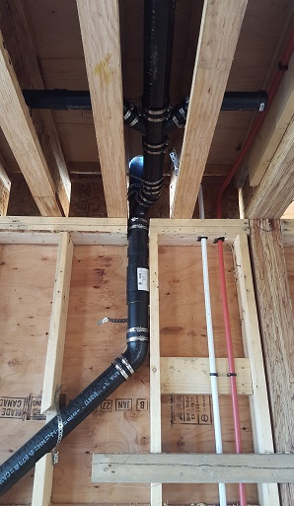

* + 1. Cut out the marked section and position the flange in the hole with the two elongated slots to the sides. Screw the flange to the floor, shimming as needed.

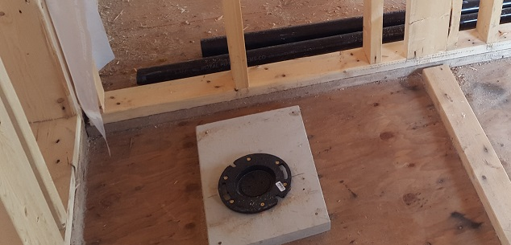

* + 1. Drain-pipe trap and vent assemblies must both be installed beneath the floor. Bear in mind that during roughing-in work that only subfloors are installed, so there are no problems placing drains under the floor. Direct the drain towards the main waste-water pipe, call the “waste stack,” with a 3-inch long, 90-degree turn fitting, running it into a 3-inch by 3-inch by 2-inch Y-shaped fitting. Position the Y fitting so the 2-inch opening can be connected to the main vent pipe. By code, a typical vanity sink can be drained using 1½-inch (or larger) pipe.

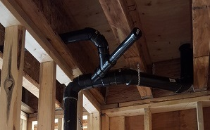

**Notes:**

* Install nail plates when plastic plumbing is within 1” of face of framing.
* Used wide-radius ﬁttings, if space inside a ﬂoor system or dropped ceiling is limited.
* Back to back fixtures require double fixture fitting.
* Pipes exposed to damage by sharp surfaces should be protected.
* Support plastic lines at every 4’. Support at each horizontal branch connection.
* Support vertical plastic lines at base and each floor. Provide mid-story guides.
* Protect Waste pipes installed in exterior walls from freezing where necessary.
* Each trap should be protected by a vent, and the length of the trap arm should not to exceed the following limits.



|  |  |  |  |  |  |  |  |  |
| --- | --- | --- | --- | --- | --- | --- | --- | --- |
|  | Checklist 09-2: **Installing Drains (TS2)** | | | | | | | |
| MC Development Corp. | | Project: | Contractor: | | | | | |
| **Number** | **Checkpoints** | | | BI | DI | | | AI |
| **1** | Status of previous TS inspections are approved by the PM/DNV | | |  |  | | |  |
| **Comment** |  | | | | | | | |
| **2** | Drains properly sized, and in correct location | | |  | |  |  | |
| **Comment** |  | | | | | | | |
| **3** | Waste line falls at least 1/4 in. per foot | | |  | |  |  | |
| **Comment** |  | | | | | | | |
| **4** | Adequate clean-outs provided in straight runs and at all bends | | |  |  | | |  |
| **Comment** |  | | | | | | | |
| **5** | Toilet spec sheets available for flanges locations | | |  |  | | |  |
| **Comment** |  | | | | | | | |
| **6** | Nail plates are installed where is necessary | | |  |  | | |  |
| **Comment** |  | | | | | | | |
| **7** | Hangers and straps don’t compress, distort, cut or abrade the piping and allow free movement of pipe | | |  |  | | |  |
| **Comment** |  | | | | | | | |
| **8** | Compare form work to start order, working drawings, field guides, and plot plan | | |  |  | | |  |
| **Comment** |  | | | | | | | |
| **9** | Verify drain pipes are not damaged | | |  |  | | |  |
| **Comment** |  | | | | | | | |
| **Quality Scores and Completion Sign-off** | | | | | | | | |
| **Inspection#**  Quality 5 4 3 2 1 Notes:  On-Time 5 4 3 2 1 Notes:  Sign and date*: Cell # / ID #: Signed: Date:  Task has been verified complete and in compliance with contract drawings and specifications except for non-conformances and incomplete items reported above. | | | | | | | | |
| **BI=** Inspection **B**efore task begin **-----------DI=** Inspection **D**uring task in-process --------**AI=** Inspection **A**fter task completed  *Quality Score**5 = 100% NO problems 4 = 1 minor problems 3 = Hotspot or 2-3 minor 2 = 6+ or major problems 1 = Excessive problems*  ***On-Time Score*** *5 = On Time 4 = Late 3 = Late by 1 day 2 = Late by 2 days 1 = Late more than 2 days*  ***Safety Score*** *5 = 100% NO problems 4 = 1 minor problem 3 = Hotspot or 2-3 minor 2= 4+ or major problem 1= Injury* | | | | | | | | |

## Venting Installation (TS3)

* + 1. The Each plumbing drain is required to have a pipe that extends upward, though the roof, and vents outdoors. Each plumbing fixture is required to have its own trap, or a U-shaped pipe that will remain filled with water, to prevent sewer gas from entering the living space.
    2. Use a carpenter's level to mark the studs for drilling holes. Run the horizontal vent lines sloped downward toward the fixtures at a rate of 1/8 to 1/4 inch per running foot. Drill holes, cut pipes, and connect them in a dry run using drain fittings

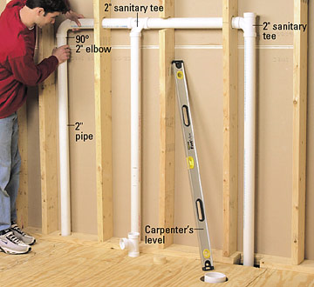

* + 1. Run the vent line over to the tee fitting. The pipes should slope gently away from the existing vent pipe so water can travel downward. The ideal height for sanitary tee fitting is usually 18 inches above the finished floor, but check your sink instructions to be sure. Cement a 1-1/4-inch trap adapter into the tee. Install a piece of 1x6 blocking and anchor the pipe with a strap.

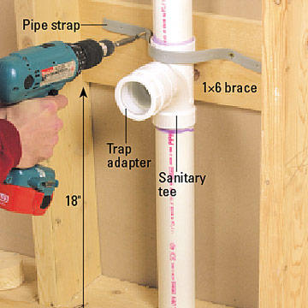

* + 1. Choose a toilet vent or drain configuration;
       - Option 1, Indirect Connection: If the toilet drain does not connect directly to a vent, you must find another way to vent it. If the drain line runs away from the wall where you want the vent, use a reducing Y and a 45-degree street elbow to point the vent line toward the wall. The horizontal vent pipe runs right next to the closet bend.

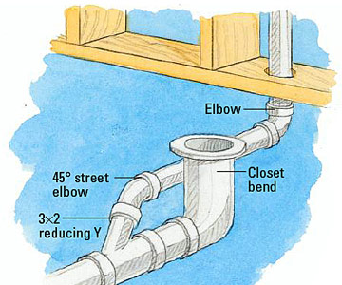

* + - * Option 2, Parallel: If the vent wall is parallel to the drain pipe, install a 45-degree reducing Y and a street elbow to point toward the wall. You may need another elbow (of any degree) to position the vertical vent where you want it.

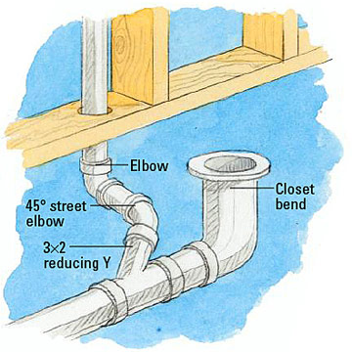

* + - * Option 3, Opposite Side: If the vent wall is opposite the drain line, use a reducing Y and a street elbow. The fittings can be pointed straight at the wall or at an angle, as needed.

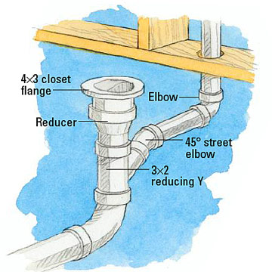

* + 1. It’s important to build a degree of fall into your vents. To comply with the code, all piping in a Drain-Waste -Vent (DWV) system must be “washed,” meaning that it will have adequate fall to insure moisture cannot accumulate anywhere in the system.
    2. Unless prohibited by structural conditions, the vent must rise vertically 6” above the flood level rim before continuing to horizontal. Vent pipe fittings located less than 6” above flood level of rim must be drainage pattern, and pipe must have drainage slope.
    3. Vents terminate a minimum 6” above roof line (10” in high snow load areas).Vent clearance to building openings are 3’ above or 10’ horizontal.

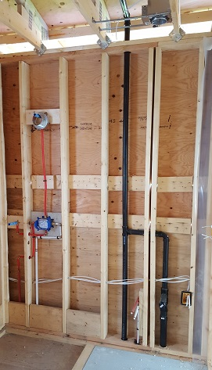

|  |  |  |  |  |  |  |  |  |
| --- | --- | --- | --- | --- | --- | --- | --- | --- |
|  | Checklist 09-3: **Venting Installation (TS3)** | | | | | | | |
| MC Development Corp. | | Project: | Contractor: | | | | | |
| **Number** | **Checkpoints** | | | BI | DI | | | AI |
| **1** | All drains are connected to a vent | | |  |  | | |  |
| **Comment** |  | | | | | | | |
| **2** | Vents discharge outside of buildings and away from air intakes | | |  | |  |  | |
| **Comment** |  | | | | | | | |
| **3** | Verify vent pipes are not damaged | | |  | |  |  | |
| **Comment** |  | | | | | | | |
| **4** | Takeoffs for vents are above the trap weir, except water closet and similar fixtures. | | |  |  | | |  |
| **Comment** |  | | | | | | | |
| **5** | Vent pipe inverts are taken off above the center line of horizontal drainage pipe, except horizontal wet vents. | | |  |  | | |  |
| **Comment** |  | | | | | | | |
| **6** | Aggregate vent areas are > to the building drain. | | |  |  | | |  |
| **Comment** |  | | | | | | | |
| **7** | The vent pipes are not visible from the street side | | |  |  | | |  |
| **Comment** |  | | | | | | | |
| **8** | Vents terminate a minimum 6” above roof line | | |  |  | | |  |
| **Comment** |  | | | | | | | |
| **Quality Scores and Completion Sign-off** | | | | | | | | |
| **Inspection#**  Quality 5 4 3 2 1 Notes:  On-Time 5 4 3 2 1 Notes:  Sign and date*: Cell # / ID #: Signed: Date:  Task has been verified complete and in compliance with contract drawings and specifications except for non-conformances and incomplete items reported above. | | | | | | | | |
| **BI=** Inspection **B**efore task begin **-----------DI=** Inspection **D**uring task in-process --------**AI=** Inspection **A**fter task completed  *Quality Score**5 = 100% NO problems 4 = 1 minor problems 3 = Hotspot or 2-3 minor 2 = 6+ or major problems 1 = Excessive problems*  ***On-Time Score*** *5 = On Time 4 = Late 3 = Late by 1 day 2 = Late by 2 days 1 = Late more than 2 days*  ***Safety Score*** *5 = 100% NO problems 4 = 1 minor problem 3 = Hotspot or 2-3 minor 2= 4+ or major problem 1= Injury* | | | | | | | | |

## Installing Water Lines (TS4)

Before you begin: consider these important aspects:

* For most of MCDC’s projects we use PEX (crosslinked polyethylene). But, before i[nstalling PEX plumbing pipes](https://www.proconstructionguide.com/how-to-install-pex/) assure it’s acceptable by the codes. With the PEX water line, we usually use copper stub outs.
* Code allows a standard three-fixture (bath/shower combination, sink and toilet) bathroom to be supplied with ½-inch water lines. To insure good water pressure, we feed no more than two fixtures from a ½-inch line. Our standard piping for a three-fixture bath is a ¾-inch cold and ½-inch hot water line, since only two of the three fixtures require hot water.
* Run a supply line up through the floor or wall so it comes out nearest the side of the toilet-tank water supply fixture. Attach a “T” fitting to the top of the supply line so the water line going into the middle outlet of the T extends upwards. Attach an 8-inch piece of supply line onto the part of the “T” that will supply the toilet and attach a screw-on cap fitting to create an air space to prevent “water hammer”.
* Keep tubing a minimum of 12 inches vertically or 6 inches horizontally from sources of high heat, such as recessed light fixtures, flue gas vents, or heating appliances.



* Do not bend PEX tubing tighter than the following minimum recommended bending radius.



* Do not drag the tubing over rough terrain, rocks, or any surface that can cut, puncture, or damage the tubing wall. Do not crush or kink the tubing.

Installation Steps:

* + 1. Drill Through the Stud and Sill Plate. Place the bit up to the stud and slowly start the drill, allowing it to build up speed. Drill through the sill plate and sub-floor for each water line. When drilling through a stud, be sure that each hole is at the same level so the pipe runs parallel to the floor.

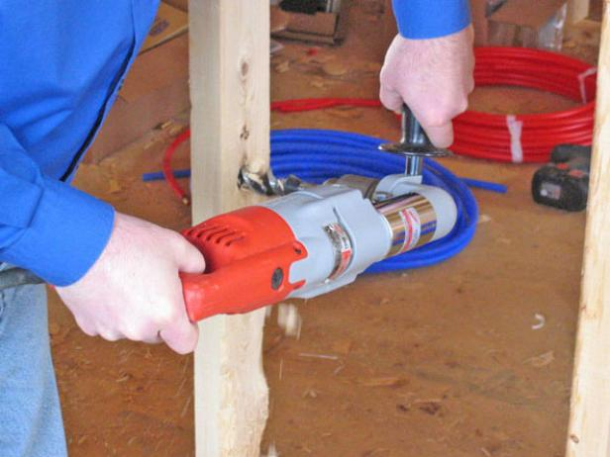

* + 1. Run the Water Lines. Once the holes are drilled, start running the water lines. In most cases, the lines will come through the floor. In some cases, the lines will have to be run across the wall studs. When running the pipes through the studs, first be sure to drill the holes in the center so that when it's time to hang the wall board, the screws or nails don't reach the pipes and damage the pipes. For extra precaution use a nail plate. The nail plate has tacks on both ends of a flat piece of steel. Line them up to cover screws or nails so they don't penetrate the steel to damage pipes.

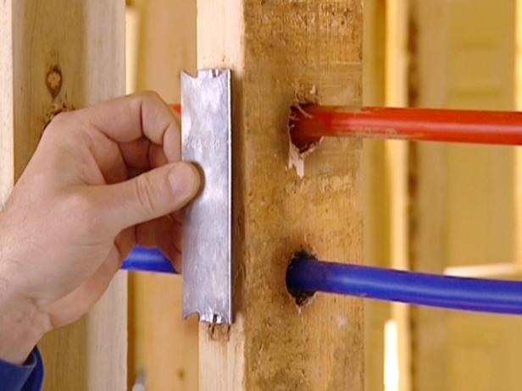

* + 1. Pull and Secure the Lines. Pull the lines up through the holes drilled in the sub-floor, and then run the other end to the area where the water will be coming into the home. Be sure to leave extra pipe on both ends of the run.

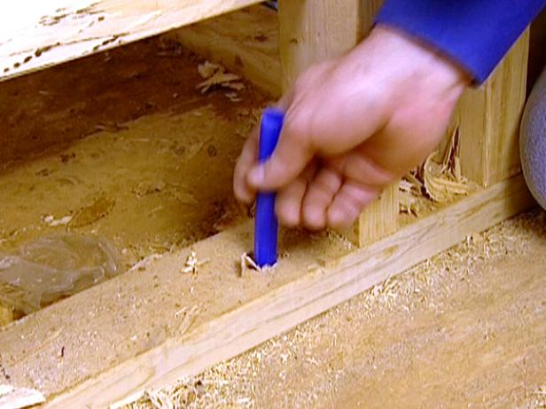

* + 1. Secure the line to the joists using clamps. Do your best to separate the hot and cold lines to minimize heat transfer. Leave a little slack in the line to allow for expansion and contraction. Don't forget to label both ends of the line.

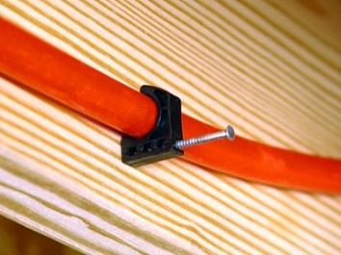

* + 1. Tubing and fittings shall be installed without placing stress on the connection.



* + 1. Do the Rough Stub Outs. It's now time to do the rough stub outs for the sinks. A rough stub out is installing a special copper fitting that will adapt to the PEX. Notice at the end, there is a cap called a rough fitting, which allows you to charge up the system with air or water to test to see if there are any leaks. After the walls are up, you can cut off the cap and install the finish valves.
    2. Apply Crimps. The crimps are the most crucial part of the job. If they aren't done right, the system could leak and cause problems down the line. Start by cutting the PEX and make sure it's straight. Slip a crimp ring onto the pipe, and then slide the pipe into the fitting. There's a little shoulder on all the fittings; that's where you slide the PEX to. Use a pair of slip-joint pliers or your fingers to slide the crimp ring up. You'll know it's in position when it's between an 1/8" and 1/4" or closer to the end of the pipe. This step is crucial to ensure leak-free crimps. The crimp can't be further than a 1/4" or closer than 1/8" to the end. Position the crimping tool so it completely covers the crimp ring. Close the jaws as tight as possible.

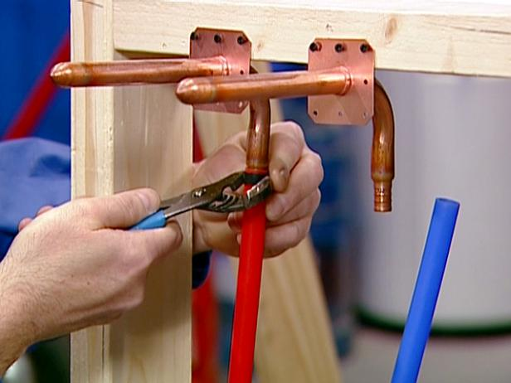

* + 1. Rough in the Lines. Now it's time to rough in the lines to a fixture. Since you can't solder around the PEX piping, use a fitting called a PEX 90 that sweats right into place on a mixing valve. Once it cools from soldering, it can be safely connected it to the PEX water line. It's crucial to take a mixing valve apart before soldering it. Remove any parts that might be affected by the heat from the torch.
    2. Position the Fittings and Solder. Once prepared, position the fittings so that they both will face down when the valve is hung in place. Solder them into position. Be sure to let the valve cool completely before putting it into place.

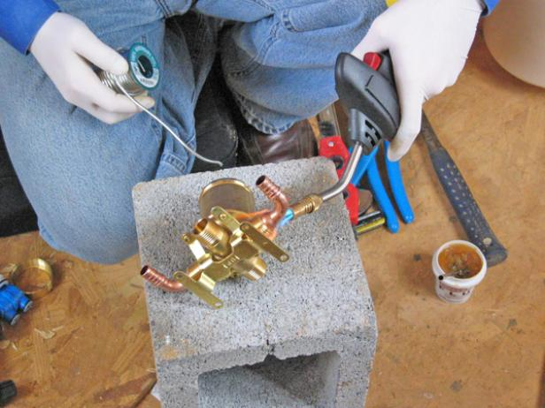

* + 1. Connect the Water Lines. The water lines can now be brought up from the crawlspace and connected to the manifold. Position the manifold about eye level, and then screw the top mounting bracket to the studs. Make sure that it's level and secure. Attach the manifold to the bracket using the manufacturer's supplied screws. Install the bottom bracket to the manifold. Check to see that it's plumb before mounting the bracket to the studs.

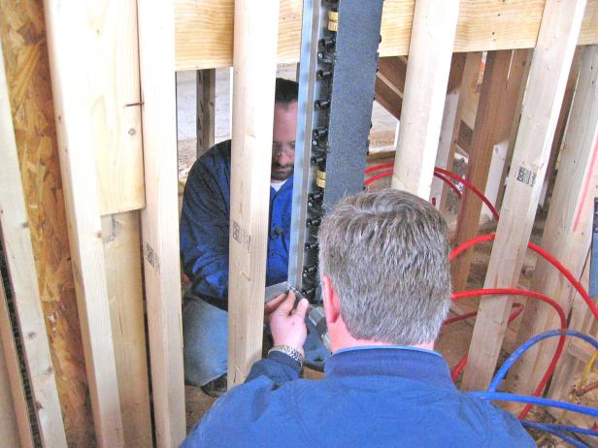

* + 1. Mark and Drill the Holes. Align the template to the manifold on the studs and either mark each hole with a nail or drill directly into it. Continue down the line until all the holes are drilled. Be careful not to damage the manifold with the drill. You may need to take the manifold down when drilling.
    2. Position the Ball Valves. With all of the holes drilled and the manifold mounted, attach the PEX ball valves to the manifold. Reach up, find the port and screw it into place. Get one of the lines and bring it up to the valve. This ensures that each fixture gets its own shut off valve. When the ball valves are in place, pull the PEX lines up from the crawl space, being careful not to kink them.

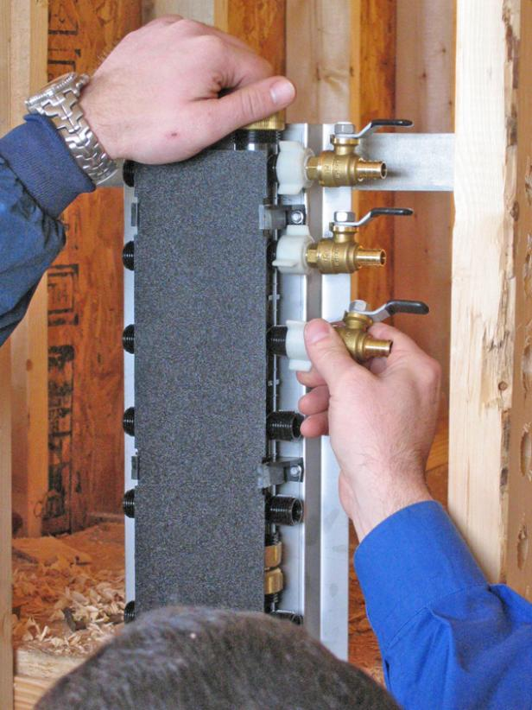

* + 1. Hot and cold-water manifolds shall be sized in accordance with the following table:



* + 1. Individual distribution lines supplied from a manifold and installed as part of a parallel water distribution system shall be sized in accordance with the following table:



* + 1. Inspect all tubing and fittings before and after installation. Cut out and replace all damaged sections or fittings.



|  |  |  |  |  |  |  |  |  |
| --- | --- | --- | --- | --- | --- | --- | --- | --- |
|  | Checklist 09-4: **Installing Water Lines (TS4)** | | | | | | | |
| MC Development Corp. | | Project: | Contractor: | | | | | |
| **Number** | **Checkpoints** | | | BI | DI | | | AI |
| **1** | Tubing stored in a way protected from mechanical damage | | |  |  | | |  |
| **Comment** |  | | | | | | | |
| **2** | Pipes kept a minimum of 12 inches vertically and 6 inches horizontally from sources of high heat | | |  |  | | |  |
| **Comment** |  | | | | | | | |
| **3** | Tubing lines protected from nail damage where appropriate | | |  | |  |  | |
| **Comment** |  | | | | | | | |
| **4** | Not tighter than minimum bending radius | | |  | |  |  | |
| **Comment** |  | | | | | | | |
| **5** | No cut, puncture, or damage on the tubing surface | | |  |  | | |  |
| **Comment** |  | | | | | | | |
| **6** | Kitchen plumbing in wall, not under cabinet | | |  |  | | |  |
| **Comment** |  | | | | | | | |
| **7** | Correct support spacing and locations | | |  |  | | |  |
| **Comment** |  | | | | | | | |
| **8** | Double check all pipe sizes be corrected | | |  |  | | |  |
| **Comment** |  | | | | | | | |
| **9** | Crimps applied correctly | | |  |  | | |  |
| **Comment** |  | | | | | | | |
| **10** | System is ready for testing | | |  |  | | |  |
| **Comment** |  | | | | | | | |
| **Quality Scores and Completion Sign-off** | | | | | | | | |
| **Inspection#**  Quality 5 4 3 2 1 Notes:  On-Time 5 4 3 2 1 Notes:  Sign and date*: Cell # / ID #: Signed: Date:  Task has been verified complete and in compliance with contract drawings and specifications except for non-conformances and incomplete items reported above. | | | | | | | | |
| **BI=** Inspection **B**efore task begin **-----------DI=** Inspection **D**uring task in-process --------**AI=** Inspection **A**fter task completed  *Quality Score**5 = 100% NO problems 4 = 1 minor problems 3 = Hotspot or 2-3 minor 2 = 6+ or major problems 1 = Excessive problems*  ***On-Time Score*** *5 = On Time 4 = Late 3 = Late by 1 day 2 = Late by 2 days 1 = Late more than 2 days*  ***Safety Score*** *5 = 100% NO problems 4 = 1 minor problem 3 = Hotspot or 2-3 minor 2= 4+ or major problem 1= Injury* | | | | | | | | |

## Testing the Pipe Lines (TS5)

Once the DWV and water lines are installed, they must be tested. This can be accomplished using either water or air pressure.

* + 1. Using air pressure:

1. Cap all the stub-outs connected to the system under testing. For a DWV system, glue a cap to each stub-out with plastic pipe cement. For testing the water system, glue or solder the caps, depending on the type of pipes.
2. Install or find a fitting that allows you to connect an air compressor hose and pressure gauge to the system. For DWV system, do this by screwing an adapter to a clean-out fitting and installing a tee. For water systems, it usually works to leave one stub-out uncapped and install a tee and adapter for the hose and gauge on that stub-out.
3. Turn on the compressor and fill the pipes with air until the gauge reaches the test pressure reading. For water system, this reading is 80 psi (assuming a working pressure of 40 psi). For DWV system, it's about 5 psi.
4. Turn off the compressor and leave the system pressurized for 15 minutes. Any reduction in pressure during that time signifies the presence of a leak.
   * 1. Test system with water pressure:
     + Once the drain system is assembled and cemented, plug the drainpipe at the lower end. Pour water into it until all the drain and vent pipes are filled with water. Allow the water to sit for a day to make sure there are no leaks.
     + For water lines, the water test pressure shall be at least equal to the expected working pressure (main pressure), but not less than 40 psi and not greater than 225 psi at 73°F.

|  |  |  |  |  |  |  |  |  |
| --- | --- | --- | --- | --- | --- | --- | --- | --- |
|  | Checklist 09-5: **Testing the Pipe Lines (TS5)** | | | | | | | |
| MC Development Corp. | | Project: | Contractor: | | | | | |
| **Number** | **Checkpoints** | | | BI | DI | | | AI |
| **1** | Status of previous TS inspections are approved by the PM/DNV | | |  |  | | |  |
| **Comment** |  | | | | | | | |
| **2** | All stab-outs are caped | | |  | |  |  | |
| **Comment** |  | | | | | | | |
| **3** | Air compressor and gauge properly fitted | | |  | |  |  | |
| **Comment** |  | | | | | | | |
| **4** | The test pressure read by the PM | | |  |  | | |  |
| **Comment** |  | | | | | | | |
| **5** | If pressure reduces, find the leak | | |  |  | | |  |
| **Comment** |  | | | | | | | |
| **6** | Double check for leaking | | |  |  | | |  |
| **Comment** |  | | | | | | | |
| **7** | Make sure entire system is under the test pressure | | |  |  | | |  |
| **Comment** |  | | | | | | | |
| **8** | The final test appointed with the DNV inspector | | |  |  | | |  |
| **Comment** |  | | | | | | | |
| **Quality Scores and Completion Sign-off** | | | | | | | | |
| **Inspection#**  Quality 5 4 3 2 1 Notes:  On-Time 5 4 3 2 1 Notes:  Sign and date*: Cell # / ID #: Signed: Date:  Task has been verified complete and in compliance with contract drawings and specifications except for non-conformances and incomplete items reported above. | | | | | | | | |
| **BI=** Inspection **B**efore task begin **-----------DI=** Inspection **D**uring task in-process --------**AI=** Inspection **A**fter task completed  *Quality Score**5 = 100% NO problems 4 = 1 minor problems 3 = Hotspot or 2-3 minor 2 = 6+ or major problems 1 = Excessive problems*  ***On-Time Score*** *5 = On Time 4 = Late 3 = Late by 1 day 2 = Late by 2 days 1 = Late more than 2 days*  ***Safety Score*** *5 = 100% NO problems 4 = 1 minor problem 3 = Hotspot or 2-3 minor 2= 4+ or major problem 1= Injury* | | | | | | | | |

# Quality Assurance Approval

Only if all 15 required Inspections, associated with 5 TS Checklists mentioned in this WM, are approved by the PM and the CM as OK, the PM will carry out the final Inspection and issues the written approval if the results are OK.

If the results do not match the allowable tolerances, the PM will communicate this issue to the CM who evaluates the NCs and issues instructions for the corrective actions to be taken.

Any non-conformance shall be reported through the NCR procedure described in MCDC’s QP and is applicable to any and all phases of the Rough in Plumbing.

# References

1. The Handouts and QMS sample documents provided by Mr. Jim Turnham (CMGT-7246)
2. Based on Behrouz Chehrehpardaz work experience
3. The various public online resources
4. BC Building Code
5. WorkSafeBC Regulations
6. DNV Bylaws

# Construction Organization Chart

MCDC Board of Directors

Construct Manager/CEO

Project Manager

Site Super Intendent

Trade Contractor

# Flow Chart

Contract

Specs

Dwgs

WM/ITP

QP

END

Pre-Work WM Review Meeting

Certificate of Completion

NCP

Corrective Action

Initial Inspection

NO YES

Final Inspection

Passed?

NO/NCP

Inspection

Passed?

YES YES

(BI & DI & AI) Inspections

Passed?

Plumbing Planning and Layout

NO/NCP

NO/NCP

Testing the lines

(BI & DI & AI) Inspections

Passed?

YES YES

(BI & DI & AI) Inspections

Passed?

Installing Drains

NO/NCP

NO/NCP

Installing water lines

(BI & DI & AI) Inspections

Passed?

YES YES

(BI & DI & AI) Inspections

Passed?

Venting Installation

NO/NCP

# Inspection and Test Plan

|  |  |  |  |  |  |  |  |  |  |  |
| --- | --- | --- | --- | --- | --- | --- | --- | --- | --- | --- |
| MC Development Corp | | Inspection and Test Plan # 09  **Plumbing Rough-in** | | | PM: MCDC Project Manager  C: Contractor | | | | | |
| Contractor: | | | Project: | | | | | |
| **#** | **Inspections** | **To Inspect Items listed in** | **Time of Inspection** | **QC**  **by** | **Acceptance Criteria** | **H/W/D** | | **Score &**  **(lowest)** | **Initials** | **Date** |
| 1 | Initial Inspection | QMP004b | Prior to any work | C | CM approval | H |  |  |  |  |
| 2 | Layout BI | Checklist 09-1 | Prior to TS1 | C | PM Approval |  |  |  |  |  |
| 3 | Layout DI | Checklist 09-1 | During TS1 | C | PM Approval |  |  |  |  |  |
| 4 | Layout AI | Checklist 09-1 | After TS1 | C | PM Approval |  |  |  |  |  |
| 5 | Drain Install BI | Checklist 09-2 | Prior TS2 | C | PM Approval |  |  |  |  |  |
| 6 | Drain Install DI | Checklist 09-2 | During TS2 | C | PM Approval |  |  |  |  |  |
| 7 | Drain Install AI | Checklist 09-2 | After TS2 | C | PM Approval |  |  |  |  |  |
| 8 | Venting BI | Checklist 09-3 | Before TS3 | C | PM Approval |  |  |  |  |  |
| 9 | Venting DI | Checklist 09-3 | During TS3 | C | PM Approval |  |  |  |  |  |
| 10 | Venting AI | Checklist 09-3 | After TS3 | C | PM Approval |  |  |  |  |  |
| 11 | Water Lines BI | Checklist 09-4 | Before TS4 | C | PM Approval |  |  |  |  |  |
| 12 | Water Lines DI | Checklist 09-4 | During TS4 | C | PM Approval |  |  |  |  |  |
| 13 | Water Lines AI | Checklist 09-4 | After TS4 | C | PM Approval |  |  |  |  |  |
| 14 | Testing BI | Checklist 09-5 | Before TS5 | C | PM Approval |  |  |  |  |  |
| 15 | Testing DI | Checklist 09-5 | During TS5 | C | PM Approval |  |  |  |  |  |
| 16 | Testing AI | Checklist 09-5 | After TS5 | C | PM Approval |  |  |  |  |  |
| 23 | Final Inspection | List of NCs | After Completion | PM | CM Approval |  |  |  |  |  |
| ITP Accepted by ……………………… Signature ……………………………… Date ……………. | | | | | | | | | | |
| **(BI**: Inspection Before Task Begin----**DI**: Inspection During Task Work----**AI**: Inspection After Task Finished)  **(W**: Witnessed by CM---- **H**: Hold further work----**D**: Document) | | | | | | | | | | |