**Work Method 07- Roof Finishing (Covering)**

(WM07-MCDC Template)

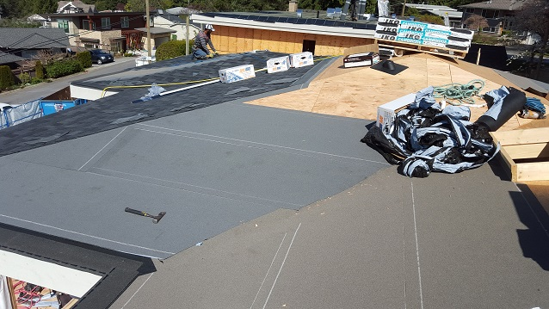

**Industry Based Project (CMGT 8800)**

**September 20, 2018**

**BCIT**

Faculty Advisor: Jim Turnham, P. Eng, MASc., ISO 9001 Lead Auditor

Prepared by: Behrouz Chehrehpardaz

Table of Contents

2. SIGNATURE PAGE 3

3. Proponent and Project Description 4

4. PURPOSE and SCOPE 5

5. DEFINITIONS 5

6. RESPONSIBILITIES 6

7. SAFETY AND ENVIRONMENT 8

8. SUBMITTALS 9

9. PROCEDURE 10

9.1. General Requirements 10

9.2. Drip Edge Installation (TS1) 12

9.3. Underlayment Installation (TS2) 16

9.4. Roof Cover Installation (TS3) 21

10. Quality Assurance Approval 34

11. References 34

12. Construction Organization Chart 35

13. Flow Chart 36

14. Inspection and Test Plan 37

# SIGNATURE PAGE

As an Approver, with my signature, I confirm that this Work Method is the plan for construction of the work. If the plan changes, I will inform the Originator so that the Work Method can be revised. Alternately, I will make revisions myself and reissue to those that require copies.

As a Reviewer, my signature confirms that I have reviewed the document and any comments to the WM have been provided to the Originator and/or to the Approver.

MCDC Construction Manager

Name: Date: ____ __ Title: _____________________ Signature: _________________

MCDC Project Manager

Name: Date: ____ __ Title: _____________________ Signature:_________________

Contractor

Name: Date: ____ __ Title: _____________________ Signature: _________________

Initial Reviewer

Name: Date: Title: Signature:

# Proponent and Project Description

**Company Name:** MC DEVELOPMENT CORP. (MCDC)

**Company type of service**

MCDC is a small construction company building Single Family Houses (SFHs) in North Vancouver, and the company’s vision is to be recognized as a model of quality excellence in construction.

**Project Description**

Under a Project Management/Design Build method, MCDC itself or on behalf of the owners manages construction projects to build new single-family houses mostly in North Vancouver.

MCDC contract out all work activities in construction stage including the covering all Roofs.

**Work Method Activity Description**

This Work Method (WM) provides the required details of how the covering of roofs are carried out, and it is also subject to a series of inspections, before the commencement, during the work, and after completion.

This Work Method will be used in order to ensure full compliance with MCDC’s quality policy and Quality Plan, drawings, specifications, and BC Building Codes.

**Work Method Scope**

This work method shall apply to the covering of all Roofs that have been shown in Roofing drawings of the project.

**Limitation of liability:** Any organization engaged as a Contractor or Subcontractor (the Contractor) agrees to use this Work Method only under the condition that those that wrote and developed this Work Method are to be held harmless for any errors or omissions, any inaccuracies in content resulting in any damages to property or any injury to any personnel that may be involved. It remains the sole responsibility of the Contractor to review any and all items contained in the above Work Method and to make any changes that may be required in order to satisfy any project specification or any regulatory or statutory obligation. As well, the Contractor shall review any and all suggested methods as contained herein and shall make any changes required and shall reissue prior to commencement of construction in order to achieve the specified product or to provide a safe work site for all workers involved. Ownership and final responsibility for the use of all Work Methods remains with the Contractor.

# PURPOSE and SCOPE

**Purpose**: To define the responsibilities, describe methods and documentation to be used for covering the Roofs in MCDC’s SFH projects.

**Scope**: This work method applies to all activities required for Roofing Finishing at (the address of the project). Reference Standards include:

* British Columbia (or applicable province) Building Code 2012.

Note: Construction documents (design drawings and specifications) should be referenced as applicable and will govern over any procedure included in this document.

# DEFINITIONS

MCDC - MC Development Corp.

CM - MCDC’s Construction Manager

PM - MCDC’s Project Manager

QC - Quality Control

WM - Work Method (this document)

WP **-** Work Procedure

TS - Task Step

CL - Checklist

RM - Review Meeting

NCP - Nonconformity Procedure

ITP - Inspection and Test Plan

BI - Before the TS Inspection

DI - During the TS Inspection

AI – After the TS Inspection

DNV - District of North Vancouver

SWP – Safe Work Practice

SWRB – Solid Waste Removal Bylaw (DNV)

# RESPONSIBILITIES

* 1. **Construction Manager (CM)** is responsible for project scheduling, and final approving the inspections, tests, and changes. The CM is also responsible for preparation of drawings and sketches to support construction as required and all making any changes if required.
  2. **Project Manager (PM)** is responsible for; identifying necessary resources and assigning individual responsibilities to run and monitor the quality control procedure that defined by MCDC’s QP and this WM. He is responsible for overseeing the Quality Management Plan, enforcing project construction standards, assisting the CM in the creation of work method documents by providing appropriate sequence and task definitions, executing the project, scheduling and delegation of the roles of quality control inspections, safety, environmental items and Contractor coordination.
  3. The PM is accountable for the Site Superintendent’s all responsibilities as well. The PM, for each WM contemplated for use at the site, provides a review and makes changes if necessary to any clause so that it is consistent with best practice, consistent with the building code of the Province, and consistent with local conditions. Issues should be reviewed by email with the CM.
  4. **Site Superintendent** must work well with people and is responsible for:
  + Requesting copies of subcontractor’s liability insurance and workmen’s compensation certificate.
  + Overall site activities; applying project methodology and enforcing project construction standards; organizing field staff and ensuring they perform as required; and supervising Contractors and ensuring they perform as required
  + Assisting the PM and the Contractors in the creation and execution of work plans including revisions to these plans as necessary.
  + Assisting the PM in supervision of Contractors’ work quality.
  + Working closely with and support the Contractor to identify potential risks/opportunities, discuss necessary changes, and conduct the inspections.
  + Scheduling and monitoring each workday with appropriately resources.
  + Serving as the representative of and primary contact with the PM.
  + Attending review meetings.
  + Maintaining site logs and other documents in jobsite.
  + Ensuring the jobsite safety and ensuring that safety practices are followed.
  1. **Trade Contractor** (Contractor) refers to the company that is bound by contract to MCDC for a certain scope of work. For their scope, the Contractor is responsible for environmental control, safety controls, and quality control for self-performed work. The Contractor is responsible to write his/her Work Methods. However, if the Contractor cannot provide the required WMs, MCDC may assist, but the final WM will be reviewed, changes made to reflect project requirements, codes, laws, and resubmitted to MCDC and owned by the Contractor. The Contractor performs the work required by the contract documents and approved Work Methods to start and complete the Project and fulfill everything indicated by the contract documents. The Contractor shall perform activities described in this WM. If any revision is needed, the Contractor shall be instructed to revise and update this WM so that the WM reflects the intent and methods of the Contractor as well. The Contractor shall be fully responsible for his means and methods, and for the content of the revised WM. The Contractor shall assign a representative who will permanently attend at the job site when the job is being done. The Site Manager or the Contractor’s site representative shall ensure following the guidelines and/or Standard Specifications outline on this work method.

# SAFETY AND ENVIRONMENT

All construction activities and job procedures shall conform to

* WCB Regulations and other applicable codes, regulations and acts
* DNV Street and Traffic Bylaw (Bylaw 7125)
* DNV Noise Regulation Bylaw (Bylaw 7188)
* DNV Environmental Protection and Preservation Bylaw (Bylaw 6515)
* DNV Tree Protection Bylaw (Bylaw 7671)

Before any work takes place, the PM and Site Superintendent will ensure that all operators, laborers, and Contractors have been site orientated.

Roofing procedures must comply with safe practices and with the requirements of the bylaw, codes and ordinances.

All work process shall be fully consistent to DNV Bylaws. Working on roofs, especially erecting roofs, is obviously a dangerous job. There are many different dangers which can cause serious accidents. For the safety of the workers all possible precautions must be taken to minimise the risks. The most important aspects are:

* Substructure strong enough to support the weight of the workers as well as stacking of the required materials
* Safe access
* Safe Clothing and Gears (For pitched roofs, wear skid-resistant shoes)
* Physical fitness!

Only mentally and physically fit and healthy workers should work on the roof. The work is too dangerous for people who are ill, unfit, weak or drunk. Make sure nobody else (other contractors) is scheduled and attend on the site when the roofing is going on.

# SUBMITTALS

The contractor submittals to MCDC:

* Contractor Quotation for doing the job described in MCDC’s RFQ package, including
  + Contract price and time (including the start time of work on site)
  + Declaration of accepting all contract terms and documents
  + Written promise to provide the required submittals (including Contractor’s Work Method and Checklists), 14 days prior to the work start
  + Documented processes and submittals to enable the PM review
  + Contractor’s initial Work Method, Checklists, and ITP for MCDC review
* The final revision of MCDC QP reviewed and confirmed by the Contractor
* Finalized WM, ITPs, Checklists, and any other documents required by the contract documents, not later than 7 days prior to the work start time, (MCDC CM written confirmation required)
* Any drawing, specs, and designing layout which is required for carrying out the work, and in order to satisfy any project specification or any regulatory or statutory obligation.
* Reports that identifies the Self inspection result and scope of work, before each MCDC scheduled inspection
* Insurance and WCB coverage

All contractor submittals are stated in the Contract and include (but not limited to)

* Marking materials, measuring stick, and measuring tape
* Nails and Fasteners
* FULLY TORCH ON Gutter with Granular UV protected 180 cap sheet and 3” drains
* IKO peel and stick underlayment
* Cambridge Asphalt singles with lifetime warranty and High-profile cap
* Cap flashing
* Air vents
* Three Ply Roofing System
  + 1/8 Thick IKO Protector Board mechanically fastened
  + TP 180 Base sheet fully Torched On over the field and Base stripping
  + TP 180 Granular UV protected Cap sheet over the fields and cap stripping
  + 3” Deck drains and over flows
  + 26-gauge interlocking Cap and Drip Edge Flashing
* Five-Year Workmanship warranty
* Ten-year Material warranty

# PROCEDURE

## General Requirements

Consult the specifications and construction drawings to determine the requirements for any aspect of the work. This Work Method is a guideline used by MCDC to describe the work process and the process of quality control by conducting the specific Inspections and relevant Checklists. The Drawings, and Specifications as well as any code and by-law are the ultimate requirements. The PM and the Contractor shall review the Work Method and make any revision (prior to each use if necessary) so that any requirements will be identified and met.

The following Task Steps (procedures) TSs are included in this Work Method:

* 9.2 Drip Edge Installation (TS1)
* 9.3 Underlayment Installation (TS2)
* 9.4 Roof Cover Installation (TS3)

Each TS comes with a Checklist and each Checklist is subject to three Inspections, before, during, and after completion of the TS. Each Checklist includes several checkpoints which must be controlled and verified by the MCDC’s PM or Site Superintendent. To continue the work and proceed to next step, the Contractor must obtain the approval of PM for all Inspections. The PM will give the approval only if all Checklist’s items are checked and passed.

The Inspections and Testing shall follow the instructions described in the Inspection and Testing Plan number 07(ITP07). The PM shall review the results of the ITP and Checklists and check if the results are acceptable. The PM will communicate the acceptable results to the CM and if the results are not acceptable, the PM will communicate this issue to the CM and the Contractor to evaluate the default and issue instructions for the corrective actions.

**Before you begin:**

* Review the Roof plans and a diagram of the roof that includes the style and shape, the pitch ratios, all the measurements, and materials.



* Once all plan revisions are finalized and confirmed by the engineers; the PM; and the Contractor, all materials will be ordered including:
* Underlayment, such as tar paper
* Roof covering (tiles, shingles, or metal)
* Roofing nails

## Drip Edge Installation (TS1)

Along the edge of the roof, drip edge flashing stops water from being blown or seeping under the roof tiles, and makes water drip down out and away from the wall or fascia.

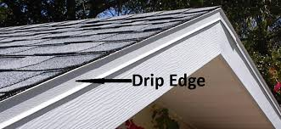

* + 1. Before you being, prepare the roof by removing all the dirt and debris.
    2. Take measurements of all the outer edges of your roof to determine how much drip edge needed.
    3. Use a metal snip to cut the lengths of the drip edge according to the measurements. For the first piece, set the strip against the corner of the fascia where the slopped edge meets the horizontal edge. Mark the angle of the slope on the strip and cut it to match so that it will be flush with the edge when installed.
    4. Start the installation at the lower edge of the roof and work your way up toward the peak. Tack the edge in place with a roofing nail every 8 to 10 inches. Drive the nail through the drip edge into the roof surface, not through the fascia.
    5. When you reach the end of a strip, start the next length with a lap joint. To create lap joint, overlap the drip edge ends with the upper edge over the lower edge, so water flowing down will pass over the joint, not divert under it. Continue the process until you have laid drip edge metal strip on all the edges of the roof, front and back and sides.
    6. Make sure to meet the codes and requirements.
       - The Drip Edge must be corrosion resistant
       - The Drip Edge should be applied directly to the deck along the eaves and then underlayment should be place over the Drip Edge
       - Along the Rake, the Drip Edge should be applied on top of the underlayment
       - The Drip Edge should be nailed every 10” starting from the corners and joints

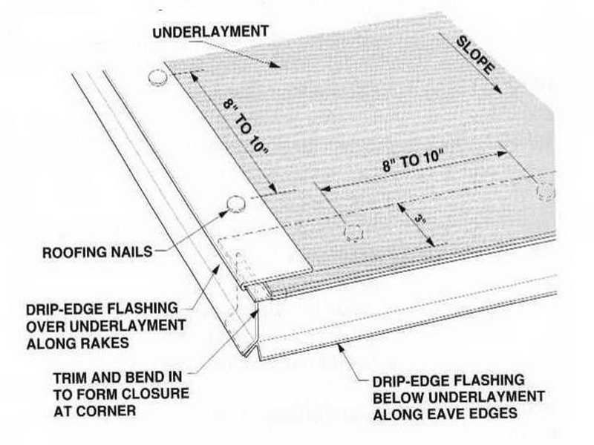

* + 1. Defer putting drip edge on angled gable ends until after the felt is laid, so the metal edge will block wind from lifting the felt.

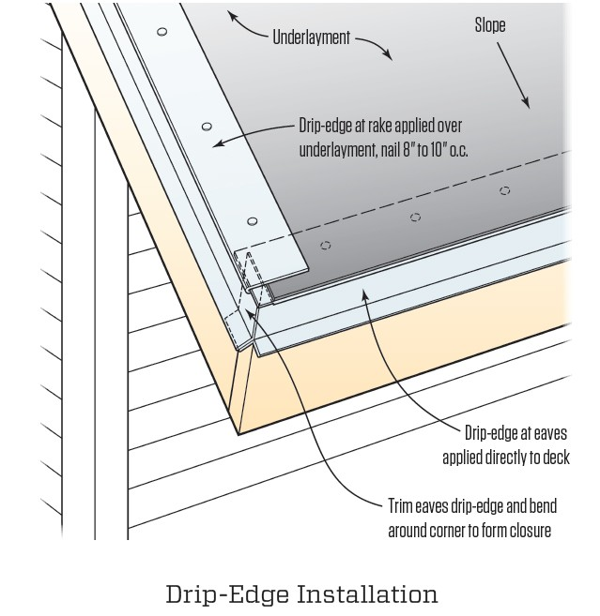

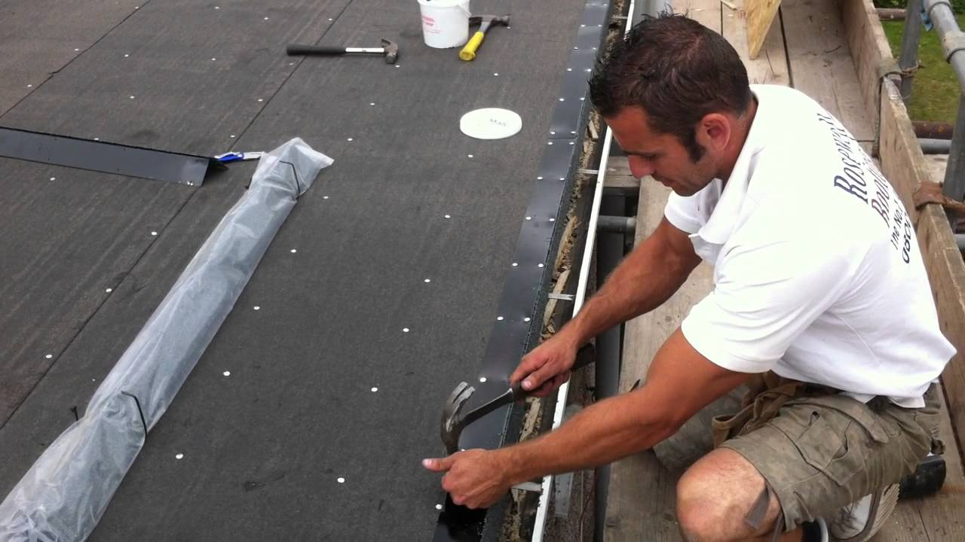

|  |  |  |  |  |  |  |  |  |
| --- | --- | --- | --- | --- | --- | --- | --- | --- |
|  | Checklist 07-1: **Drip Edge Installation (TS1)** | | | | | | | |
| MC Development Corp. | | Project: | Contractor: | | | | | |
| **Number** | **Checkpoints** | | | BI | DI | | | AI |
| **1** | DNV permit/inspection approval as required | | |  |  | | |  |
| **Comment** |  | | | | | | | |
| **2** | Review the work requirements with ENGINEER when needed | | |  | |  |  | |
| **Comment** |  | | | | | | | |
| **3** | The roof top is clean of any debris and unnecessary materials | | |  | |  |  | |
| **Comment** |  | | | | | | | |
| **4** | The right type/shape of drip edge is delivered on the site | | |  |  | | |  |
| **Comment** |  | | | | | | | |
| **5** | The drip edge is place correctly- on the top of the underlayment along the rake and under the underlayment along the eaves | | |  |  | | |  |
| **Comment** |  | | | | | | | |
| **6** | The proper nailing- 8 to 10 inches | | |  |  | | |  |
| **Comment** |  | | | | | | | |
| **7** | The drip edge pieces have proper overlaps | | |  |  | | |  |
| **Comment** |  | | | | | | | |
| **8** | 3” overlap with the underlayment | | |  |  | | |  |
| **Comment** |  | | | | | | | |
| **9** | The correct layout and in right order | | |  |  | | |  |
| **Comment** |  | | | | | | | |
| **Quality Scores and Completion Sign-off** | | | | | | | | |
| **Inspection#**  Quality 5 4 3 2 1 Notes:  On-Time 5 4 3 2 1 Notes:  Sign and date*: Cell # / ID #: Signed: Date:  Task has been verified complete and in compliance with contract drawings and specifications except for non-conformances and incomplete items reported above. | | | | | | | | |
| **BI=** Inspection **B**efore task begin **-----------DI=** Inspection **D**uring task in-process --------**AI=** Inspection **A**fter task completed  *Quality Score**5 = 100% NO problems 4 = 1 minor problems 3 = Hotspot or 2-3 minor 2 = 6+ or major problems 1 = Excessive problems*  ***On-Time Score*** *5 = On Time 4 = Late 3 = Late by 1 day 2 = Late by 2 days 1 = Late more than 2 days*  ***Safety Score*** *5 = 100% NO problems 4 = 1 minor problem 3 = Hotspot or 2-3 minor 2= 4+ or major problem 1= Injury* | | | | | | | | |

## Underlayment Installation (TS2)

The underlayment choice depends on the roof’s pitch and other factors, but the standard is Roofing Felt (often called tar paper, builder’s paper, or Torch-On roles).

The felt’s thickness is measured in pounds per square (one square equals 100 square feet of roofing material); 15- and 30-pound felt are most common. Thirty-pound paper lasts longer and provides better leak protection. Pay particular attention to seams during installation: this is the most common point of failure with this roofing products.

Before you begin:

* Make sure the roof’s sheathing is dry–the waterproof underlayment can trap moisture and damage sheathing.
* Arrange the material delivery using a crane and specify a proper place on the roof for putting the materials.

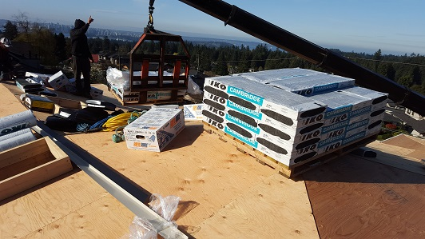

Process of Triply Torch-on:

* + 1. A proper and fully charged fire extinguisher must be on roof and ready to use. Never torch a ply roofing membrane directly to wood decks. Always install a suitable base sheet over wooden surface before applying flame. The layer of base sheet helps to prevent fires and provides a suitable base for the modified bitumen to be applied.
    2. Lay the base sheet on top of the roof surface and make sure that it lies flat and even. Start the base sheet at one bottom corner of the roof. Tack it in place at the corner, with the end flush with the end of the roof and the bottom edge of the roll right along the bottom of the roof deck, over the drip edge. Roll out about 10 feet of base sheet and fasten with staples or roofing nails with plastic washer heads. Use a construction stapler or a hammer. Put fasteners at least every 8 inches.

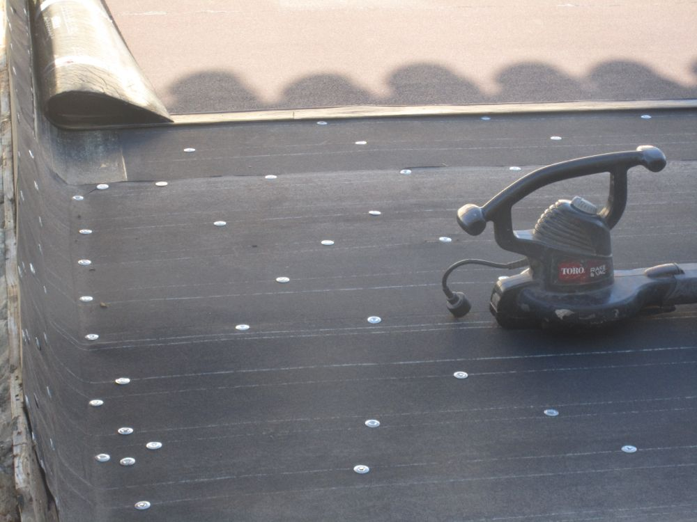

* + 1. Roll the first layer of modified bitumen over the base sheet and start at one bottom corner of the roof. Cut the layer of modified bitumen to size using a utility knife. You should be able to stretch the modified bitumen to cover any odd corners or angles. To ensure a straight run, the membrane should be ruled out and aligned in the direction of the application. The slope of the roof will determine the direction of the rolls (follow the specifications). All laps must be parallel or perpendicular to the slope of the roof so that water is never running against the lap edge.
    2. After rolling out (10 feet) and aligning the membrane roll, reroll the membrane back approximately one half of the length of the roll. Rerolling the membrane while walking backward on the roll helps prevent the roll from going out of alignment during the torching application, and to keep the roll square and free of wrinkles by utilizing your body weight to keep the membrane roll in position.
    3. With the membrane roll aligned and rerolled, begin by applying the torch flame to the rolled portion of the membrane. The torch head should be approximately four to six inches above the surface of the roll. Move the torch flame from end to end of the role. The torch flame should be positioned so that eighty percent of the flame is on the roll itself and the remaining twenty percent is on the base sheet. Torch-applied membranes generally have a thin plastic burn-off film that melts off as the asphalt heats. The asphalt on the back of the tri-ply torch membrane is actually melted by the torch, providing a strong bond. Too much heating, and the membrane scorches; Too little, and there is insufficient bonding. Either one may lead to roof failure. For a visual cue to correct torching, look for a slight green sheen to develop when correctly heated. Sand-coated rolls darken slightly when correctly heated. Touch the heated roll with a trowel to determine if the membrane compound is slightly molten. Immediately after correctly applying the torch to the membrane, roll forward only the distance of the heated portion of the membrane roll. Repeat these steps until you reach the end of the roll.

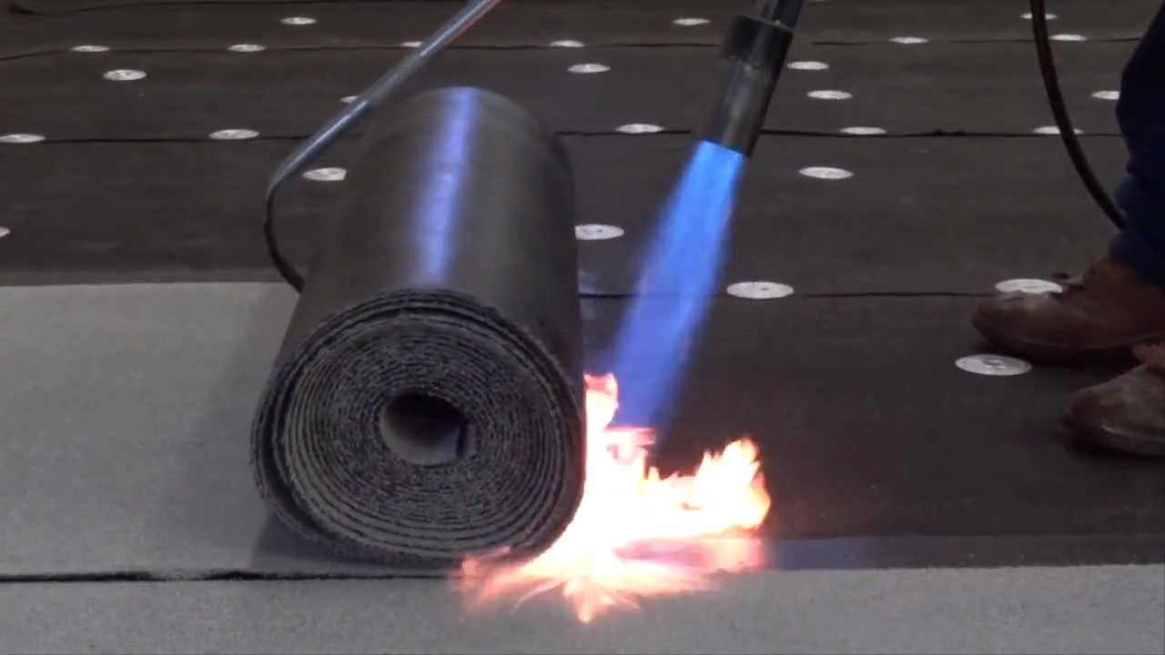

* + 1. When installing consecutive membrane rolls, the rolls generally overlap at side laps by three to four inches. Headlaps are formed at roll ends and generally overlap six to eight inches. Headlaps must be staggered from adjacent endlaps at a minimum of 18 inches apart so that no adjacent endlaps coincide. To ensure complete bonding and seam integrity, both membranes must be heated equally during the torching process. A visual cue for correct heating is the flow of molten compound out of the membrane seam or headlap (one-quarter to one-half inch flow out). During the membrane roll installation, the side lap seam is preheated by the torch approximately twelve inches in from the edge of the roll, which results in an L-shaped torching pattern. To ensure that seam compound is molten at the time of roll advancement, start the torch L pattern at the side lap, move across the width of the roll, and then back to the side. With the torch at the side lap, advance the roll forward. To ensure full bonding at side and head lap seams, the use of four-inch seam roller is recommended.

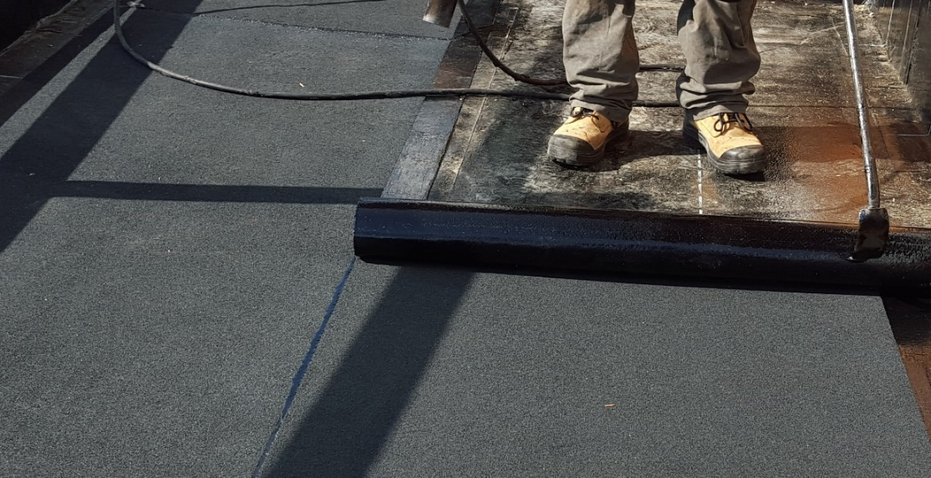

* + 1. Repeat Steps 2-6 twice so that there are three layers of base sheet and modified bitumen on top of each other, with a layer of modified bitumen on top.
    2. Apply primer to the metal flashing to allow the torch down roofing to adhere to it more easily.

|  |  |  |  |  |  |  |  |  |
| --- | --- | --- | --- | --- | --- | --- | --- | --- |
|  | Checklist 07-2: **Underlayment Installation (TS2)** | | | | | | | |
| MC Development Corp. | | Project: | Contractor: | | | | | |
| **Number** | **Checkpoints** | | | BI | DI | | | AI |
| **1** | Status of previous TS inspections are approved by the PM/DNV | | |  |  | | |  |
| **Comment** |  | | | | | | | |
| **2** | The sheathings and base sheets are flat, clean, smooth, and dry | | |  | |  |  | |
| **Comment** |  | | | | | | | |
| **3** | Correct cap sheet installation direction according to slope (specs) | | |  | |  |  | |
| **Comment** |  | | | | | | | |
| **4** | Base sheets are nailed properly (nails with plastic washer heads) | | |  |  | | |  |
| **Comment** |  | | | | | | | |
| **5** | Cap sheets are aligned and rerolled | | |  |  | | |  |
| **Comment** |  | | | | | | | |
| **6** | The torching correct application and L-shape pattern | | |  |  | | |  |
| **Comment** |  | | | | | | | |
| **7** | Check all overlaps, side laps, and head laps | | |  |  | | |  |
| **Comment** |  | | | | | | | |
| **8** | Headlaps are staggered properly | | |  |  | | |  |
| **Comment** |  | | | | | | | |
| **9** | Check the flow of molten compound out of the membrane seam or headlap (one-quarter to one-half inch) | | |  |  | | |  |
| **Comment** |  | | | | | | | |
| **10** | Underlayment layout and laps: per specifications; damage free | | | | | | | |
| **Comment** |  | | | | | | | |
| **Quality Scores and Completion Sign-off** | | | | | | | | |
| **Inspection#**  Quality 5 4 3 2 1 Notes:  On-Time 5 4 3 2 1 Notes:  Sign and date*: Cell # / ID #: Signed: Date:  Task has been verified complete and in compliance with contract drawings and specifications except for non-conformances and incomplete items reported above. | | | | | | | | |
| **BI=** Inspection **B**efore task begin **-----------DI=** Inspection **D**uring task in-process --------**AI=** Inspection **A**fter task completed  *Quality Score**5 = 100% NO problems 4 = 1 minor problems 3 = Hotspot or 2-3 minor 2 = 6+ or major problems 1 = Excessive problems*  ***On-Time Score*** *5 = On Time 4 = Late 3 = Late by 1 day 2 = Late by 2 days 1 = Late more than 2 days*  ***Safety Score*** *5 = 100% NO problems 4 = 1 minor problem 3 = Hotspot or 2-3 minor 2= 4+ or major problem 1= Injury* | | | | | | | | |

## Roof Cover Installation (TS3)

The 3-tab asphalt shingle, also called a composition or fiberglass shingle, is the most common type of shingle. Other composition shingles, such as architectural and random cutouts, are installed using most of the same techniques. Here is described how to install shingles using the racking method. A pneumatic nail gun makes quick work of fastening shingles.

Do Not Apply Shingles Below 2/12 Slope.

Before you begin:

* Make sure the gables cut to be straight and angle flashing in good condition.
* Make sure there in no damage or deficiency on the underlayment.
* Make sure the ordered shingles are acceptable quality roofing products based on the project specifications.
* To prevent cracking, shingles must be sufficiently warm to allow proper forming for hips, ridges and valleys.
* Check all safety aspects to be in an acceptable condition.
  + 1. If possible, have the shingles delivered by a crane or boom directly onto the roof. If the slope is shallow so there's no danger that the shingles will slide off, scatter the shingles on the roof so they will be in easy reach. Otherwise, stack them near the ridge in a way that prevents them from sliding or on a roof-jack platform.

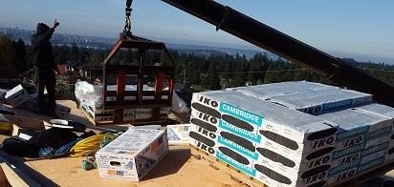

* + 1. Snap horizontal chalklines to help you keep the courses straight. First, snap a line for the top of the starter course, whose bottom will be flush with the underlayment (which overhangs the drip edge by 1/2 inch). Then snap lines for every course or every other course. Assuming that the shingles have a 5-inch reveal, snap these lines in 5-inch increments, starting at the bottom of the underlayment.



* + 1. Install a continuous starter strip or full-sized shingles, which are simply turned downside up. Often, however, a starter course is made of cut shingles. Place the shingle upside down on a sheet of plywood and use a straightedge to cut it 7 inches wide; you will use the portion with no tabs.



* + 1. Starting at one end, place the starter shingles downside up so the self-seal strip is near the bottom. The top should be aligned with the chalkline and the bottom should be flush with the bottom of the underlayment.

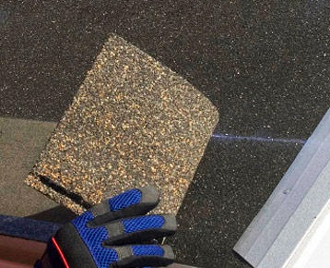

To make sure you've got the right sizes to lay courses correctly, cut several sizes of shingles from the three-tab variety you purchased. Cut off one-half tab-width of the first tab to start the first course. Each cut is needed to shift the slots of the shingles on the course of shingles a 1/2 tab from aligning with the slots in shingles above and below. Keep all scrap, especially any single tabs for use on the ridge cap shingles. Make the following cuts:

* Cut a half tab off for your first course shingles,
* Cut off a full tab for your second course shingles
* Cut one and a half tabs off of your third course shingles,
* Cut two tabs off your fourth course shingles
* For your fifth course, cut off half of the final tab
* Keep your sixth course tabs intact



* + 1. Attach each starter shingle by driving three nails along its top edge. Fastening along the top edge assures that nail heads will not be exposed.





* + 1. To avoid ending up with a narrow strip of tab along one of the rakes, lay out a full course of shingles and adjust their position as needed.

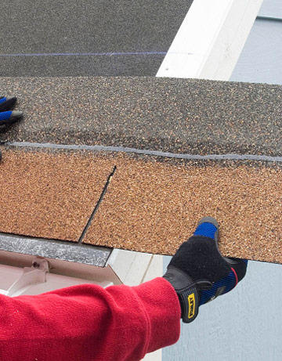

* + 1. To attach a shingle, align it with the layout line and drive nails 1/2 inch above the cutout slots (including the half slots at each side). Nail the "cut off shingle" into place, about 6 inches from its lower edge. Hammer in one nail about 2 inches from each end of each shingle and another nail about 1 inch above each cutout. Make sure to keep nails out of the tar strip as you work.

The next shingles above should cover the nails by about 1 inch vertically. Horizontally, end nails will be covered by up to about 1/2 of a tab, of the shingle(s) above. Be sure that these nails will hold the top edge of the course of shingles immediately below.

Drive a nail at one end first, then drive the others. If you are using a power nailer, drive nails by squeezing the trigger and bouncing the nailer's tip onto the shingle.



* + 1. For a racking or midroof pyramid layout method, snap two vertical lines (called bond lines) near the center of the roof, the appropriate distance apart. Check them with a framing square or measure so the lines are parallel with the rake ends.

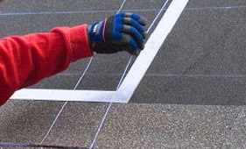

* + 1. Install four or five courses of shingles along the bond lines in an alternating pattern as shown. Take care that the shingles are correctly aligned with consistent reveals. Later, you will need to lift up the outermost ends of the shingles on each side in order to slip in a shingle, so don't drive the outermost nails now.

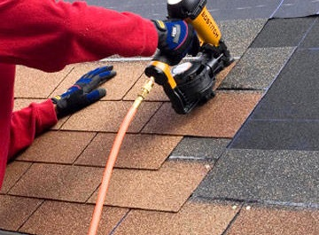

* + 1. Starting at the racked shingles, fill in the courses. Align the shingles with the horizontal lines and nail them in place. Note: In areas with high winds, it is common to drive two nails above each cutout line.

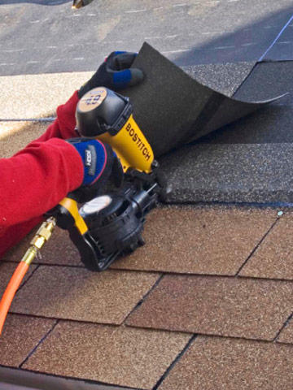

* + 1. Shingles often have small cuts on the top and sides that can be used as guides for horizontal and vertical alignment. Use these whenever there is no layout line. Also, roofing hatchets and some roofing nailers have adjustable guides.

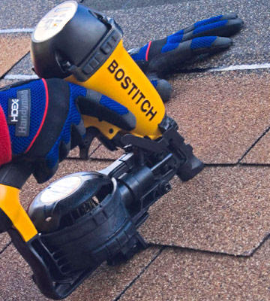

* + 1. To easily check your work, or if you find the guide on the nailer awkward to use, make a simple plywood jig like the one shown as a guide for the 5-inch reveal.



* + 1. If the roof is steep enough that you could slide off, install roof jacks and planks to keep you stable and safe. A scrap of roofing laid upside down beneath the heel of the jack will keep it from denting the shingles.



* + 1. When you encounter a plumbing vent pipe, shingle up to it so the flashing will rest on a row of shingles below the pipe. You may need to cut out part of the rubber flange so it fits over the pipe. Apply roofing cement (a caulk tube is usually the neatest and easiest method) where it will rest on top of shingles.

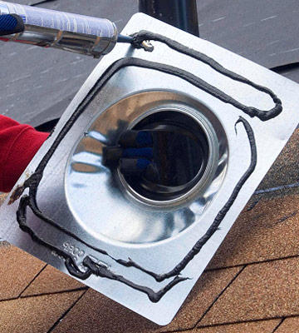

* + 1. Slip the flashing over the pipe and press it in place. Drive nails around the perimeter as recommended by the manufacturer.

Then, cut the upper shingles so they fit snugly but do not ride up on the flashing's raised portion; the shingles should lie flat at all points. Where shingles overlap the flashing, attach them with roofing cement rather than nails. Cover any exposed nailheads with dabs of roofing cement.

 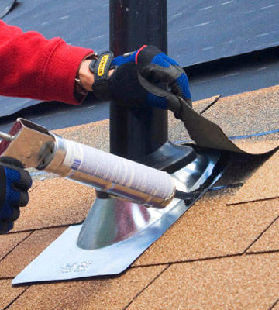

* + 1. Where a wall is perpendicular to the roofing, slip pieces of step flashing under the siding. Apply a flashing piece, then a shingle, then flashing, as you would apply step flashing for a chimney. If the roof meets a wall that is parallel to the shingles, roof up to the wall, then slip a long, continuous piece of flashing under the siding and on top of the shingles.



* + 1. When you reach a peak or hip, shingle all the way up the first side (until the reveal portion of the shingles is within 4 inches of the peak) and cut the shingles just below the ridge. Shingle the other side and bend the last course of shingles over the ridge, up to about 6 inches, and nail it onto the other side so that the roofing extends over the top of the ridge, where nails will be covered, leaving no exposed nails. However, do not do this if a ridge vent system is being installed as well. To prevent cracking, make sure the caps are warm enough to permit proper forming over the ridge or hip.

Fasten each cap shingle with two nails installed at 55⁄8" from the bottom edge and 1" in from each side. Leave only the 5" tab exposed to the weather. Do not expose fasteners.

 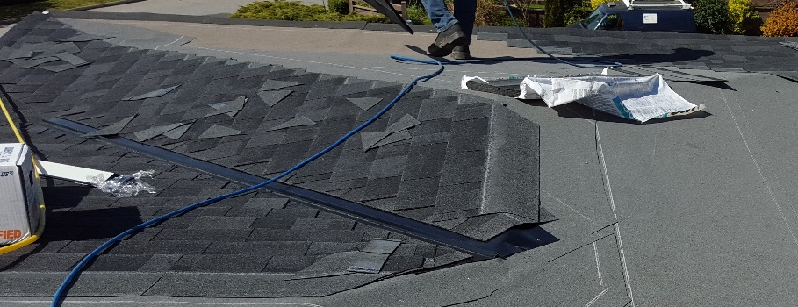

* + 1. To cut ridgecaps, turn shingles upside down and cut off single tabs. Angle the cuts slightly so the nonreveal portions will not be visible when the caps are installed. Make a cut on the backside, then bend and break the shingle. Using a 5-inch reveal, estimate the number of caps needed. Prepare the ridge by snapping chalklines 6 inches on each side.

Install ridgecaps along the lines, leaving a 5-inch reveal. Drive the nails about 1-1/2 inches from the sides and just below the self-sealing strip. Shingle to the middle of the ridge, then start from the other end. Where the ridgecaps meet, install a 5-inch-wide strip. Cover nailheads with dabs of roofing cement.

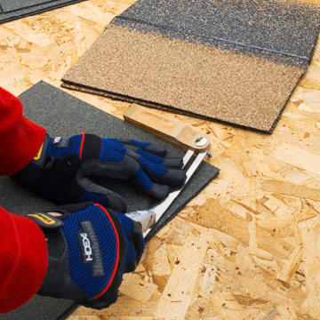 

* + 1. If you have a hip that runs into the main roof, cover the area with waterproof shingle underlayment (WSU) when you are installing the sheathing; cut the WSU so it lies flat at all points. Then cover the resulting V-shape notch with another piece of WSU. When you install the shingles, leave one shingle unnailed so you can later slip a ridgecap under it.

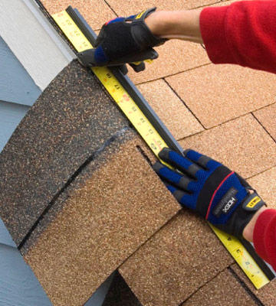

* + 1. Shingle sealing may be delayed if shingles are applied in cool weather and may be further delayed by airborne dust accumulation. If any shingles have not sealed after a reasonable time period, hand sealing may be necessary.

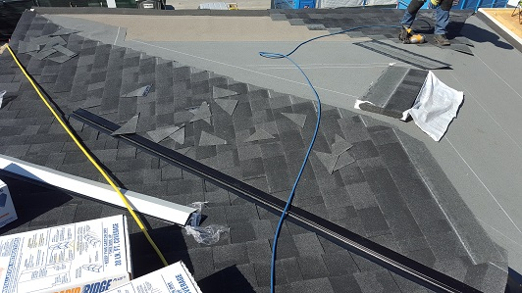

|  |  |  |  |  |  |  |  |  |
| --- | --- | --- | --- | --- | --- | --- | --- | --- |
|  | Checklist 07-3: **Roof Cover Installation (TS3)-** (Page 1) | | | | | | | |
| MC Development Corp. | | Project: | Contractor: | | | | | |
| **Number** | **Checkpoints** | | | BI | DI | | | AI |
| **1** | Status of previous TS inspections are approved by the PM/DNV | | |  |  | | |  |
| **Comment** |  | | | | | | | |
| **2** | No damage or deficiency on the underlayment | | |  | |  |  | |
| **Comment** |  | | | | | | | |
| **3** | Gables cut straight, and angle flashing in good condition | | |  | |  |  | |
| **Comment** |  | | | | | | | |
| **4** | Roof top cleaned before material delivery | | |  |  | | |  |
| **Comment** |  | | | | | | | |
| **5** | Felt cut back under ridge vent (if applicable) | | |  |  | | |  |
| **Comment** |  | | | | | | | |
| **6** | 3 Tab shingles installed with 6" offset pattern | | |  |  | | |  |
| **Comment** |  | | | | | | | |
| **7** | Mortars/ Adhesives/ membranes: See manual and specifications | | |  |  | | |  |
| **Comment** |  | | | | | | | |
| **8** | Architectural shingles installed with 6 1/2" offset pattern | | |  |  | | |  |
| **Comment** |  | | | | | | | |
| **9** | Cut valleys used at all locations (No Laced Valleys) | | |  |  | | |  |
| **Comment** |  | | | | | | | |
| **Quality Scores and Completion Sign-off** | | | | | | | | |
| **Inspection#**  Quality 5 4 3 2 1 Notes:  On-Time 5 4 3 2 1 Notes:  Sign and date*: Cell # / ID #: Signed: Date:  Task has been verified complete and in compliance with contract drawings and specifications except for non-conformances and incomplete items reported above. | | | | | | | | |
| **BI=** Inspection **B**efore task begin **-----------DI=** Inspection **D**uring task in-process --------**AI=** Inspection **A**fter task completed  *Quality Score**5 = 100% NO problems 4 = 1 minor problems 3 = Hotspot or 2-3 minor 2 = 6+ or major problems 1 = Excessive problems*  ***On-Time Score*** *5 = On Time 4 = Late 3 = Late by 1 day 2 = Late by 2 days 1 = Late more than 2 days*  ***Safety Score*** *5 = 100% NO problems 4 = 1 minor problem 3 = Hotspot or 2-3 minor 2= 4+ or major problem 1= Injury* | | | | | | | | |
|  | Checklist 07-3: **Roof Cover Installation (TS3)-** (Page 2) | | | | | | | |
| MC Development Corp. | | Project: | Contractor: | | | | | |
| **Number** | **Checkpoints** | | | BI | DI | | | AI |
| **10** | Shingles cut neatly and straight along edges of roof | | |  |  | | |  |
| **Comment** |  | | | | | | | |
| **11** | Toe boards removed and shingles repaired / replaced | | |  | |  |  | |
| **Comment** |  | | | | | | | |
| **12** | Vent stacks installed | | |  | |  |  | |
| **Comment** |  | | | | | | | |
| **13** | Ridge vent straight | | |  |  | | |  |
| **Comment** |  | | | | | | | |
| **14** | Drip edge on eaves straight and undamaged | | |  |  | | |  |
| **Comment** |  | | | | | | | |
| **15** |  | | |  |  | | |  |
| **Comment** |  | | | | | | | |
| **7** | assures that nail heads will not be exposed | | |  |  | | |  |
| **Comment** |  | | | | | | | |
| **8** | ensure sufficient deck ventilation. | | |  |  | | |  |
| **Comment** |  | | | | | | | |
| **9** | Overview the whole roof for any deficiencies | | |  |  | | |  |
| **Comment** |  | | | | | | | |
| **Quality Scores and Completion Sign-off** | | | | | | | | |
| **Inspection#**  Quality 5 4 3 2 1 Notes:  On-Time 5 4 3 2 1 Notes:  Sign and date*: Cell # / ID #: Signed: Date:  Task has been verified complete and in compliance with contract drawings and specifications except for non-conformances and incomplete items reported above. | | | | | | | | |
| **BI=** Inspection **B**efore task begin **-----------DI=** Inspection **D**uring task in-process --------**AI=** Inspection **A**fter task completed  *Quality Score**5 = 100% NO problems 4 = 1 minor problems 3 = Hotspot or 2-3 minor 2 = 6+ or major problems 1 = Excessive problems*  ***On-Time Score*** *5 = On Time 4 = Late 3 = Late by 1 day 2 = Late by 2 days 1 = Late more than 2 days*  ***Safety Score*** *5 = 100% NO problems 4 = 1 minor problem 3 = Hotspot or 2-3 minor 2= 4+ or major problem 1= Injury* | | | | | | | | |

# Quality Assurance Approval

Only if all 9 required Inspections, associated with 3 TS Checklists mentioned in this WM, are approved by the PM and the CM as OK, the PM will carry out the final Inspection and issues the written approval if the results are OK.

If the results do not match the allowable tolerances, the PM will communicate this issue to the CM who evaluates the NCs and issues instructions for the corrective actions to be taken.

Any non-conformance shall be reported through the NCR procedure described in MCDC’s QP and is applicable to any and all phases of shingle installment.

# References

1. The Handouts and QMS sample documents provided by Mr. Jim Turnham (CMGT-7246)
2. Based on Behrouz Chehrehpardaz work experience
3. “Better Homes and Gardens” website
4. All pictures are taken during MCDC’s last project at 4438 Ranger Ave, North Vancouver
5. BC Building Code
6. WorkSafeBC Regulations
7. DNV Bylaws

# Construction Organization Chart

MCDC Board of Directors

Construct Manager/CEO

Project Manager

Site Super Intendent

Trade Contractor

# Flow Chart

Contract

Specs

Dwgs

WM/ITP

QP

END

Pre-Work WM Review Meeting

Certificate of Completion

NCP

Corrective Action

Initial Inspection

NO YES

Final Inspection

Passed?

NO/NCP

Inspection

Passed?

YES YES

(BI & DI & AI) Inspections

Passed?

Drip Edge Installation

NO/NCP

NO/NCP

Roof Cover Installation

(BI & DI & AI) Inspections

Passed?

YES YES

(BI & DI & AI) Inspections

Passed?

Underlayment Installation

NO/NCP

# Inspection and Test Plan

|  |  |  |  |  |  |  |  |  |  |  |
| --- | --- | --- | --- | --- | --- | --- | --- | --- | --- | --- |
| MC Development Corp | | Inspection and Test Plan # 07  **Roof Finishing (Covering)** | | |  | | | | | |
| Contractor: | | | Project: | | | | | |
| **#** | **Inspections** | **To Inspect Items listed in** | **Time of Inspection** | **QC**  **by** | **Acceptance Criteria** | **H/W/D** | | **Score &**  **(lowest)** | **Initials** | **Date** |
| 1 | Initial Inspection | QMP004b | Prior to any work | PM | CM approval | H |  |  |  |  |
| 2 | Drip Edge BI | Checklist 07-1 | Prior to TS1 | PM | PM Approval |  |  |  |  |  |
| 3 | Drip Edge DI | Checklist 07-1 | During TS1 | PM | PM Approval |  |  |  |  |  |
| 4 | Drip Edge AI | Checklist 07-1 | After TS1 | PM | PM Approval |  |  |  |  |  |
| 5 | Underlayment BI | Checklist 07-2 | Prior TS2 | PM | PM Approval |  |  |  |  |  |
| 6 | Underlayment DI | Checklist 07-2 | During TS2 | PM | PM Approval |  |  |  |  |  |
| 7 | Underlayment AI | Checklist 07-2 | After TS2 | PM | PM Approval |  |  |  |  |  |
| 8 | Roof Cover BI | Checklist 07-3 | Before TS3 | PM | PM Approval |  |  |  |  |  |
| 9 | Roof Cover DI | Checklist 07-3 | During TS3 | PM | PM Approval |  |  |  |  |  |
| 10 | Roof Cover AI | Checklist 07-3 | After TS3 | PM | PM Approval |  |  |  |  |  |
| 23 | Final Inspection | List of NCs | After Completion | PM | CM Approval |  |  |  |  |  |
| ITP Accepted by ……………………… Signature ……………………………… Date ……………. | | | | | | | | | | |
| **(BI**: Inspection Before Task Begin----**DI**: Inspection During Task Work----**AI**: Inspection After Task Finished)  **(W**: Witnessed by CM---- **H**: Hold further work----**D**: Document) | | | | | | | | | | |