**Work Method 06- Roof Framing**

(WM06-MCDC Template)

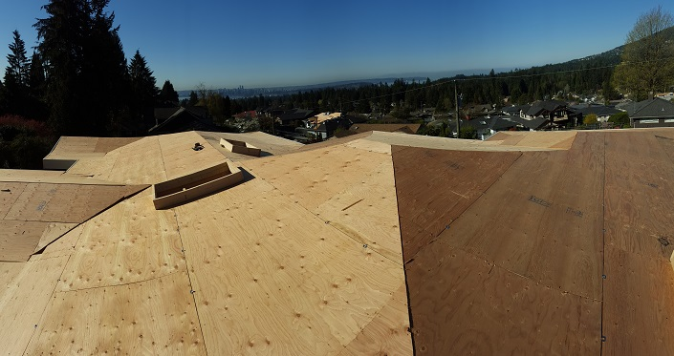

**Industry Based Project (CMGT 8800)**

**September 20, 2018**

**BCIT**

Faculty Advisor: Jim Turnham, P. Eng, MASc., ISO 9001 Lead Auditor

Prepared by: Behrouz Chehrehpardaz

Table of Contents

2. SIGNATURE PAGE 3

3. Proponent and Project Description 4

4. PURPOSE and SCOPE 5

5. DEFINITIONS 5

6. RESPONSIBILITIES 6

7. SAFETY AND ENVIRONMENT 8

8. SUBMITTALS 9

9. PROCEDURE 10

9.1. General Requirements 10

9.2. Erecting Trusses (TS1) 12

9.3. Roof Sheathing (TS2) 16

10. Quality Assurance Approval 20

11. References 20

12. Construction Organization Chart 21

13. Flow Chart 22

14. Inspection and Test Plan 23

# SIGNATURE PAGE

As an Approver, with my signature, I confirm that this Work Method is the plan for construction of the work. If the plan changes, I will inform the Originator so that the Work Method can be revised. Alternately, I will make revisions myself and reissue to those that require copies.

As a Reviewer, my signature confirms that I have reviewed the document and any comments to the WM have been provided to the Originator and/or to the Approver.

MCDC Construction Manager

Name: Date: ____ __ Title: _____________________ Signature: _________________

MCDC Project Manager

Name: Date: ____ __ Title: _____________________ Signature:_________________

Contractor

Name: Date: ____ __ Title: _____________________ Signature: _________________

Initial Reviewer

Name: Date: Title: Signature:

# Proponent and Project Description

**Company Name:** MC DEVELOPMENT CORP. (MCDC)

**Company type of service:** MCDC is a small construction company building Single Family Houses (SFHs) in North Vancouver, and the company’s vision is to be recognized as a model of quality excellence in construction.

**Project Description:** Under a Project Management/Design Build method, MCDC itself or on behalf of the owners manages construction projects to build new single-family houses mostly in North Vancouver.

MCDC contract out all work activities in construction stage including the Roof Framing.

**Work Method Activity Description:** This Work Method (WM) provides the required details of how the construction of roofs are carried out, and it is also subject to a series of inspections, before the commencement, during the work, and after completion.

This Work Method will be used in order to ensure full compliance with MCDC’s quality policy and Quality Plan, drawings, specifications, and BC Building Codes.

**Work Method Scope:** This work method shall apply to the construction of all Roofs that have been shown in Roofing drawings of the project.

**Limitation of liability:** Any organization engaged as a Contractor or Subcontractor (the Contractor) agrees to use this Work Method only under the condition that those that wrote and developed this Work Method are to be held harmless for any errors or omissions, any inaccuracies in content resulting in any damages to property or any injury to any personnel that may be involved. It remains the sole responsibility of the Contractor to review any and all items contained in the above Work Method and to make any changes that may be required in order to satisfy any project specification or any regulatory or statutory obligation. As well, the Contractor shall review any and all suggested methods as contained herein and shall make any changes required and shall reissue prior to commencement of construction in order to achieve the specified product or to provide a safe work site for all workers involved. Ownership and final responsibility for the use of all Work Methods remains with the Contractor.

# PURPOSE and SCOPE

**Purpose**: To define the responsibilities, describe methods and documentation to be used for building the Roofs in MCDC’s SFH projects.

**Scope**: This work method applies to all activities required for Roof Framing at (the address of the project). Reference Standards include:

* British Columbia (or applicable province) Building Code 2012.

Note: Construction documents (design drawings and specifications) should be referenced as applicable and will govern over any procedure included in this document.

# DEFINITIONS

MCDC - MC Development Corp.

CM - MCDC’s Construction Manager

PM - MCDC’s Project Manager

QC - Quality Control

WM - Work Method (this document)

WP **-** Work Procedure

TS - Task Step

CL - Checklist

RM - Review Meeting

NCP - Nonconformity Procedure

ITP - Inspection and Test Plan

BI - Before the TS Inspection

DI - During the TS Inspection

AI – After the TS Inspection

DNV - District of North Vancouver

SWP – Safe Work Practice

SWRB – Solid Waste Removal Bylaw (DNV)

# RESPONSIBILITIES

* 1. **Construction Manager (CM)** is responsible for project scheduling, and final approving the inspections, tests, and changes. The CM is also responsible for preparation of drawings and sketches to support construction as required and all making any changes if required.
  2. **Project Manager (PM)** is responsible for; identifying necessary resources and assigning individual responsibilities to run and monitor the quality control procedure that defined by MCDC’s QP and this WM. He is responsible for overseeing the Quality Management Plan, enforcing project construction standards, assisting the CM in the creation of work method documents by providing appropriate sequence and task definitions, executing the project, scheduling and delegation of the roles of quality control inspections, safety, environmental items and Contractor coordination.
  3. The PM is accountable for the Site Superintendent’s all responsibilities as well. The PM, for each WM contemplated for use at the site, provides a review and makes changes if necessary to any clause so that it is consistent with best practice, consistent with the building code of the Province, and consistent with local conditions. Issues should be reviewed by email with the CM.
  4. **Site Superintendent** must work well with people and is responsible for:
  + Requesting copies of subcontractor’s liability insurance and workmen’s compensation certificate.
  + Overall site activities; applying project methodology and enforcing project construction standards; organizing field staff and ensuring they perform as required; and supervising Contractors and ensuring they perform as required
  + Assisting the PM and the Contractors in the creation and execution of work plans including revisions to these plans as necessary.
  + Assisting the PM in supervision of Contractors’ work quality.
  + Working closely with and support the Contractor to identify potential risks/opportunities, discuss necessary changes, and conduct the inspections.
  + Scheduling and monitoring each workday with appropriately resources.
  + Serving as the representative of and primary contact with the PM.
  + Attending review meetings.
  + Maintaining site logs and other documents in jobsite.
  + Ensuring the jobsite safety and ensuring that safety practices are followed.
  1. **Trade Contractor** (Contractor) refers to the company that is bound by contract to MCDC for a certain scope of work. For their scope, the Contractor is responsible for environmental control, safety controls, and quality control for self-performed work. The Contractor is responsible to write his/her Work Methods. However, if the Contractor cannot provide the required WMs, MCDC may assist, but the final WM will be reviewed, changes made to reflect project requirements, codes, laws, and resubmitted to MCDC and owned by the Contractor. The Contractor performs the work required by the contract documents and approved Work Methods to start and complete the Project and fulfill everything indicated by the contract documents. The Contractor shall perform activities described in this WM. If any revision is needed, the Contractor shall be instructed to revise and update this WM so that the WM reflects the intent and methods of the Contractor as well. The Contractor shall be fully responsible for his means and methods, and for the content of the revised WM. The Contractor shall assign a representative who will permanently attend at the job site when the job is being done. The Site Manager or the Contractor’s site representative shall ensure following the guidelines and/or Standard Specifications outline on this work method.

# SAFETY AND ENVIRONMENT

All construction activities and job procedures shall conform to

* WCB Regulations and other applicable codes, regulations and acts
* DNV Street and Traffic Bylaw (Bylaw 7125)
* DNV Noise Regulation Bylaw (Bylaw 7188)
* DNV Environmental Protection and Preservation Bylaw (Bylaw 6515)
* DNV Tree Protection Bylaw (Bylaw 7671)

Before any work takes place, the PM and Site Superintendent will ensure that all operators, laborers, and Contractors have been site orientated.

Roofing procedures must comply with safe practices and with the requirements of the bylaw, codes and ordinances.

All work process shall be fully consistent to DNV Bylaws. Working on roofs, especially erecting roofs, is obviously a dangerous job. There are many different dangers which can cause serious accidents. For the safety of the workers all possible precautions must be taken to minimise the risks. The most important aspects are:

* Construction of a reliable scaffold
* Substructure strong enough to support the weight of the workers as well as stacking of the required materials
* Safe access
* Safe Clothing and Gears (For pitched roofs, wear skid-resistant shoes)
* Physical fitness!

Only mentally and physically fit and healthy workers should work on the roof. The work is too dangerous for people who are ill, unfit, weak or drunk. Make sure nobody else (other contractors) is scheduled and attend on the site when the roofing is going on.

# SUBMITTALS

The contractor submittals to MCDC:

* Contractor Quotation for doing the job described in MCDC’s RFQ package, including
  + Contract price and time (including the start time of work on site)
  + Declaration of accepting all contract terms and documents
  + Written promise to provide the required submittals (including Contractor’s Work Method and Checklists), 14 days prior to the work start
  + Documented processes and submittals to enable the PM review
  + Contractor’s initial Work Method, Checklists, and ITP for MCDC review
* The final revision of MCDC QP reviewed and confirmed by the Contractor
* Finalized WM, ITPs, Checklists, and any other documents required by the contract documents, not later than 7 days prior to the work start time, (MCDC CM written confirmation required)
* Any drawing, specs, and designing layout which is required for carrying out the work, and in order to satisfy any project specification or any regulatory or statutory obligation. (example: Roof Trusses Layout)
* Reports that identifies the Self inspection result and scope of work, before each MCDC scheduled inspection

All contractor submittals are stated in the Contract and include (but not limited to)

* Marking materials, measuring stick, and measuring tape
* All framing materials
* Nails and Fasteners
* Trusses
* Anchors
* Steel Connectors

# PROCEDURE

## General Requirements

Consult the specifications and construction drawings to determine the requirements for any aspect of the work. This Work Method is a guideline used by MCDC to describe the work process and the process of quality control by conducting the specific Inspections and relevant Checklists. The Drawings, and Specifications as well as any code and by-law are the ultimate requirements. The PM and the Contractor shall review the Work Method and make any revision (prior to each use if necessary) so that any requirements will be identified and met.

The following Task Steps (procedures) TSs are included in this Work Method:

* 9.2 Erecting Trusses (TS1)
* 9.3 Roof Sheathing (TS2)

Each TS comes with a Checklist and each Checklist is subject to three Inspections, before, during, and after completion of the TS. Each Checklist includes several checkpoints which must be controlled and verified by the MCDC’s PM or Site Superintendent. To continue the work and proceed to next step, the Contractor must obtain the approval of PM for all Inspections. The PM will give the approval only if all Checklist’s items are checked and passed.

The Inspections and Testing shall follow the instructions described in the Inspection and Testing Plan number 06(ITP06). The PM shall review the results of the ITP and Checklists and check if the results are acceptable. The PM will communicate the acceptable results to the CM and if the results are not acceptable, the PM will communicate this issue to the CM and the Contractor to evaluate the default and issue instructions for the corrective actions.

**Before you begin:**

* Review the Roof plans and a diagram of the roof that includes the roofing style and shape, pitch ratios, all the measurements, materials, and truss spacing.



* Double check the relevant DNV bylaws for the eave height and roof slope codes (pitch ratio).

|  |  |  |  |
| --- | --- | --- | --- |
| **Single-Family Residential Buildings:** | | | |
| (a) shall not exceed either the maximum height or maximum eave height stipulated here: | |  | | --- | | **Roof Pitch** | | **Maximum Height** | **Maximum Eave Height** |
| Flat Roof | Not Permitted | Shall not exceed 5.49m (18 ft.) at the minimum 1.83m (6 ft.) side yard but then may increase at a 45-degree angle inwards to a maximum eave height of 6.71m (22 ft.) |
| Slope ≥ 3 in 12 | 7.32m (24 ft.) |
| Slope ≥ 4½ in 12 | 7.92m (26 ft.) |
| Slope ≥ 6 in 12 | 8.53m (28 ft.) |
|  | | | |
| (b) shall not extend above a line projected at a vertical angle of 45° inward from the point of maximum eave height with the exception of dormers of no more than 2.44m (8 ft.) in width and gable ends; | | | |

* Once all plan revisions are finalized and confirmed by the engineers; the PM; and the Contractor, all materials will be ordered including:
* Prefabricated trusses
* Sheathing (decking) material, such as plywood or fiberglass
* Roofing nails

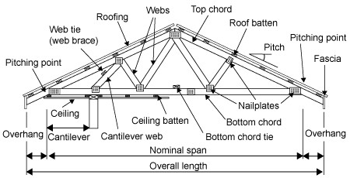

## Erecting Trusses (TS1)

* + 1. Schedule a date to have delivered the pre-fabricated trusses, the handling crane, and installation crew at the job site, at the same time. It is important (cost effective) to have all roof trusses pre-positioned in one day. It is the PM and the Contractor’s responsibility to arrange everything for that day, to find out and obtain anything the installers need, and to remove any obstacle and material from the way.
    2. Drop trusses- bundles in their places. In the placing operation, the trusses are lifted from the delivery truck (or from stock pile) and located in their approximate final position using a proper crane. A crew of three plus a crane operator carry out the work.
    3. During loading, unloading and placing operations, control and safety can be improved by using a long-handled quick-disconnecting clamp, shown in this Figure.



* + 1. If erecting the trusses is not possible and it is necessary to store them in site, stacked trusses should be placed on enough supports to protect them from unsupported long spans and ground moisture. For vertical storage, they should be adequately blocked or braced to prevent toppling. In either case, they should be covered for protection from the elements and adequately ventilated to prevent moisture build up.
    2. Align the pre-positioned trusses. The first end truss is erected and exactly plumbed and braced. Subsequently erected trusses are spaced and squared by means of precut spacer blocks. Every truss should be checked for alignment with a carpenter’s spirit level. Every fourth trusses erected should be plumbed at the center and at both sides (using the layout marks) to assure that accurate alignment is being maintained.



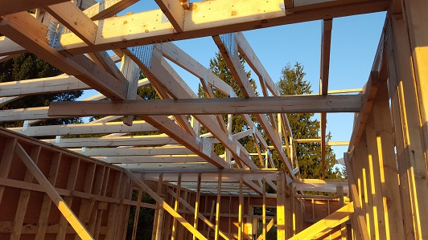

|  |  |  |  |  |  |  |  |  |
| --- | --- | --- | --- | --- | --- | --- | --- | --- |
|  | Checklist 06-1: **Erecting Trusses (TS1)** | | | | | | | |
| MC Development Corp. | | Project: | Contractor: | | | | | |
| **Number** | **Checkpoints** | | | BI | DI | | | AI |
| **1** | DNV permit/inspection approval as required | | |  |  | | |  |
| **Comment** |  | | | | | | | |
| **2** | Review the work with ENGINEER when needed | | |  | |  |  | |
| **Comment** |  | | | | | | | |
| **3** | Layout/ sizes/ and dimensions: per plans | | |  | |  |  | |
| **Comment** |  | | | | | | | |
| **4** | Hangers are used as specified | | |  |  | | |  |
| **Comment** |  | | | | | | | |
| **5** | Trusses delivery arranged with supplier, crane, and Contractor | | |  |  | | |  |
| **Comment** |  | | | | | | | |
| **6** | Proper space for crane to easily move and deliver materials | | |  |  | | |  |
| **Comment** |  | | | | | | | |
| **7** | Double check all layouts marked on Top Plates | | |  |  | | |  |
| **Comment** |  | | | | | | | |
| **8** | Check all additional members (rafters, joists, and so on) for any deficiencies and required corrective actions | | |  |  | | |  |
| **Comment** |  | | | | | | | |
| **9** | The truss-bundles delivery and erection done **SAFELY** | | |  |  | | |  |
| **Comment** |  | | | | | | | |
| **Quality Scores and Completion Sign-off** | | | | | | | | |
| **Inspection#**  Quality 5 4 3 2 1 Notes:  On-Time 5 4 3 2 1 Notes:  Sign and date*: Cell # / ID #: Signed: Date:  Task has been verified complete and in compliance with contract drawings and specifications except for non-conformances and incomplete items reported above. | | | | | | | | |
| **BI=** Inspection **B**efore task begin **-----------DI=** Inspection **D**uring task in-process --------**AI=** Inspection **A**fter task completed  *Quality Score**5 = 100% NO problems 4 = 1 minor problems 3 = Hotspot or 2-3 minor 2 = 6+ or major problems 1 = Excessive problems*  ***On-Time Score*** *5 = On Time 4 = Late 3 = Late by 1 day 2 = Late by 2 days 1 = Late more than 2 days*  ***Safety Score*** *5 = 100% NO problems 4 = 1 minor problem 3 = Hotspot or 2-3 minor 2= 4+ or major problem 1= Injury* | | | | | | | | |

## Roof Sheathing (TS2)

Before you begin:

* Make sure all trusses are anchored and permanently braced.
* Double check rough window-well and ventilation opening dimensions for accuracy, vent exhaust air from kitchens, baths, and laundry to the outdoors with vent pipes that run through the roof cavity or attic to roof ventilators. Do not vent exhaust air directly into roof cavity or attic.
* Always check for a level nailing surface. This can be done with a straight piece of lumber (6 feet to 10 feet long) or a long carpenter’s level. Trusses or rafters should be shimmed as necessary to provide a level nailing surface. If the top chords of trusses or rafters are warped or bowed, install blocking to straighten.

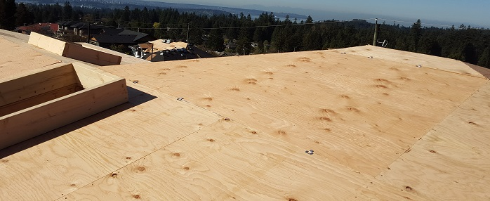

* + 1. Install baffles providing a minimum of 1 inch of clear space between framing and/or under roof sheathing at eaves to ensure that ceiling or roof insulation does not block ventilation paths. For vaulted or cathedral roof construction, provide a free ventilation path from eaves to ridge between all rafters.
    2. Sheathing is installed lengthwise, starting at the bottom corner, and moving across the bottom first. When moving up to the next row, begin at the same end with a half sheet of sheathing, so that the sheathing is staggered. Always join panels over supports, and ensure that panels are one-eighth of an inch apart. Repeat for both sides of the roof.
    3. To fasten the sheathing to the frame, use 8D common (0.131-inch by 2-1/2-inch) nails or deformed shank nails, on center at supported panel ends and edges. Fasteners should be three-eighths of an inch from the edges. Fasteners should be spaced six inches apart around the edges of each panel, and 12 inches apart within each panel.
    4. On panels with a screened surface or skid-resistant coating, install panels with the non-skid surface up.
    5. Other Fastening hints:
  1. Position panel and use temporary fasteners at corners if needed to square panel on framing.
  2. Install fasteners at one panel end.
  3. Remove temporary fasteners at corners.
  4. Install intermediate fasteners, starting at panel edge. Use a chalk line or straight edge to align fasteners on framing. Fasten panels in rows across the width, continuing this sequence along the length of the panel. This procedure keeps internal stress from accumulating in panels.
  5. Stand on the panel over the framing near the fastener location to ensure contact with framing while driving fasteners. Fasteners should be driven flush with the panel surface. Avoid standing between framing, which can induce panel deflection.
  6. For improved performance, consider thicker roof sheathing panels, panel edge clips, or panels with tongue-and-groove edges.
  7. A 1/8-inch space between adjacent panel end and edge joints is recommended, unless the panel manufacturer indicates otherwise. Check building code requirements for installation of panel edge clips. Edge clip requirements depend on the relationship of the panel Span Rating to the actual distance between roof framing.

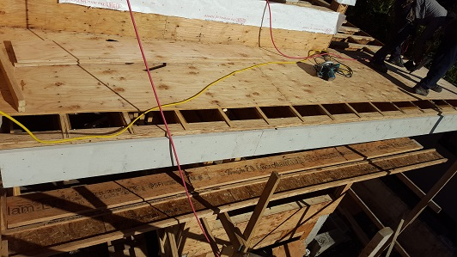

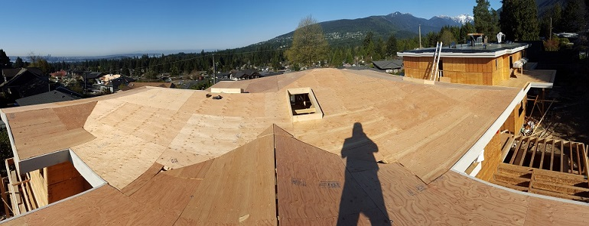

|  |  |  |  |  |  |  |  |  |
| --- | --- | --- | --- | --- | --- | --- | --- | --- |
|  | Checklist 06-2: **Roof Sheathing (TS2)** | | | | | | | |
| MC Development Corp. | | Project: | Contractor: | | | | | |
| **Number** | **Checkpoints** | | | BI | DI | | | AI |
| **1** | Status of previous TS inspections are approved by the PM/DNV | | |  |  | | |  |
| **Comment** |  | | | | | | | |
| **2** | Are the defected top chords of trusses/rafters corrected by blocking installation? | | |  | |  |  | |
| **Comment** |  | | | | | | | |
| **3** | All required openings cut before insulation? | | |  | |  |  | |
| **Comment** |  | | | | | | | |
| **4** | Roof nailed off according to project specifications? | | |  |  | | |  |
| **Comment** |  | | | | | | | |
| **5** | Double check window-well and ventilation opening dimensions | | |  |  | | |  |
| **Comment** |  | | | | | | | |
| **6** | Smooth nailing surface on top of the trusses? | | |  |  | | |  |
| **Comment** |  | | | | | | | |
| **7** | Baffles installed? a minimum of 1 inch of clear space between framing and/or under roof sheathing at eaves? | | |  |  | | |  |
| **Comment** |  | | | | | | | |
| **8** | Sheathing has a correct layout and 1/8” space between panels? | | |  |  | | |  |
| **Comment** |  | | | | | | | |
| **Quality Scores and Completion Sign-off** | | | | | | | | |
| **Inspection#**  Quality 5 4 3 2 1 Notes:  On-Time 5 4 3 2 1 Notes:  Sign and date*: Cell # / ID #: Signed: Date:  Task has been verified complete and in compliance with contract drawings and specifications except for non-conformances and incomplete items reported above. | | | | | | | | |
| **BI=** Inspection **B**efore task begin **-----------DI=** Inspection **D**uring task in-process --------**AI=** Inspection **A**fter task completed  *Quality Score**5 = 100% NO problems 4 = 1 minor problems 3 = Hotspot or 2-3 minor 2 = 6+ or major problems 1 = Excessive problems*  ***On-Time Score*** *5 = On Time 4 = Late 3 = Late by 1 day 2 = Late by 2 days 1 = Late more than 2 days*  ***Safety Score*** *5 = 100% NO problems 4 = 1 minor problem 3 = Hotspot or 2-3 minor 2= 4+ or major problem 1= Injury* | | | | | | | | |

# Quality Assurance Approval

Only if all 6 required Inspections, associated with 2 TS Checklists mentioned in this WM, are approved by the PM and the CM as OK, the PM will carry out the final Inspection and issues the written approval if the results are OK.

If the results do not match the allowable tolerances, the PM will communicate this issue to the CM who evaluates the NCs and issues instructions for the corrective actions to be taken.

Any non-conformance shall be reported through the NCR procedure described in MCDC’s QP and is applicable to any and all phases of Roof Framing.

# References

1. The Handouts and QMS sample documents provided by Mr. Jim Turnham (CMGT-7246)
2. Based on Behrouz Chehrehpardaz work experience
3. All pictures are taken during MCDC’s last project at 4438 Ranger Ave, North Vancouver
4. BC Building Code
5. WorkSafeBC Regulations
6. DNV Bylaws

# Construction Organization Chart

MCDC Board of Directors

Construct Manager/CEO

Project Manager

Site Super Intendent

Trade Contractor

# Flow Chart

Contract

Specs

Dwgs

WM/ITP

QP

END

Pre-Work WM Review Meeting

Certificate of Completion

NCP

Corrective Action

Initial Inspection

NO YES

Final Inspection

Passed?

NO/NCP

Inspection

Passed?

YES

Erecting Trusses

NO/NCP

(BI & DI & AI) Inspections

Passed?

YES YES

(BI & DI & AI) Inspections

Passed?

Roof Sheathing

NO/NCP

# Inspection and Test Plan

|  |  |  |  |  |  |  |  |  |  |  |
| --- | --- | --- | --- | --- | --- | --- | --- | --- | --- | --- |
| MC Development Corp | | Inspection and Test Plan # 06  **Roof Framing** | | | PM: MCDC Project Manager  C: Contractor | | | | | |
| Contractor: | | | Project: | | | | | |
| **#** | **Inspections** | **To Inspect Items listed in** | **Time of Inspection** | **QC**  **by** | **Acceptance Criteria** | **H/W/D** | | **Score &**  **(lowest)** | **Initials** | **Date** |
| 1 | Initial Inspection | QMP004b | Prior to any work | C | CM approval | H |  |  |  |  |
| 2 | Trusses BI | Checklist 06-1 | Prior to TS1 | C | PM Approval |  |  |  |  |  |
| 3 | Trusses DI | Checklist 06-1 | During TS1 | C | PM Approval |  |  |  |  |  |
| 4 | Trusses AI | Checklist 06-1 | After TS1 | C | PM Approval |  |  |  |  |  |
| 5 | Sheathing BI | Checklist 06-2 | Prior to TS2 | C | PM Approval |  |  |  |  |  |
| 6 | Sheathing DI | Checklist 06-2 | During TS2 | C | PM Approval |  |  |  |  |  |
| 7 | Sheathing AI | Checklist 06-2 | After TS2 | C | PM Approval |  |  |  |  |  |
| 23 | Final Inspection | List of NCs | After Completion | PM | CM Approval |  |  |  |  |  |
| ITP Accepted by ……………………… Signature ……………………………… Date ……………. | | | | | | | | | | |
| **(BI**: Inspection Before Task Begin----**DI**: Inspection During Task Work----**AI**: Inspection After Task Finished)  **(W**: Witnessed by CM---- **H**: Hold further work----**D**: Document) | | | | | | | | | | |