**Work Method 05- Framing**

(WM05-MCDC Template)

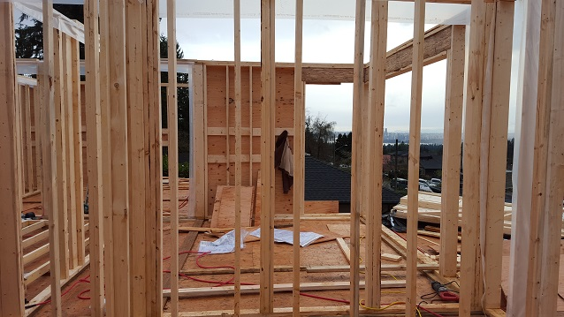

**Industry Based Project (CMGT 8800)**

**September 20, 2018**

**BCIT**

Faculty Advisor: Jim Turnham, P. Eng, MASc., ISO 9001 Lead Auditor

Prepared by: Behrouz Chehrehpardaz

Table of Contents

2. SIGNATURE PAGE 3

3. Proponent and Project Description 4

4. PURPOSE and SCOPE 5

5. DEFINITIONS 5

6. RESPONSIBILITIES 6

7. SAFETY AND ENVIRONMENT 7

8. SUBMITTALS 8

9. PROCEDURE 9

9.1. General Requirements 9

9.2. Material Selection (TS0) 10

9.3. Place Foundations Sill Plates (TS1) 12

9.4. Install Floor Joist (TS2) 15

9.5. Install the Floor Sheathing (TS3) 18

9.6. Framing Exterior Walls (TS4) 21

9.7. Sheathing Walls (TS5) 26

9.8. Standing and Bracing Walls (TS6) 29

10. Quality Assurance Approval 32

11. References 32

12. Construction Organization Chart 33

13. Flow Chart 34

14. Inspection and Test Plan 35

# SIGNATURE PAGE

As an Approver, with my signature, I confirm that this Work Method is the plan for construction of the work. If the plan changes, I will inform the Originator so that the Work Method can be revised. Alternately, I will make revisions myself and reissue to those that require copies.

As a Reviewer, my signature confirms that I have reviewed the document and any comments to the WM have been provided to the Originator and/or to the Approver.

MCDC Construction Manager

Name: Date: ____ __ Title: _____________________ Signature: _________________

MCDC Project Manager

Name: Date: ____ __ Title: _____________________ Signature:_________________

Contractor

Name: Date: ____ __ Title: _____________________ Signature: _________________

Initial Reviewer

Name: Date: Title: Signature:

# Proponent and Project Description

**Company Name:** MC DEVELOPMENT CORP. (MCDC)

**Company type of service:** MCDC is a small construction company building Single Family Houses (SFHs) in North Vancouver, and the company’s vision is to be recognized as a model of quality excellence in construction.

**Project Description:** Under a Project Management/Design Build method, MCDC itself or on behalf of the owners manages construction projects to build new single-family houses mostly in North Vancouver.

MCDC contract out all work activities in construction stage including building Framing.

**Work Method Activity Description:** This Work Method (WM) provides the required details of how the framing work processes are carried out, and it is also subject to a series of inspections, before the commencement, during the work, and after completion.

This Work Method will be used in order to ensure full compliance with MCDC’s quality policy and Quality Plan, drawings, specifications, and BC Building Codes.

**Work Method Scope:** This work method shall apply to carrying out all works related to Framing procedures within the scope of the MCDC’s construction drawings provided, including the drawings and specifications.

**Limitation of liability:** Any organization engaged as a Contractor or Subcontractor (the Contractor) agrees to use this Work Method only under the condition that those that wrote and developed this Work Method are to be held harmless for any errors or omissions, any inaccuracies in content resulting in any damages to property or any injury to any personnel that may be involved. It remains the sole responsibility of the Contractor to review any and all items contained in the above Work Method and to make any changes that may be required in order to satisfy any project specification or any regulatory or statutory obligation. As well, the Contractor shall review any and all suggested methods as contained herein and shall make any changes required and shall reissue prior to commencement of construction in order to achieve the specified product or to provide a safe work site for all workers involved. Ownership and final responsibility for the use of all Work Methods remains with the Contractor.

# PURPOSE and SCOPE

**Purpose**: To define the responsibilities, describe methods and documentation to be used for carrying out the framing work in MCDC’s SFH projects.

**Scope**: This work method applies to all activities required for erecting the framing structure at (the address of the project). Reference Standards include:

* British Columbia (or applicable province) Building Code 2012.

Note: Construction documents (design drawings and specifications) should be referenced as applicable and will govern over any procedure included in this document.

# DEFINITIONS

MCDC - MC Development Corp.

CM - MCDC’s Construction Manager

PM - MCDC’s Project Manager

QC - Quality Control

WM - Work Method (this document)

WP **-** Work Procedure

TS - Task Step

CL - Checklist

RM - Review Meeting

NCP - Nonconformity Procedure

ITP - Inspection and Test Plan

BI - Before the TS Inspection

DI - During the TS Inspection

AI – After the TS Inspection

DNV - District of North Vancouver

SWP – Safe Work Practice

SWRB – Solid Waste Removal Bylaw (DNV)

# RESPONSIBILITIES

* 1. **Construction Manager (CM)** is responsible for project scheduling, and final approving the inspections, tests, and changes. The CM is also responsible for preparation of drawings and sketches to support construction as required and all making any changes if required.
  2. **Project Manager (PM)** is responsible for; identifying necessary resources and assigning individual responsibilities to run and monitor the quality control procedure that defined by MCDC’s QP and this WM. He is responsible for overseeing the Quality Management Plan, enforcing project construction standards, assisting the CM in the creation of work method documents by providing appropriate sequence and task definitions, executing the project, scheduling and delegation of the roles of quality control inspections, safety, environmental items and Contractor coordination.
  3. The PM is accountable for the Site Superintendent’s all responsibilities as well. The PM, for each WM contemplated for use at the site, provides a review and makes changes if necessary to any clause so that it is consistent with best practice, consistent with the building code of the Province, and consistent with local conditions. Issues should be reviewed by email with the CM.
  4. **Site Superintendent** must work well with people and is responsible for:
  + Requesting copies of subcontractor’s liability insurance and workmen’s compensation certificate.
  + Overall site activities; applying project methodology and enforcing project construction standards; organizing field staff and ensuring they perform as required; and supervising Contractors and ensuring they perform as required
  + Assisting the PM and the Contractors in the creation and execution of work plans including revisions to these plans as necessary.
  + Assisting the PM in supervision of Contractors’ work quality.
  + Working closely with and support the Contractor to identify potential risks/opportunities, discuss necessary changes, and conduct the inspections.
  + Scheduling and monitoring each workday with appropriately resources.
  + Serving as the representative of and primary contact with the PM.
  + Attending review meetings.
  + Maintaining site logs and other documents in jobsite.
  + Ensuring the jobsite safety and ensuring that safety practices are followed.
  1. **Trade Contractor** (Contractor) refers to the company that is bound by contract to MCDC for a certain scope of work. For their scope, the Contractor is responsible for environmental control, safety controls, and quality control for self-performed work. The Contractor is responsible to write his/her Work Methods. However, if the Contractor cannot provide the required WMs, MCDC may assist, but the final WM will be reviewed, changes made to reflect project requirements, codes, laws, and resubmitted to MCDC and owned by the Contractor. The Contractor performs the work required by the contract documents and approved Work Methods to start and complete the Project and fulfill everything indicated by the contract documents. The Contractor shall perform activities described in this WM. If any revision is needed, the Contractor shall be instructed to revise and update this WM so that the WM reflects the intent and methods of the Contractor as well. The Contractor shall be fully responsible for his means and methods, and for the content of the revised WM. The Contractor shall assign a representative who will permanently attend at the job site when the job is being done. The Site Manager or the Contractor’s site representative shall ensure following the guidelines and/or Standard Specifications outline on this work method.

# SAFETY AND ENVIRONMENT

All construction activities and job procedures shall conform to

* WCB Regulations and other applicable codes, regulations and acts
* DNV Street and Traffic Bylaw (Bylaw 7125)
* DNV Noise Regulation Bylaw (Bylaw 7188)
* DNV Environmental Protection and Preservation Bylaw (Bylaw 6515)

Before any work takes place, the PM and Site Superintendent will ensure that all operators, laborers, and Contractors have been site orientated.

Framing procedures must comply with safe practices and with the requirements of the bylaw, codes and ordinances.

All work process shall be fully consistent to DNV Bylaws. Everyone working in MCDC’s site must implement safe and practical working practices, and if anyone is unsure of the safest work method to implement then should seek guidance.

# SUBMITTALS

The contractor submittals to MCDC:

* Along with the Quotation, the Contactors will provide
  + Contract price and time (including the start time of work on site)
  + Declaration of accepting all contract terms and documents
  + Written promise to provide the required submittals along with the contract
  + Documented processes and submittals to enable the PM review
  + Contractor’s Work Method, Checklists, and ITP for MCDC review
* The final revision of MCDC QP reviewed and confirmed by the Contractor
* A report that identifies the Self inspection result and scope of work, after each inspection

All contractor submittals are stated in the Contract and include (but not limited to)

* Marking materials, measuring stick, and measuring tape
* All framing materials
* Nails and Fasteners
* Trusses
* Anchors
* Steel Connectors

# PROCEDURE

## General Requirements

Consult the specifications and construction drawings to determine the requirements for any aspect of the work. This Work Method is a guideline used by MCDC to describe the work process and the process of quality control by conducting the specific Inspections and relevant Checklists. The Drawings, and Specifications as well as any code and by-law are the ultimate requirements. The PM and the Contractor shall review the Work Method and make any revision (prior to each use if necessary) so that any requirements will be identified and met.

The following Task Steps (procedures) TSs are included in this Work Method:

* Material Selection (TS0)
* Place Foundations Sill Plates (TS1)
* Install Floor Joist (TS2)
* Install Floor Sheathing (TS3)
* Framing Exterior Walls (TS4)
* Sheathing Walls (TS5)
* Standing and Bracing Walls (TS6)

Each TS comes with a Checklist and each Checklist is subject to three Inspections, before, during, and after completion of the TS. Each Checklist includes several checkpoints which must be controlled and verified by the MCDC’s PM or Site Superintendent. To continue the work and proceed to next step, the Contractor must obtain the approval of PM for all Inspections. The PM will give the approval only if all Checklist’s items are checked and passed.

The Inspections and Testing shall follow the instructions described in the Inspection and Testing Plan number 05(ITP05). The PM shall review the results of the ITP and Checklists and check if the results are acceptable. The PM will communicate the acceptable results to the CM and if the results are not acceptable, the PM will communicate this issue to the CM and the Contractor to evaluate the default and issue instructions for the corrective actions.

## Material Selection (TS0)

All material submittals will be handled by the Site Superintendent. Once material is on-site it must be on a level surface, covered, and out of the way of general walking routes and working areas. There will be 14-foot lengths of lumber, and studs on-site.

First, the lumbers will be sighted for crown(crook), and marked on both faces of the piece. Sort the 14-foot pieces into three categories. The best, second best, and third best. The best will be used for top and bottom plates for the walls. Second best will be used in openings, and shorter walls. The third best will be used to cut into shorter pieces. After, the studs will be handled in the same fashion as the 14-foot lengths creating three piles which are ranked for quality, first, second, and third. The first ranked studs will be used for all wall partitions and openings. Second, will be used as filler studs between the openings. Finally, the third ranked studs will be used to cut shorter jack studs. The following figure shows the material defects:

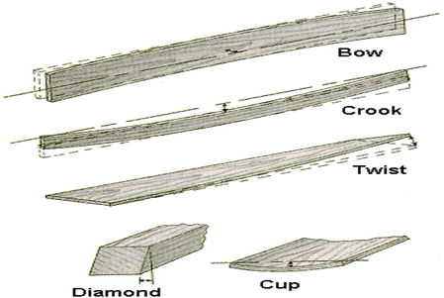

|  |  |  |  |  |  |  |  |  |
| --- | --- | --- | --- | --- | --- | --- | --- | --- |
|  | Checklist 05-0: **Material Selection (TS0)** | | | | | | | |
| MC Development Corp. | | Project: | Contractor: | | | | | |
| **Number** | **Checkpoints** | | | BI | DI | | | AI |
| **1** | are the quality and ranking of the lumbers/suppliers specified? | | |  |  | | |  |
| **Comment** |  | | | | | | | |
| **2** | A proper space (leveled surface) to unload the materials in site? | | |  | |  |  | |
| **Comment** |  | | | | | | | |
| **3** | The stocked materials are protected from rain and water | | |  | |  |  | |
| **Comment** |  | | | | | | | |
| **4** | All materials are sighted for crown(crook), and marked on both faces of the piece for any defect. | | |  |  | | |  |
| **Comment** |  | | | | | | | |
| **5** | Are the lumbers and studs sorted according to the defects? (3 categories) | | |  |  | | |  |
| **Comment** |  | | | | | | | |
| **6** |  | | |  |  | | |  |
| **Comment** |  | | | | | | | |
| **7** |  | | |  |  | | |  |
| **Comment** |  | | | | | | | |
| **8** |  | | |  |  | | |  |
| **Comment** |  | | | | | | | |
| **Quality Scores and Completion Sign-off** | | | | | | | | |
| **Inspection#**  Quality 5 4 3 2 1 Notes:  On-Time 5 4 3 2 1 Notes:  Sign and date*: Cell # / ID #: Signed: Date:  Task has been verified complete and in compliance with contract drawings and specifications except for non-conformances and incomplete items reported above. | | | | | | | | |
| **BI=** Inspection **B**efore task begin **-----------DI=** Inspection **D**uring task in-process --------**AI=** Inspection **A**fter task completed  *Quality Score**5 = 100% NO problems 4 = 1 minor problems 3 = Hotspot or 2-3 minor 2 = 6+ or major problems 1 = Excessive problems*  ***On-Time Score*** *5 = On Time 4 = Late 3 = Late by 1 day 2 = Late by 2 days 1 = Late more than 2 days*  ***Safety Score*** *5 = 100% NO problems 4 = 1 minor problem 3 = Hotspot or 2-3 minor 2= 4+ or major problem 1= Injury* | | | | | | | | |

## Place Foundations Sill Plates (TS1)

Before you begin:

* Make note and inform supervisor of any honey combing in the concrete that should be repaired.
* Make sure wall marking on foundation walls have been completed according to the drawings.
* Check overall square of the floor/concrete foundation that is been worked off of. The goal is to get square to within 1/8” everywhere. Check all corners of the building, and adjust in or out if necessary.
* Once all walls are square to each other then check parallel. If all the corners established are true and square the parallel should be accurate as well. If not, go back to 10.1.1 and recheck. Once square and parallel are established chalk-line in between the marks to indicate wall locations (inside of wall location) over all exterior walls.
* Check the level of the floor/concrete foundation with a builder’s level every 4 feet, at every wall junction, and all corners. Tolerable deviations at 4 foot intervals is 1/8”. From absolute high spot on the building to absolute low spot over the entire building should be within ¼”, dependant on the square footage. While measuring heights mark down on sighting locations any deviations. This will allow any height deviations to be recorded and will enable the wall builder to make adjustments to their stud lengths to accommodate.
  + 1. Lay a 2x4 (sill plate) flat on top the foundation wall with the edge along the wall marking. Using the wall markings as your reference point, mark the bolt locations longitudinally and transversely onto the sill plate making a cross hair. Sill plate should meet local codes, and in some cases Pressure Treated wood (PT) is required.
    2. Drill holes at least 1/8” wider than the anchor bolts at each cross hair previously marked. (Drill a 3/4" hole for a 5/8” bolt).
    3. Place sill gasket on top of foundation so that the sill plate is not in directly contact with concrete. Use the wall marking as a guide for the sill gasket placement.
    4. Drop sill plate on top of the foundation wall directly on top of sill gasket.
    5. Place a washer and nut on each anchor bolt to secure the sill plate in place. Avoid countersinking the washers to maintain the integrity of the sill plate.

Sill Gasket

Anchor Bolts

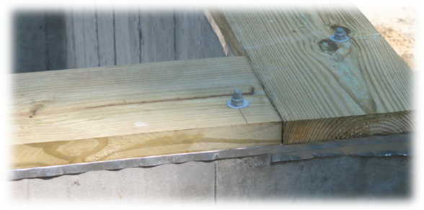

Bottom Sill Plate

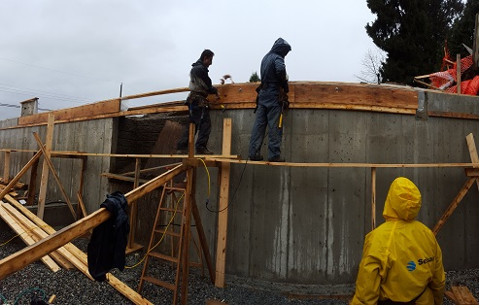

|  |  |  |  |  |  |  |  |  |
| --- | --- | --- | --- | --- | --- | --- | --- | --- |
|  | Checklist 05-1: **Place Foundations Sill Plates (TS1)** | | | | | | | |
| MC Development Corp. | | Project: | Contractor: | | | | | |
| **Number** | **Checkpoints** | | | BI | DI | | | AI |
| **1** | DNV permit/inspection approval as required | | |  |  | | |  |
| **Comment** |  | | | | | | | |
| **2** | Review the work with ENGINEER when needed | | |  | |  |  | |
| **Comment** |  | | | | | | | |
| **3** | Elevations checked with the architectural plans and specifications | | |  | |  |  | |
| **Comment** |  | | | | | | | |
| **4** | Holes drilled in 2x4 1/8” wider than the anchor bolts? | | |  |  | | |  |
| **Comment** |  | | | | | | | |
| **5** | Sill gasket between concrete and sill plate? | | |  |  | | |  |
| **Comment** |  | | | | | | | |
| **6** | Sill plate lined up with wall marking? | | |  |  | | |  |
| **Comment** |  | | | | | | | |
| **7** | Nut and washers fit tight, but not countersunk? | | |  |  | | |  |
| **Comment** |  | | | | | | | |
| **8** |  | | |  |  | | |  |
| **Comment** |  | | | | | | | |
| **9** |  | | |  |  | | |  |
| **Comment** |  | | | | | | | |
| **Quality Scores and Completion Sign-off** | | | | | | | | |
| **Inspection#**  Quality 5 4 3 2 1 Notes:  On-Time 5 4 3 2 1 Notes:  Sign and date*: Cell # / ID #: Signed: Date:  Task has been verified complete and in compliance with contract drawings and specifications except for non-conformances and incomplete items reported above. | | | | | | | | |
| **BI=** Inspection **B**efore task begin **-----------DI=** Inspection **D**uring task in-process --------**AI=** Inspection **A**fter task completed  *Quality Score**5 = 100% NO problems 4 = 1 minor problems 3 = Hotspot or 2-3 minor 2 = 6+ or major problems 1 = Excessive problems*  ***On-Time Score*** *5 = On Time 4 = Late 3 = Late by 1 day 2 = Late by 2 days 1 = Late more than 2 days*  ***Safety Score*** *5 = 100% NO problems 4 = 1 minor problem 3 = Hotspot or 2-3 minor 2= 4+ or major problem 1= Injury* | | | | | | | | |

## Install Floor Joist (TS2)

Before you begin:

* If there are walls below the floor joists, make sure all walls are properly plumbed and braced.
* Ensure floor joist meets structural specifications for size.
* If using engineered floor joist, installation must be according to manufacturer specifications and engineered layout.
  + 1. Mark the location of the joists (and beams if applicable) according to the structural spacing specifications, noting openings for stairwells, as well as toilet and tub drains.
    2. Cut all floor joists to length and lay them flat in position, and label the crown (crest) in the joist to be referenced when standing the joists.
    3. Nail the joists into both the top plate and the rim joist (see picture below) with the crown (crest) of the joist facing up.

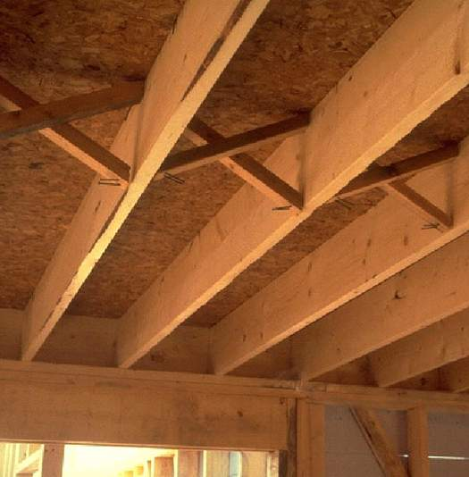

Joists

Bracing or bridging (solid blocking could be substituted)

Rim joist

Top plate, should typically be double

* + 1. Make sure all joists are parallel to each other and correct any deviations or mistakes.
    2. Install extra blocking for load bearing walls and point loads according to the structural specifications.
    3. Install any bridging that is required between joists.

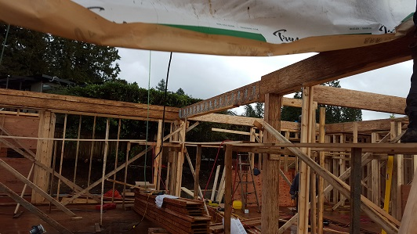

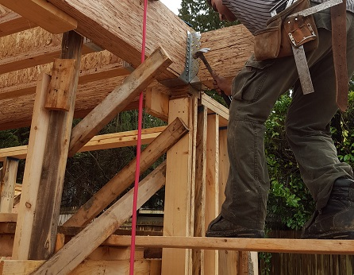

|  |  |  |  |  |  |  |  |  |
| --- | --- | --- | --- | --- | --- | --- | --- | --- |
|  | Checklist 05-2: **Install Floor Joist (TS2)** | | | | | | | |
| MC Development Corp. | | Project: | Contractor: | | | | | |
| **Number** | **Checkpoints** | | | BI | DI | | | AI |
| **1** | Status of previous TS inspections are approved by the PM/DNV | | |  |  | | |  |
| **Comment** |  | | | | | | | |
| **2** |  | | |  | |  |  | |
| **Comment** |  | | | | | | | |
| **3** | Joist spacing meets the project specifications? | | |  | |  |  | |
| **Comment** |  | | | | | | | |
| **4** | Openings left for stairwells, toilets, and tub drains? | | |  |  | | |  |
| **Comment** |  | | | | | | | |
| **5** | Joists labelled according to the direction of the crown? | | |  |  | | |  |
| **Comment** |  | | | | | | | |
| **6** | Joists nailed to the top plate and the rim joist? | | |  |  | | |  |
| **Comment** |  | | | | | | | |
| **7** | All joists running parallel to each other (no accidental offsets?) | | |  |  | | |  |
| **Comment** |  | | | | | | | |
| **8** | Blocking installed for load bearing walls and points loads? | | |  |  | | |  |
| **Comment** |  | | | | | | | |
| **9** | Bridging blocks installed? | | |  |  | | |  |
| **Comment** |  | | | | | | | |
|  |  | | | | | | | |
| **Quality Scores and Completion Sign-off** | | | | | | | | |
| **Inspection#**  Quality 5 4 3 2 1 Notes:  On-Time 5 4 3 2 1 Notes:  Sign and date*: Cell # / ID #: Signed: Date:  Task has been verified complete and in compliance with contract drawings and specifications except for non-conformances and incomplete items reported above. | | | | | | | | |
| **BI=** Inspection **B**efore task begin **-----------DI=** Inspection **D**uring task in-process --------**AI=** Inspection **A**fter task completed  *Quality Score**5 = 100% NO problems 4 = 1 minor problems 3 = Hotspot or 2-3 minor 2 = 6+ or major problems 1 = Excessive problems*  ***On-Time Score*** *5 = On Time 4 = Late 3 = Late by 1 day 2 = Late by 2 days 1 = Late more than 2 days*  ***Safety Score*** *5 = 100% NO problems 4 = 1 minor problem 3 = Hotspot or 2-3 minor 2= 4+ or major problem 1= Injury* | | | | | | | | |

## Install the Floor Sheathing (TS3)

Before you begin:

* Make sure all blocks, point loads, and bridging are installed in the floor.
  + 1. Snap a chalk line across the joists from one end of the building to the other to mark the location where the first row of floor sheathing will be placed. In an effort to ensure a safe installation, place a temporary walk board or scattered loose floor sheathing approximately five feet in from rim joist. This will provide a safe surface to walk on while chalking lines, applying adhesive and placing first row of sheathing.
    2. Starting from one end of the building, apply sub floor adhesive to the top of joists where the floor sheathing will be placed. Stop the glue line 2” from the chalk line. DO NOT glue the end joists. They need to remain movable for squaring the building off once all sheets have been laid.
    3. Drop the sheaths in place ensuring the correct side is down (the floor sheathing will say “this side down”). The tongue in the sheet faces the outside of the building (in most cases), and the groove will be positioned to accept the next row of sheathing. Align the sheaths to the chalk line.
    4. Cut the sheathing as required, to ensure any joints land on the centre of the joist.
    5. Fasten the sheath in place with two 2 ¼’ nails at each end.
    6. Continue steps 2-5 until the entire row of sheathing has been fastened in place.
    7. Once the entire row of sheathing has been laid, mark the location of each joist onto the grooved edge of the sheathing for the entire row. Correct any bows in the joists when nailing.
    8. Check the structural specifications for nailing pattern and nail off the row of sheathing.
    9. Use the cut off sheath from the last placed sheath of the row to start the next row of sheathing if it is large enough. Sheaths must have at least a 2’ overlap between rows.
    10. Continue through steps 2-9 until the entire floor has been sheathed.

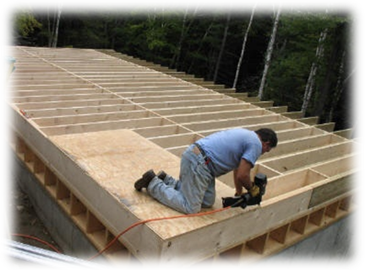

Sheathing

Joists

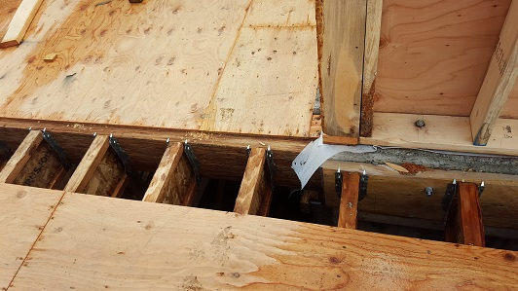

|  |  |  |  |  |  |  |  |  |
| --- | --- | --- | --- | --- | --- | --- | --- | --- |
|  | Checklist 05-3: **Install the Floor Sheathing (TS3)** | | | | | | | |
| MC Development Corp. | | Project: | Contractor: | | | | | |
| **Number** | **Checkpoints** | | | BI | DI | | | AI |
| **1** | Status of previous TS inspections are approved by the PM/DNV | | |  |  | | |  |
| **Comment** |  | | | | | | | |
| **2** | All sheaths placed with “this side down” side facing down? | | |  | |  |  | |
| **Comment** |  | | | | | | | |
| **3** | Tongues fit in groove of previous sheaths? | | |  | |  |  | |
| **Comment** |  | | | | | | | |
| **4** | Sheath edges land on joists? | | |  |  | | |  |
| **Comment** |  | | | | | | | |
| **5** | Bows in joists corrected before sheathing is nailed off? | | |  |  | | |  |
| **Comment** |  | | | | | | | |
| **6** | Sheathing nailed according to structural specifications? | | |  |  | | |  |
| **Comment** |  | | | | | | | |
| **7** | Cut-off pieces used to ensure efficient use of material? | | |  |  | | |  |
| **Comment** |  | | | | | | | |
| **8** |  | | |  |  | | |  |
| **Comment** |  | | | | | | | |
| **9** |  | | |  |  | | |  |
| **Comment** |  | | | | | | | |
|  |  | | | | | | | |
| **Quality Scores and Completion Sign-off** | | | | | | | | |
| **Inspection#**  Quality 5 4 3 2 1 Notes:  On-Time 5 4 3 2 1 Notes:  Sign and date*: Cell # / ID #: Signed: Date:  Task has been verified complete and in compliance with contract drawings and specifications except for non-conformances and incomplete items reported above. | | | | | | | | |
| **BI=** Inspection **B**efore task begin **-----------DI=** Inspection **D**uring task in-process --------**AI=** Inspection **A**fter task completed  *Quality Score**5 = 100% NO problems 4 = 1 minor problems 3 = Hotspot or 2-3 minor 2 = 6+ or major problems 1 = Excessive problems*  ***On-Time Score*** *5 = On Time 4 = Late 3 = Late by 1 day 2 = Late by 2 days 1 = Late more than 2 days*  ***Safety Score*** *5 = 100% NO problems 4 = 1 minor problem 3 = Hotspot or 2-3 minor 2= 4+ or major problem 1= Injury* | | | | | | | | |

## Framing Exterior Walls (TS4)

Before you begin:

* Make sure wall plates have been completely marked by the layout worker.
* The layout worker will have cut, positioned and marked the top and bottom plates.
  + 1. Lay both the bottom and top plate of the wall on the floor. Space the plates 8’ (or as specs mention) apart from each other; this will allow you enough room to spread all wall components between the plates.
    2. For each window and door opening, the layout worker will have written down the lengths for the framing components on the bottom plate. For each window location, cut the lengths, according to the information given, and label each component. If proper components have been previously cut, retrieve from stockpile.
    3. Position all studs in place, as marked on the layout.
    4. Assemble door and window framing components first using framing nails.
    5. Once door and window framing components are assembled (in location) install remaining studs by driving two framing nails through the bottom & top plate into the stud.
    6. Cut the double top plate noting marked setbacks and overlaps for the double plate at corners and wall partitions.
    7. Install any required fire-blocking as marked on layout.
    8. The wall is now ready to be squared and sheathed.

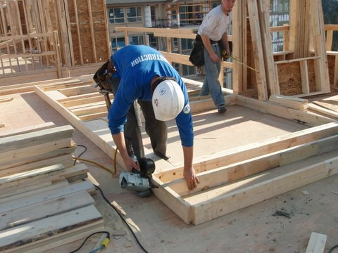

Wall Plates

Studs

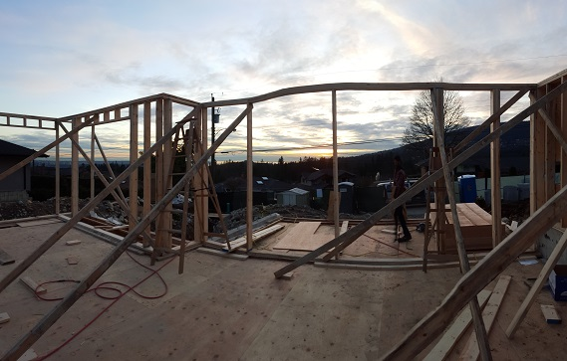

**Note: Wall Components**

The figure below shows all the components to a wall.

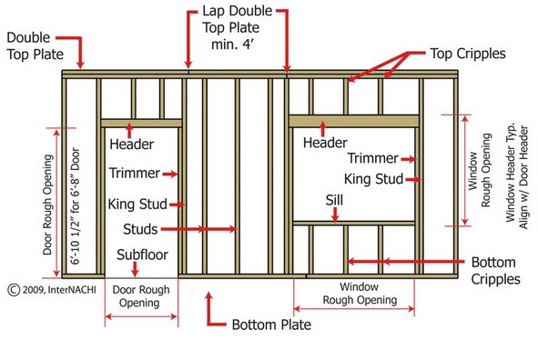

* + - **Headers:** will be cut to the opening plus the depth of the cripples that it is sitting on within a 1/16”. The headers will cut to ensure that the crown is facing up or away from the opening.
    - **Jacks(cripple):** must be cut to within a 1/32”. If there is any wane on the cripple it must be facing away from the opening. Furthermore, if there is any bow to the cripple it must be facing away from the opening. This will ensure that any window or door that will be installed into the opening will not rock or be impeded by the curve of the pieces surrounding the opening.
    - **Sill:** will be cut from the thirds best pieces. Again, if there is any wane or bow on the piece, it will be facing away from the opening.
    - **Cripple(jacks):** The shortest studs in the wall above windows and doors, and below windows. These will be cut from the third best pieces to within a 1/16”.
    - **L’s:** are not shown in the figure but will be used for any connecting wall location. These will be made from two of the first best studs, and must be nailed together ensuring proper flushness across the entire length. Any crown must be facing to the outside of the building, or away from the partitioning wall.

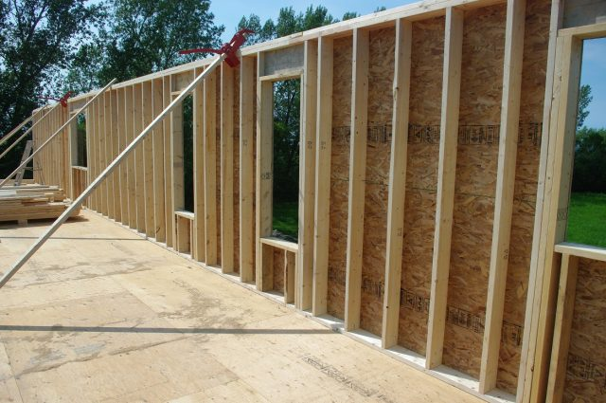

|  |  |  |  |  |  |  |  |  |
| --- | --- | --- | --- | --- | --- | --- | --- | --- |
|  | Checklist 05-4: **Framing Exterior Walls (TS4)** | | | | | | | |
| MC Development Corp. | | Project: | Contractor: | | | | | |
| **Number** | **Checkpoints** | | | BI | DI | | | AI |
| **1** | Status of previous TS inspections are approved by the PM/DNV | | |  |  | | |  |
| **Comment** |  | | | | | | | |
| **2** | All wall components line up with wall markings? | | |  |  | | |  |
| **Comment** |  | | | | | | | |
| **3** | All wall components secured with framing nails? | | |  | |  |  | |
| **Comment** |  | | | | | | | |
| **4** | Window and door openings checked for size? | | |  | |  |  | |
| **Comment** |  | | | | | | | |
| **5** | Double top plate cut for setbacks and overlaps? | | |  |  | | |  |
| **Comment** |  | | | | | | | |
| **6** |  | | |  |  | | |  |
| **Comment** |  | | | | | | | |
| **7** |  | | |  |  | | |  |
| **Comment** |  | | | | | | | |
| **8** |  | | |  |  | | |  |
| **Comment** |  | | | | | | | |
| **9** |  | | |  |  | | |  |
| **Comment** |  | | | | | | | |
| **10** |  | | |  |  | | |  |
| **Comment** |  | | | | | | | |
| **Quality Scores and Completion Sign-off** | | | | | | | | |
| **Inspection#**  Quality 5 4 3 2 1 Notes:  On-Time 5 4 3 2 1 Notes:  Sign and date*: Cell # / ID #: Signed: Date:  Task has been verified complete and in compliance with contract drawings and specifications except for non-conformances and incomplete items reported above. | | | | | | | | |
| **BI=** Inspection **B**efore task begin **-----------DI=** Inspection **D**uring task in-process --------**AI=** Inspection **A**fter task completed  *Quality Score**5 = 100% NO problems 4 = 1 minor problems 3 = Hotspot or 2-3 minor 2 = 6+ or major problems 1 = Excessive problems*  ***On-Time Score*** *5 = On Time 4 = Late 3 = Late by 1 day 2 = Late by 2 days 1 = Late more than 2 days*  ***Safety Score*** *5 = 100% NO problems 4 = 1 minor problem 3 = Hotspot or 2-3 minor 2= 4+ or major problem 1= Injury* | | | | | | | | |

## Sheathing Walls (TS5)

Before you begin:

* Make sure necessary fire-blocking, point loads, and backing have been installed in the framed wall.
* Double check rough window and door opening dimensions for accuracy. Tolerances and rough opening sizes may vary with window and door supplier.
  + 1. To square the wall, a chalk-line will be snapped on the floor. Move the wall so that the bottom plate is lined up to chalk line. Secure the bottom of the wall to the chalk-line using 3” nails, not fully driven so that they can be removed before lifting the wall.
    2. With two tapes measuring diagonally from corner to corner, adjust the top of the wall until both ends of the top plates are at equal diagonal distances from the bottom plate. Once completed secure the top plate to the floor. You now have a square wall that is ready for sheathing.
    3. All sheathing setbacks and overhangs will be marked on the wall plates. Lay sheathing according to the strength axis marked on the sheathing across wall assembly.
    4. Cut out window and door openings using a circular saw while the wall is laying flat on the floor.
    5. Check structural specifications for sheathing nailing pattern, and nail sheathing to wall panel.
    6. Install guard rails along the top of the wall prior to lifting if there is to be joisting done on top of the wall and there is adequate work space for the railing. Top rail is to be 50” above top of wall.

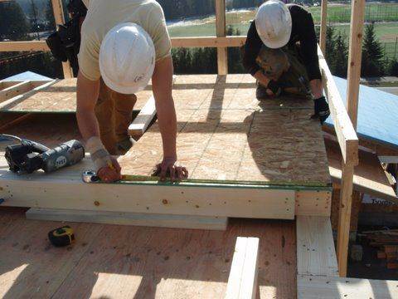

Wall Sheathing

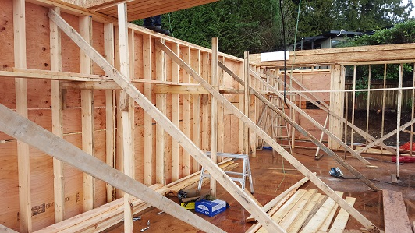

|  |  |  |  |  |  |  |  |  |
| --- | --- | --- | --- | --- | --- | --- | --- | --- |
|  | Checklist 05-5: **Sheathing Walls (TS5)** | | | | | | | |
| MC Development Corp. | | Project: | Contractor: | | | | | |
| **Number** | **Checkpoints** | | | BI | DI | | | AI |
| **1** | Status of previous TS inspections are approved by the PM/DNV | | |  |  | | |  |
| **Comment** |  | | | | | | | |
| **2** | Bottom plate nailed to a straight line? | | |  |  | | |  |
| **Comment** |  | | | | | | | |
| **3** | Top plate secured in place after wall is squared? | | |  |  | | |  |
| **Comment** |  | | | | | | | |
| **4** | Sheathing placed according to strength axis? | | |  | |  |  | |
| **Comment** |  | | | | | | | |
| **5** | All window and door openings cut before lifting walls? | | |  | |  |  | |
| **Comment** |  | | | | | | | |
| **6** | Walls nailed off according to project specifications? | | |  |  | | |  |
| **Comment** |  | | | | | | | |
| **7** | Guard rails installed to top of wall (when joisting will be done on top of wall and space allows? | | |  |  | | |  |
| **Comment** |  | | | | | | | |
| **8** |  | | |  |  | | |  |
| **Comment** |  | | | | | | | |
| **9** |  | | |  |  | | |  |
| **Comment** |  | | | | | | | |
| **Quality Scores and Completion Sign-off** | | | | | | | | |
| **Inspection#**  Quality 5 4 3 2 1 Notes:  On-Time 5 4 3 2 1 Notes:  Sign and date*: Cell # / ID #: Signed: Date:  Task has been verified complete and in compliance with contract drawings and specifications except for non-conformances and incomplete items reported above. | | | | | | | | |
| **BI=** Inspection **B**efore task begin **-----------DI=** Inspection **D**uring task in-process --------**AI=** Inspection **A**fter task completed  *Quality Score**5 = 100% NO problems 4 = 1 minor problems 3 = Hotspot or 2-3 minor 2 = 6+ or major problems 1 = Excessive problems*  ***On-Time Score*** *5 = On Time 4 = Late 3 = Late by 1 day 2 = Late by 2 days 1 = Late more than 2 days*  ***Safety Score*** *5 = 100% NO problems 4 = 1 minor problem 3 = Hotspot or 2-3 minor 2= 4+ or major problem 1= Injury* | | | | | | | | |

## Standing and Bracing Walls (TS6)

Before you begin:

* Ensure wall sheathing is nailed off to project specifications.
* Make sure all window and door openings are cut into the wall.
  + 1. Gather enough people to lift the wall together safely without causing back strain, or use a jacking system to lift the wall mechanically. Before lifting, eliminate the possibility for the wall to slide off the floor while lifting, by nailing 2x4 cut-offs to the perimeter of the building. If guard rails are already around the building perimeter, the guardrail uprights may be sufficient to prevent the wall from sliding off the building. Lift the wall together on one person’s count to distribute the weight evenly, and have pre-selected workers install temporary braces on the wall while the rest of the crew hold the wall in place. Nail the wall to the floor according to the nailing pattern in the specifications.
    2. As additional walls are lifted, they will need to be connected to the already standing walls by nailing the double top plate overlap together where the walls meet. Nail the overlap together from a ladder to limit potential injuries.
    3. After the exterior walls are standing and temporarily braced, the interior walls can be built and stood in the same fashion, nailing off the double top plate overlaps, and using temporary braces where needed.
    4. Use a level to check the exterior corners. Run a tensioned string line around the perimeter of and correct any bows in the wall to the string. There are various bracing methods, so consult the Site Supervisor or House Leader for direction. Temporary braces should only be knocked off as needed to straighten the walls. Brace the walls with a maximum of 8’ spacing between braces, and be sure to brace the wall where another wall ties into the wall being braced. Once all walls are straightened, plumbed, and braced, give all walls a firm shake to ensure they are held in place.

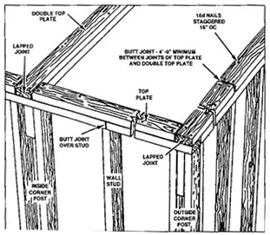

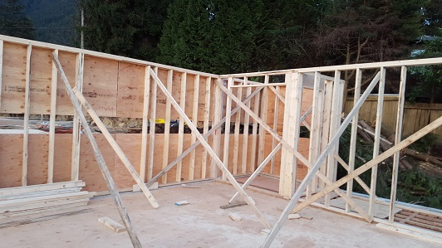

|  |  |  |  |  |  |  |  |  |
| --- | --- | --- | --- | --- | --- | --- | --- | --- |
|  | Checklist 05-6: **Standing and Bracing Walls (TS6)** | | | | | | | |
| MC Development Corp. | | Project: | Contractor: | | | | | |
| **Number** | **Checkpoints** | | | BI | DI | | | AI |
| **1** | Status of previous TS inspections are approved by the PM/DNV | | |  |  | | |  |
| **Comment** |  | | | | | | | |
| **2** | Preventative measures taken to keep the wall from sliding? | | |  | |  |  | |
| **Comment** |  | | | | | | | |
| **3** | Adequate temporary bracing used to hold walls in place with consideration to safety and weather? | | |  | |  |  | |
| **Comment** |  | | | | | | | |
| **4** | Double top plates nailed off from a ladder? | | |  |  | | |  |
| **Comment** |  | | | | | | | |
| **5** | Double top plate overlaps nailed off as walls are stood | | |  |  | | |  |
| **Comment** |  | | | | | | | |
| **6** | Walls straightened to a string line and brace at a maximum of 8’ and at wall partitions? | | |  |  | | |  |
| **Comment** |  | | | | | | | |
| **7** | All walls double checked for being firmly held in place? | | |  |  | | |  |
| **Comment** |  | | | | | | | |
| **8** |  | | |  |  | | |  |
| **Comment** |  | | | | | | | |
| **9** |  | | |  |  | | |  |
| **Comment** |  | | | | | | | |
| **Quality Scores and Completion Sign-off** | | | | | | | | |
| **Inspection#**  Quality 5 4 3 2 1 Notes:  On-Time 5 4 3 2 1 Notes:  Sign and date*: Cell # / ID #: Signed: Date:  Task has been verified complete and in compliance with contract drawings and specifications except for non-conformances and incomplete items reported above. | | | | | | | | |
| **BI=** Inspection **B**efore task begin **-----------DI=** Inspection **D**uring task in-process --------**AI=** Inspection **A**fter task completed  *Quality Score**5 = 100% NO problems 4 = 1 minor problems 3 = Hotspot or 2-3 minor 2 = 6+ or major problems 1 = Excessive problems*  ***On-Time Score*** *5 = On Time 4 = Late 3 = Late by 1 day 2 = Late by 2 days 1 = Late more than 2 days*  ***Safety Score*** *5 = 100% NO problems 4 = 1 minor problem 3 = Hotspot or 2-3 minor 2= 4+ or major problem 1= Injury* | | | | | | | | |

# Quality Assurance Approval

Only if all 21 required Inspections, associated with 7 TS Checklists mentioned in this WM, are approved by the PM and the CM as OK, the PM will carry out the final Inspection and issues the written approval if the results are OK.

If the results do not match the allowable tolerances, the PM will communicate this issue to the CM who evaluates the NCs and issues instructions for the corrective actions to be taken.

Any non-conformance shall be reported through the NCR procedure described in MCDC’s QP and is applicable to any and all phases of Framing.

# References

1. The Handouts and QMS sample documents provided by Mr. Jim Turnham (CMGT-7246)
2. Based on Behrouz Chehrehpardaz work experience
3. The Concrete WMs by Andre Ekkert
4. All pictures are taken during MCDC’s last project at 4438 Ranger Ave, North Vancouver
5. BC Building Code
6. WorkSafeBC Regulations
7. DNV Bylaws

# Construction Organization Chart

MCDC Board of Directors

Construct Manager/CEO

Project Manager

Site Super Intendent

Trade Contractor

# Flow Chart

Contract

Specs

Dwgs

WM/ITP

QP

END

Pre-Work WM Review Meeting

Certificate of Completion

NCP

Corrective Action

Initial Inspection

NO YES

Final Inspection

Passed?

NO/NCP

Inspection

Passed?

YES YES

(BI & DI & AI) Inspections

Passed?

Material Selection

NO/NCP

NO/NCP

Standing and Bracing Walls

(BI & DI & AI) Inspections

Passed?

YES YES

(BI & DI & AI) Inspections

Passed?

Place Foundations Sill Plates

NO/NCP

NO/NCP

Sheathing Walls

(BI & DI & AI) Inspections

Passed?

YES YES

(BI & DI & AI) Inspections

Passed?

Install Floor Joist

NO/NCP

NO/NCP

(BI & DI & AI) Inspections

Passed?

Framing Exterior Walls

YES YES

Install Floor Sheathing

(BI & DI & AI) Inspections

Passed?

NO/NCP

# Inspection and Test Plan

|  |  |  |  |  |  |  |  |  |  |  |
| --- | --- | --- | --- | --- | --- | --- | --- | --- | --- | --- |
| MC Development Corp | | Inspection and Test Plan # 05  **Framing** | | | PM: MCDC Project Manager  C: Contractor | | | | | |
| Contractor: | | | Project: | | | | | |
| **#** | **Inspections** | **To Inspect Items listed in** | **Time of Inspection** | **QC**  **by** | **Acceptance Criteria** | **H/W/D** | | **Score &**  **(lowest)** | **Initials** | **Date** |
| 1 | Initial Inspection | QMP004b | Prior to any work | C | CM approval | H |  |  |  |  |
| 2 | Material Select BI | Checklist 05-0 | Prior to TS0 | C | PM Approval |  |  |  |  |  |
| 3 | Material Select DI | Checklist 05-0 | During TS0 | C | PM Approval |  |  |  |  |  |
| 4 | Material Select AI | Checklist 05-0 | After TS0 | C | PM Approval |  |  |  |  |  |
| 5 | Place Sill Plate BI | Checklist 05-1 | Prior TS1 | C | PM Approval |  |  |  |  |  |
| 6 | Place Sill Plate DI | Checklist 05-1 | During TS1 | C | PM Approval |  |  |  |  |  |
| 7 | Place Sill Plate AI | Checklist 05-1 | After TS1 | C | PM Approval |  |  |  |  |  |
| 8 | Floor Joist Ins BI | Checklist 05-2 | Before TS2 | C | PM Approval |  |  |  |  |  |
| 9 | Floor Joist Ins DI | Checklist 05-2 | During TS2 | C | PM Approval |  |  |  |  |  |
| 10 | Floor Joist Ins AI | Checklist 05-2 | After TS2 | C | PM Approval |  |  |  |  |  |
| 11 | Floor Sheathing BI | Checklist 05-3 | Before TS3 | C | PM Approval |  |  |  |  |  |
| 12 | Floor Sheathing DI | Checklist 05-3 | During TS3 | C | PM Approval |  |  |  |  |  |
| 13 | Floor Sheathing AI | Checklist 05-3 | After TS3 | C | PM Approval |  |  |  |  |  |
| 14 | Exterior Walls BI | Checklist 05-4 | Before TS4 | C | PM Approval |  |  |  |  |  |
| 15 | Exterior Walls DI | Checklist 05-4 | During TS4 | C | PM Approval |  |  |  |  |  |
| 16 | Exterior Walls AI | Checklist 05-4 | After TS4 | C | PM Approval |  |  |  |  |  |
| 17 | Wall Sheathing BI | Checklist 05-5 | Before TS5 | C | PM Approval |  |  |  |  |  |
| 18 | Wall Sheathing DI | Checklist 05-5 | During TS5 | C | PM Approval |  |  |  |  |  |
| 19 | Wall Sheathing AI | Checklist 05-5 | After TS5 | C | PM Approval |  |  |  |  |  |
| 20 | Stand/Bracing BI | Checklist 05-6 | Before TS6 | C | PM Approval |  |  |  |  |  |
| 21 | Stand/Bracing DI | Checklist 05-6 | During TS6 | C | PM Approval |  |  |  |  |  |
| 22 | Stand/Bracing AI | Checklist 05-6 | After TS6 | C | PM Approval |  |  |  |  |  |
| 23 | Final Inspection | List of NCs | After Completion | PM | CM Approval |  |  |  |  |  |
| ITP Accepted by ……………………… Signature ……………………………… Date ……………. | | | | | | | | | | |
| **(BI**: Inspection Before Task Begin----**DI**: Inspection During Task Work----**AI**: Inspection After Task Finished)  **(W**: Witnessed by CM---- **H**: Hold further work----**D**: Document) | | | | | | | | | | |