**Work Method 04- Concrete Foundation Walls**

(WM04-MCDC Template)

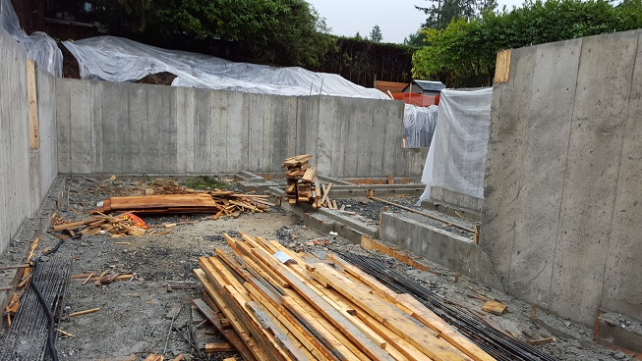

**Industry Based Project (CMGT 8800)**

**Aug 12, 2018**

**BCIT**

Faculty Advisor: Jim Turnham, P. Eng, MASc., ISO 9001 Lead Auditor

Prepared by: Behrouz Chehrehpardaz

Table of Contents

2. SIGNATURE PAGE 3

3. Proponent and Project Description 4

4. PURPOSE and SCOPE 5

5. DEFINITIONS 5

6. RESPONSIBILITIES 6

7. SAFETY AND ENVIRONMENT 8

8. SUBMITTALS 8

9. PROCEDURE 9

9.1. General Requirements 9

9.2. Foundation Wall Forms (TS1) 10

9.3. Foundation Wall Reinforcement (TS2) 17

9.4. Pouring Foundation Walls (TS3) 20

10. Quality Assurance Approval 25

11. References 25

12. Construction Organization Chart 26

13. Flow Chart 27

14. Inspection and Test Plan 28

# SIGNATURE PAGE

As an Approver, with my signature, I confirm that this Work Method is the plan for construction of the work. If the plan changes, I will inform the Originator so that the Work Method can be revised. Alternately, I will make revisions myself and reissue to those that require copies.

As a Reviewer, my signature confirms that I have reviewed the document and any comments to the WM have been provided to the Originator and/or to the Approver.

MCDC Construction Manager

Name: Date: ____ __ Title: _____________________ Signature: _________________

MCDC Project Manager

Name: Date: ____ __ Title: _____________________ Signature:_________________

Contractor

Name: Date: ____ __ Title: _____________________ Signature: _________________

Initial Reviewer

Name: Date: Title: Signature:

# Proponent and Project Description

**Company Name:** MC DEVELOPMENT CORP. (MCDC)

**Company type of service:** MCDC is a small construction company building Single Family Houses (SFHs) in North Vancouver, and the company’s vision is to be recognized as a model of quality excellence in construction.

**Project Description:** Under a Project Management/Design Build method, MCDC itself or on behalf of the owners manages construction projects to build new single-family houses mostly in North Vancouver.

MCDC contract out all work activities in construction stage including construction of concrete foundation walls.

**Work Method Activity Description:** This Work Method (WM) provides the required details of how the construction of concrete foundation walls is carried out, and it is also subject to a series of inspections, before the commencement, during the work, and after completion.

This Work Method will be used in order to ensure full compliance with MCDC’s quality policy and Quality Plan, drawings, specifications, and BC Building Codes.

**Work Method Scope:** This work method shall apply to the construction of all exterior concrete retaining walls that has been shown in drawings of the project.

**Limitation of liability:** Any organization engaged as a Contractor or Subcontractor (the Contractor) agrees to use this Work Method only under the condition that those that wrote and developed this Work Method are to be held harmless for any errors or omissions, any inaccuracies in content resulting in any damages to property or any injury to any personnel that may be involved. It remains the sole responsibility of the Contractor to review any and all items contained in the above Work Method and to make any changes that may be required in order to satisfy any project specification or any regulatory or statutory obligation. As well, the Contractor shall review any and all suggested methods as contained herein and shall make any changes required and shall reissue prior to commencement of construction in order to achieve the specified product or to provide a safe work site for all workers involved. Ownership and final responsibility for the use of all Work Methods remains with the Contractor.

# PURPOSE and SCOPE

**Purpose**: To define the responsibilities, describe methods and documentation to be used for building the concrete foundation walls in MCDC’s SFH projects.

**Scope**: This work method applies to all activities required for building the concrete foundation walls at (the address of the project). Reference Standards include:

* British Columbia (or applicable province) Building Code 2012.

Note: Construction documents (design drawings and specifications) should be referenced as applicable and will govern over any procedure included in this document.

# DEFINITIONS

MCDC - MC Development Corp.

CM - MCDC’s Construction Manager

PM - MCDC’s Project Manager

QC - Quality Control

WM - Work Method (this document)

WP **-** Work Procedure

TS - Task Step

CL - Checklist

RM - Review Meeting

NCP - Nonconformity Procedure

ITP - Inspection and Test Plan

BI - Before the TS Inspection

DI - During the TS Inspection

AI – After the TS Inspection

DNV - District of North Vancouver

SWP – Safe Work Practice

SWRB – Solid Waste Removal Bylaw (DNV)

# RESPONSIBILITIES

* 1. **Construction Manager (CM)** is responsible for project scheduling, and final approving the inspections, tests, and changes. The CM is also responsible for preparation of drawings and sketches to support construction as required and all making any changes if required.
  2. **Project Manager (PM)** is responsible for; identifying necessary resources and assigning individual responsibilities to run and monitor the quality control procedure that defined by MCDC’s QP and this WM. He is responsible for overseeing the Quality Management Plan, enforcing project construction standards, assisting the CM in the creation of work method documents by providing appropriate sequence and task definitions, executing the project, scheduling and delegation of the roles of quality control inspections, safety, environmental items and Contractor coordination.
  3. The PM is accountable for the Site Superintendent’s all responsibilities as well. The PM, for each WM contemplated for use at the site, provides a review and makes changes if necessary to any clause so that it is consistent with best practice, consistent with the building code of the Province, and consistent with local conditions. Issues should be reviewed by email with the CM.
  4. **Site Superintendent** must work well with people and is responsible for:
  + Requesting copies of subcontractor’s liability insurance and workmen’s compensation certificate.
  + Overall site activities; applying project methodology and enforcing project construction standards; organizing field staff and ensuring they perform as required; and supervising Contractors and ensuring they perform as required
  + Assisting the PM and the Contractors in the creation and execution of work plans including revisions to these plans as necessary.
  + Assisting the PM in supervision of Contractors’ work quality.
  + Working closely with and support the Contractor to identify potential risks/opportunities, discuss necessary changes, and conduct the inspections.
  + Scheduling and monitoring each workday with appropriately resources.
  + Serving as the representative of and primary contact with the PM.
  + Attending review meetings.
  + Maintaining site logs and other documents in jobsite.
  + Ensuring the jobsite safety and ensuring that safety practices are followed.
  1. **Trade Contractor** (Contractor) refers to the company that is bound by contract to MCDC for a certain scope of work. For their scope, the Contractor is responsible for environmental control, safety controls, and quality control for self-performed work. The Contractor is responsible to write his/her Work Methods. However, if the Contractor cannot provide the required WMs, MCDC may assist, but the final WM will be reviewed, changes made to reflect project requirements, codes, laws, and resubmitted to MCDC and owned by the Contractor. The Contractor performs the work required by the contract documents and approved Work Methods to start and complete the Project and fulfill everything indicated by the contract documents. The Contractor shall perform activities described in this WM. If any revision is needed, the Contractor shall be instructed to revise and update this WM so that the WM reflects the intent and methods of the Contractor as well. The Contractor shall be fully responsible for his means and methods, and for the content of the revised WM. The Contractor shall assign a representative who will permanently attend at the job site when the job is being done. The Site Manager or the Contractor’s site representative shall ensure following the guidelines and/or Standard Specifications outline on this work method.

# SAFETY AND ENVIRONMENT

All construction activities and job procedures shall conform to

* WCB Regulations and other applicable codes, regulations and acts
* DNV Street and Traffic Bylaw (Bylaw 7125)
* DNV Noise Regulation Bylaw (Bylaw 7188)
* DNV Environmental Protection and Preservation Bylaw (Bylaw 6515)
* DNV Tree Protection Bylaw (Bylaw 7671)

Before any work takes place, the PM and Site Superintendent will ensure that all operators, laborers, and Contractors have been site orientated.

Forming installation and pouring procedures must comply with safe practices and with the requirements of the bylaw, codes and ordinances.

All work process shall be fully consistent to DNV Bylaws, and all concrete trucks delivering to site will be equipped with wash down buckets. Concrete truck wash down waste water will be collected in wash down buckets and removed from site. Surplus concrete in concrete trucks will be returned to the supplying company.

# SUBMITTALS

The contractor submittals to MCDC:

* Contractor Quotation for doing the job described in MCDC’s RFQ package, including
  + Contract price and time (including the start time of work on site)
  + Declaration of accepting all contract terms and documents
  + Written promise to provide the required submittals (including Contractor’s Work Method and Checklists), 14 days prior to the work start
  + Documented processes and submittals to enable the PM review
  + Contractor’s initial Work Method, Checklists, and ITP for MCDC review
* The final revision of MCDC QP reviewed and confirmed by the Contractor
* Finalized WM, ITPs, Checklists, and any other documents required by the contract documents, not later than 7 days prior to the work start time, (MCDC CM written confirmation required)
* Any drawing, specs, and designing layout which is required for carrying out the work, and in order to satisfy any project specification or any regulatory or statutory obligation.
* Reports that identifies the Self inspection result and scope of work, before each MCDC scheduled inspection

All contractor submittals are stated in the Contract and include (but not limited to)

* Marking materials, measuring stick, and measuring tape
* Heavy duty Plastic Sheeting, enough to cover concrete if needed
* All forming materials needed to do the job
* Rebars as mentioned in drawing specs
* Proper vibrator, approved by the MCDC PM.

# PROCEDURE

## General Requirements

Consult the specifications and construction drawings to determine the requirements for any aspect of the work. This Work Method is a guideline used by MCDC to describe the work process and the process of quality control by conducting the specific Inspections and relevant Checklists. The Drawings, and Specifications as well as any code and by-law are the ultimate requirements. The PM and the Contractor shall review the Work Method and make any revision (prior to each use if necessary) so that any requirements will be identified and met.

The following Task Steps (procedures) TSs are included in this Work Method:

* 9.2 Foundation Wall Forms (TS1)
* 9.3 Foundation Wall Reinforcement (TS2)
* 9.4 Pouring Foundation Walls (TS3)

Each TS comes with a Checklist and each Checklist is subject to three Inspections, before, during, and after completion of the TS. Each Checklist includes several checkpoints which must be controlled and verified by the MCDC’s PM or Site Superintendent. To continue the work and proceed to next step, the Contractor must obtain the approval of PM for all Inspections. The PM will give the approval only if all Checklist’s items are checked and passed.

The Inspections and Testing shall follow the instructions described in the Inspection and Testing Plan number 04(ITP04). The PM shall review the results of the ITP and Checklists and check if the results are acceptable. The PM will communicate the acceptable results to the CM and if the results are not acceptable, the PM will communicate this issue to the CM and the Contractor to evaluate the default and issue instructions for the corrective actions.

## Foundation Wall Forms (TS1)

Before you begin:

* Foundation walls forming drawings may need to be engineered and drawings should be available. As a minimum, the manufacturer of the forming systems instructions should be followed completely. Concrete is extremely heavy (150 lbs/ft3) and the taller the wall, the more pressure on the forms, hence each foundation wall needs to be assessed structurally by a competent person prior to ordering forms.
* Foundation wall form locations on the footing need to be located before forms can be placed.
* Measuring off the centerline of footing, half of the wall width is measured out and marked with a chalk line.

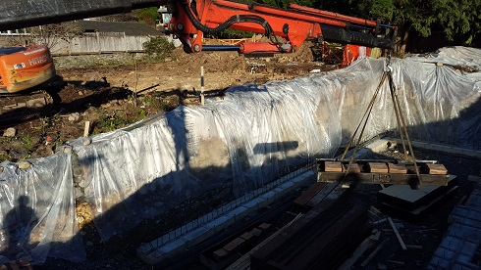

* + 1. On the footing, chalk a line the thickness of the plywood away from the outside line of the concrete wall. Place a 2x4 letting the chalk line indicate the edge of the 2x4 plate as shown to the left. Therefore, if you are using ¾” plywood for the form, the chalk line would be ¾” outside the line of the concrete wall. You will have to use a power drill with a concrete drill bit to drill through the top of the 2x4 and into the concrete. Drill through the center line of the 2x4. Plywood will be nailed into the footing plates.

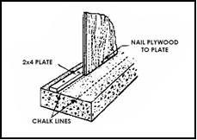 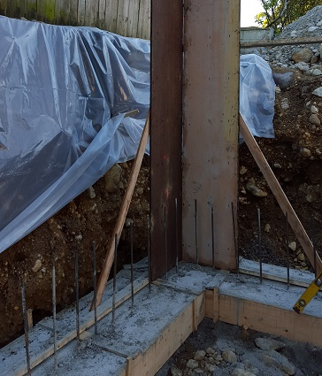

* + 1. After consulting the snap tie drawings and the snap tie pattern is established with certainty, snap-tie holes can be drilled into the plywood by gang drilling as shown in the figure when the plywood is still horizontal. You can drill up to 5 panels at once using this method. The holes need to be drilled 1/8" larger than the snap-tie head, and normally a 9/16" diameter drill bit will be required. Apply form release oil to the forms prior to assembly.

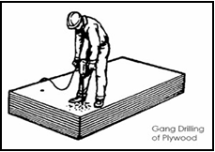

* + 1. Nail the predrilled plywood boards to the footing plates. You will have to use temporary bracing to hold the boards up until the 2x4 studs are nailed into place. Place the ends of the snap-ties through the holes in the plywood.

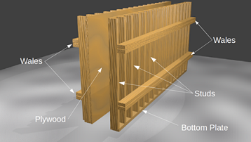

* + 1. Horizontal 2x4’s called whalers are nailed to the plywood per spacing shown on drawings above and below the snap-tie holes as shown. Snap-tie brackets are then hung from the snap-ties. Double vertical 2x4’s called “strong backs” are spaced according to the drawings, nailed to the horizontal members and held in place by the snap tie bracket (which are only tightened when both sides of the form are put on). Form one side of the wall first, then place wall rebar per spacing on the drawings, before erecting and closing the second wall form. To ease form stripping, use double headed nails.

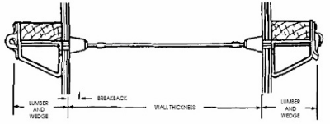

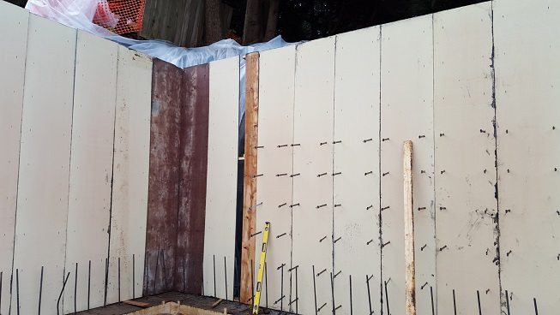

* + 1. Diagonal braces are used to align and plumb the form panels. Temporary bracing needs to be adequate to support the lateral pressure of fresh concrete and any wind loads. Use a string along the top of the forms, attached from corner to corner, to straighten the form.

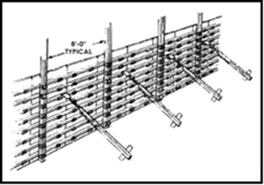

* + 1. Once the rebar is in place (see reinforcement procedure), the forms can be closed by repeating the same procedure in steps 8.6.2 to 8.6.5. With both sides of the forms in place, the brackets can be tightened by hammering them down.
    2. The inside corners of the forms are attached with alternating whales. You can secure whales together one of two ways. Either have the whales flush with each other as shown, and then secured together with corner locks, or have the whales at different heights (the thickness of the 2x4) and overlap and then fasten them together. Outside panels are attached the same way as the inside panels. Whales are attached the by either method mentioned above.

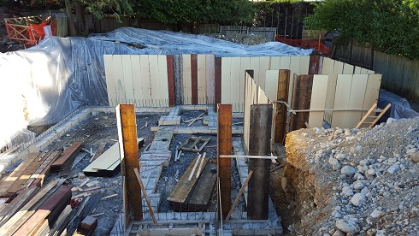

* + 1. Perform a final review of the forming system, checking the details on the snap-tie manufacturer’s drawings and the form work engineered drawings. Review allowable pour rate in vertical feet of concrete per hour. Review that wall height is consistent with drawings. An Engineer may be required to sign and stamp the drawings as evidence that the formwork drawings are followed completely in all of their detail. WorkSafeBC’s Policy-Item R20.17 sets out the requirements for specifications and plans for concrete formwork and falsework, and it is the responsibility of the Contractor to ensure the erection drawings and any supplementary instructions are complete and comply with the Regulation.

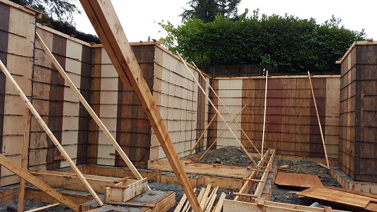

|  |  |  |  |  |  |  |  |  |
| --- | --- | --- | --- | --- | --- | --- | --- | --- |
|  | Checklist 04-1: **Foundation Wall Forms (TS1)** | | | | | | | |
| MC Development Corp. | | Project: | Contractor: | | | | | |
| **Number** | **Checkpoints** | | | BI | DI | | | AI |
| **1** | Status of previous TS inspections are approved by the PM/DNV | | |  |  | | |  |
| **Comment** |  | | | | | | | |
| **2** | Formwork appropriate for required concrete finish (architectural) | | |  |  | | |  |
| **Comment** |  | | | | | | | |
| **3** | Formwork drawings or snap tie manufacturer’s drawings  are available? (Height of pour, pour rate, and any unusual details.) | | |  |  | | |  |
| **Comment** |  | | | | | | | |
| **4** | Double check on level and plumb? Engineered forms are signed off; field inspection by engineer required? | | |  | |  |  | |
| **Comment** |  | | | | | | | |
| **5** | 2x4 on the footing secured in the proper location | | |  | |  |  | |
| **Comment** |  | | | | | | | |
| **6** | Snap-tie holes drilled 1/8” larger than the snap-tie head | | |  |  | | |  |
| **Comment** |  | | | | | | | |
| **7** | Underground Facilities located and marked to prevent damage from form pins | | |  |  | | |  |
| **Comment** |  | | | | | | | |
| **8** | Temporary bracing of form panels adequate to support the lateral  pressure of fresh concrete and any wind loads? | | |  |  | | |  |
| **Comment** |  | | | | | | | |
| **9** | Final review of forming system complete? | | |  |  | | |  |
| **Comment** |  | | | | | | | |
| **Quality Scores and Completion Sign-off** | | | | | | | | |
| **Inspection#**  Quality 5 4 3 2 1 Notes:  On-Time 5 4 3 2 1 Notes:  Sign and date*: Cell # / ID #: Signed: Date:  Task has been verified complete and in compliance with contract drawings and specifications except for non-conformances and incomplete items reported above. | | | | | | | | |
| **BI=** Inspection **B**efore task begin **-----------DI=** Inspection **D**uring task in-process --------**AI=** Inspection **A**fter task completed  *Quality Score**5 = 100% NO problems 4 = 1 minor problems 3 = Hotspot or 2-3 minor 2 = 6+ or major problems 1 = Excessive problems*  ***On-Time Score*** *5 = On Time 4 = Late 3 = Late by 1 day 2 = Late by 2 days 1 = Late more than 2 days*  ***Safety Score*** *5 = 100% NO problems 4 = 1 minor problem 3 = Hotspot or 2-3 minor 2= 4+ or major problem 1= Injury* | | | | | | | | |

## Foundation Wall Reinforcement (TS2)

Before you begin:

* Make sure one side of wall form is level and plumb.
* Check drawings specifications to make sure the right diameter, right number of rebar is being used, and the correct spacing of rebar to forms is followed. Plastic rebar “chairs” or spacers are suggested to be purchased.
* Make sure appropriate personal protective equipment is available for cutting rebar.
  + 1. Vertical bars are tied to the dowels in the footing using metal tie wire. Mark the horizontal spacing of the rebar on the forms at the spacing provided on the drawings or specifications.
    2. Rebar may be centered between the wall forms or there may be two layers of rebar. (The higher the wall, the greater the soil pressure and the engineer may need to specify the rebar configuration.) Use chairs or spacers to provide the concrete cover to rebar as specified on the drawings.
    3. Use metal tie wire to tie the rebar together in the corners, joining the bars together. This is referred to as splicing.
    4. If the length of rebar required is longer than a single bar, two or more bars can be lapped together to achieve the required length. To lap rebar, the bars are put together, so that their ends are overlapping at least 24” and then tied together using metal tie wire with two ties. Laps splices must be maintained at corners as well and rebar must be bent to accommodate corners.
    5. Horizontal bars are then tied to the vertical bars. Ensure none of the bars protrude above the form by cutting off the ends. Because of the potential difficulty, it is recommended to pre-cut the bars to the required heights before tying them.

* + 1. The plans and drawings shall be reviewed and any required PVC conduits are installed.

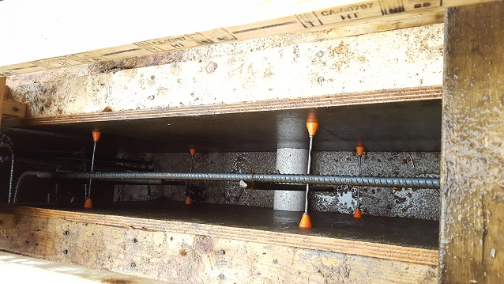

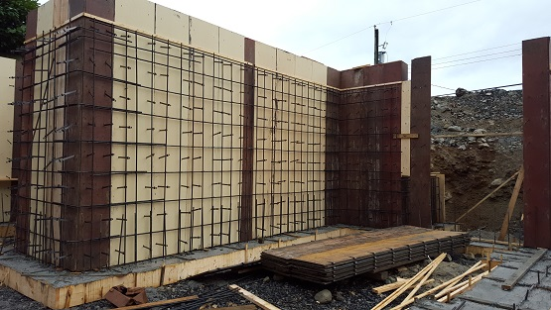

|  |  |  |  |  |  |  |  |  |
| --- | --- | --- | --- | --- | --- | --- | --- | --- |
|  | Checklist 04-2: **Foundation Wall Reinforcement (TS2)** | | | | | | | |
| MC Development Corp. | | Project: | Contractor: | | | | | |
| **Number** | **Checkpoints** | | | BI | DI | | | AI |
| **1** | Status of previous TS inspections are approved by the PM/DNV | | |  |  | | |  |
| **Comment** |  | | | | | | | |
| **2** | Support chairs and ties are compatible with reinforcing type | | |  | |  |  | |
| **Comment** |  | | | | | | | |
| **3** | Correct gauge/size/class/type/coating of reinforcing is used | | |  | |  |  | |
| **Comment** |  | | | | | | | |
| **4** | Vertical bars tied to the dowels in the footing | | |  |  | | |  |
| **Comment** |  | | | | | | | |
| **5** | Rebar spaced according to project specifications | | |  |  | | |  |
| **Comment** |  | | | | | | | |
| **6** | Rebar centred between the wall forms | | |  |  | | |  |
| **Comment** |  | | | | | | | |
| **7** | Cross pieces tied together in the corners | | |  |  | | |  |
| **Comment** |  | | | | | | | |
| **8** | Rebars lapped with a 24” overlap and tied with two metal ties | | |  |  | | |  |
| **Comment** |  | | | | | | | |
| **9** | Reinforcing is clean and stable for concrete placement | | |  |  | | |  |
| **Comment** |  | | | | | | | |
|  |  | | | | | | | |
| **Quality Scores and Completion Sign-off** | | | | | | | | |
| **Inspection#**  Quality 5 4 3 2 1 Notes:  On-Time 5 4 3 2 1 Notes:  Sign and date*: Cell # / ID #: Signed: Date:  Task has been verified complete and in compliance with contract drawings and specifications except for non-conformances and incomplete items reported above. | | | | | | | | |
| **BI=** Inspection **B**efore task begin **-----------DI=** Inspection **D**uring task in-process --------**AI=** Inspection **A**fter task completed  *Quality Score**5 = 100% NO problems 4 = 1 minor problems 3 = Hotspot or 2-3 minor 2 = 6+ or major problems 1 = Excessive problems*  ***On-Time Score*** *5 = On Time 4 = Late 3 = Late by 1 day 2 = Late by 2 days 1 = Late more than 2 days*  ***Safety Score*** *5 = 100% NO problems 4 = 1 minor problem 3 = Hotspot or 2-3 minor 2= 4+ or major problem 1= Injury* | | | | | | | | |

## Pouring Foundation Walls (TS3)

Before you begin:

* Make sure wall forms are in the correct location (top and bottom).
* Check that forms are completed, plumb, properly supported, and inspected for required structural elements.
* The top elevation of the pour should be marked on the form with a very visible system. Nails are sometimes used so that the line can’t be lost or obscured with concrete. Even better if the form is cut at the correct elevation so that the screeding to the correct elevation is easy.
* Ensure the proper concrete mix design is ordered – consider that it will be exterior exposure, may need air entrainment for freeze thaw resistance. The mix may need to be a pumpable mix (assuming you will pump the concrete instead of crane and bucket), and may need superplasticizer to facilitate pumping without addition of water.
* Vibrator(s) are on site and in good repair and a spare vibrator is recommended.
  + 1. Concrete pump truck will set up near the forms and pump concrete into the forms. Provide adequate access for the concrete ready-mix trucks to the concrete pump truck.

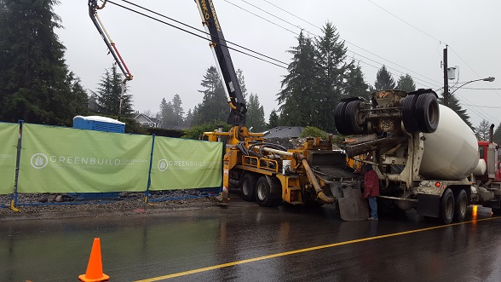

* + 1. Direct the concrete pump hose into the forms and fill them with concrete in designated lift thicknesses and at the pour rate specified by the form designer. For example, if a two-foot lift is to be placed and a maximum 4 foot per hour rate of placement, the concrete would be poured in two-foot lifts and the pour rate of no more than 2 lifts per hour would be followed.

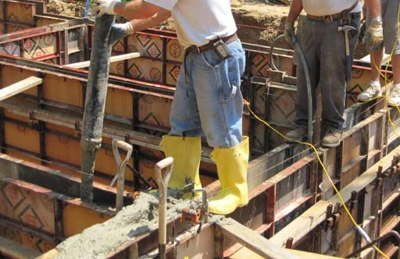

* + 1. As concrete is being poured, each lift will need to be slowly vibrated including vibration into the lift below using the concrete vibrator using a pattern of approximately one-foot vibration intervals. When the top of form is reached, the top of the concrete is levelled off with a float or trowel and the excess concrete cleaned off.

Throughout the pour, ensure that the concrete is consolidated to eliminate voids, air pockets, and any separation from the rebar. This will be accomplished by one of these methods:

* Churning the concrete cell with a piece of rebar.
* Placing a block of wood (2x4 or 2x6) against the side of the form and tapping it firmly with a hammer while moving along the wall.
* And most importantly, a small pencil vibrator must be used inside the forms.

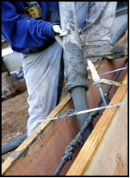 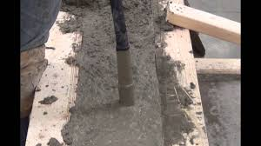

* + 1. To finish the concrete placement, pour concrete to the top and screed off level to the top rail, or the top of the forms.

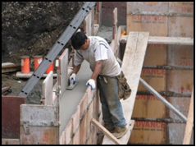

* + 1. During and after the concrete pouring the concrete surface should be protected from the rain by locating polyethylene sheeting or burlap and stretch it over the entire area of wet concrete extending it over the edges by at least 6 to 12 inches to prevent rain from splashing under it.

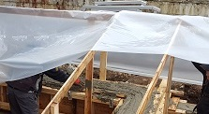 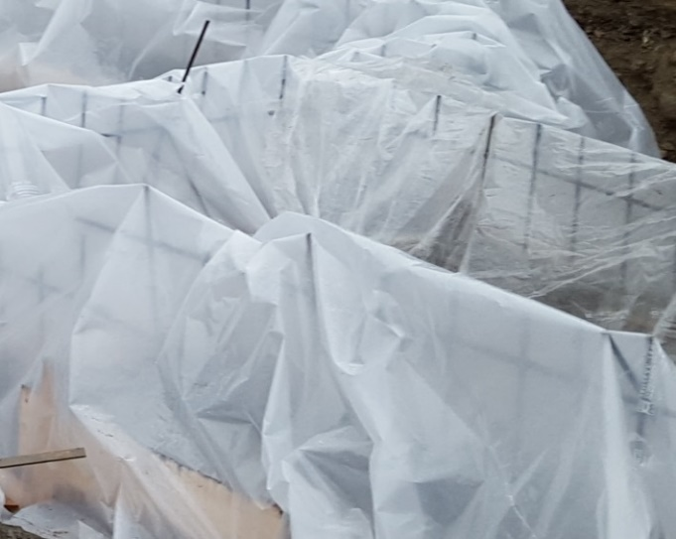

* + 1. All formwork must be removed from the completed structure. Formwork shall not be removed without the approval of the CM or Engineer. The minimum period during which forms and supports for concrete structures must remain in place are listed in the following Table and are defined either by the "Time" or the "Strength" requirements. The strength requirement refers to the minimum strength of field cured cylinders as a percentage of the specified 28 day compressive strength.

**Table 1: Minimum Requirements for Removal of Formwork,**

**Placement of Superimposed Vertical Loads, and Placement of Backfill**

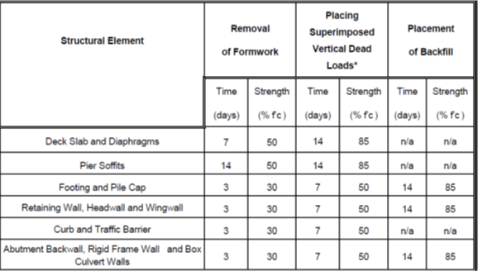

In using the Table, consideration shall be given to the location and character of the structure, the weather and other conditions influencing the setting of the concrete, and the material used in the mix. The use of fly ash or set retarding admixtures shall require special consideration and may require additional curing time as specified by the Engineer.

|  |  |  |  |  |  |  |  |  |
| --- | --- | --- | --- | --- | --- | --- | --- | --- |
|  | Checklist 04-3: **Pouring Foundation Walls (TS3)** | | | | | | | |
| MC Development Corp. | | Project: | Contractor: | | | | | |
| **Number** | **Checkpoints** | | | BI | DI | | | AI |
| **1** | Status of previous TS inspections are approved by the PM/DNV | | |  |  | | |  |
| **Comment** |  | | | | | | | |
| **2** | Forms in correct location, completed, plumb, properly supported | | |  | |  |  | |
| **Comment** |  | | | | | | | |
| **3** | Proper concrete mix design is ordered (per exposure conditions, spec, and code) | | |  | |  |  | |
| **Comment** |  | | | | | | | |
| **4** | Electrical conduit installed if required | | |  |  | | |  |
| **Comment** |  | | | | | | | |
| **5** | Proper vibrator in place and used correctly to consolidate concrete | | |  |  | | |  |
| **Comment** |  | | | | | | | |
| **6** | Adequate form release agent has been applied to the formwork | | |  |  | | |  |
| **Comment** |  | | | | | | | |
| **7** | Top of concrete levelled off, trowelled to required finish, and cleaned of excess concrete? | | |  |  | | |  |
| **Comment** |  | | | | | | | |
| **8** | The finished concrete covered properly (curing) | | |  |  | | |  |
| **Comment** |  | | | | | | | |
| **9** | Finished surface is smooth and in a good condition | | |  |  | | |  |
| **Comment** |  | | | | | | | |
| **Quality Scores and Completion Sign-off** | | | | | | | | |
| **Inspection#**  Quality 5 4 3 2 1 Notes:  On-Time 5 4 3 2 1 Notes:  Sign and date*: Cell # / ID #: Signed: Date:  Task has been verified complete and in compliance with contract drawings and specifications except for non-conformances and incomplete items reported above. | | | | | | | | |
| **BI=** Inspection **B**efore task begin **-----------DI=** Inspection **D**uring task in-process --------**AI=** Inspection **A**fter task completed  *Quality Score**5 = 100% NO problems 4 = 1 minor problems 3 = Hotspot or 2-3 minor 2 = 6+ or major problems 1 = Excessive problems*  ***On-Time Score*** *5 = On Time 4 = Late 3 = Late by 1 day 2 = Late by 2 days 1 = Late more than 2 days*  ***Safety Score*** *5 = 100% NO problems 4 = 1 minor problem 3 = Hotspot or 2-3 minor 2= 4+ or major problem 1= Injury* | | | | | | | | |

# Quality Assurance Approval

Only if all 9 required Inspections, associated with 3 TS Checklists mentioned in this WM, are approved by the PM and the CM as OK, the PM will carry out the final Inspection and issues the written approval if the results are OK.

If the results do not match the allowable tolerances, the PM will communicate this issue to the CM who evaluates the NCs and issues instructions for the corrective actions to be taken.

Any non-conformance shall be reported through the NCR procedure described in MCDC’s QP and is applicable to any and all phases of the constructing of foundation walls.

# References

1. The Handouts and QMS sample documents provided by Mr. Jim Turnham (CMGT-7246)
2. Based on Behrouz Chehrehpardaz work experience
3. The Concrete WMs by Andre Ekkert
4. All pictures are taken during MCDC’s last project at 4438 Ranger Ave, North Vancouver
5. BC Building Code
6. WorkSafeBC Regulations
7. DNV Bylaws

# Construction Organization Chart

MCDC Board of Directors

Construct Manager/CEO

Project Manager

Site Super Intendent

Trade Contractor

# Flow Chart

Contract

Specs

Dwgs

WM/ITP

QP

END

Pre-Work WM Review Meeting

Certificate of Completion

NCP

Corrective Action

Initial Inspection

NO YES

Final Inspection

Passed?

NO/NCP

Inspection

Passed?

YES YES

(BI & DI & AI) Inspections

Passed?

Wall Forms

NO/NCP

NO/NCP

Pouring Walls

(BI & DI & AI) Inspections

Passed?

YES YES

(BI & DI & AI) Inspections

Passed?

Wall Reinforcement

NO/NCP

# Inspection and Test Plan

|  |  |  |  |  |  |  |  |  |  |  |
| --- | --- | --- | --- | --- | --- | --- | --- | --- | --- | --- |
| MC Development Corp | | Inspection and Test Plan # 04  **Concrete Foundation Walls** | | | PM: MCDC Project Manager  C: Contractor | | | | | |
| Contractor: | | | Project: | | | | | |
| **#** | **Inspections** | **To Inspect Items listed in** | **Time of Inspection** | **QC**  **by** | **Acceptance Criteria** | **H/W/D** | | **Score &**  **(lowest)** | **Initials** | **Date** |
| 1 | Initial Inspection | QMP004b | Prior to any work | C | CM approval | H |  |  |  |  |
| 2 | Wall Forms BI | Checklist 04-1 | Before TS1 | C | PM Approval |  |  |  |  |  |
| 3 | Wall Forms DI | Checklist 04-1 | During TS1 | C | PM Approval |  |  |  |  |  |
| 4 | Wall Forms AI | Checklist 04-1 | After TS1 | C | PM Approval |  |  |  |  |  |
| 5 | Wall Reinforce BI | Checklist 04-2 | Before TS2 | C | PM Approval |  |  |  |  |  |
| 6 | Wall Reinforce DI | Checklist 04-2 | During TS2 | C | PM Approval |  |  |  |  |  |
| 7 | Wall Reinforce AI | Checklist 04-2 | After TS2 | C | PM Approval |  |  |  |  |  |
| 8 | Wall Pouring BI | Checklist 04-3 | Before TS3 | C | PM Approval |  |  |  |  |  |
| 9 | Wall Pouring DI | Checklist 04-3 | During TS3 | C | PM Approval |  |  |  |  |  |
| 10 | Wall Pouring AI | Checklist 04-3 | After TS3 | C | PM Approval |  |  |  |  |  |
| 11 | Final Inspection | List of NCs | After Completion | PM | CM Approval |  |  |  |  |  |
| ITP Accepted by ……………………… Signature ……………………………… Date ……………. | | | | | | | | | | |
| **(BI**: Inspection Before Task Begin----**DI**: Inspection During Task Work----**AI**: Inspection After Task Finished)  **(W**: Witnessed by CM---- **H**: Hold further work----**D**: Document) | | | | | | | | | | |