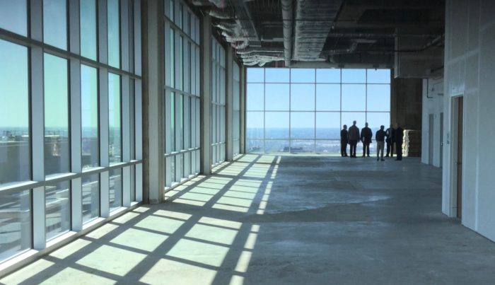

**Work Method: Office Tenant Improvements –**

Preliminary Design and Building Permit Application

**Prepared by:**

**Shivraj Gill, Farzad Sadeghi, Siavash Mahzari**

**Prepared for:**

**The Company**

**And for**

**BCIT 7246 Quality Management in Construction**

**[Good work Shivraj, Farzad, Siavash;**

**Permission was obtained by Jim Turnham for the future use of this document**

**All the best, Jim]**

**Proponent and Work Method Description**

**Company Name:** F&S Construction Ltd. (**The Company**)

**Company type of service:** Construction Management and Design Build

**Company representatives:** Shivraj Gill, Farzad Sadeghi, Siavash Mahzari

**Reference Project Name:** Tenant improvement for office space building in the city of Burnaby, BC, Canada

**Project description:** Design and permit application for tenant improvement for office space building in Burnaby.

**Work Method Scope:** The scope includes collecting initial data and requirements, concept design, preliminary design, obtaining client approval, and getting building permit. This method is applicable in all tenant improvements projects in building spaces intended to be used for offices.

|  |  |  |  |
| --- | --- | --- | --- |
| **Signature Page** | | | |
| Occupation | Name | Signature | Date |
| Lead Architect/Engineer |  |  |  |
| Project Manager |  |  |  |
| Draftsman |  |  |  |

Signing indicates that this document has been approved by the Architect and reviewed and understood by the Project Coordinator and Draftsman.

TABLE OF CONTENTS

1.0 PURPOSE 5

2.0 SCOPE 5

3.0 DEFINITION & ACRONYM 5

4.0 RESPONSIBILITIES AND AUTHORITIES 5

4.1 Team Responsibilities 7/10 5

4.1.1 Architect 5

4.1.2 Project Coordinator 5

4.1.3 Draftsman 6

4.2 Other Authorities 6

4.2.1 Consultants 6

4.2.2 City of Burnaby 6

5.0 SUBMITTALS 6

6.0 SPECIFICATIONS 7

7.0 PROCEDURE 7

7.1 Initial Review 7

7.2 Preliminary Plan Approval 7

7.3 BC Building Code Review 7

7.4. Client Meeting 8

7.5. Preliminary Design 8

7.5.1 Initial Design 8

7.5.2 Client Approval 8

7.5.3 BPD 9

7.6 Coordination 9

7.6.1 Sending Drawings to Consultants 9

7.6.2 Receiving Information from Consultants 9

7.6.3 Implementing Corrections 10

7.6.4 Final Review 10

7.7 Preparing Additional Documents 10

7.8 Building Permit 11

8.0 ORGANIZATIONAL CHART 13

8.1 See attached Organization Chart 13

9.0 REFERENCES 13

10.0 ATTACHMENTS 14

10.1 Organizational Chart 14

10.2 BPD Requirements by City of Burnaby 15

10.3 Drawing Checklist for Coordination 15

10.4 Flow Chart 17

# 1.0 PURPOSE

To define the responsibility and describe the method to be used by F & S Construction architects, project coordinators and draftsmen to carry out the preliminary design and get the building permit.

# 2.0 SCOPE

This work method shall apply to do the preliminary design and getting building permit for Tenant improvement for office space building in City of Burnaby.

## No Guarantee, Limit of Liability:

**NO GUARANTEE IS MADE FOR THIS TEMPLATE. The authors of this Quality Plan or Work Method or documented procedure, shall not be liable for any errors or omissions resulting in loss or injury of any kind from use of this document. The user shall make changes to reflect how they plan and perform these processes and shall submit any changes to the authority having jurisdiction prior to use of this document. Ownership of this document resides with the document user.**

# 3.0 DEFINITION & ACRONYM

AIBC Architectural Institute of British Columbia

P.ENG Professional Engineer

PPA Preliminary Plan Approval

BCBC British Columbia Building Code 2018

TIS Tenant Improvement Site

BPD Building Permit Drawings

BAH Building Access Handbook 2014

# 4.0 RESPONSIBILITIES AND AUTHORITIES

## 4.1 Team Responsibilities

### 4.1.1 Architect

Architect, professional registered with AIBC, shall manage the process from preliminary design to building permit stage. Architect performs the following tasks:

* contract the Consultants
* give instructions to the draftsman
* responsible for the client relationship, consultants, and City of Burnaby
* check and verify BPD.

### 4.1.2 Project Coordinator

Project Coordinator shall perform the following tasks:

* review and coordinate✔ the signed client contract
* coordinate and meet with client, consultants, and City of Burnaby
* review BCBC for compatibility of design drawings with codes
* document decisions and information with client, consultant and City of Burnaby
* send BPD to consultants and client
* prepare documents
* gather documents and BPD and go to City Hall to submit for building permit.

### 4.1.3 Draftsman

The Draftsman shall meet the client on TLS, draw the BPD on a computer software, perform design verification and self-check, and update the BPD when instructed by architect.

## 4.2 Other Authorities

### 4.2.1 Consultants

The consultants involved in the process include the structural engineer, electrical engineer, and mechanical engineer.

Note: all consultants shall hold the title of P.Eng.

The architect shall contract the consultants. The consultant shall prepare their drawings which are in coordination with the BPD. He/she shall also fill out forms, documents, and other necessary items which are required to complete the process.

### 4.2.2 City of Burnaby

All steps, drawings, etc. shall follow the guidelines listed by the City of Burnaby bylaw, website, and employees. The coordinator is responsible for correspondence and submittals to the City of Burnaby.

# 5.0 SUBMITTALS

All materials are to be specified in the design documents with requirements for the successful contractor to submit various materials to the designer for approval. The design may enlist requirements of certain products unavailable in the local market. The contractor shall assure the conformity of all materials with BCBC and all bylaws of the City of Burnaby. The contractor is required by the contract to issue submittals and get the approval prior to purchase of any materials listed in the design documents as “Pre-approval Required”.

# 6.0 SPECIFICATIONS

The specifications used in this work method include:

* BCBC: Section 3.1 General
* BCBC: Section: 3.2 Building Fire Safety - Group D: from 3.22.54 to 3.2.2.61 (Page: 100 – 103)
* BCBC: Section: 3.7 Health Requirements
* BAH: Section 3.8.2.32 Business and Personal Service Occupancies
* BAH: Section 3.8.4 Alterations and Additions to Existing Buildings
* City of Burnaby Tenant Improvement Permits Information Guide: Updated July 2017
* City of Burnaby requirements for BP: Section 10.2

# 7.0 PROCEDURE

## 7.1 Initial Review

Project coordinator shall receive signed contract from architect and review it to learn about the design requirements and related obligations based on the contract documents. Then, he or she will contact the client to ask for the architectural drawings and specifications of the building where the TIS is located. Project coordinator will do the follow-ups such as contacting the previous consultants to accelerate the process. After collecting the documents, project coordinator must make sure the received documents are the final approved revision and include the data required for the design process. Then he or she will record them and send copies to architect and draftsman.

## 7.2 Preliminary Plan Approval

In case of certain conditions listed below, it is required to apply for the PPA by project coordinator.

* “Changing the use of a business (e.g. from a restaurant to an office)
* Changing floor area use (e.g. increased office area in a previous warehouse space)
* Adding seats [e.g. restaurant seats or office seats]
* Exterior modifications to a building
* Mezzanine or second floor addition
* Increasing floor area in an existing space”. (City of Burnaby , 2017)

In order to apply for PPA, project coordinator will call the Planning Department of City of Burnaby. He or she will explain the situation by giving the address, floor and area of the TIS for tenant improvement and the verbal confirmation about the intended changes in the property. The only verbal confirmation is required in this step and it can also be obtained by in-person visits in place of calling.

## 7.3 BC Building Code Review

Project coordinator will look through the building classification listed on pages 100 to 103 of the BCBC to make sure about the design requirements. The BCBC Design Requirements Checklist will be used in this step. The project coordinator should study about the following specifications of the property before the review:

* The area
* Total floors of the building
* Building architectural drawings of the floor that the property is located
* Fire exit locations of the building
* The location and dimensions of building corridors
* The building structure and materials.

After reviewing the BCBC, project coordinator will report the results together with the filled BC Building Code Design Requirements Checklist to the architect in a meeting.

## 7.4. Client Meeting

The architect, project coordinator, and draftsman will meet the client on TIS to discuss the following

* review existing site conditions
* confirm the scope of work
* design intent
* functional space needs and aesthetics
* time and budget.

The project coordinator will record the decisions in a meeting minute and have all the participants sign the document. The project coordinator will also email the meeting minute to the participants.

If the meeting can’t take place on TIS, it will be done in the office, presentation room, client’s chosen location, or via phone or online correspondence.

## 7.5. Preliminary Design

### 7.5.1 Initial Design

The architect will give instructions and basic floor layout sketches to the draftsman to initiate the drawing. The draftsman will draw the floor layouts on a computer software (example: Revit or AutoCAD, etc.) and get feedback from the architect simultaneously. Once the final draft has been drawn by the draftsman, he/she will ask the architect to✔ review the draft. The architect will check the drawings and verify if the design matches the outcomes of the client meeting.

### 7.5.2 Client Approval

The project coordinator will send the drawings to the client via email for his/her approval. The project coordinator will get and communicate the client feedback to the architect. The architect will mark up and ask the draftsman to make the changes to the drawings. The updated drawings will be sent to the client again by the project coordinator. This cycle will repeat until the client is fully satisfied with the design.

### 7.5.3 BPD

Once the initial drawings have been verifiably approved by the client, the draftsman will start to sketch the BPD. The BPD are drawn according to Attachment: 10.2 BPD Requirements by City of Burnaby.

Once the draftsman finishes the BPD, with self-check, the architect will review and check BPD by following the steps below:

* “design concept review
* design layouts and details
* presentation and format” (QMP 6.1 Engineering Project Procedures, 2019)

## 7.6 Coordination

### 7.6.1 Sending Drawings to Consultants

1. The architect will ask the project coordinator to send BPD to the consultants for coordination.
2. The project coordinator will complete Drawing Checklist for Coordination (Attachment 10.3) prior to sending the BPD to the consultants.
3. The project coordinator will send the BPD via email to all the required consultants in
   * PDF format
   * CAD (AutoCAD) or RVT (Revit) file formats. (The coordinator be aware that the consultants may require other formats.)

* The email will
  + have the Project Address in the subject title
  + give brief description of any important information, attached files
  + ask the consultant to acknowledge the receipt of the email
  + include the client or clients in the email.

1. If requested by the consultant, the project coordinator will send the BPD (black/white, or colored, check with consultant) hard copies via mail, facsimile, or in-person.
   * The project coordinator will phone call/email to verify
     + once drawings are sent to the consultant
     + if drawings have reached the consultant.

### 7.6.2 Receiving Information from Consultants

All information received by the project coordinator from the consultant will be

* + recorded
    - written in a document for record (if received over phone)
    - saved (if received by email).
  + presented
    - to architect, draftsman that are working on the project
    - to the client by email, phone, or-in person
      1. if information is important (design change, over budget)
      2. if client requests all information to be presented to him/her.

### 7.6.3 Implementing Corrections

If the consultants want changes to be made to the BPD, the project coordinator will notify the architect of the changes. The architect will review the changes and ask the draftsman to update the BPD. The draftsman will follow the instructions given by the architect and change the BPD on the computer software.

### 7.6.4 Final Review

Once the draftsman has updated the BPD, he/she will self-check and send them to the architect for a final review. The architect will check and review the BPD according to the following criteria:

* BCBC compliant
* client requirements
* City of Burnaby requirements
* design intent.

After architect has approved the BPD, he/she will ask the project coordinator to print the BPD. The printed copies will be stamped and signed by the architect.

## 7.7 Preparing Additional Documents

The project coordinator will prepare the following documents:

* Application Form
* Schedule F
* Fire Suppression at Sprinkler Permit Stage
* Consent to Construction
* Alternate Solutions Accepted by City Building Official.

Refer to Table 1 for additional information to all the documents listed above.

Table 1: List of Building Permit Documents.

|  |  |  |  |  |
| --- | --- | --- | --- | --- |
| **Document** | **Required?** | **Copies** | **Information Required** | **PDF Format** |
| Application Form | Yes. | 1 | - Project Address  - Tenant Name  - Owner, Designer, Contractor information  - Adjacent Tenants | <https://www.burnaby.ca/Assets/city+services/building/Applications+$!26+Forms/Building+Permits/Tenant+Improvement+Permit+(including+Fast+Tracking).pdf> |
| Schedule F | Yes. | 1 | - Project Address  - Legal Description  - Building Permit number  - Owner Information with signature. | <https://www.burnaby.ca/Assets/city+services/building/Applications+$!26+Forms/Building+permits/Schedule+F+-+Owner(s)+Undertaking.pdf> |
| Consent to Construction | Yes. | 1 | -Tenant or Strata Owner  -Property Address  -Legal Description  -Signature of Owner, Strata Council or Property Manager. | <https://www.burnaby.ca/Assets/city+services/building/Applications+$!26+Forms/Building+Permits/Consent+to+Construction.pdf> |
| Fire Suppression | No. Only if altering an existing system. | 3 | _ | https://www.burnaby.ca/City-Services/Building/Applications-and-Forms.html |
| Alternate Solutions | No. Only if deviating from the BCBC. | 1 | -Applicant  -Code References  -Project Address  -Alternative Solutions  -Signature, Seal of Registered Professional responsible for Alternative Solution | https://www.burnaby.ca/Assets/city+services/building/Applications+$!26+Forms/Building+Permits/Alternative+Solution+Submission+and+Sign+Off+Form.pdf |

Table 1 describes when each form is required, how many copies required, information required to fill the form, and URL link to the PDF format.

The project coordinator will also

* contact and ask the client for the information he/she may not be sure of in the documents
* email, facsimile, or meet the client in-person for signatures required for the documents.

## 7.8 Building Permit

The project coordinator will gather the approved BPD and documents and follow the steps listed in the flow chart below (Figure 1) to get a building permit from City of Burnaby. Finally, he/she will inform client after getting permit.

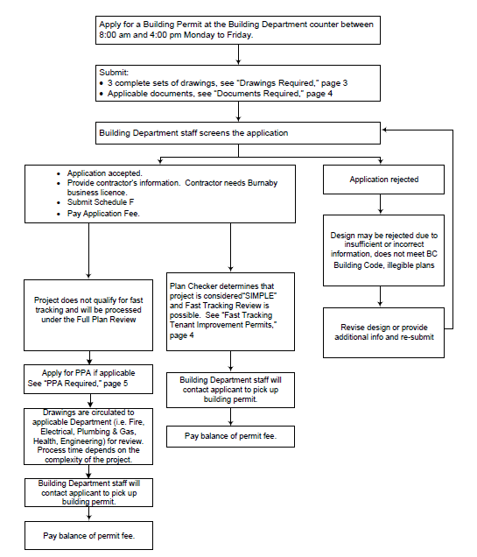

Figure 1: Building Permit Application Process in City of Burnaby. (City of Burnaby , 2017)

# 8.0 ORGANIZATIONAL CHART

## 8.1 See attached Organization Chart

# 9.0 REFERENCES

City of Burnaby . (2017, July 24). *City of Burnaby .* Retrieved from City of Burnaby Web site : https://www.burnaby.ca/Assets/city+services/building/Brochures+$!26+Bulletins/General+Information/Tenant+Improvement+Permits.pdf

(2019). *QMP 6.1 Engineering Project Procedures.*

# 10.0 ATTACHMENTS

## 10.1 Organizational Chart

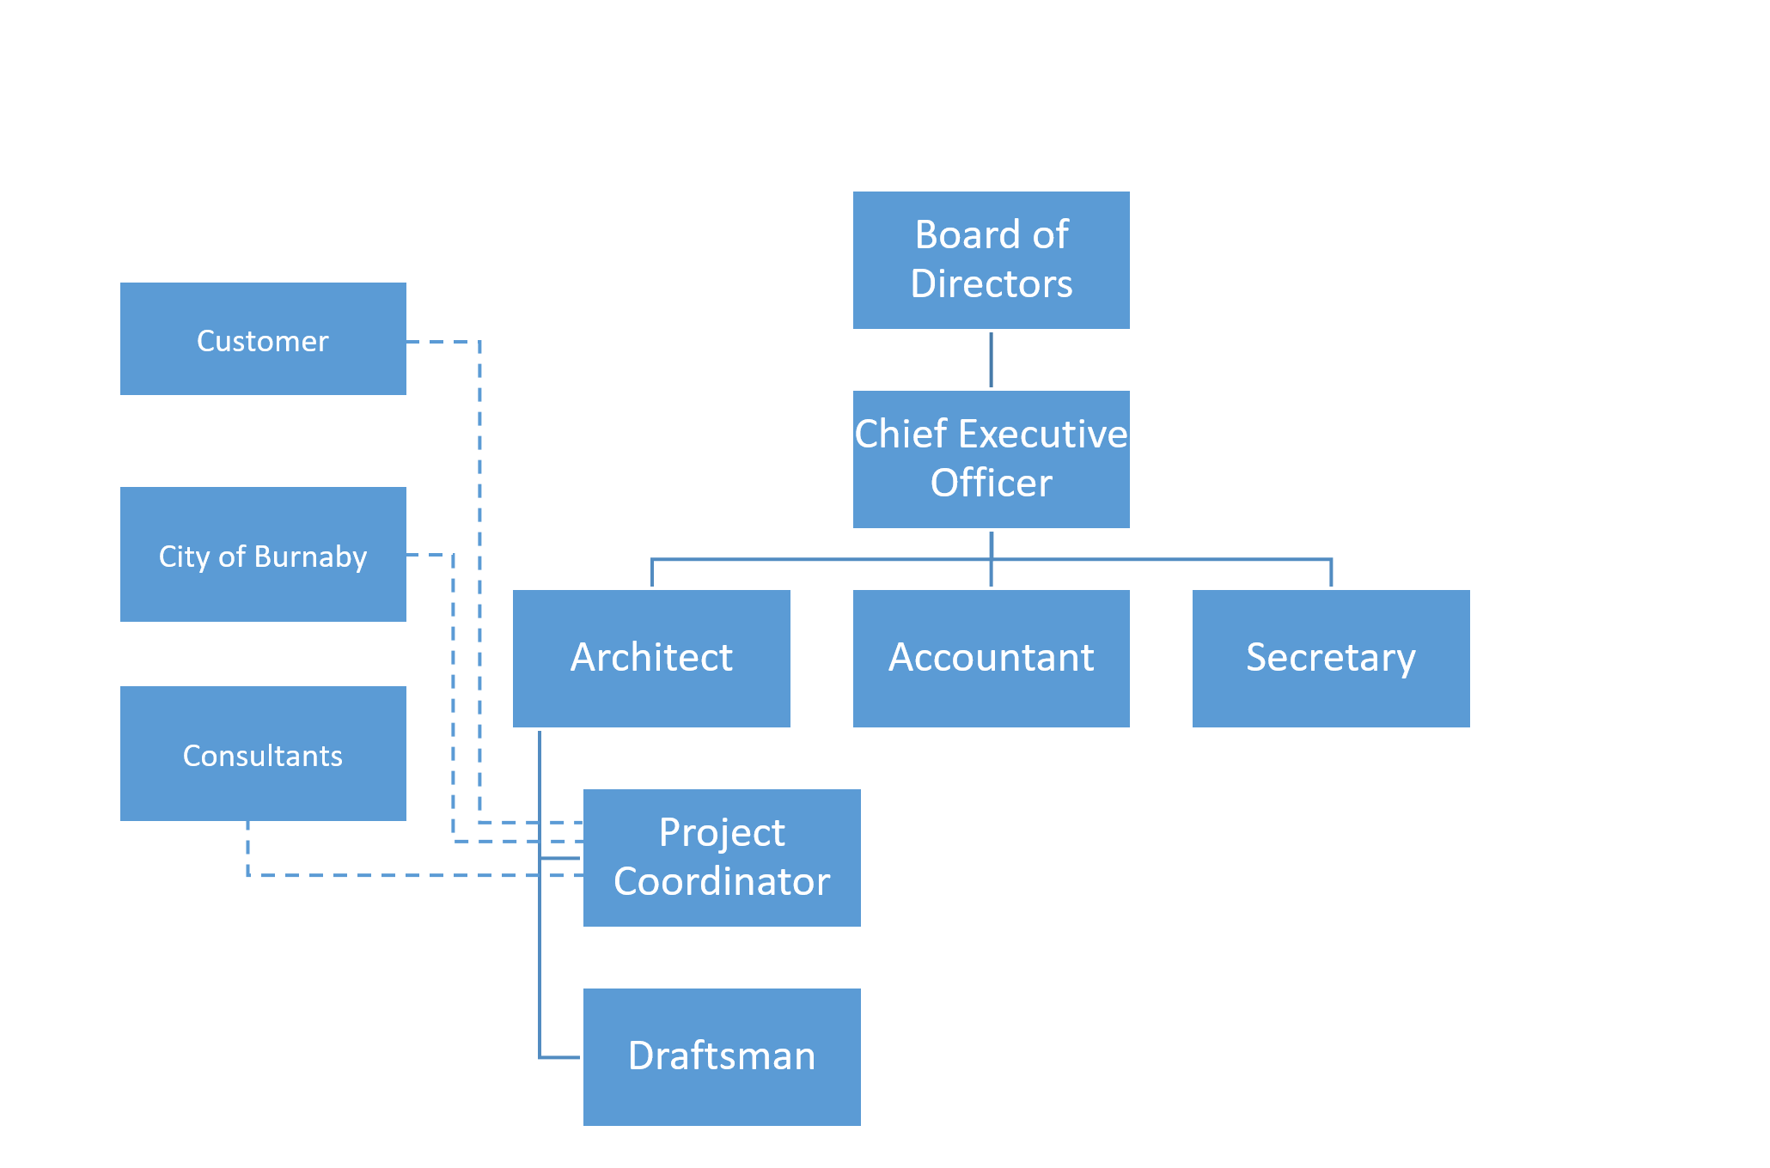

## 10.2 BPD Requirements by City of Burnaby

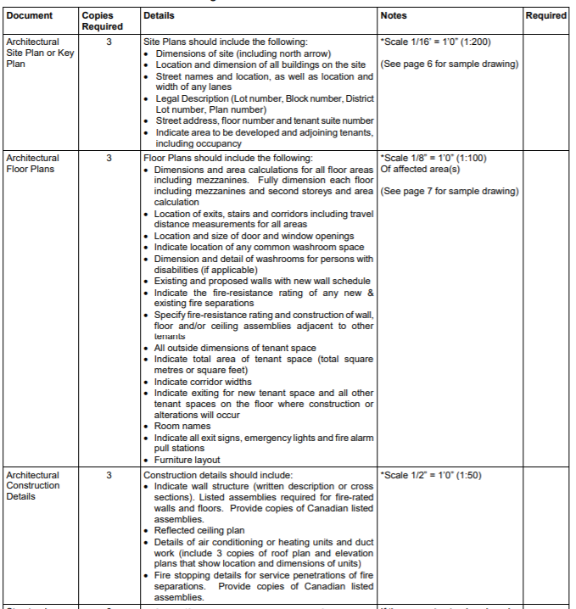

(City of Burnaby , 2017)

## 10.3 Drawing Checklist for Coordination

|  |  |  |  |  |  |  |
| --- | --- | --- | --- | --- | --- | --- |
| **Drawing Checklist for Coordination** | | | | | | |
| **Item**  **No.** | **Item of Work to be Inspected or Tested** | **Circle**  **P= Pass**  **F=Fail** | | **Notes** | **Check by Project Coordinator** | **Comments** |
| 1 | Issue Date | **P** | **F** | Date when the drawings will be sent | Date:  Initial: |  |
| 2 | Issue To | **P** | **F** | To whom are the drawings being sent to | Date:  Initial: |  |
| 3 | Drawing Number | **P** | **F** | Number of drawing pages (A100, A101…) | Date:  Initial: |  |
| 4 | Sheet Name | **P** | **F** | _ | Date:  Initial: |  |
| 5 | Project Address and Project Name | **P** | **F** | _ | Date:  Initial: |  |
| 6 | North Arrow | **P** | **F** | Orientation | Date:  Initial: |  |
| 8 | Scale | **P** | **F** | Drawings should be easily readable | Date:  Initial: |  |
| 7 | Fenestration Layouts | **P** | **F** | Correct placement of fenestrations | Date:  Initial: |  |
| 8 | Room Names and  Room Layouts | **P** | **F** | _ | Date:  Initial: |  |
| 9 | Drawings consistent with client feedback | **P** | **F** | _ | Date:  Initial: |  |

## 10.4 Flow Chart

