**Project:**

*Single-Family Residential*

**Hepco’s Excavation**

Work Method:

**Excavation**

Prepared by:

**Mark Burrill**

**Alireza Khalili**

**Denise Reyes**

Modified by:

**Ali Reza Khalili**

for:

**Hepco Construction Ltd**

And for:

**BCIT 7246 Quality Management in Construction**

# Proponent and Work Method Description

**Company Name:** Hepco Construction Ltd.

**Company Type of Service:**  Subcontractor

**Company Representatives:** Mark Burrill, Ali Reza Khalili, and Denise Reyes

**Reference Project Name:** BKR-001-A (Smith Residence)

## Project Description:

We are a Subcontractor that specializes in excavation and most of our projects are single family residential buildings that have basements. We do our best to provide the best quality of service and finish our work in a timely manner for the benefit of the clients. We also make sure to identify the particular changes in each project we partake such as geographical location, topography of land, weather (relative humidity and moisture condition), and many more. We hope our services will be able to reach out to the farther parts of Canada and someday branch out to different countries as well.

**Work Method Scope –** This scope of work applies and consists of the work related to the project “Smith Residence”. In reference to previous projects, the standard rules and regulations must be applied.

*In most projects excavation indicates the start of a project after demolition. Excavation is considered a high-risk operation; hence the safety measures are to be considered.

**Work Method Activity Description:**

This Work Method aims to be a standard guide for typical single residential homes, given that the soil has had prior surveying and inspection by geotechnical engineers and professionals.

Note: This is a controlled document. Those listed herein are recipients for future editions.

This document provides a focused Work Method (WM) format – for Robinsons Construction LLP. This is the detailed format that includes all of the items necessary for the project.

|  |  |
| --- | --- |
| **Signature Page** | |
| **Originator:**  Name:  Date:  Signature: | **Construction Supervisor:**  Name:  Date:  Signature: |
| **Site Safety Officer / Coordinator**  Name:  Date:  Signature: | **Foreman:**  Name:  Date:  Signature: |
| **Quality Manager: Approver**  Name:  Date:  Signature: | **Project Manager:**  Name:  Date:  Signature: |

As Approver and Quality Manager, with my signature, I confirm that this Work Method is the plan for construction of the work. If the plan changes, the person making the change will notify me so that the Work Method can be revised. Alternately, I will propose suggested revisions, review with the foreman or superintendent, for reissue to those on the distribution list.

As a Reviewer, my signature confirms that I have reviewed the document and any comments to the WM have been provided to the Originator and to the Approver.

**Limitation of liability: Any organization engaged by GC as a Contractor or Subcontractor (the Contractor) agrees to use this Work Method only under the condition that those that wrote and developed this Work Method are to be held harmless for any errors or omissions, any inaccuracies in content resulting in any damages to property or any injury to any personnel that may be involved. It remains the sole responsibility of the Contractor to review any and all items contained in the above Work Method and to make any changes that may be required in order to satisfy any project specification or any regulatory or statutory obligation. As well, the Contractor shall review any and all suggested methods as contained herein and shall make any changes required and shall reissue prior to commencement of construction in order to achieve the specified product or to provide a safe work site for all workers involved. Ownership and final responsibility for the use of all Work Methods remains with the Contractor.**

Table of Contents

Proponent and Work Method Description 2

Project Description: 2

1.0 PURPOSE 5

2.0 SCOPE 5

3.0 DEFINITIONS AND ACRONYMS 5

4.0 RESPONSIBILITIES AND AUTHORITIES 5

5.0 SAFETY 7

6.0 ENVIRONMENTAL ISSUES 7

7.0 CRITERIA 8

8.0 REFERENCES 8

9.0 TOOLS & EQUIPMENT 8

10.0 PROCEDURE 9

10.1 PROFESSIONAL ENGINEERS & PLANNING: 9

10.2 INSPECTION AND PLANNING 9

10.3 EXCAVATION 10

10.4 OPERATIONAL PAUSE 12

10.5 BACKFILLING 12

11.0 QUALITY ASSURANCE APPROVAL 13

12.0 ATTACHMENTS 13

12.1 Inspection and Test Plan ITP/ Check List # 14

12.2 Flow Chart 15

12.3 Excavation Project Specs 16

# PURPOSE

1. The following work method is based on personal experience, as well as referring to the construction code and ASTM references for soil testing and properties. Contractors planning to perform excavation work must register as excavation contractors with the Workplace Safety and Health Division.

# SCOPE

* 1. This Method Statement describes a proper work procedure shall be carried out during the open excavation stage for residential buildings based on project’s specification and contract drawings.

# DEFINITIONS AND ACRONYMS

QA Quality Assurance

QC Quality Control

WM Work Method

ITP Inspection Test Plan

IF Inspection Form

* **Excavation** means a dug-out area of ground and includes a deep foundation excavation, trench, tunnel and shaft.
* **Open Excavation** means an excavation in which the width is greater than the depth, measured at the bottom.
* **Geo Tech Engineer** means a person who is a member of the Association of Professional Engineers and Geoscientists of BC, and holds a valid certificate of registration under The Engineering and Geoscientific Professions Act.
* **Shoring** is an assembly of structural members designed to prevent earth or material from falling, sliding or rolling into an excavation.

# RESPONSIBILITIES AND AUTHORITIES

* 1. **Geotechnical Engineer**
     + Responsible for mapping of technical results obtained from borehole and subsurface surveys
     + Investigate subsurface conditions and materials to determine their properties and risks
     + Responsible for performing a field review and examining the soil, rock, underground water, and site and structural conditions of the project
     + Performs appropriate calculations for data reports
     + Provides direction to technical team in field
  2. **Excavator Operator**
* Responsible for safely operating machinery for excavations, backfilling, trenching, ditching, slope work, erosion control, grubbing, stumping, clearing, looming, and fine ground
* Also responsible for final clean-up
  1. **Labourers** 
     + Assisting the operator and engineers with layout measurements
     + Responsible for giving direction and verifying soil conditions and giving warnings to operator
  2. **Site Supervisor**

Aside from the ordinary duties, site supervisor is responsible for:

* Ensuring the good flow of excavation process
* Measures for excavator and trucks entrance and leave
* Maintaining a site log.
* Ensuring the safety of workers and ensuring that safety practices are followed.
  1. **Crew Leaders**

Crew leaders have four basic responsibilities:

* Providing on-the-job training and supervision for semi-skilled and unskilled volunteers.
* Ensuring necessary tools are on the site for specific tasks.
* Maintaining safety - use of equipment, protective measures for workers, conducting safety-quality tool box meetings, Safe Work Procedures (or coordinate their production with the safety officer) etc.
* Maintaining quality - the crew leaders should perform tasks that require a high level of skill. Crew leaders also should be able to quickly assess the abilities. He/she must be able to teach crew members proper construction techniques answer their questions and show patience.
  1. **The Site Safety Officer**
* Must have WorkSafeBC accreditation
* Ensures that the affiliate’s safety policy is being followed on the build site at all times.
* Must not be responsible for overseeing any part of the construction process other than safety.
* Ensures that all those working at the site have completed the required safety training.
* Inspects the build site for any possible safety hazards.
* Has the authority to shut down the site, if necessary for safety reasons.

# SAFETY

All work practices and job procedures are to conform with the authority having jurisdiction and to:

* Work Safe BC regulations and practices
* All applicable instructions, codes, regulations, and acts
* Field inspection to ensure there are no hazardous material or contamination on site.
* Reviewing resources for any possible pipes or power lines in the excavation field
* All works shall comply with safety procedure or instruction as set in out in project Safety Plan and Municipality rules and regulation.
* Basic Personal Protective Equipment (steel toe boots, hi-visibility vest, hard hat, eye and ear protection) shall be worn by all staff, laborers and visitors.
* Trained operator or shall be engaged to control or operate heavy equipment machine.

**\*Note:** It is advisable to consult with a geotechnical engineer prior to the start of excavation to reduce risk of avoidable ground movement at adjacent properties as well as safety of personnel onsite, and possibly costly damages.

# ENVIRONMENTAL ISSUES

         The following are the considerations for dealing with environmental issues:

* Inspection of the site condition and the soil for avoiding the excavation of soil mixed with hazardous elements.
* To prevent the water run mixed with mud being discharged into the water discharge system, based on BC’s raining conditions, in addition to silt sheeting the subleveled sides, one may need to consider using the sump hole, located in the sub elevated considered corner as instructed by planning, filled with gravel to separate the mud from water; then discharging the clear water.
* During the excavation, if faced with undesirable soil types, such as blue clay, the digging must go deeper, as instructed by Geotechnical Engineer, and adjusting the elevation with appropriate amount of compacted subbase material.
* If the site’s soil conditions were not suitable for the back fill, it must be removed and suitable soil material brought in for the backfill.

# CRITERIA

1. Checking with the engineer planning for parking and septic system location.
2. Referring to Geotechnical engineering firm and planning to know if excavation will reach below the natural water level. (If so, additional septic tank is required to collect, and settle the mud before discharge)
3. Inspecting the type of soil in the field to implement the best suited method of approach (checking if there is any large bedrock in our excavation and implement the safe controlled explosion with minimum impact of surrounding structure.)
4. Based on plans, take the best suited route and approach.
5. If there is a risk of soil failure planes, implementation of shotcrete and anchoring based on engineering suggestion.
6. Periodic depth measurements by a skilled worker on site. As we reach our desire depth, measurements become more frequent to ensure no over excavation and added costs.
7. After reaching the desired depth and leveling, along with soil compaction. We need to test the load bearing capacity of the soil to meets the requirements of the project (if needed additional measures will be implemented such as piling or widening the footings to meet the requirements.
8. Consideration for the spacing between the excavated soil and the edge of our excavation, to be equal or greater than our final depth.
9. Check for soil permeability (existence of layers).
10. Safety Considerations for surrounding structures.
11. Considerations for employees, gear, and operators both in terms of operation and safety.

# REFERENCES

* + 1. Based on excavation work experience with Hepco Construction Ltd
    2. Work Safe BC (Part 20: Excavation)
    3. BC Building Code
    4. Vancouver Building By-Law

# TOOLS & EQUIPMENT

1. Excavator
2. Compactor
3. Dump Truck
4. Calculated depth of each excavation corner
5. Surveying equipment
6. Measuring stick and measuring tape

# PROCEDURE

Below describes the excavation procedure described in three major stages, as the following:

## PROFESSIONAL ENGINEERS & PLANNING:

1. Acquire an excavation permit from the city for the specific lot and project.
2. Parking location. If the parking spaces are not sufficient for a desired project, for street parking, the allowance must be followed up with the city.
3. Sewer and Drainage location. If drainage require additional considerations for pump-septic system, or we can take opportunity of natural slope.
4. Erosion tests. If the depth of excavation goes below the natural water levels, additional steps must be taken to pump the water into a tank which the mud can settle and then the clear water can be pumped out.
5. If the depth of excavations could cause risk for neighboring structures. Based on the professional engineer’s opinion and obtained design for shoring, either use the shotcrete and anchoring on the required wall, or the steel plates can be placed in required sides.
6. If the excavation project is occurring during a period where substantial rain fall is forecast, tarping the walls and 2 meters back of the edges of the excavation will prevent the moisture content of the soil to increase. This will minimize the risk of soil destabilization around the edges of the excavation and increase workers safety.

## INSPECTION AND PLANNING

1. Existing Services – conduct an investigation and acquire information about buried site services. Services, wherever found shall be marked, protected, and if necessary moved as to not affect site activities.
2. Before the excavation starts, the excavation site must be free of standing water. If removal of excess water is necessary, additional settling tank may be required to allow the muddy water to settle, and clear water to be discharge into city’s storm drains. Depending on preexisting ground water and weather conditions the removal of excess water may need to be repeated during the excavation process.
3. Excavation Slope Stability is to be reviewed by Geo Tech Engineers for safety, structural, and logistical reasons. All soil types require that excavation slope stabilization measures are implemented which includes excavation cut slope or installing temporary excavation support where there is insufficient space for sloping; and acting in accordance to the Geo Tech Engineering opinion and recommendation.
4. A site survey would be conduct. The site survey would mark/stake-out the building lines and corners. It would also establish a Bench Mark to reference for the excavation elevations and to compare to the approved drawing.
5. Place the hoarding, security fences, and tree protection for all excavation activities, adequate safety barriers, sign boards, and no parking signs would be used. In addition to the fences, the project information, adequate permits, and trucking bylaw route must be attached to be visible by people outside the site.
6. Delivery of excavation equipment onto the site. Determining the proper site access and adequate position for extraction (this consideration becomes more important as depth of excavation increases). Also, consideration for adequate positioning for the dump trucks to stop for loading. Ensure safe work methods are used. Ensure, only short-term traffic stops are allowed, hence consider providing side access, rather than main road blockade, as permitted.
7. Double check to ensure that lot building placement survey and markings are done correctly in accordance to the specs of the project. The area to be excavated shall be properly marked and clear before starting the works. Batter boards may be necessary so that building corners are not lost during excavation.

## EXCAVATION

1. Make sure all services (electrical, gas, water, telephone, and cables) are disconnected. Show where the storm and sanitation connection are located.
2. The proper starting corner of the excavation is determined by the excavation management in accordance for future considerations. Plan where the trucks are going to be loaded and where the start of excavation going to be. So, once you start at the furthest point and work your way back to where the access to the job is which at the end of excavation excavator is going to be picked up.
3. Starting the excavator operation by digging a corner as rough depth grade, slightly higher than the required excavation. This point will be used as an eye reference for expanding the excavation within the reference range. This elevation can be determined by the given elevation of bench mark by surveyor.

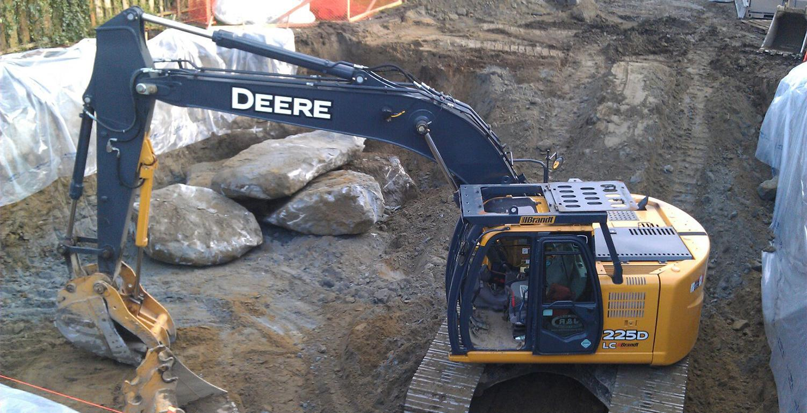

**Figure 1. Excavation during rainy season**

**Note 1:** During the rainy seasons in BC, it is part of the procedure to cover the edges of excavation and excavated material by large tarps or plastic covering as shown in Figure 1. Based on experience in BC, this step strongly helps the prevention of slope failure during heavy rains. As water content rises in the soil, the soil is weakened and susceptible to failure (and “failure planes” on the loaded side).

1. As excavation progress, the depth of excavation shall be periodically checked by the onsite personnel with respect to the elevation of our rough depth digging
2. Pile all the excavated material so that the material cannot roll back or add to the risk of slope failure. The excavated material must never be placed near than three feet from the edge of the excavation. Ideally, the excavated material should be placed as far away from the edge of vertical excavation as the excavation height (d ≥ h : See Fig. 2 below).

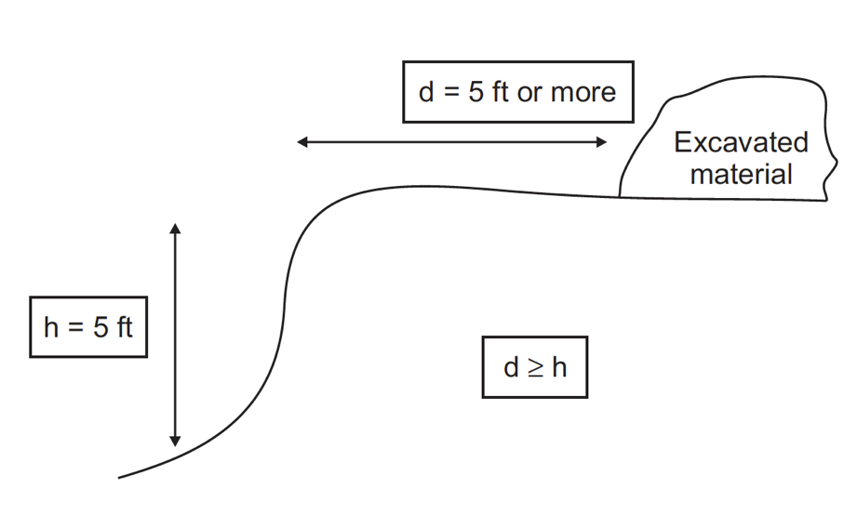

**Figure 2.**

1. The bank of excavated area shall be sloped and shall be maintained to avoid a collapse of the bank into the excavated area. The sloping of the bank is to be done in accordance with Work Safe BC regulation (see Fig 3 below). In case 2; A to B shall not exceed 4 feet and H/V shall be 3/1 (WSBC 2018). If site dimensions do not allow for this consideration, additional steps are to be taken in accordance to Geo Tech Engineering approach, such as shoring).

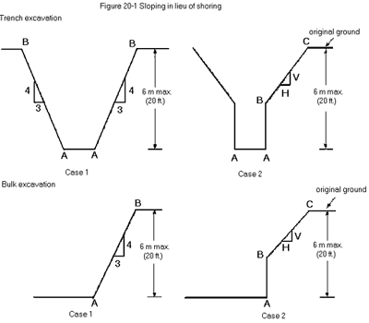

**Figure 3.**

1. The excavated dirt is collected in a suitable corner that is reachable for dump truck position; as noted in decisions made in Section f above. Variety of options depends on site specs and positioning logistics of the site (If there is side or back access).
2. Dirt removal can be done in stages or all at once, depending on the site logistics, when reaching the required excavation depth. Note: adequate amount of soil must be kept for backfill
3. When required depth of the four main corners is reached, the surface shall be leveled and shall be compacted to 95 % of maximum dry density or MDD. The slightly higher elevation considered in “rough depth” allows leveling to be implemented by removing layers from the top as well as large boulders in soil, in order to have a proper compaction implemented on the base of the excavation.
4. The Geotechnical Engineer will then do an inspection of the finished excavation. They will provide a report allowing the commencement of forming the foundation and ensuring safety of the site

## OPERATIONAL PAUSE

Allowing the required steps taken by other sub-contractors for completion of footings, foundation, drainage, damp proofing, basement gravel. In this stage the excavator, compactor and other equipment is removed from the site to attend other jobs. The excavator is scheduled to be back on site on date these tasks are scheduled to complete.

## BACKFILLING

1. After completion of the foundation (Footing, slabs, walls, and damp proofing) and passing the relevant inspections prior to backfilling, the drainage, damp proofing and insulation of foundation walls shall be inspected by the city.
2. Arrival of preferably smaller excavator and compactor onsite.
3. Backfilling shall commence using similar excavated material. The drain pipe may require drain rock. Care shall be taken to remove bolder, vegetation and any other unwanted materials.
4. The sub-grade once approved, the excavated materials or any material source approved by the Engineer shall be placed in layers not more than 300 mm thick, followed by compaction. Then adding another layer and performing compaction accordingly. Compaction is needed to reduce the amount of settlement that occurs in time. Also, it ensures the healthy life time of foundation walls (quality work).

**Note:** The compaction, using a small compactor (Vibratory Plate Compactor) must be performed carefully, avoiding the possibility of damaging the foundation damp proofing. It is advised that additional soil is shoveled on the edges of foundation wall, this creates a small protective slop/edge which reduces the risk of damaging the seal or pipes by operator performing the task carefully

1. Backfilling followed with compaction shall continue as described in step d until final required elevation is achieved.
2. Inspection for compaction test(this step is not required for residential units).
3. The equipment is ready to be transported to the next job site.

# 11.0 QUALITY ASSURANCE APPROVAL

1. Geotechnical Engineer’s Approval
2. Inspection and Test Plan
3. 7.3 Project HSE Plan

**Note:** If soil was not qualified for the foundation work, steps must be taken by subcontractors for foundation quality. Often number of piling placement reaching the bed rock will provide the loading bearing capacity required. In other special cases, the widening of the footings might be suggested by the engineer.

# 12.0 ATTACHMENTS

* 1. Check List
  2. Flow Chart
  3. Org Chart

|  |  |
| --- | --- |
| 12.1 Inspection and Test Plan ITP/ Check List # | |
| Revision: BKR Excavation | Date: 2018-02-21 |
| Prepared By: Mark Burrill  Reviewed By: Ali Reza Khalili and Denise Reyes | BKR Excavation |

|  |  |  |  |  |  |  |  |  |  |  |
| --- | --- | --- | --- | --- | --- | --- | --- | --- | --- | --- |
| **Item No.** | **Work or Report to be Inspected or Tested** | **Method** | **Acceptance Criteria, can also reference spec item or spec #** | **QC Frequency Inspection/ Test** | **QC by** | **\*Verification**  **H: Hold**  **W: Witness**  **D:Document** | | **Date checked** | **PM** | **QC Insp. Initial** |
| 10.1 a | Excavation Permit | Visual | Permit approved and stamped by city. | Prior to equipment mobilization | Site Supervisor | H | D |  |  |  |
| 10.2a. | Existing Services Located | Visual & Measure | As per W.M. # 10.2a. | Prior to equipment mobilization | Site Supervisor | W | D |  |  |  |
| 10.2b. | Excess water removal plan | Visual | As per W.M. # 10.2b. | Prior to equipment Mobilization | Site  Supervisor |  | D |  |  |  |
| 10.2d | Site Survey | Visual & Measure | As per W.M. # 10.2d | Prior to equipment mobilization | Site Supervisor | H | D |  |  |  |
| 10.2e.  10.2g.  10.3a. | Public & tree protection/ fencing | Visual | As per W.M. # 10.2 & 10.3a | Prior to equipment Mobilization | Site Supervisor | W | D |  |  |  |
| 10.3b | Excavation equipment Mobilization | Visual | As per W.M. # 10.3b | Prior to excavation | Site Supervisor |  | D |  |  |  |
| 10.3c. | Excavation | Visual & Measure | As per W.M. # 10.3c | Prior foundation work. | Site Supervisor | H | D |  |  |  |
| 10.3h. | Stock piling material or removal & Storage | Visual & Measure | As per Work Safe standards, and W.M. 10.3h. | Prior foundation work. | Site Supervisor | H | D |  |  |  |
| 10.4j | Geo Tech Excavation Inspection | Visual & Measure | Review excavation inspection and proceed as requested | Prior to foundation work. | Site Supervisor | H | D |  |  |  |
| 10.5 | Backfilling | Visual | As per W.M. # 10.5 |  | Site Supervisor | W | D |  |  |  |

Stop work! So that foundation Forming can take place

Stock Piling or Removal of Excavated Material

Excess Water Removal Plan

Site Survey & Geo Tec Report

Public & Tree Protection

Excavation Permit

Existing Site Services Located

## 12.2 Flow Chart

## 12.3 Excavation Project Specs

Below describes the detailed plots, the initial average grade, and their finishing grade for the points presented in the project plan in following page.

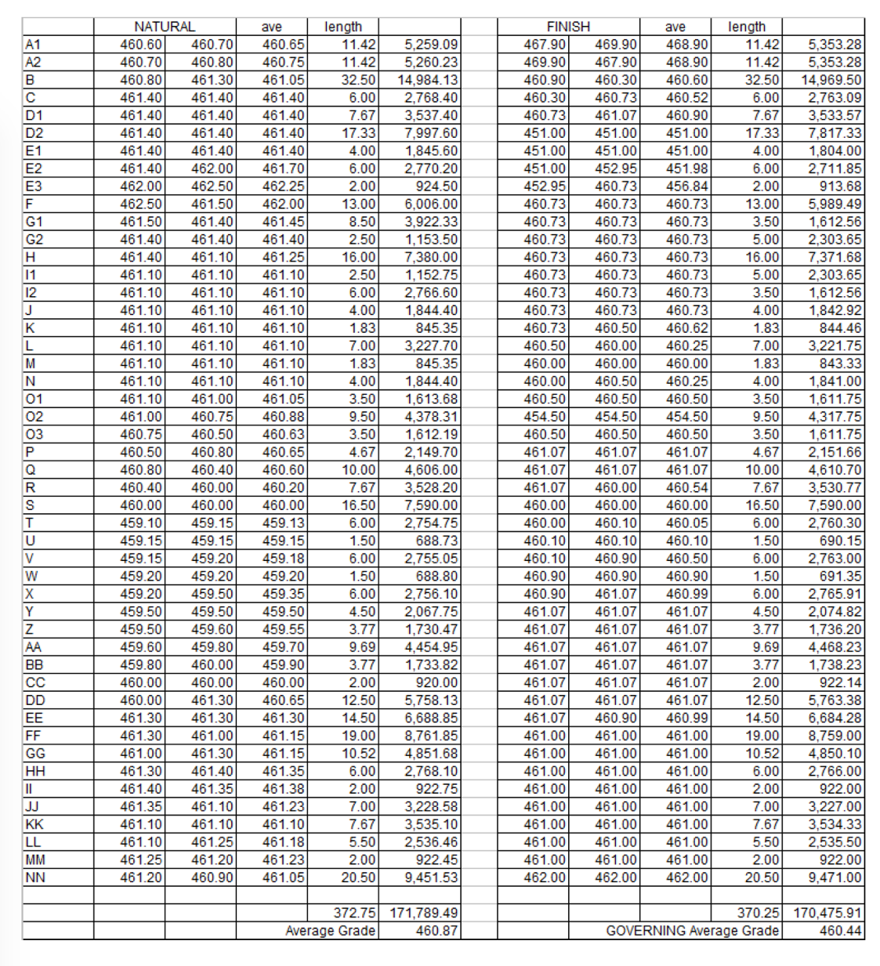

Table describing project excavation plots