**Restorations Unlimited**

*Figure 1: Piccadilly Court Townhomes..*

**08 01 52 Work Method: Window Replacement & Restoration**

*Prepared by*:

Matthew Kudyba A01185195, Spencer Crowter A00885610, Nolan Cayer A00818797

*Prepared For:*

*And for:*

Jim Turnham BCIT 7246 Quality Management in Construction

**Overall Mark: Rev 0**

**Revise and Resubmit Rev 1**

**Rev 1 of Quality Plan**

Spencer, Matt, and Nolan:

**Thx for the “Pay-it-forward”** per my Linkedin.   <https://www.linkedin.com/in/jimturnham/>

**Proponent and Work Method Description**

**Company Name**: Restorations Unlimited.

**Company Services**: General Contracting, Construction Management, and Subcontracting.

**Company Representatives:** Spencer Crowter, Nolan Cayer, Matthew Kudyba.

**This Work Method is generally applicable to:**

Any project that involves the removal and replacement of a window failing to prevent water ingress in a wood frame building.

**Scope:**

This work method was written for the Restorations Unlimited restoration of Piccadilly Courts Townhome complex in Burnaby. Many of the units suffered water ingress from improperly installed windows. This work method will cover the testing, removal and replacement of a failing window.

**Work Method Activity Description:**

The activity covered in this work method is the removal and replacement of a failing window. It will detail how to test if a window is failing to prevent water ingress (moisture testing), what signs to look for (mold), and how to safely remove and replace the window unit correctly.

This document provides a generic Work Method (WM) format-that conforms to the management system within Restorations Unlimited organization. This is a detailed report that includes all items necessary to ensure successful completion of contracts.

|  |  |
| --- | --- |
| **Signature Page** | |
| **Originator** | **Project Manager**: |
| Name:  Date:  Signature: | Name:  Date:  Signature: |
| **Originator** | **Construction Supervisor** |
| Name:  Date:  Signature: | Name:  Date:  Signature: |
| **Originator** | **Site Lead Hand** |
| Name:  Date:  Signature: | Name:  Date:  Signature: |

As Approver and Quality Manager, with our signature, we confirm that this Work Method is the plan for construction of the work. If the plan changes, the person making the change will notify Spencer Crowter, Nolan Cayer, or Matt Kudyba so that the Work Method can be revised. Alternately, we will propose suggested revisions, review with the supervisor and superintendent, for reissue to those on the distribution list.

As Reviewers, our signatures confirm that we have reviewed the document and any comments to the WM have been provided to the Originator and to the Approvers.

**Limitation of Liability:**

**Restorations unlimited and any other user, authorized or not (collectively identified as The Contractor), agrees to use this Quality Plan, Quality Management Procedures, and/or Work Methods (collectively referred to as the Quality Documents) only under the condition that those that have written and provided this Quality Documents including BCIT are to be held harmless for any errors or omissions, any inaccuracies in content resulting in any damages to property or injury to any personnel that may be involved. It remains the sole responsibility of The Contractor to review any and all items contained in the above Quality Documents and to make changes that**

**Limitation of Liability Cont’d:**

**may be required in order to satisfy any specification or any regulatory or statutory obligation. As well, The Contractor shall review any and all suggested methods as contained herein and shall make any changes required and shall reissue prior to commencement of construction in order to provide a safe work site for all workers involved. Ownership and final responsibility for the use of all Quality Documents remains with The Contractor.**

**Contents**

1.0 Purpose 6

2.0 SCOPE 6

3.0 DEFINITIONS and ACRONYMS 6

4.0 RESPONSIBILITES & AUTHORITIES 7

5.0 SAFETY 9

6.0. ENVIRONMENTAL REQUIREMENTS 9

7.0 INSPECTION AND TESTING 10

8.0 SUBMITTALS 10

9.0 SPECIFICATIONS and/or Contractor quality management requirements 11

10. Generic Work Method Check List 12

11. Procedure 14

12.0 ORGANIZATION CHART 24

13.0 REFERENCES 24

13.1 FIGURE REFERENCES 24

14.0 ATTACHMENTS 26

14.1 Inspection and test Plan (ITP) 27

14.2 Org Chart 28

14.3 Procedure Flow Chart 29

## 1.0 Purpose

* 1. To define the responsibilities and describe the method to be used by Restorations Unlimited (RU), project managers, site supervisors and skilled workers to remove and replace residential windows. This work method envisages that an internal RU labour crew will perform the work, with minimal work subcontracted out. ✔
  2. The main goal of this work method is to ensure that all windows retrofitted by Restorations Unlimited are installed correctly; ✔ Above the quality required by BCBC 2018.
  3. To be reviewed all crew members prior to commencing window installation and to be reviewed regularly at WM Review Meetings.
  4. To be referenced and followed during the work to ensure proper installation and quality is met.

## 2.0 SCOPE

* 1. This work method shall apply to the construction of all residential window installation.
  2. Reference Standards
     1. British Columbia Building Code 2018.
     2. Rules and regulations from Authority Having Jurisdiction (AHJ)

## 3.0 DEFINITIONS and ACRONYMS

QA Quality Assurance

QC Quality Control

WM Work Method

ITP Inspection Test Plan

IF Inspection Form

AHJ Authority Having Jurisdiction

RU Restorations Unlimited

RO Rough Opening

CSO Construction Safety Officer

SS Site Supervisor

RE & RE Remove & Replace

## 4.0 RESPONSIBILITES & AUTHORITIES

the responsibilities and authority of RU personal pertinent to this work method are outlined below.

### 4.1 Project Manager

* Establish and maintain positive relationships with the client, consultants, subcontractors, public and project team
* Manage all aspects of the project including profitability, schedule adherence and customer expectations
* Work with Superintendent to develop and monitor the project schedule
* Develop recovery strategies when project schedule or budget are in jeopardy
* Resolve project disputes in a timely manner
* Negotiate and issue subcontracts and major purchase orders and monitor their progress and schedule
* Work with Superintendent in establishing the construction plan and engineering methods
* Assist Superintendent in establishing and maintaining project safety culture
* Review/approve subcontractor applications for payment
* Chair relevant consultant/owner project meetings and effectively communicate status of project
* Process all change orders, including negotiating and assessing cost and schedule impact
* Manage all facets of project close-out, including archiving of documents, maintenance and warranty manuals, deficiencies and warranty work
* Approve all purchase orders over a value of $300.00.

### 4.2 Site Superintendent

* provide direct supervision and coordination to general foreman, sub-contractors, project equipment, material and labour
* have the authority to direct all RU site personnel and are responsible for the project being completed:
* on time
* on budget
* to a quality that meets or exceeds standards defined in the contract, BCBC, and/or RU’s own quality standards
* Maintain a close relationship to the project manager; must report site based issues on a daily, weekly, and monthly basis

### 4.3 Quality Supervisor

* Reviews contract documents and heads the development of the Project Quality Plan (PQP)
* Implements, coordinates and maintains systems and procedures in accordance with PQP
* Ensures quality records are accurately completed
* Identifies and corrects non-conforming conditions and deficiencies when materials, products or labour do not meet the required specifications
* Develops inspection test plans to meet project requirements
* Interfaces with project teams, sub-trades, clients and contacts to ensure quality standards are being met
* Provides RU’s quality manager with ongoing measurements to improve efficiency and quality of RU’s work methods

### 4.4 Carpentry Foreman

* Supervise, co-ordinate and instruct the activities of carpenters and labourers who construct, renovate and maintain structures of wood and other building materials
* build and install interior finishing and structural framing in residential, commercial and industrial buildings
* Establish methods to meet work schedules and co-ordinate work activities
* Lead through example, and teach apprentices proper wood framing and finishing methods
* Ensure work carried out meets the quality outlined in the PQP
* Maintain safe, secure, and healthy work environment by following and enforcing standards and procedures; complying with WorkSafeBC regulations
* Requisition materials and supplies
* Resolve work problems and recommend work measures to the superintendent to improve productivity
* Train or arrange for training of workers
* Maintain the security of equipment

### 4.5 Construction Safety Officer (CSO)

* Ensures all workers and visitors are always following RU’s safety rules and regulations while on site
* Conducts site safety orientations with all personnel before they enter the site
* Must not be responsible for overseeing any part of the construction process ONLY responsible for safety
* Ensuresthat all those working at the site have completed the required safety training (IE fall protection training)
* Establish and maintain a First Aid Station with all required equipment and supplies
* Regular inspection of all safety equipment for wear and compliance (fall protection, fire extinguishers, etc.)
* Take daily headcount of all RU personnel and Subcontractors on-site
* Inspects the building site for any possible safety hazards
* Provide Level 2 or 3 first aid
* Has the authority to shut down the site, if necessary, for safety reasons
* Maintains safety documentation of subcontractors working on site
* Ensure all traffic control is executed in a safe manner
* Ensure the public is protected from site hazards (adequate signage and hoarding)

**Safety is of the utmost concern on any build site, so it is important to have someone monitoring the safety conditions at all times. Volunteers shall be trained on safety requirements on the job site and informed that their safety on the jobsite is Restoration Unlimited priority. Ultimately, it is individuals using safe methods and making safe choices that contribute greatly to individual safety. Individuals always remain personally responsible for their own.**

## 5.0 SAFETY

All work practices and job procedures are to conform with the authority having jurisdiction and to:

5.1 The Restorations Unlimited Health and Safety program.

5.2 All applicable instructions, codes, regulations and acts.

5.3 Work safe BC OHS regulations and best practices.

.

5.4 BCCSA COR program

## 6.0. ENVIRONMENTAL REQUIREMENTS

2. 1. Care should be exercised to prevent the inhalation and spread of any potential asbestos so health risks may be minimized.
   2. Due care regarding the release of excess dust and debris into the air so health risks may be minimized.
   3. Care and attention while working near bodies of water or run-offs to minimize contamination.
   4. Garbage and debris to be properly disposed of and follow any requirements put forth by AHJ.

## 7.0 INSPECTION AND TESTING

* 1. Please refer to the attached inspection and testing plan (ITP).
  2. Specifications provide Foreman and crew with instructions on allowable tolerances and an Inspection Form (IF) for recording that specified requirements were achieved.

## **8.0 SUBMITTALS**

* All material requisitions over $300.00 by RU personnel and subcontractors must be approved by the project manager; Requisitions under $300.00 can be approved by the superintendent or the quality supervisor.
* All employee hours are to be submitted electronically on a daily basis through the exaktime application
* Equipment rentals to be paid for by RU must be approved by the project manager if the rental charge exceeds $300.00.
* All Subtrades must submit a signed form stating they will comply with the quality standards in RU’s QMP and PCP; see QMP 2.5 of ISO9001: Subcontractor Quality Plan. ✔
* Checklists from RU’s quality supervisor are to be signed and dated after completion by their respective trade (in-house or subcontract) to comply with RU’s PCP.
* All change orders must be submitted to the corresponding RU PM in a digital and physical format
* All RFI’s submitted should have a copy forwarded to the RU PM✔
* All receipts received by site personal (for materials, deliveries, services rendered etc) must be kept and submitted to the project manager.

Submittals from sub contractors must include the following:

* Schedules
* Meeting minutes
* Product data and specs
* Shop drawings
* Test data
* Product samples

Once Restorations Unlimited has received all submittals from subtrades, a submittal Log, or Register will be completed, which lists in detail all the submittals required on our project. Our project engineer will complete this job. On our bigger projects, it will take some time to complete, so all submittals must be submitted 3 months prior to commencement on our larger sites. Next, our project manager will assign portions of the log to responsible parties. Some submittals, such as the project schedule or the waste management plan, will be assigned to Restorations Unlimited. The vast majority are assigned to the individual subs on the project. This system will help Restorations Unlimited to ensure that our project stays on track and evidently leading to a successful completion of the project.

9.0 SPECIFICATIONS and/or Contractor quality management requirements

Specifications, Quality management requirements and sources will be provided by Restorations Unlimited; all parties involved must and will conform to the provided documents. The specifications, quality management requirements, and sources documents are as follows:

* **QMP 2.5a – RFQ Quality Requirements and Commitments – small – medium scope s**ubcontractor
* **QMP 4.1a Pre-Mobilization**
* **QMP 4.2****WM and Checklist Review Meeting** (for self-performed and subcontracted work) ✔
* **QMP 4.3** **– Initial Inspection**
* **QMP 11.1** – Correct Waterproofing Checklist✔
* British Columbia Building Code 2018

The provided documents will act as the generic method to address and implement specifications and sources for our projects. Additional documents might be provided depending on site specifics; The building code will be the standard unless the Design Rep provides the specifications and documents. ✔ In RU’s field of restoration, it is unlikely an architect is involved. ✔ “Design Rep” refers to any consultant (such as a structural engineer) that may be required to engineer or design certain aspects of RU’s work. For most of RU’s work, repair and replacement of common construction items can be derived from the BCBC 2018 by field staff. The scope of work that RU provides in restoration is mostly known by any journey-man carpenter.

For situations where subcontractors do not have inspection checklists for their trade, QMP 11.1 will provide a generic starter-level checklist to subcontractors to review and develop in accordance with plans and specifications (or building code if no formal design exists). Such checklists will be submitted by subs to RU for approval, and upon acceptance, will✔ follow and maintain. All alterations to this checklist will be done by the subcontractor, unless relieved of this responsibility by Restorations Unlimited, Checklists will be site specific when completed. All checklists must be submitted to the RU project manager for approval ~~completion~~.

## 10. Generic Work Method Check List

### 10.1 Prior to Start Date

* Initial site inspection done by project manager, site supervisor, and client.
* Quality Plan is composed or edited/updated/revised to fit the needs of the current project✔
* Take off estimates for material and labour required for project:

1. Lumber / Material
2. Resources (Labour)
3. Equipment

* Deadlines and Liabilities identified and established
* Contract completed and signed.
* Subcontracts prioritized, and signing date for each trade is posted
* Schedule created; tasks organised in a Critical path method format

### 10.2 Site Prep

* Muster Station, Site Office, and Medical Station identified
* Safety plan put in place for emergency situations.
* Environmental hazards considered and prepped accordingly.
* Material drop off location
* Storage for equipment, tools, and material location identified.
* Equipment and tools delivered, stored safe and secure.
* Work Methods written, updated and scheduled for completion
* WM Review Meeting✔ held with all applicable parties in attendance; the WM review meeting will cover: ✔
* Scope of work
* Time Frame of Project & Schedule
* Safety Plan and Emergency Plan
* General Hazards included with work and surrounding community
* Environment concerns (underground rivers, power lines)

### 10.3 Daily Tasks and Methods

Daily tasks and methods will be addressed during a **Daily Toolbox Meeting** held at the beginning of the workday. Toolbox meetings will address all safety and quality✔ concerns, questions and issues. Topics covered will include:

* Daily Tasks and Expectations
* Weather and Environmental concerns
* Safety Hazards in Circulation
* New Safety Hazards Identified
* Tasks in Progress and update on current state
* Quality Standards
* Tool Wrap, Site Safety, and Security

### 10.4 Upon Completion of Project

_ Site clean up and environment restoration

_ Removal of site office, tools and all excess material.

_ Site walk through with client, Project Manager, and Supervisor

_ Contract Completed Successfully

### 10.5 Comments or Concerns:

**____________________________________________________________________________________________________________________________________________________________________________________________________________________________________________________________________________________________________________________________________________________________________________________________________________**

**Note: This is a controlled document.**  **Those listed herein are recipients for future additions**.

## 11. Procedure

In this section we will detail a procedure and associated work methods and processes.

### 11.1 Introduction

Restorations Unlimited has found that windows are often a source of water ingress in wood frame construction. This procedure acts as a brief narrative schedule annotated with relevant notes relating to work methods when replacing a failing window. the procedure will detail:

* the testing and identification of water ingress through a window,
* the site preparation required to remove and replace a window
* correct window installation practices (flashings, waterproofing, rainscreen etc.)
* Reframing of compromised structural elements
* Subtrade work
* Interior and exterior finishing associated with window replacement

*Note: This is just for a singular or small amount of window failures; if the building requires a complete envelope retrofit that is not covered in this procedure.*

Processes to be carried out in the following order:

11.2 Moisture Testing

11.3 Site Prep

11.3.1 Exterior Site Prep

11.3.2 Interior Site Prep

11.4 Demolition

11.4.1 Interior Demolition

11.4.2 Exterior Demolition

11.5 Reframing

### 11.6 Waterproofing

11.7 Window Installation

11.8 Window Flashing Installation

11.9 Sub Trade Work

11.10: Finishing (interior & Exterior)

11.10.1 Interior Finishing

11.10.2 Exterior Finishing

11.11 Paint

11.12 Demobilize

*\*For additional information, refer to the Procedure Flow Chart on page 30.*

### 

### 11.2 Moisture Testing

* First inspect for black mold/pink mold/ soft drywall and pooling water
* If above is present, expose framing underneath; probe with moisture meter
* Find source of water ingress; which detail is leaking? Flashing? Faulty window? Incorrect installation?
* Investigate level of damage/water ingress - Identify all damaged members and building components
* Unit to be FULLY tested for dangerous materials before any construction: Asbestos, etc.

*Figure 3: Interior Rot.*

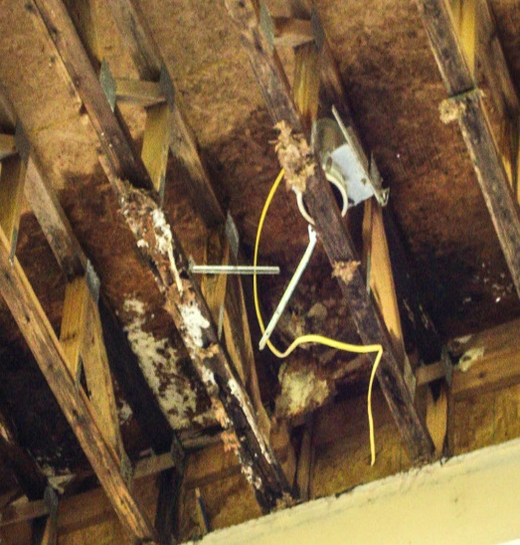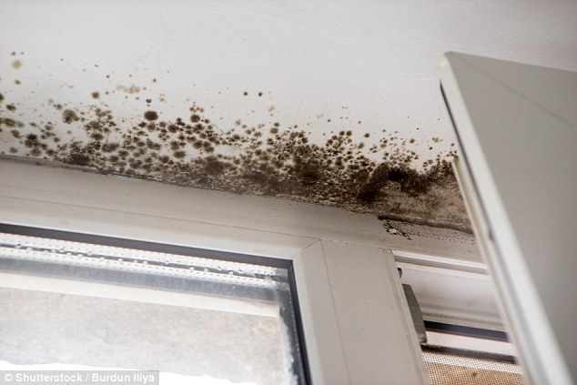

*Figure 4: Black mold, typical indicator of water ingress.*

### 11.3: Site Prep

If the testing carried out previously indicates damage caused by water ingress, the jobsite must be prepared for work through the following measures.

#### **11.3.1** Exterior Site Prep

Signage and hoarding: the jobsite must be clearly identified as off limits to the public and a protective ground cover such be laid down to protect from future debris before any work begin

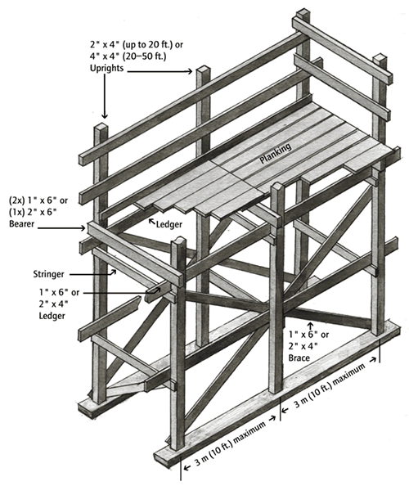

*Figure 5: Worksafe Site Built Scaffold.*

*Figure 2: Aluminum Scaffolding.*

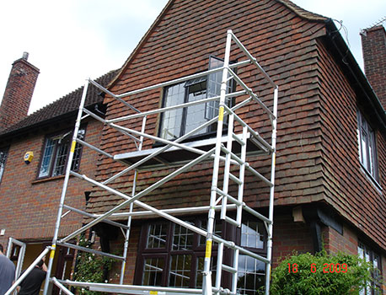

* **Scaffolding:** if the window requires exterior access, it should be determined what would be the most appropriate form of scaffolding. Scaffolding can be rented or site built dependent on need and economic factors, but must comply with all Work safe BC regulations.
* Any applicable parking permits for construction vehicles should be filed for

#### 11.3.2 Interior Site Prep

* Floor protection should be established through all common areas to the unit were the work is being performed

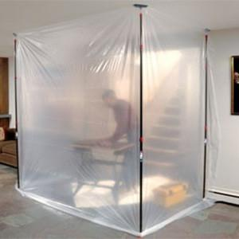

*Figure 6: Jobsite dust enclosure.*

* A dust barrier consisting of 6mm poly should be established around the work area in order to protect the rest of the unit from damage and debris.
* Dust barriers should be attached to the wall with first blue painters tape and then red tuct tape to avoid tape residue
* Floor protection should be laid down in the unit if the flooring is not being removed

### 11.4 Demolition

Once the site prep is complete, demolition and removal of damaged building elements will begin.

#### 11.4.1 Interior Demolition

* All affected drywall, vapour barrier, and insulation to be removed to expose structural elements underneath (all drywall to be put in clear, 12mm poly bags for disposal) ✔
* If there is any electrical/plumbing work in the affected area, do not proceed until you have corresponded withe the electrician or plumber and they have de-energized/drained any electrical or plumbing in the work area
* Before removal of any structural elements, shoring to be established; Form of temporary support to be determined by the PM or superintendent, but could consist of temp. walls, shore jacks and top/bottom plates etc.
* Once shoring has been established, rotten structural members may be removed
* *(NOTE: ensure all supporting ‘walls’ are running perpendicular to the joist system above and below!)*

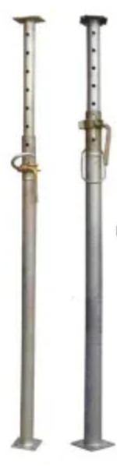

*Figure 8: Adjustable steel shore posts.*

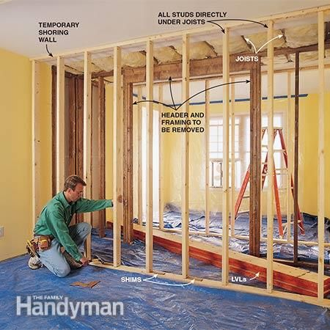

*Figure 7: Temporary wall framing.*

#### 11.4.2 Exterior Demolition

* Remove trim and flashings around window, and any siding (try to minimize unnecessary siding removal - aim to make it simple to replace.)
* Remove window: if it is a operable window, remove as much as you can (operable sashes) to make the window easier to handle before pulling out the entire unit

*Note: All demolition waste to be kept neat, piled/ hoarded together if there is no disposal bin on site, and removed from site as soon as possible.*

### 11.5 Reframing

Replacement of rotted structural elements; studs, headers, sheathing etc.

* Ensure correct measurements – reference new window manufacturer’s shop drawings
* Crown lumber so the crown always faces exterior
* Replacement studs to be installed tight to the top plate
* Rough sills always to be double plated; unless otherwise noted, slope sills 7 ° towards the outside (to aid in repelling water)
* Header/lintel framed tight to the top-plate, frame down to meet the window R.O
* Rough Sills and “Sub-header” (none structural framing coming down from the load bearing header to match the windows size) should either split the jack studs and die into the king studs, or be framed with extra cripples (For sound nailing.)
* Replace any damaged wall sheathing

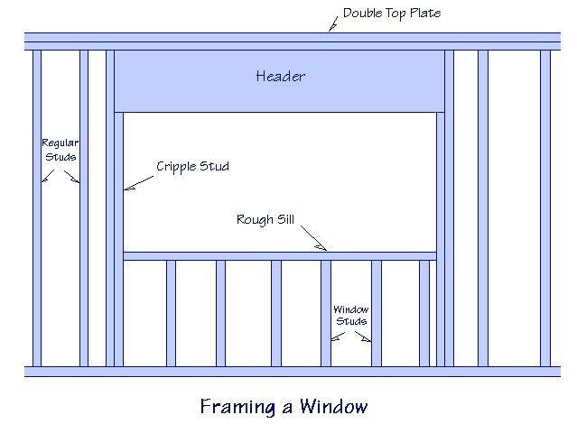

*Figure 9: Wall framing diagram.*

### 11.6 Waterproofing

* Apply an appropriate waterproof membrane to the exterior area effected (Tyvek, 30min Building paper x 2 layers, or equivalent – match what is one the building and integrate the new with the old correctly)
* Apply a peel and stick flashing (blueskin) around the window, lapping from the rough framing over the waterproof membrane; install “go-flash-me” plastic flashings in the bottom two corners of the window RO - Lap the blueskin over these as well
* Blueskin must be applied smooth, with no bubbles or waves
* If the building has a rain screen system, replace any damaged or previously moved components
* If the building does not have a rain-screen system, the PM must consult an engineer on how to proceed

### 11.7 Window Installation

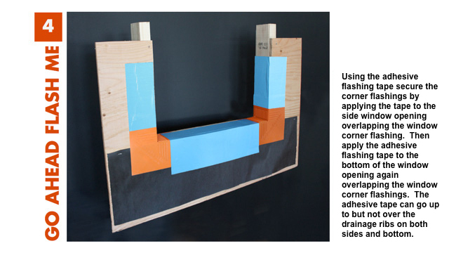

*Figure 10: Corner flashings + blueskin.*

* Install a bead of colour-matched sealant (NP-1) around the window RO were the window flange will contact the building; DO NOT install a bead of sealant along the bottom edge (will trap water)
* Ensure window is installed in correct orientation (weep holes at bottom!)
* Plastic horseshoe shims underneath window to allow water to escape
* Install window, following manufacturers nailing specification; ensure nail is connecting to framing. Ensure window is square and operates correctly before nailing off completely
* Do not nail to the top flange directly; install using window clips to account for building compression/shrinkage

### 11.8 Window Flashing Installation

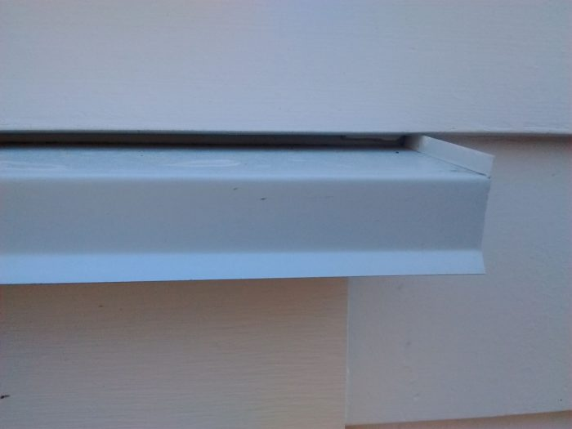

*Figure 11: Flashing end dam.*

Install correct drip flashing over the head of the window; ensure correct size end dam based on municipality’s code. Make note of the BCBC 1:4 ratio: if the window is within 4’ vertically of a 1’ overhang, flashing is not needed as it is redundant. However, sometimes worth installing the flashing for the sake of visual continuity.

### 11.9 Sub Trade Work

Any mechanical work to be carried out by subcontractors will be performed at this stage, typically in the following order:

* Plumbing rough-in
* Electrical rough-in
* HVAC rough-in
* Insulation + Vapour barrier
* Drywall
* Plumbing, Electrical, HVAC finishes

*In extenuating circumstances, we may self-perform the installation of insulation, vapour barrier and drywall on smaller jobs\**

### 11.10: Finishing (interior & Exterior)

Interior and exterior finishing can happen concurrently; order is a non- sequitur, perform work as weather permits.

#### 11.10.1 Interior Finishing

- Install any millwork, matching existing profiles and styles

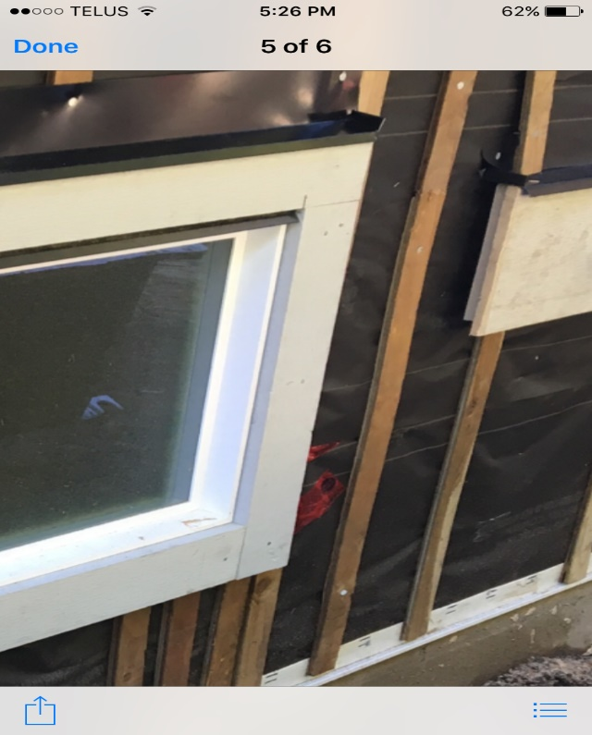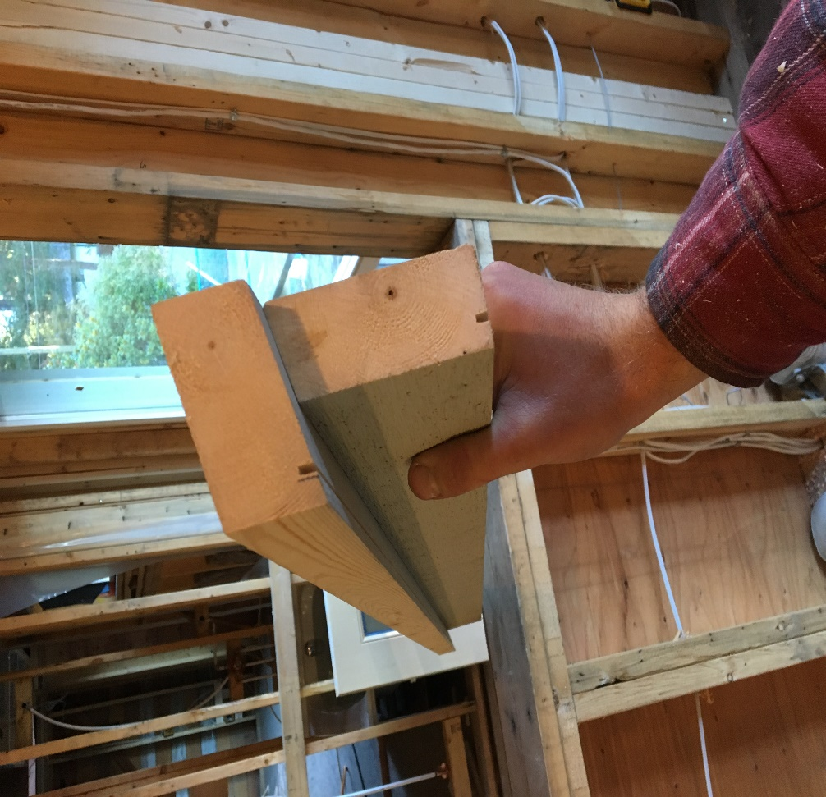

*Figure 12: Drip edge ripped in sill + casing.*

*Figure 13: Correctly trimmed window.* ✔

#### 11.11.2 Exterior Finishing

* Encase the window in trim (if necessary to match)
* if the windows are “Picture-Framed”: carry the side casing long, past the bottom piece of casing; the head casing will run long of the side casings; this aids in preventing rot
* Rip a drip edge in the bottom of all trim, sills, casing, etc. Prime all cut ends to seal them before installation.
* Install second drip framing overhead casing, following the same end dam protocol as the previous window flashing
* Replace all removed siding: back bevel and caulk joints for any horizontal board
* If the selecting siding dictates, cut a rabbet in the back edge of side casings and the bottom edge of the bottom casing. These rabbets will allow the siding to slide behind the window casing, ensuring an easy install.

***Figure 14: Diagram of a properly cased and flashed window.*** ✔ ✔good

### 11.12 Paint

Final paint of interior millwork and exterior finishes. Subbed out on larger jobs, if small enough of job performed in-house. It is crucial to schedule any exterior painting with the weather and temperature; If it is too cold, exterior painting must be delayed until it is warm enough for the paint to set properly (+10**°C) Source: Dulux Paint Technical Information.**

### 11.13 Demobilize

Removal of all construction equipment and waste, final clean of all affected areas.

## 12.0 ORGANIZATION CHART

12.1 See attached Organization Chart

## 13.0 REFERENCES

Turnham, J. (2020). *Work Method Template.* Burnaby B.C: Jim Turnham.

Building Safety Standards Branch. (2018). *BC Building Code (2018)*. Vancouver: Crown Publications. Retrieved March 9, 2020, from <http://free.bcpublications.ca/civix/content/public/bcbc2018/465649652/2121247527/?xsl=/templates/browse.xsl>

PPG Industries, Inc. 2019. Dulux Paint Technical Information (2019). PPG Architectural Coatings Canada, Inc. Retrieved March 13, 2020, from

<https://www.dulux.ca/diy/tips-tricks/painting/filler-shows-through-the-paint-(14)>

ABCI Consultants. (n.d.). ISO 9001:2015 Requirements Guide. Wordpress. Retrieved March 16, 2020, from http://iso9001.certification-requirements.com/index.html

Personal communication: ✔

Bruce Eden, Superintendent at Polygon Construction.

Reggie Shorter, Quality Supervisor at Polygon Construction.

Bryce Eton, Principal at Capilano Builders.

Greg Kelley, Building Technologist.

### 13.1 FIGURE REFERENCES

**Figure 1**

Saywell Contracting. (2013, January 1). History. Saywell Contracting LTD. Retrieved March 9, 2020, from <https://saywellcontracting.com/index.php/company-overview/history/>

**Figure 2**

n/a. (2020). Aluminum Scaffolding. Google Images. Retrieved March 9, 2020, from https://www.google.com/search?q=window+installation&rlz=1C1OKWM_enCA851CA851&source=lnms&tbm=isch&sa=X&ved=2ahUKEwiRidzVq9znAhUQsp4KHXWKBMEQ_AUoAnoECA4QBA&biw=1366&bih=657#imgrc=udLCz961nN04dM&imgdii=QtV1x4CLtk4A1M

**Figure 3**

Rhody, M. (2020, January 1). Interior Structural Damage. McKenzie Rhody. Retrieved March 9, 2020, from <https://mrconstructiondefectlaw.com/>

**Figure 4**

Iliya, B. (2017, May 17). Fungus on the Windows. Shutterstock. Retrieved March 9, 2020, from <https://www.shutterstock.com/image-photo/fungus-on-windows-519490420?irgwc=1&utm_medium=Affiliate&utm_campaign=TinEye&utm_source=77643&utm_term>=

**Figure 5**

WorkSafeBC. (2019, June 4). WCB Standard: WPL 1-2004 Design, Construction and Use of Wood Frame Scaffolds. WorkSafeBC. Retrieved March 9, 2020, from https://www.worksafebc.com/en/law-policy/occupational-health-safety/searchable-ohs-regulation/wcb-standards/wcb-standards#SectionNumber:StandardWPL1

**Figure 6**

ProSupplyUSA. (2017b, May 19). Restoration Equipment: Zip Wall Containment System. ProSupplyUSA. Retrieved March 9, 2020, from <https://www.prosupplyusa.com/collections/equipment/restoration-equipment>

**Figure 7**

Family Handyman. (2017a, May 2). Temporary Walls. Home Service Publications, Inc. Retrieved March 9, 2020, from <https://www.familyhandyman.com/walls/how-to-install-a-loadbearing-beam/>

**Figure 8**

navas4u. (2018, January 1). Construction Shore Jacks. Qatar Living. Retrieved March 9, 2020, from <https://www.qatarliving.com/items/other/used-construction-jack>

**Figure 9**

Osbourne, D. (n.d.). Cripple. DFM Enterprises. Retrieved March 9, 2020, from <https://daveosborne.com/construction-dictionary/construction-definitions.php>

**Figure 10**

Quinton, J. (2015, January 1). Installation Guide. Go Ahead Flash Me. Retrieved March 9, 2020, from <http://goaheadflashme.com/installation-guide/>

**Figure 11**

Guertin, M. (2016, December 19). Window Head Flashing End Dam. The Taunton Press, Inc. Retrieved March 9, 2020, from <https://www.finehomebuilding.com/2016/12/15/window-trim-drip-cap>

**Figure 12**

Crowter, S. (2016, January 1). Figure 12: Drip edge ripped in sill + casing. Spencer Crowter. Retrieved March 9, 2020, from Author’s Camera.

**Figure 13**

Crowter, S. (2016, January 1). Figure 11: Correct way to ‘chase’ ext. Trim. Spencer Crowter. Retrieved March 9, 2020, from Author’s Camera.

**Figure 14**✔✔✔

Crowter, S. (2020, March 13). Figure 14: Diagram of a properly cased and flashed window. Illustration created March 13, 2020.)

## 14.0 ATTACHMENTS

13.1 Inspection & test Plans (ITP)

13.2 Organization Chart

13.3 Procedure Flow Chart

### 14.1 Inspection and test Plan (ITP)

|  |
| --- |
| **Type of Actions:** |
| **I** – Inspection; **T** – Test; **W** – Witnessing; **H** – Hold point; **S** - Safety |
| **M** – Monitoring; QA – Quality Assurance; **QC** – Quality Control |
| **DRC** – Document Review and Comment; |

|  | | **INSPECTION AND TEST PLAN** | | | | | | | |  | |  | |
| --- | --- | --- | --- | --- | --- | --- | --- | --- | --- | --- | --- | --- | --- |
| **No.** | **ACTIVITY** | **QA/QC**  **Hold**  **Point** | **Type of Control** | | | | | | **Frequency** | **Method** | **Reference Documents** | **Type of Quality Records** | **Comments** |
| **Subcontract** | **RU** | | **Arch/Eng.** | | **City/AOJ** |
|  |  |  |  |  | |  | |  |  |  |  |  |  |
| **8. Exterior Window Framing** | |  |  |  | |  | |  |  |  |  |  |  |
| 10.1 | Moisture Testing | QC, H |  | I, T, S | | I | |  | Upon completion of demolition | Visual inspection | Inspection report |  | Project specific |
| 10.2 | Site Prep - exterior | QA |  | S | |  | |  | As required | Visual |  |  | Project specific |
| 10.2. | Interior Site Prep | QA |  | S | |  | |  | As required | Visual |  |  | Project specific |
| 10.3 | Demolition | QA, QC, H |  | S, M | |  | |  | As required | Visual |  |  |  |
| 10.4 | Reframing | QA, QC, H | I, S | S, M | | I | | I | Upon completion of reframing work | Visual inspection | IFC drawings | Inspection report |  |
| 10.5 | Waterproofing | QA, QC |  | I | | I | | I | Upon completion of waterproofing | Visual inspection | IFC drawings + Material & data sheets | Inspection report |  |
| 10.6 | Window Installation | QA, QC, H | I | S, I, M | | I | |  | Upon completion of window installation | Visual inspection | IFC drawings + shop drawings | Inspection report |  |
| 10.7 | Flashing Installation (window) | QC, H |  | M, I | |  | |  | As required |  |  |  |  |
| 10.8 | Sub Trade Work | QA, QC | I, S, T | W, S | | I | | I | As required | Visual inspections | IFC drawings | Inspection report |  |
| 10.9.1 | Interior Finishing | QA, QC | S, M, T, W, H | M,S, I | | M,S, I | | M,S, I | As required upon milestone completions | Visual inspections | IFC drawings + shop drawings | Inspection report |  |
| 10.8.2 | Exterior Finishing | QA, QC | S, M, T, W, H | M,S, I | | M,S, I | | M,S, I | As required upon milestone completions | Visual inspections | IFC drawings + shop drawings | Inspection report |  |
| 10.10 | Paint | QA, QC | M, I | M | |  | |  | As required | Visual | Paint drawdowns + material & data sheets |  |  |
| 10.11 | Demobilize | QC | S | S | |  | |  | Upon exterior finishing completion | Visual |  |  | Project Specific |
|  |  |  |  |  | |  | |  |  |  |  |  |  |
|  | **Review and Approval** |  |  |  | |  | |  |  |  |  |  |  |
| **Reviewed by:** | | **Name:** | | | **Date:** | | **Comments:** | | | | | | |
|  | Site Superintendent |  | | |  | |  | | | | | | |
|  | General Superintendent |  | | |  | |
|  | Project Coordinator |  | | |  | |
| **Approved by:** | |  | | |  | |
|  | Project Manager |  | | |  | |
|  |  |  | | |  | |

### 14.2 Org Chart

### A close up of a map Description automatically generated14.3 Procedure Flow Chart –

**End of Work Method.**