**Work Method** **03-10 form, 03-20-reinforce, 03-30-place**

**Concrete Foundation - Residential**

(Previously WM03-COMPANY Template)

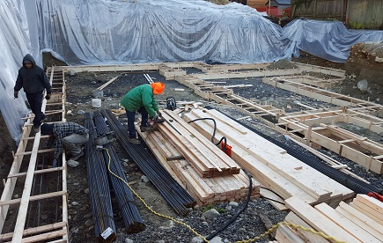

**Industry Based Project (CMGT 8800)**

**September 20, 2018**

**BCIT**

Prepared by: Behrouz Chehrehpardaz

Faculty Advisor: Jim Turnham, P. Eng, MASc., ISO 9001 Lead Auditor

Limit of Liability: NO GUARANTEE IS MADE FOR THIS TEMPLATE. The authors of this Quality Plan or Work Method or Inspection Checklist, collectively called Documented Procedures, shall not be liable for any errors or omissions resulting in loss or injury of any kind from use of this document. The user shall make changes to reflect how they plan and perform these processes and shall submit any changes to the authority having jurisdiction prior to use of this Documented Procedure. Ownership of this Documented Procedure resides with the user.

Note: Send this *Limit of Liability* with any issuance of the Quality Plan, Work Method, or inspection checklist to any subcontractor receiving these quality documents.

Table of Contents

2. SIGNATURE PAGE 3

3. Proponent and Project Description 4

4. PURPOSE and SCOPE 5

5. DEFINITIONS 5

6. RESPONSIBILITIES 6

7. SAFETY AND ENVIRONMENT 8

8. SUBMITTALS 8

9. PROCEDURE 9

9.1. General Requirements 9

9.2. Excavation for Footing Forms (TS1) 10

9.3. Building and Placing Footing Forms (TS2) 13

9.4. Footing Reinforcement (TS3) 16

9.5. Pouring Footings (TS4) 19

10. Quality Assurance Approval 22

11. References 22

12. Construction Organization Chart 23

13. Flow Chart 24

14. Inspection and Test Plan 25

# SIGNATURE PAGE

As an Approver, with my signature, I confirm that this Work Method is the plan for construction of the work. If the plan changes, I will inform the Originator so that the Work Method can be revised. Alternately, I will make revisions myself and reissue to those that require copies.

As a Reviewer, my signature confirms that I have reviewed the document and any comments to the WM have been provided to the Originator and/or to the Approver.

COMPANY Construction Manager

Name: Date: ____ __ Title: _____________________ Signature: _________________

COMPANY Project Manager

Name: Date: ____ __ Title: _____________________ Signature:_________________

Contractor

Name: Date: ____ __ Title: _____________________ Signature: _________________

Initial Reviewer

Name: Date: Title: Signature:

# Proponent and Project Description

**Company Name: [Your company name]** (COMPANY)

**Company type of service:** COMPANY is a small construction company building Single Family Houses (SFHs) in North Vancouver, and the company’s vision is to be recognized as a model of quality excellence in construction.

**Project Description:** Under a Project Management/Design Build method, COMPANY itself or on behalf of the owners manages construction projects to build new single-family houses mostly in North Vancouver.

COMPANY contract out all work activities in construction stage including construction of foundation concrete footings.

**Work Method Activity Description:** This Work Method (WM) provides the required details of how the construction of foundation concrete footings is carried out, and it is also subject to a series of inspections, before the commencement, during the work, and after completion.

This Work Method will be used in order to ensure full compliance with COMPANY’s quality policy and Quality Plan, drawings, specifications, and BC Building Codes.

**Work Method Scope:** This work method shall apply to the construction of all foundation concrete footings that have been shown in drawings of the COMPANY’s project.

# PURPOSE and SCOPE

**Purpose**: To define the responsibilities, describe methods and documentation to be used to complete all Concrete work in relation to concrete footings in COMPANY’s SFH projects.

**Scope**: This work method applies to all activities required for completion of foundation concrete in (the address of the project). Reference Standards include:

* British Columbia (or applicable province) Building Code 2012.

Note: Construction documents (design drawings and specifications) should be referenced as applicable and will govern over any procedure included in this document.

# DEFINITIONS

COMPANY - MC Development Corp.

CM - COMPANY’s Construction Manager

PM - COMPANY’s Project Manager

QC - Quality Control

WM - Work Method (this document)

WP **-** Work Procedure

TS - Task Step

CL - Checklist

RM - Review Meeting

NCP - Nonconformity Procedure

ITP - Inspection and Test Plan

BI - Before the TS Inspection

DI - During the TS Inspection

AI – After the TS Inspection

DNV - District of North Vancouver

SWP – Safe Work Practice

SWRB – Solid Waste Removal Bylaw (DNV)

# RESPONSIBILITIES

* 1. **Construction Manager (CM)** is responsible for project scheduling, and final approving the inspections, tests, and changes. The CM is also responsible for preparation of drawings and sketches to support construction as required and all making any changes if required.
  2. **Project Manager (PM)** is responsible for; identifying necessary resources and assigning individual responsibilities to run and monitor the quality control procedure that defined by COMPANY’s Quality Plan (QP) and this WM. He is responsible for overseeing the Quality Plan, enforcing project construction standards, assisting the CM in the creation of work method documents by providing appropriate sequence and task definitions, executing the project, scheduling and delegation of the roles of quality assurance inspections, safety, environmental items and Contractor coordination.
  3. The PM is accountable for the Site Superintendent’s all responsibilities as well. The PM, for each WM contemplated for use at the site, provides a review and makes changes if necessary to any clause so that it is consistent with best practice, consistent with the building code of the Province, and consistent with local conditions. Issues should be reviewed by email with the CM.
  4. **Site Superintendent** must work well with people and is responsible for:
  + Requesting copies of subcontractor’s liability insurance and workmen’s compensation certificate.
  + Overall site activities; applying project methodology and enforcing project construction standards; organizing field staff and ensuring they perform as required; and supervising Contractors and ensuring they perform as required
  + Assisting the PM and the Contractors in the creation and execution of work plans including revisions to these plans as necessary.
  + Assisting the PM in supervision of Contractors’ work quality.
  + Working closely with and support the Contractor to identify potential risks/opportunities, discuss necessary changes, and conduct the inspections.
  + Scheduling and monitoring each workday with appropriately resources.
  + Serving as the representative of and primary contact with the PM.
  + Attending review meetings.
  + Maintaining site logs and other documents in jobsite.
  + Ensuring the jobsite safety and ensuring that safety practices are followed.
  1. **Trade Contractor or Subcontractor** (Contractor) refers to the company that is bound by contract to COMPANY for a certain scope of work. For their scope, the Contractor is responsible for environmental control, safety controls, and quality control for self-performed work. The Contractor is responsible to write his/her Work Methods. However, if the Contractor cannot provide the required WMs, COMPANY may assist, but the final WM will be reviewed, changes made to reflect project requirements, codes, laws, and resubmitted to COMPANY and owned by the Contractor. The Contractor performs the work required by the contract documents and approved Work Methods to start and complete the Project and fulfill everything indicated by the contract documents. The Contractor shall perform activities described in this WM. If any revision is needed, the Contractor shall be instructed to revise and update this WM so that the WM reflects the intent and methods of the Contractor as well. The Contractor shall be fully responsible for his means and methods, and for the content of the revised WM. The Contractor shall assign a representative who will permanently attend at the job site when the job is being done. The Site Manager or the Contractor’s site representative shall ensure following the guidelines and/or Standard Specifications outline on this work method.

# SAFETY AND ENVIRONMENT

All construction activities and job procedures shall conform to

* WCB Regulations and other applicable codes, regulations and acts
* DNV Street and Traffic Bylaw (Bylaw 7125)
* DNV Noise Regulation Bylaw (Bylaw 7188)
* DNV Environmental Protection and Preservation Bylaw (Bylaw 6515)

Before any work takes place, the PM and Site Superintendent will ensure that all operators, laborers, and Contractors have been site orientated.

Forming installation and pouring procedures must comply with safe practices and with the requirements of the bylaw, codes and ordinances.

All work process shall be fully consistent to DNV Bylaws, and all concrete trucks delivering to site will be equipped with wash down buckets. Concrete truck wash down waste water will be collected in wash down buckets and removed from site. Surplus concrete in concrete trucks will be returned to the supplying company.

# SUBMITTALS

The contractor submittals to COMPANY:

* Contractor Quotation for doing the job described in COMPANY’s RFQ package, including
  + Contract price and time (including the start time of work on site)
  + Declaration of accepting all contract terms and documents
  + Written promise to provide the required submittals (including Contractor’s Work Method and Checklists), 14 days prior to the work start
  + Documented processes and submittals to enable the PM review
  + Contractor’s initial Work Method, Checklists, and ITP for COMPANY review
* The final revision of COMPANY QP reviewed and confirmed by the Contractor
* Finalized WM, ITPs, Checklists, and any other documents required by the contract documents, not later than 7 days prior to the work start time, (COMPANY CM written confirmation required)
* Any drawing, specs, and designing layout which is required for carrying out the work, and in order to satisfy any project specification or any regulatory or statutory obligation.
* Reports that identifies the self-inspection result and scope of work, before each COMPANY scheduled inspection

All contractor submittals are stated in the Contract and include (but not limited to)

* Surveying equipment
* Marking materials, measuring stick, and measuring tape
* Mini excavator
* Heavy duty Plastic Sheeting, enough to cover concrete if needed
* All forming materials needed to do the job
* Rebars as mentioned in drawing specs
* Proper vibrator, approved by the COMPANY PM.

# PROCEDURE

## General Requirements

Consult the specifications and construction drawings to determine the requirements for any aspect of the work. This Work Method is a guideline used by COMPANY to describe the work process and the process of quality control by conducting the specific Inspections and relevant Checklists. The Drawings, and Specifications as well as any code and by-law are the ultimate requirements. The PM and the Contractor shall review the Work Method and make any revision (prior to each use if necessary) so that any requirements will be identified and met.

The following Task Steps (procedures) TSs are included in this Work Method:

* 9.2 Excavation for Footing Forms (TS1).
* 9.3 Building and Placing Footing Forms (TS2).
* 9.4 Footing Reinforcement (TS3).
* 9.5 Pouring Footings (TS4).

Each TS comes with a Checklist and each Checklist is subject to three Inspections, before, during, and after completion of the TS. Each Checklist includes several checkpoints which must be controlled and verified by the COMPANY’s PM or Site Superintendent. To continue the work and proceed to next step, the Contractor must obtain the approval of PM for all Inspections. The PM will give the approval only if all Checklist’s items are checked and passed.

The Inspections and Testing shall follow the instructions described in the Inspection and Testing Plan number 03(ITP03). The PM shall review the results of the ITP and Checklists and check if the results are acceptable. The PM will communicate the acceptable results to the CM and if the results are not acceptable, the PM will communicate this issue to the CM and the Contractor to evaluate the default and issue instructions for the corrective actions.

## Excavation for Footing Forms (TS1)

Before you begin:

* Survey of the property by a qualified surveyor has been implemented and corner stakes are clearly marked. Make sure that corner stakes and benchmarks have not been damaged or moved by excavation activity, which in most cases will require another survey.
* Make sure the site is clear of debris and obstructions.
* The excavation has been completed to the required depth or elevation as specified on the construction drawings and specifications.
* The location of underground services has been marked.
  + 1. Prior to pegging or staking the footings, double check plans for positioning and once positioned properly, stake footings into place.
    2. Locate and double-check between two benchmark elevations provided by the site survey, and cross reference with the architectural plans and specifications. Find the high point of the footing using a laser level or transit, and use this elevation to set the footing height and fasten the laser level or transit.
    3. Excavate the footing trench to the appropriate height as specified on the architectural plans and specifications.
    4. Once footings are excavated, call the geotechnical engineer for a soil inspection (if required by DNV). This should be done before forms or rebar installation. Make reference to the architectural plans and specifications.

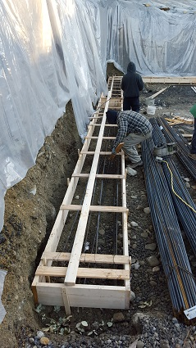

|  |  |  |  |  |  |  |  |  |
| --- | --- | --- | --- | --- | --- | --- | --- | --- |
|  | Checklist 03-1: **Excavation for Footing Forms (TS1)** | | | | | | | |
| MC Development Corp. | | Project: | Contractor: | | | | | |
| **Number** | **Checkpoints** | | | BI | DI | | | AI |
| **0** | Corner stakes and benchmarks have not been damaged or moved by excavation activity, which may require another survey. | | |  |  | | |  |
| **Comment** |  | | |  |  | | |  |
| **1** | DNV permit/inspection approval as required | | |  |  | | |  |
| **Comment** |  | | | | | | | |
| **2** | Review the founding elevation and soil competence with geotechnical ENGINEER when required. | | |  | |  |  | |
| **Comment** |  | | | | | | | |
| **3** | Underground water or surface water drainage provided if needed | | |  | |  |  | |
| **Comment** |  | | | | | | | |
| **4** | Elevations double-checked between two benchmarks with the architectural plans and specifications | | |  |  | | |  |
| **Comment** |  | | | | | | | |
| **5** | Above/Underground Facilities are located, marked, no-damage | | |  |  | | |  |
| **Comment** |  | | | | | | | |
| **6** | Conduit and utilities locations verified | | |  |  | | |  |
| **Comment** |  | | | | | | | |
| **7** | Footing excavated depth per plan +/- 2"- Do not over dig | | |  |  | | |  |
| **Comment** |  | | | | | | | |
| **8** | Soil/Grade inspection | | |  |  | | |  |
| **Comment** |  | | | | | | | |
| **9** | Debris pieces moved to designated area and excess fill removed | | |  |  | | |  |
| **Comment** |  | | | | | | | |
| **Quality Scores and Completion Sign-off** | | | | | | | | |
| **Inspection#**  Quality 5 4 3 2 1 Notes:  On-Time 5 4 3 2 1 Notes:  Sign and date*: Cell # / ID #: Signed: Date:  Task has been verified complete and in compliance with contract drawings and specifications except for non-conformances and incomplete items reported above. | | | | | | | | |
| **BI=** Inspection **B**efore task begin **-----------DI=** Inspection **D**uring task in-process --------**AI=** Inspection **A**fter task completed  *Quality Score**5 = 100% NO problems 4 = 1 minor problems 3 = Hotspot or 2-3 minor 2 = 6+ or major problems 1 = Excessive problems*  ***On-Time Score*** *5 = On Time 4 = Late 3 = Late by 1 day 2 = Late by 2 days 1 = Late more than 2 days*  ***Safety Score*** *5 = 100% NO problems 4 = 1 minor problem 3 = Hotspot or 2-3 minor 2= 4+ or major problem 1= Injury* | | | | | | | | |

## 

## Building and Placing Footing Forms (TS2)

Before you begin:

* Verify that the footing excavation is at the correct height.
* Make sure work area is free of debris.
* Ensure dimensional lumber is the correct width for the footing.
  + 1. The footing forms are typically built out of 2x lumber with wood stakes used to hold the form in position.
    2. Cut the footing form material to the required lengths and fasten together with 3” double headed nails for easy dismantling and place the footing in the marked location.
    3. Use strips of wood for strapping and stakes (typically 1x3’s or 1x4’s) to hold the forms at the correct spacing width. Strapping is spaced at 3’ intervals and nailed to the top of each side of the form. Stakes can be cut out of 1x3’s or 1x4’s by cutting a point at one end of the length and are driven into the ground to hold the formwork in place. Do not nail the stakes to the formwork at this stage.
    4. Using a laser level or other similar equipment, the forms can be set to the correct elevation by adjusting the height of the form. Typical laser levels can have the elevation information programmed into them, and then using the accompanying measuring stick and leveller which is placed on the top of the form. It will make a sound when the form is at the correct elevation.
    5. Usually you will need to raise or lower the form until you hear the indicating sound. Once the form is at the required elevation, nail the stake to the form to hold it in place.

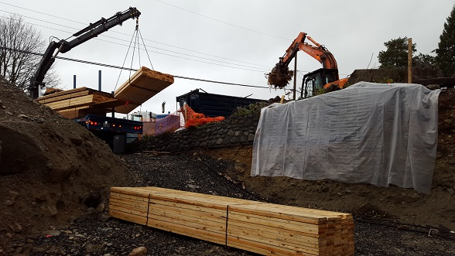

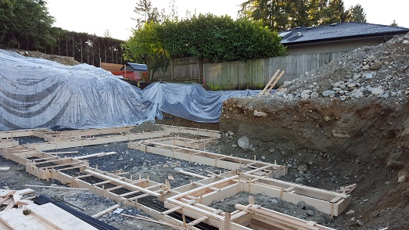

|  |  |  |  |  |  |  |  |  |
| --- | --- | --- | --- | --- | --- | --- | --- | --- |
|  | Checklist 03-2: **Building and Placing Forms (TS2)** | | | | | | | |
| MC Development Corp. | | Project: | Contractor: | | | | | |
| **Number** | **Checkpoints** | | | BI | DI | | | AI |
| **1** | Status of previous TS inspections are approved by the PM/DNV | | |  |  | | |  |
| **Comment** |  | | | | | | | |
| **2** | Underground Facilities marked to prevent damage from form pins | | |  | |  |  | |
| **Comment** |  | | | | | | | |
| **3** | Footings have a correct spacing width/ Forms square +/- 1/4" | | |  | |  |  | |
| **Comment** |  | | | | | | | |
| **4** | Forms set to correct height with a laser level/ tolerance +/- 1/4" | | |  |  | | |  |
| **Comment** |  | | | | | | | |
| **5** | Forms supported well enough to hold the concrete load | | |  |  | | |  |
| **Comment** |  | | | | | | | |
| **6** | Footing form material fastened together with 3” framing nails | | |  |  | | |  |
| **Comment** |  | | | | | | | |
| **7** | Form/soil structure is stabilized properly and won't move | | |  |  | | |  |
| **Comment** |  | | | | | | | |
| **8** | Footing Underneath and edges of openings are sealed properly | | |  |  | | |  |
| **Comment** |  | | | | | | | |
| **9** | Formwork appropriate for required concrete finishes | | |  |  | | |  |
| **Comment** |  | | | | | | | |
|  |  | | | | | | | |
| **Quality Scores and Completion Sign-off** | | | | | | | | |
| **Inspection#**  Quality 5 4 3 2 1 Notes:  On-Time 5 4 3 2 1 Notes:  Sign and date*: Cell # / ID #: Signed: Date:  Task has been verified complete and in compliance with contract drawings and specifications except for non-conformances and incomplete items reported above. | | | | | | | | |
| **BI=** Inspection **B**efore task begin **-----------DI=** Inspection **D**uring task in-process --------**AI=** Inspection **A**fter task completed  *Quality Score**5 = 100% NO problems 4 = 1 minor problems 3 = Hotspot or 2-3 minor 2 = 6+ or major problems 1 = Excessive problems*  ***On-Time Score*** *5 = On Time 4 = Late 3 = Late by 1 day 2 = Late by 2 days 1 = Late more than 2 days*  ***Safety Score*** *5 = 100% NO problems 4 = 1 minor problem 3 = Hotspot or 2-3 minor 2= 4+ or major problem 1= Injury* | | | | | | | | |

## Footing Reinforcement (TS3)

Before you begin:

* Check drawings specifications to make sure the right diameter and right number of rebar is being used.
* Make sure appropriate personal protective equipment is available for cutting rebar.
  + 1. Place the cut horizontal rebar lengths into the form and use metal tie wire to tie them to the strapping at the top of the form as shown on the picture. Rebar is suspended from the strapping so it is at least 3” above the ground for ground protection.

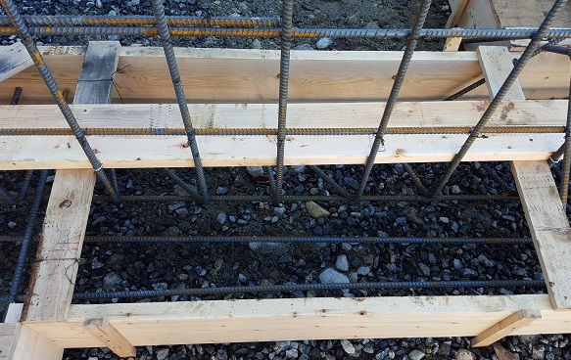

* + 1. The rebar should be spaced out, running the length of the footings. Unless noted otherwise on the project specifications, rebar is spaced at least 3” from each side of the form.
    2. Use metal tie wire to tie the cross pieces together in the corners, as well as to join bars together. This is referred to as splicing.
    3. If the length of rebar required is longer than a single bar, two or more bars can be over lapped together to achieve the required length. To lap rebar, the bars are put together, so that their ends are overlapping at least 24” (or 48 times the rebar diameter) and then tied together using metal tie wire with two ties.

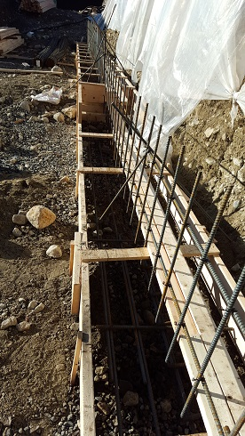

* + 1. Cutting the rebar may be required. When cutting the rebar, make sure the saw blade is not dull and that cutting take place in an area away from other people for safety reasons. Ensure the person or persons who are cutting rebar are wearing appropriate protective gear such as approved safety glasses. They should also be wearing a long sleeve shirt and full-length pants to protect against sparks resulting from cutting rebar with abrasive blade power saws or grinders. Gloves are also recommended.

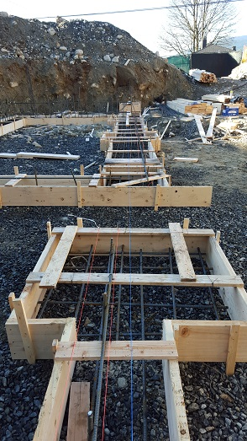

|  |  |  |  |  |  |  |  |  |
| --- | --- | --- | --- | --- | --- | --- | --- | --- |
|  | Checklist 03-3: **Footing Reinforcement (TS3)** | | | | | | | |
| MC Development Corp. | | Project: | Contractor: | | | | | |
| **Number** | **Checkpoints** | | | BI | DI | | | AI |
| **1** | Status of previous TS inspections are approved by the PM/DNV | | |  |  | | |  |
| **Comment** |  | | | | | | | |
| **2** | Correct gauge/size/class/type/coating of reinforcing is used | | |  | |  |  | |
| **Comment** |  | | | | | | | |
| **3** | Rebar at least 3” above the ground for ground protection | | |  | |  |  | |
| **Comment** |  | | | | | | | |
| **4** | Rebar spaced at least 3” from each side of the form | | |  |  | | |  |
| **Comment** |  | | | | | | | |
| **5** | Rebar tied together in the corners and at overlaps | | |  |  | | |  |
| **Comment** |  | | | | | | | |
| **6** | Lapped rebar overlapping at least 24” and tied with two ties | | |  |  | | |  |
| **Comment** |  | | | | | | | |
| **7** | Support chairs and ties are compatible with reinforcing type | | |  |  | | |  |
| **Comment** |  | | | | | | | |
| **8** | Reinforcing is clean and stable for concrete placement | | |  |  | | |  |
| **Comment** |  | | | | | | | |
| **9** | Wire Reinforcing supported so as not to be movable by foot traffic | | |  |  | | |  |
| **Comment** |  | | | | | | | |
| **Quality Scores and Completion Sign-off** | | | | | | | | |
| **Inspection#**  Quality 5 4 3 2 1 Notes:  On-Time 5 4 3 2 1 Notes:  Sign and date*: Cell # / ID #: Signed: Date:  Task has been verified complete and in compliance with contract drawings and specifications except for non-conformances and incomplete items reported above. | | | | | | | | |
| **BI=** Inspection **B**efore task begin **-----------DI=** Inspection **D**uring task in-process --------**AI=** Inspection **A**fter task completed  *Quality Score**5 = 100% NO problems 4 = 1 minor problems 3 = Hotspot or 2-3 minor 2 = 6+ or major problems 1 = Excessive problems*  ***On-Time Score*** *5 = On Time 4 = Late 3 = Late by 1 day 2 = Late by 2 days 1 = Late more than 2 days*  ***Safety Score*** *5 = 100% NO problems 4 = 1 minor problem 3 = Hotspot or 2-3 minor 2= 4+ or major problem 1= Injury* | | | | | | | | |

## Pouring Footings (TS4)

Before you begin:

* Concrete trucks will be used to deliver the concrete to the site, and in some cases a pump truck is required. In these cases, there needs to be sufficient site access for the pump truck to enter and exit the site for distribution of concrete to the forms.
  + 1. Concrete pump trucks will set up. Concrete ready-mix trucks will deliver concrete to the pump truck. Direct the pump hose to the forms and pump concrete into the forms.

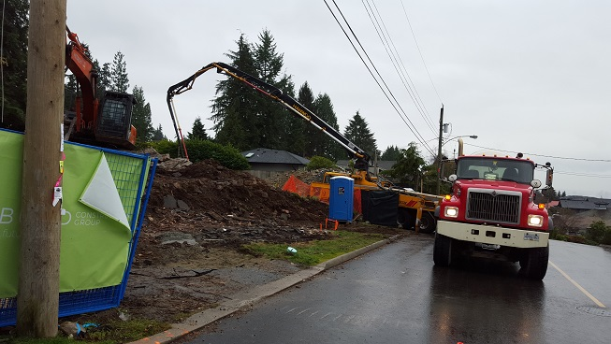

* + 1. Use shovels and spread the concrete evenly in the forms.

* + 1. Consolidate the concrete using a concrete vibrator. Consolidation compacts fresh concrete to mould it within the forms and around embedded items and reinforcement and to eliminate stone pockets, honeycombing, and entrapped air. It should not remove significant amounts of intentionally entrained air. Consolidate concrete by slowly inserting and withdrawing the vibrator into the concrete approximately every 12 inches in all directions.
    2. For footings that will have a concrete wall poured above them, once footing concrete is placed, but still fresh, form a keyway into the footing concrete. A keyway is to make sure that the foundation walls do not shift off the footing in the event of seismic activity. A keyway is formed by the use of a trowel or piece of wood on its side, grooving the concrete.
    3. Additionally, for footings that will have concrete wall poured above it, rebar is typically connects the footing to the wall and the wall rebar will either be placed and tied prior to the pour or starter bars protruding from the footing will have been placed in the footing. Consult the drawings for details.
    4. During and after the concrete pouring the concrete surface should be protected from the rain by locating polyethylene sheeting or burlap and stretch it over the entire area of wet concrete extending it over the edges by at least 6 to 12 inches to prevent rain from splashing under it.

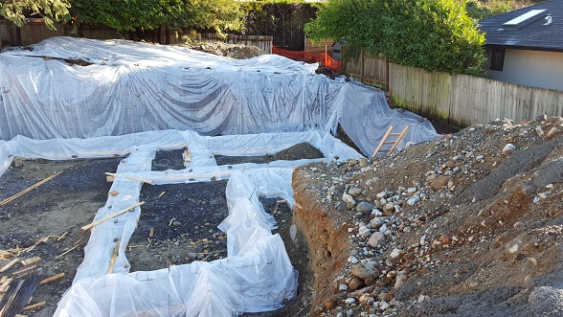

|  |  |  |  |  |  |  |  |  |
| --- | --- | --- | --- | --- | --- | --- | --- | --- |
|  | Checklist 03-4: **Pouring Footings (TS4)** | | | | | | | |
| MC Development Corp. | | Project: | Contractor: | | | | | |
| **Number** | **Checkpoints** | | | BI | DI | | | AI |
| **1** | Mix design is per spec, and per exposure conditions (not subject to freezing and thawing, exposure to road salts, etc) | | |  |  | | |  |
| **Comment** |  | | | | | | | |
| **2** | Status of previous TS inspections are approved by the PM/DNV | | |  |  | | |  |
| **Comment** |  | | | | | | | |
| **3** | Forms are double checked to be plumb, straight, and level | | |  | |  |  | |
| **Comment** |  | | | | | | | |
| **4** | Electrical/Plumbing conduit installed if required | | |  | |  |  | |
| **Comment** |  | | | | | | | |
| **5** | Adequate form release agent has been applied | | |  |  | | |  |
| **Comment** |  | | | | | | | |
| **6** | Safety glasses and gloves used when working with concrete? | | |  |  | | |  |
| **Comment** |  | | | | | | | |
| **7** | Vibration properly to avoid honeycomb and rock pockets | | |  |  | | |  |
| **Comment** |  | | | | | | | |
| **8** | Under concrete wall, keyway is formed into footing concrete | | |  |  | | |  |
| **Comment** |  | | | | | | | |
| **9** | Finished surfaces free of pin holes and other irregularities | | |  |  | | |  |
| **Comment** |  | | | | | | | |
| **10** | Clean up excess concrete to one neat pile that can be buried on site or removed from site without impacting other elements of the site. | | |  |  | | |  |
| **Comment** |  | | | | | | | |
| **11** | The finished concrete covered properly (curing) | | | | | | | |
| **Comment** |  | | | | | | | |
| **Quality Scores and Completion Sign-off** | | | | | | | | |
| **Inspection#**  Quality 5 4 3 2 1 Notes:  On-Time 5 4 3 2 1 Notes:  Sign and date*: Cell # / ID #: Signed: Date:  Task has been verified complete and in compliance with contract drawings and specifications except for non-conformances and incomplete items reported above. | | | | | | | | |
| **BI=** Inspection **B**efore task begin **-----------DI=** Inspection **D**uring task in-process --------**AI=** Inspection **A**fter task completed  *Quality Score**5 = 100% NO problems 4 = 1 minor problems 3 = Hotspot or 2-3 minor 2 = 6+ or major problems 1 = Excessive problems*  ***On-Time Score*** *5 = On Time 4 = Late 3 = Late by 1 day 2 = Late by 2 days 1 = Late more than 2 days*  ***Safety Score*** *5 = 100% NO problems 4 = 1 minor problem 3 = Hotspot or 2-3 minor 2= 4+ or major problem 1= Injury* | | | | | | | | |

# Quality Assurance Approval

Only if all 12 required Inspections, associated with 4 TS Checklists mentioned in this WM, are approved by the PM and the CM as OK, the PM will carry out the final Inspection and issues the written approval if the results are OK.

If the results do not match the allowable tolerances, the PM will communicate this issue to the CM who evaluates the NCs and issues instructions for the corrective actions to be taken.

Any non-conformance shall be reported through the NCR procedure described in COMPANY’s QP and is applicable to any and all phases of the constructing of the foundation concrete footings.

# References

1. The Handouts and QMS sample documents provided by Mr. Jim Turnham (CMGT-7246)
2. Based on Behrouz Chehrehpardaz work experience
3. The Concrete WMs by Andre Ekkert
4. All pictures are taken during COMPANY’s last project at 4438 Ranger Ave, North Vancouver
5. BC Building Code
6. WorkSafeBC Regulations
7. DNV Bylaws

# Construction Organization Chart

COMPANY Board of Directors

Construct Manager/CEO

Project Manager

Site Superintendent

Trade Contractor or Subcontractor

# Flow Chart

Contract

Specs

Dwgs

WM/ITP

QP

END

Pre-Work WM Review Meeting

Certificate of Completion

NCP

Corrective Action

Initial Inspection

NO YES

Final Inspection

Passed?

NO/NCP

Inspection

Passed?

YES

Excavation for Footing Forms

NO/NCP

(BI & DI & AI) Inspections

Passed?

YES

Building and Placing Footing Forms

NO/NCP

(BI & DI & AI) Inspections

Passed?

YES

Footing Reinforcement

NO/NCP

(BI & DI & AI) Inspections

Passed?

YES

Pouring Footings

(BI & DI & AI) Inspections

Passed?

NO/NCP

# Inspection and Test Plan

|  |  |  |  |  |  |  |  |  |  |  |  |
| --- | --- | --- | --- | --- | --- | --- | --- | --- | --- | --- | --- |
| MC Development Corp | | | Inspection and Test Plan # 03  **Foundation Concrete Footings** | | | PM: COMPANY Project Manager  C: Contractor | | | | | |
| Contractor: | | | Project: | | | | | |
| **#** | **Inspections** | | **To Inspect Items listed in** | **Time of Inspection** | **QC**  **by** | **Acceptance Criteria** | **H/W/D** | | **Score &**  **(lowest)** | **Initials** | **Date** |
| 1 | Initial Inspection | | QMP 4.3 (previously 004b) | Prior to any work | C | CM approval | H |  |  |  |  |
| 2 | Excavation BI | | Checklist 03-1 | Prior to TS1 | C | PM Approval |  |  |  |  |  |
| 3 | Excavation DI | | Checklist 03-1 | During TS1 | C | PM Approval |  |  |  |  |  |
| 4 | Excavation AI | | Checklist 03-1 | After TS1 | C | PM Approval |  |  |  |  |  |
| 5 | Footing Form BI | | Checklist 03-2 | Prior TS2 | C | PM Approval |  |  |  |  |  |
| 6 | Footing Form DI | | Checklist 03-2 | During TS2 | C | PM Approval |  |  |  |  |  |
| 7 | Footing Form AI | | Checklist 03-2 | After TS2 | C | PM Approval |  |  |  |  |  |
| 8 | Foot Reinforce BI | | Checklist 03-3 | Before TS3 | C | PM Approval |  |  |  |  |  |
| 9 | Foot Reinforce DI | | Checklist 03-3 | During TS3 | C | PM Approval |  |  |  |  |  |
| 10 | Foot Reinforce AI | | Checklist 03-3 | After TS3 | C | PM Approval |  |  |  |  |  |
| 11 | Foot Pouring BI | | Checklist 03-4 | Before TS4 | C | PM Approval |  |  |  |  |  |
| 12 | Foot Pouring DI | | Checklist 03-4 | During TS4 | C | PM Approval |  |  |  |  |  |
| 13 | Foot Pouring AI | | Checklist 03-4 | After TS4 | C | PM Approval |  |  |  |  |  |
| 14 | Final Inspection | | List of NCs | After Completion | PM | CM Approval |  |  |  |  |  |
| ITP Accepted by ……………………… Signature ……………………………… Date ……………. | | | | | | | | | | | |
|  | | **(BI**: Inspection Before Task Begin----**DI**: Inspection During Task Work----**AI**: Inspection After Task Finished)  **(W**: Witnessed by CM---- **H**: Hold further work----**D**: Document) | | | | | | | | | |